**MINISTRY OF EDUCATION AND TRAINING**

**Shoes Seconhand Exchange**

**Software Requirement Specification**

Project Code: SWR302

Document Code: SRS – v1.0

|  |  |
| --- | --- |
| **Group 2** | |
| **Group members** | Lê Tiến Đạt – SE140919 – Team Leader  Trần Trung Tá – SE140962 – Team Member  Nguyễn Lê Anh Long – SE140929 – Team Member  Nguyễn Lâm Thanh Tú – SE141052 – Team Member |
| **Supervisor** | Lại Đức Hùng |

-Ho Chi Minh city, 11/07/2021-

**Record of change**

*A - Added M - Modified D - Deleted

|  |  |  |  |  |
| --- | --- | --- | --- | --- |
| **Effective Date** | **Changed Items** | **A* M, D** | **Change Description** | **New Version** |
| 02/12/2020 | Initial | a | Add project over view |  |
| 03/17/2021 | SRS | M | Finish SRS |  |
|  |  |  |  |  |
|  |  |  |  |  |
|  |  |  |  |  |
|  |  |  |  |  |
|  |  |  |  |  |
|  |  |  |  |  |
|  |  |  |  |  |
|  |  |  |  |  |
|  |  |  |  |  |
|  |  |  |  |  |
|  |  |  |  |  |
|  |  |  |  |  |
|  |  |  |  |  |
|  |  |  |  |  |
|  |  |  |  |  |
|  |  |  |  |  |
|  |  |  |  |  |
|  |  |  |  |  |
|  |  |  |  |  |

**TABLE OF CONTENTS**

1 Introduction * 6

1.1 Purpose * 6

1.2 Scope* 6

1.3 Definitions, Acronyms, and Abbreviations* 6

1.4 References* 6

2 Overall Description* 7

2.1 Current situation* 7

2.2 The proposed system* 7

2.3 Web Application 7

3 FUNCTIONAL REQUIREMENTS 8

3.1 ShoesShopSeconhandExchange Use Cases Diagram 8

3.2 < Guest > Overview Use Case 8

3.3 < Guest > Register an account 9

3.4 < Guest > Login 12

3.5 < Guest > View list shoes 14

3.6 < Guest > View a specific shoes 16

3.7 < Guest > Add to cart 18

3.8 < Guest > View cart 20

3.9 < Guest > Remove shoes 22

3.10 < Guest > Checkout cart 24

3.11 < Guest > Search shoes 27

3.12 < Authenticated user > Overview Use Case 29

3.13 < Authenticated user > View profile 29

3.14 < Authenticated user > Edit profile 32

3.15 < Authenticated user > Sign out 34

3.16 < Deliveryman > Overview Use Case 36

3.17 < Deliveryman > View list order 37

3.18 < Deliveryman > View an order 38

3.19 < Deliveryman > Change status 40

3.20 < Moderator > Overview Use Case 42

3.21 < Moderator > Check shoes 42

3.22 < Customer > Overview Use Case 44

3.23 < Customer > View list order 45

3.24 < Customer > View an order 47

3.25 < Customer > Send feedback 49

3.26 < Customer > Cancel order 50

3.27 < Customer > Chat 52

3.28 < Vendor > Overview Use Case 54

3.29 < Vendor > View list order 54

3.30 < Vendor > View an order 56

3.31 < Vendor > Delete shoes 58

3.32 < Vendor > Add new shoes 60

3.33 < Vendor > Update shoes 62

3.34 < Vendor > View list shoes 64

3.35 < Vendor > View feedback 66

3.36 < Vendor > Reply feedback 68

3.37 < Vendor > Report feedback to admin 70

3.38 < Vendor > Chat 72

3.39 < Vendor > Cancel order 74

3.40 < Admin > Overview Use Case 76

3.41 < Admin > View list account 76

3.42 < Admin > Ban account 78

3.43 < Admin > Add moderator 80

3.44 < Admin > Add deliveryman 83

3.45 < Admin > View list report 86

3.46 < Admin > View list report of vendor 88

3.47 < Admin > Delete feedback 90

3.48 < Admin > View list of moderator 92

3.49 < Admin > Prevent order 95

4 NON-FUNCTIONAL RQUIMENTS 97

4.1 Usability 97

4.2 Reliability 97

4.3 Performance 98

4.4 Supportability 98

4.5 Design Constraints 98

4.6 On-line User Documentation and Help System Requirements 98

4.7 Purchased Components 98

4.8 Interfaces 99

4.9 Licensing Requirements 99

4.10 Legal, Copyright, and Other Notices 99

4.11 Applicable Standards 99

5 Supporting Information 99

# Introduction *

Nowadays, genuine shoes have good quality and the price is quite high compared to the average salary of people in Vietnam, but some low-income people are passionate about shoes especially they like to collect them. they want to try. In addition, some people have used and feel they are not suitable for the purchased shoes and need someone to buy them back. A big problem is that sellers and buyers if they transact on forums or social networks, will not be assured of the quality of the shoes. That's a big problem for both the seller and the buyer

In our project, we create a website to easily find the shoess that buyers need, more specifically we want to create an exchange between buyers and sellers and buyers can rest assured about the quality of the shoe and its price.

## Purpose *

According to some surveys of people who prefer to wear genuine shoes. They think that genuine shoes are quite expensive and when they want to resell them, it is difficult to find a buyer. On the contrary, most of the buyers feel it is a waste to buy a new pair of shoes but are not comfortable buying second-hand online, so our solution now is to create a website for them to transact. and guarantee the quality of the shoes

## Scope*

Buyers and sellers can trade shoes with each other

## Definitions, Acronyms, and Abbreviations*

UC: Use case

## References*

Book: Software requirements Third Edition

Software Requirements template: [SWR302_ HungLD](http://lms-undergrad.fpt.edu.vn/course/view.php?id=1257)

https://developers.facebook.com/docs/

# Overall Description*

## Current situation*

Seconhand shoes are now a lot on social networks or forums, but there is no exchange between buyers and sellers that can guarantee its quality.

## The proposed system*

Shoes Seconhand Exchange is a system that enables shoe sellers and shoe buyers to transact with each other and ensure quality.

## Web Application

Web application consists of three main parts:

* Administrator:
* View list account
* View list Report
* Add Moderator
* Add Deliveryman
* Deliveryman
* Change status
* View list order
* Moderator:
* Check shoes

- Vendor:

* Manage shoes
* View list shoes
* Chat

- Customer:

* Search
* View list order
* Chat

# FUNCTIONAL REQUIREMENTS

## ShoesShopSeconhandExchange Use Cases Diagram

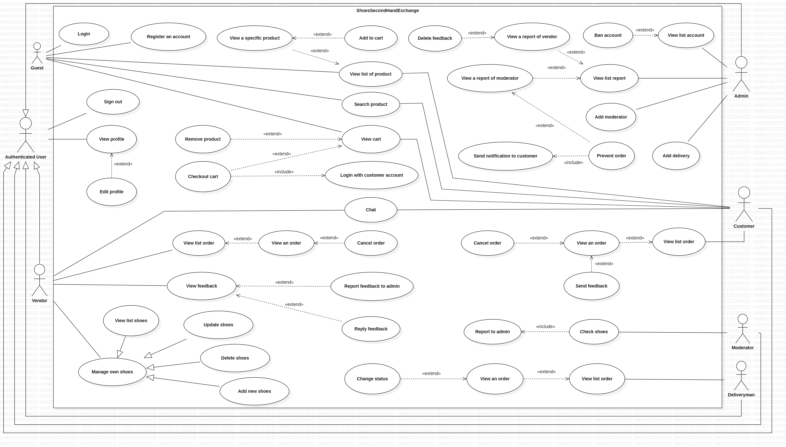

Figure 3.1 ShoesSeconhandExchange Overview Use Case

## < Guest > Overview Use Case

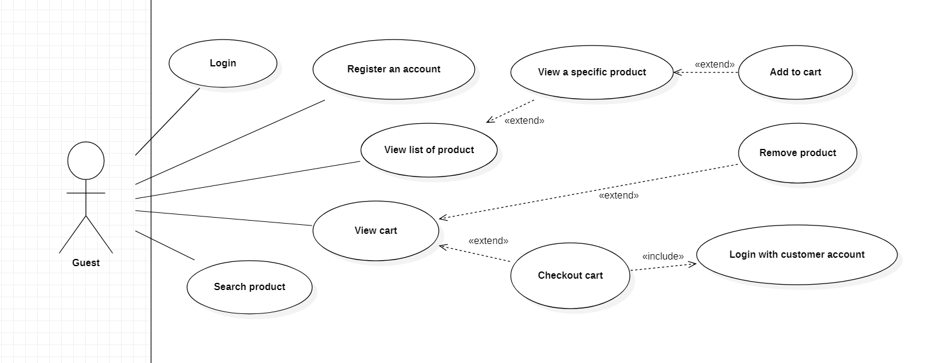

Figure 3.2 <Guest> User Case

## < Guest > Register an account

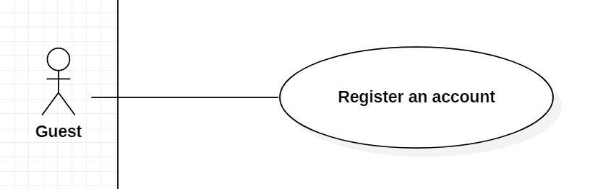

Figure 3.3 < Guest > Register an account

Use Case Specification

|  |  |  |  |  |
| --- | --- | --- | --- | --- |
| USE CASE – sSs_UC_02 | | | | |
| Use-case No. | <UC002> | Use-case Version | | 1.0 |
| Use-case Name | Register an account | | | |
| Author | Tran Trung Ta | | | |
| Date | 01/07/2021 | Priority | Normal | |
| Actor:  Guest  Summary:  This use case allows guest to create an account.  Goal:  Guest has an account.  Triggers  Guest clicks on button “Register an account”.  Preconditions:  None.  Post Conditions:  Success: Register an account successfully.  Main Success Scenario:   |  |  |  | | --- | --- | --- | | Step | Actor Action | System Response | | 1 | Guest clicks on button “Register” | The system shows a form in a table:  - Username : Textbox, required.  - Password : Password, required.  - Fullname : Textbox, required.  - Address : Textbox, required.  - Email : Textbox, required.  - Phone : Textbox, required.  - Role : Combobox [Customer, Vender].  “Create” button “Cancel” button  Exception[1,2,3,4,5,6,7,8] | | 2 | Guest inputs information. |  | | 3 | Guest clicks on button “Create” | The system shows a message “Created successfully!”  Exception[1,2,3,4,5,6,7,8,9]. |   Alternative:  - None.  Exceptions:   |  |  |  | | --- | --- | --- | | No | Actor Action | System Response | | 1 | Guest inputs field is empty | The system shows a message “This field is not allow to be empty”. | | 2 | The internet is not available | The system shows a message “The internet was interrupted. Please try again!”. | | 3 | Phone number is wrong format | The system show error message “Phone number format is +84XXXXXXXXX or 0XXXXXXXXX”. | | 4 | Length of Username is under 6 characters | The system shows an error message “Length of Username must be 6 – 50 characters”. | | 5 | Length of Username is over 50 characters | The system shows an error message “Length of Username must be 6 – 50 characters”. | | 6 | Length of Password is under 8 characters | The system shows an error message “Length of Username must be 8 – 30 characters”. | | 7 | Length of Password is over 30 characters | The system shows an error message “Length of Password must be 8 – 30 characters”. | | 8 | Password is included special character | The system shows an error message “Password is included special characters”. | | 9 | Username existed | The system shows an error message “Username existed”. |   Relationships:  - None.  Business Rules:  - Guest must inputs all information. | | | | |

## < Guest > Login

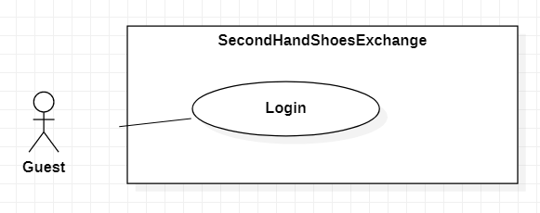

Figure 3.4 < Guest > Login

Use Case Specification

|  |  |  |  |  |
| --- | --- | --- | --- | --- |
| USE CASE – sSs_UC_03 | | | | |
| Use-case No. | <UC003> | Use-case Version | | 1.0 |
| Use-case Name | Login | | | |
| Author | Tran Trung Ta | | | |
| Date | 7/03/2021 | Priority | Normal | |
| Actor:  Guest  Summary:  This use case allows Guest to log in.  Goal:  Guest can View log in in the system.  Triggers  Guest input username, password click on button “Log in”.  Preconditions:  Guest is on log in screen.  Post Conditions:  Success: Guest log in to the system successfully.  Fail: Show error messages.  Main Success Scenario:     |  |  |  | | --- | --- | --- | | Step | Actor Action | System Response | | 1 | Guest click on button “Log in”. | The system requires the following input from User includes:  + Username: textbox,required  +Password: password,required  +”Sign in” : button  Exception[1,2,3] | | 2 | Guest inputs information. |  | | 3 | Guest click on button “Sign in”. | The system show message that the user has logged in successfully |   Exception :   |  |  |  | | --- | --- | --- | | Step | Actor Action | System Response | | 1. | Input field is empty. | System show error message” This field is not allow empty”. | | 2. | Username is invalid. | System show error message “Invalid username”. | | 3. | Password is invalid. | System show error message “Invalid password ”. |   Relationships: N/A  Business Rules:  User password character is secured and hidden with “****” character | | | | |

## < Guest > View list shoes

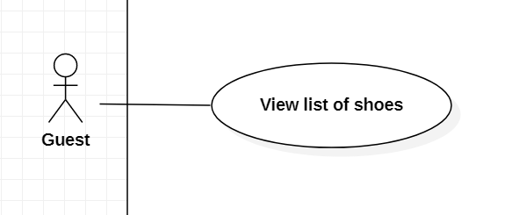

Figure 3.5 < Guest > View list shoes

Use Case Specification

|  |  |  |  |  |
| --- | --- | --- | --- | --- |
| USE CASE – sSs_UC_04 | | | | |
| Use-case No. | <UC004> | Use-case Version | | 1.0 |
| Use-case Name | View list of shoes | | | |
| Author | Tran Trung Ta | | | |
| Date | 7/03/2021 | Priority | Normal | |
| Actor:  Guest  Summary:  This use case allows Guest to view list of shoes.  Goal:  Guest can view list of shoes in the system.  Triggers:  Guest click on button “Sign in” and the system go to the home screen.  Preconditions:  Have at least one shoes in the system.  Post Conditions:  Success: Guest view list of shoes in the system successfully.  Fail: Show error messages.  Main Success Scenario:     |  |  |  | | --- | --- | --- | | Step | Actor Action | System Response | | 1 | Guest log in in the system. | +The system show:  -“Log out” button  -“View profile” button  -‘’View cart” button  -Search shoe: textbox + “Search” button  +The system show list shoes:  -imageURL  -shoesName  -price  Exception[1] |   Exception :   |  |  |  | | --- | --- | --- | | Step | Actor Action | System Response | | 1. | Guest log in in the system. | If don’t have any shoe . The system show message: ”There aren't any shoe. Sorry about the inconvenience”. |   Relationships: N/A  Business Rules: | | | | |

## < Guest > View a specific shoes

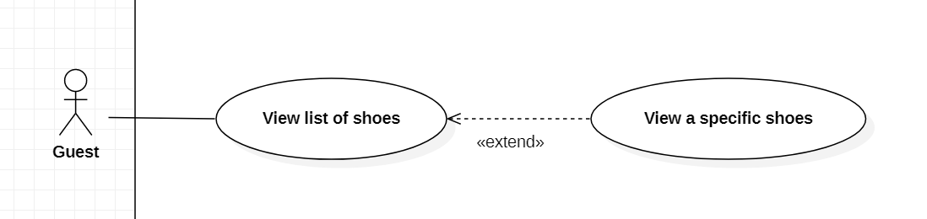

Figure 3.6 < Guest > View a specific shoes

Use Case Specification

|  |  |  |  |  |
| --- | --- | --- | --- | --- |
| USE CASE – sSs_UC_05 | | | | |
| Use-case No. | <UC005> | Use-case Version | | 1.0 |
| Use-case Name | View a specific shoes | | | |
| Tran Trung Ta | Tran Trung Ta | | | |
| Date | 7/03/2021 | Priority | Normal | |
| Actor:  Guest  Summary:  This use case allows Guest to view a specific of shoes.  .  Goal:  Guest can view a specific of shoes in the system.  Triggers:  Guest click on the image of the shoe .  Preconditions:  Have at least one shoes in the system.  Post Conditions:  Success: Guest view a specific of shoes in the system successfully.  Fail: Show error messages.  Main Success Scenario:     |  |  |  | | --- | --- | --- | | Step | Actor Action | System Response | | 1 | Guest log in in the system. | +The system show:  -“Log out” button  -“View profile” button  -‘’View cart” button  -Search shoe: textbox + “Search” button  The system show list shoe:  -imageURL  -shoesName  -price  Exception[1] | | 2 | Guest click on the image of shoe. | The system show a shoe:  -imageURL  -shoesName  -price  -description  -vendorID  -quantity [-,+]  “Add to cart ” button |   Exception :   |  |  |  | | --- | --- | --- | | Step | Actor Action | System Response | | 1. | Guest log in in the system. | If don’t have any shoe . The system show message: ”There aren't any shoe. Sorry about the inconvenience”. |   Relationships: N/A  Business Rules: | | | | |

## < Guest > Add to cart

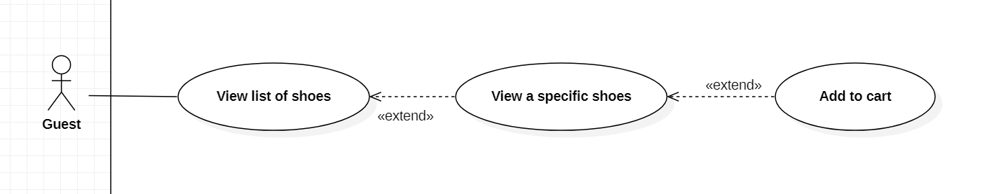

Figure 3.7 < Guest > Add to cart

Use Case Specification

|  |  |  |  |  |
| --- | --- | --- | --- | --- |
| USE CASE – sSs_UC_06 | | | | |
| Use-case No. | <UC006> | Use-case Version | | 1.0 |
| Use-case Name | Add to cart | | | |
| Author | Tran Trung Ta | | | |
| Date | 7/03/2021 | Priority | Normal | |
| Actor:  Guest  Summary:  This use case allows Guest add shoe to cart.  .  Goal:  Guest can add shoe to cart in the system.  Triggers:  Guest click on the button “Add to cart” .  Preconditions:  Guest stay on the “View a specific of shoes” screen . .  Post Conditions:  Success: Guest add shoe to cart in the system successfully.  Fail: Show error messages.  Main Success Scenario:   |  |  |  | | --- | --- | --- | | Step | Actor Action | System Response | | 1 |  | The system show a shoe:  -imageURL  -shoesName  -price  -description  -vendorID  -quantity  “-,+” button  “Add to cart ” button | | 2 | Guest clicks “+” button or “-” button |  | | 3 | Guest click on the button”Add to cart”. | The system add shoe to cart and show message”Add to cart successfully”  Exception[1] |   Alternative Scenario:  Exception:   |  |  |  | | --- | --- | --- | | No | Actor Action | System Response | | 1 | Out of stock quantity | The system shows message “Out of stock quantity, please try again!” |   Relationships:  - None.  Business Rules: | | | | |

## < Guest > View cart

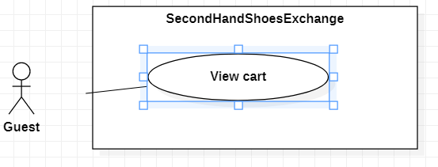

Figure 3.8 < Guest > View cart

Use Case Specification

|  |  |  |  |  |
| --- | --- | --- | --- | --- |
| USE CASE – sSs_UC_07 | | | | |
| Use-case No. | <UC007> | Use-case Version | | 1.0 |
| Use-case Name | View cart | | | |
| Author | Tran Trung Ta | | | |
| Date | 7/03/2021 | Priority | Normal | |
| Actor:  Guest  Summary:  This use case allows Guest view cart.  Goal:  Guest can views cart in the system.  Triggers:  Guest clicks on the button “View cart” .  Preconditions:  Guest stays in home screen.  Have at least one shoes in cart.  Post Conditions:  Success: Guest views cart in the system successfully.  Main Success Scenario:   |  |  |  | | --- | --- | --- | | Step | Actor Action | System Response | | 1 |  | +The system show:  -“Log out” button  -“View profile” button  -‘’View cart” button  -Search shoe: textbox + “Search” button  The system show list shoe:  -imageURL  -shoesName  -price | | 2 | Guest click on the button”View cart” | +The system show list shoe in cart:  -imageURL  -shoesName  -price  -quantity  “-,+” button  “Remove shoes” button  “Checkout” button  +The system show total.  Exception[1] |   Exception:   |  |  |  | | --- | --- | --- | | Step | Actor Action | System Response | | 1 | Guest click on button “View cart”. | If don’t have any shoe . The system show message: ”There aren't any shoe in cart”. |   Relationships: N/A  Business Rules: | | | | |

## < Guest > Remove shoes

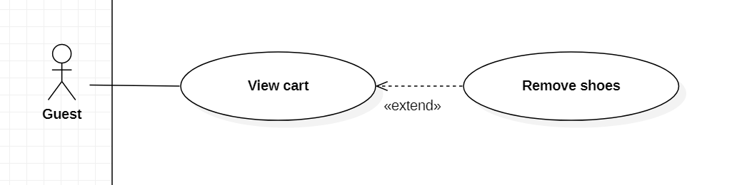

Figure 3.9 < Guest > Remove shoes

Use Case Specification

|  |  |  |  |  |
| --- | --- | --- | --- | --- |
| USE CASE – sSs_UC_08 | | | | |
| Use-case No. | <UC008> | Use-case Version | | 1.0 |
| Use-case Name | Remove shoes | | | |
| Author | Tran Trung Ta | | | |
| Date | 7/03/2021 | Priority | Normal | |
| Actor:  Guest  Summary:  This use case allows Guest remove shoe in cart.  .  Goal:  Guest can remove shoe in cart in the system.  Triggers:  Guest click on the button “Remove shoes” .  Preconditions:  Guest stay in View cart screen.  Have at least one shoe in cart.  Post Conditions:  Success: Guest remove shoe in cart in the system successfully.  Fail: Show error messages.  Main Success Scenario:     |  |  |  | | --- | --- | --- | | Step | Actor Action | System Response | | 1 |  | +The system show list shoe in cart:  -imageURL  -shoesName  -price  -quantity  “-,+” button  “Remove shoes” button  “Checkout” button  +The system show total.  Exception[1] | | 2 | Guest click on the button”Remove shoes” | The system remove shoes and show message ”Remove successfully”. |   Exception:   |  |  |  | | --- | --- | --- | | Step | Actor Action | System Response | | 1 | Guest click on button “View cart”. | If don’t have any shoe . The system show message: ”There aren't any shoe in cart”. |   Relationships: N/A  Business Rules: | | | | |

## < Guest > Checkout cart

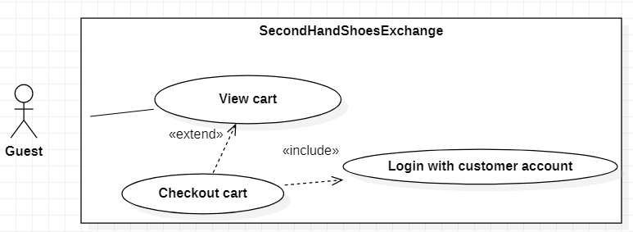

Figure 3.10 < Guest > Check out cart

Use Case Specification

|  |  |  |  |  |
| --- | --- | --- | --- | --- |
| USE CASE – sSs_UC_09 | | | | |
| Use-case No. | <UC009> | Use-case Version | | 1.0 |
| Use-case Name | Checkout cart | | | |
| Author | Tran Trung Ta | | | |
| Date | 7/03/2021 | Priority | Normal | |
| Actor:  Guest  Summary:  This use case allows Guest checkout cart.  .  Goal:  Guest can checkout cart in the system.  Triggers:  Guest click on the button “Checkout” .  Preconditions:  Guest stay in View cart screen.  Have at least one shoe in cart.  Post Conditions:  Success: Guest checkout cart in the system successfully.  Fail: Show error messages.  Main Success Scenario:   |  |  |  | | --- | --- | --- | | Step | Actor Action | System Response | | 1 | Guest click on the button”View cart” | +The system show list shoe in cart:  -imageURL  -shoesName  -price  -quantity  “-,+” button  “Remove shoes” button  “Checkout” button  +The system show total.  Exception[1] | | 2 | Guest click on the button ”+”. | The system increase quantity of shoe and update total. | | 3 | Guest click on the button ”-”. | The system decrease quantity of shoe and  update total. | | 4 | Guest click on the button”Checkout” | The system show information checkout cart  again:  -address  -imageURL  -shoesName  -quantity  -total  “Order now” button | | 5 | Guest click on the button”Order now” | The system go to the log in screen and requires the following input from User includes:  + Username: textbox,required  +Password: password,required  +”Sign in” : button  Exception[1,2,3] | | 6 | Guest inputs information. |  | | 7 | Guest click on button “Sign in”. | The system accept order and show message”Order successfully”. |   Alternative Scenario:   |  |  |  | | --- | --- | --- | | Step | Actor Action | System Response | | 1 | Guest click on the button”Order now” | In guest has been log in, the system accept order and show message”Order successfully”. |   Relationships: N/A  Business Rules: | | | | |

## < Guest > Search shoes

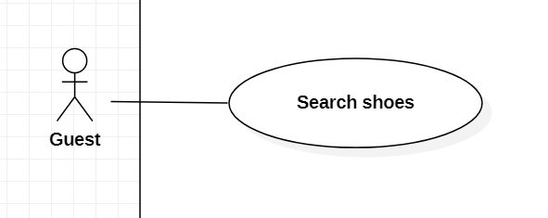

Figure 3.11 < Guest > Search shoes

Use Case Specification

|  |  |  |  |  |
| --- | --- | --- | --- | --- |
| USE CASE – sSs_UC_10 | | | | |
| Use-case No. | <UC010> | Use-case Version | | 1.0 |
| Use-case Name | Search shoes | | | |
| Author | Tran Trung Ta | | | |
| Date | 7/03/2021 | Priority | Normal | |
| Actor:  Guest  Summary:  This use case allows Guest to search shoes.  Goal:  Guest can search shoes in the system.  Triggers:  Guest click on button “Search”.  Preconditions:  Guest stay in home screen.  Have at least one shoe in the system.  Post Conditions:  Success: Guest view search shoe in the system successfully.  Fail: Show error messages.  Main Success Scenario:   |  |  |  | | --- | --- | --- | | Step | Actor Action | System Response | | 1 | Guest log in in the system. | +The system show:  -“Log out” button  -“View profile” button  -‘’View cart” button  -Search shoe: textbox + “Search” button  +The system show list shoes:  -imageURL  -shoesName  -price  Exception[1] | | 2 | Guest input value into Search shoe[textbox] |  | | 3 | Guest click on the button“Search” | The system show list shoe by name:  -imageURL  -shoesName  -price |   Exception :   |  |  |  | | --- | --- | --- | | Step | Actor Action | System Response | | 1. | Guest log in in the system. | If don’t have any shoe . The system show message: ”There aren't any shoe. Sorry about the inconvenience”. |   Relationships: N/A  Business Rules: | | | | |

## < Authenticated user > Overview Use Case

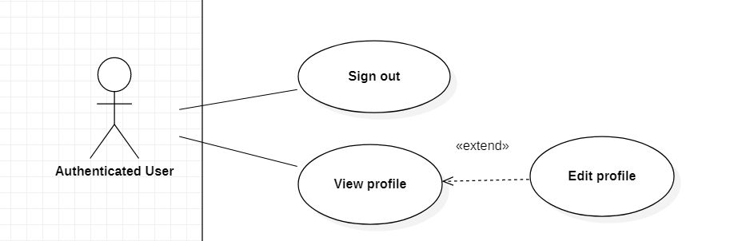

Figure 3.12 < Authenticated user > Overview use case

## < Authenticated user > View profile

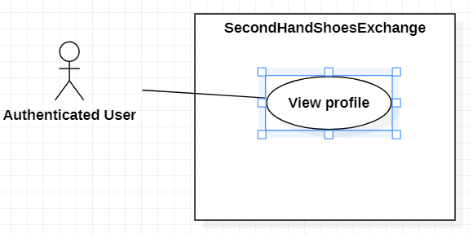

Figure 3.13 < Authenticated user > View profile

Use Case Specification

|  |  |  |  |  |
| --- | --- | --- | --- | --- |
| USE CASE – sSs_UC_11 | | | | |
| Use-case No. | <UC011> | Use-case Version | | 1.0 |
| Use-case Name | View profile | | | |
| Author | Nguyen Le Anh Long | | | |
| Date | 04/07/2021 | Priority | Normal | |
| Actor:  Authenticated User  Summary:  This use case allows Authenticated User to View profile.  Goal:  Authenticated User can View profile in the system.  Triggers  Authenticated User click on button “View profile ”.  Preconditions:  Authenticated User has log in before.  Post Conditions:  Success: Authenticated User View profile in the system successfully.  Fail: Show error messages.  Main Success Scenario:     |  |  |  | | --- | --- | --- | | Step | Actor Action | System Response | | 1 | Authenticated User stay  on the screen. |  | | 2 | Authenticated User click  on the button ”View profile” | The system show profile in table:  - Username: textbox, required  - Password : password, required.  - Fullname: textbox, required  - Address: textbox, required  - Email: textbox, required  - Phone: textbox, required  - Role : Combobox [Customer, Vender].  “Update ” button |   Exceptions:   |  |  |  | | --- | --- | --- | | Step | Actor Action | System Response | |  |  |  |   Relationships: N/A  Business Rules: | | | | |

## < Authenticated user > Edit profile

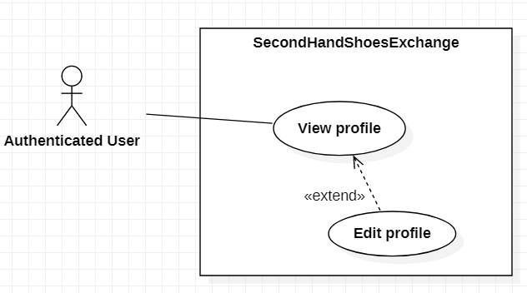

Figure 3.14 < Authenticated user > Edit profile

Use Case Specification

|  |  |  |  |  |
| --- | --- | --- | --- | --- |
| USE CASE – sSs_UC_12 | | | | |
| Use-case No. | <UC012> | Use-case Version | | 1.0 |
| Use-case Name | Edit profile | | | |
| Author | Nguyen Le Anh Long | | | |
| Date | 04/07/2021 | Priority | Normal | |
| Actor:  Authenticated User  Summary:  This use case allows Authenticated User to Edit profile.  Goal:  Authenticated User can Edit profile in the system.  Triggers  Authenticated User click on button “Update”.  Preconditions:  Authenticated User stay on the View profile screen.  Post Conditions:  Authenticated User must enter valid information.  Main Success Scenario:     |  |  |  | | --- | --- | --- | | Step | Actor Action | System Response | | 1 | Authenticated User enter new Username,Password Fullname ,Address , Email,Phone,Role . |  | | 2. | Authenticated User click on button “Update ”. | The system update new Username, Password ,Fullname ,Address ,Email ,Phone,Role successfully.  Exception[1,2,3,4,5,6,7,8] |   Exceptions:   |  |  |  | | --- | --- | --- | | Step | Actor Action | System Response | | 1. | Authenticated User input field is empty. | System show error message” This field is not allow empty”. | | 2. | Internet is not available. | System show error message”Internet was interrupted. Please try again.” | | 3. | Phone number is wrong format. | System show error message “Phone number format is +84XXXXXXXXXX or  0XXXXXXXXX”. | | 4. | Length of Username is under 6 characters. | System show error message “Length of Username must be 6-50 characters”. | | 5. | Length of Username is over 50 characters. | System show error message “Length of Username must be 6-50 characters”. | | 6 | Length of Password is under 8 characters | The system show error message “Length of Password must be 8 – 30 characters”. | | 7 | Length of Password is over 30 characters | The system show error message “Length of Password must be 8 – 30 characters”. | | 8 | Password is included special character | The system show error message “Password is included special characters”. |   Relationships: N/A  Business Rules:  Authenticated User must input all information. | | | | |

## < Authenticated user > Sign out

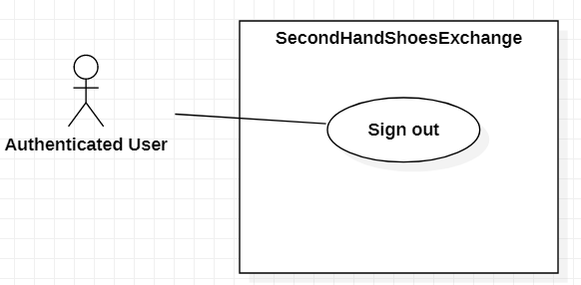

Figure 3.15 < Authenticated user > Sign out

Use Case Specification

|  |  |  |  |  |
| --- | --- | --- | --- | --- |
| USE CASE – sSs_UC_13 | | | | |
| Use-case No. | <UC013> | Use-case Version | | 1.0 |
| Use-case Name | Sign out | | | |
| Author | Nguyen Le Anh Long | | | |
| Date | 7/03/2021 | Priority | Normal | |
| Actor:  Authenticated User  Summary:  This use case allows Authenticated User to Sign out.  Goal:  Authenticated User can sign out in the system.  Triggers  Authenticated User click on button “Log out”.  Preconditions:  Authenticated Users stay on the screen.  Post Conditions:  Success: Authenticated Users sign out successfully.  Fail: Show error messages.  Main Success Scenario:     |  |  |  | | --- | --- | --- | | Step | Actor Action | System Response | | 1 | Authenticated User stay  on the screen. |  | | 2 | Authenticated User click on button “Log out”. | The system sign out successfully. |   Exceptions:   |  |  |  | | --- | --- | --- | | Step | Actor Action | System Response | |  |  |  |   Relationships: N/A  Business Rules: | | | | |

## < Deliveryman > Overview Use Case

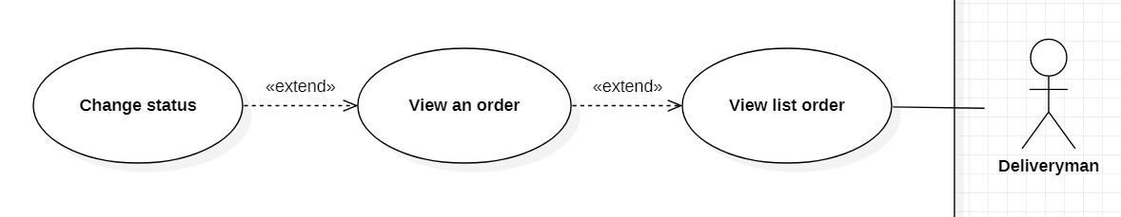

Figure 3.16 < Deliveryman > Overview use case

## < Deliveryman > View list order

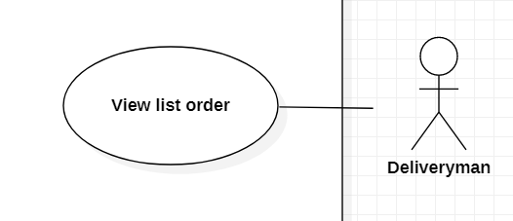

Figure 3.17 < Deliveryman > View list order

Use Case Specification

|  |  |  |  |  |
| --- | --- | --- | --- | --- |
| USE CASE – sSs_UC_14 | | | | |
| Use-case No. | <UC014> | Use-case Version | | 1.0 |
| Use-case Name | View list order | | | |
| Author | Le Tien Dat | | | |
| Date | 04/07/2021 | Priority | Normal | |
| Actor:  Deliveryman  Summary:  This use case allows Deliveryman to view list order.  Goal:  Deliveryman can view list order.  Triggers  Deliveryman clicks “List order”.  Preconditions:  Deliveryman is on “List order” screen.  Post Conditions:  Success: Deliveryman views list order successfully.  Main Success Scenario:   |  |  |  | | --- | --- | --- | | Step | Actor Action | System Response | | 1 | Deliveryman clicks on “List order” | + The system shows a table in which each row includes the information, as followed:  - orderID:  - customerName:  - dateOrder:  - total:  - statusName:  - vendorName:  “View more” hyperlink at the end of each row.  “Back” button  Exception[1] |   Alternative:  - None.  Exceptions:   |  |  |  | | --- | --- | --- | | No | Actor Action | System Response | | 1 | List order is empty. | The system shows a message “List Order not found!”. |   Relationships:  - None.  Business Rules:  - None. | | | | |

## < Deliveryman > View an order

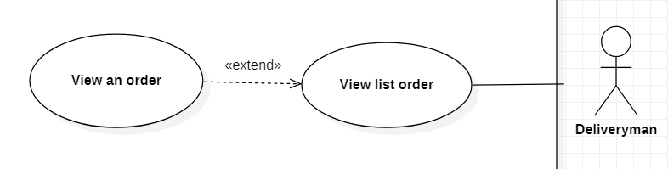

Figure 3.18 < Deliveryman > View an order

Use Case Specification

|  |  |  |  |  |
| --- | --- | --- | --- | --- |
| USE CASE – sSs_UC_15 | | | | |
| Use-case No. | <UC015> | Use-case Version | | 1.0 |
| Use-case Name | View an order | | | |
| Author | Le Tien Dat | | | |
| Date | 04/07/2021 | Priority | Normal | |
| Actor:  Deliveryman  Summary:  This use case allows Deliveryman to view an order.  Goal:  Deliveryman can view an order.  Triggers  Deliveryman clicks “View more” on “View list order” screen.  Preconditions:  Deliveryman is on “An order” screen.  Post Conditions:  Success: Deliveryman view an order successfully.  Main Success Scenario:   |  |  |  | | --- | --- | --- | | Step | Actor Action | System Response | | 1 | Deliveryman clicks on hyperlink “View more” | The system shows a list:  - orderID:  - customerName:  - dateOrder:  - total:  - statusName:  - vendorName:  - price:  - quantity:  - shoesName:  - address:  - phone:  “Change status” button  “Back” button |   Alternative:  - None.  Exceptions:  - None.  Relationships:  - None.  Business Rules:  - None. | | | | |

## < Deliveryman > Change status

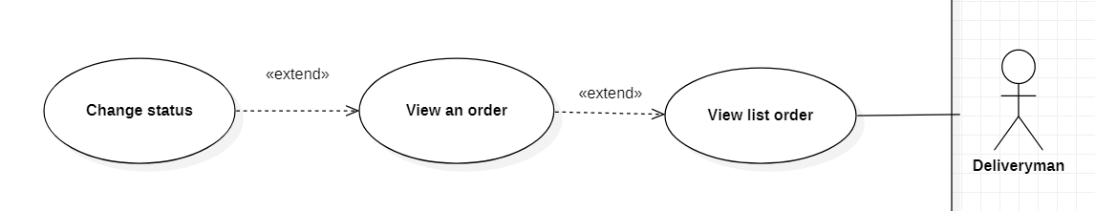

Figure 3.19 < Deliveryman > Change status

Use Case Specification

|  |  |  |  |  |
| --- | --- | --- | --- | --- |
| USE CASE – sSs_UC_16 | | | | |
| Use-case No. | <UC016> | Use-case Version | | 1.0 |
| Use-case Name | Change status | | | |
| Author | Le Tien Dat | | | |
| Date | 04/07/2021 | Priority | Normal | |
| Actor:  Deliveryman  Summary:  This use case allows Deliveryman to change status of the order.  Goal:  Deliveryman can change status of the order.  Triggers  Deliveryman clicks “Change status” on “View an order” screen.  Preconditions:  Deliveryman is on “Change status” screen.  Post Conditions:  Success: Deliveryman views an order successfully.  Main Success Scenario:   |  |  |  | | --- | --- | --- | | Step | Actor Action | System Response | | 1 | Deliveryman clicks on button “Change status” | The system shows a list:  Status: “Received” or “Checked” or “Delivering” or “Delivered (Success, Fail)”  “Next step” button  “Back” button | | 2 | Deliveryman clicks on button “Next step” | The systen increase statusID  The system sends a message “Change status successfully!”  The systen back to “View an order” screen.  Exception[1] |   Alternative:  - None.  Exceptions:   |  |  |  | | --- | --- | --- | | Step | Actor Action | System Response | | 1 | StatusID equal “1” | The system sends message “Not under your authority, please wait for the moderator!” |   Relationships:  - Change status extend from view an order.  Business Rules:  - None. | | | | |

## < Moderator > Overview Use Case

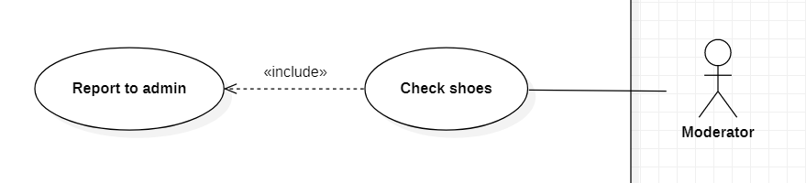

Figure 3.20 < Moderator > Overview use case

## < Moderator > Check shoes



Figure 3.21 < Moderator > Check shoes

Use Case Specification

|  |  |  |  |  |
| --- | --- | --- | --- | --- |
| USE CASE – sSs_UC_17 | | | | |
| Use-case No. | <UC0017> | Use-case Version | | 1.0 |
| Use-case Name | Check shoes | | | |
| Author | Le Tien Dat | | | |
| Date | 04/07/2021 | Priority | Normal | |
| Actor:  Moderator  Summary:  This use case allows Moderator to check shoes and change status of the order.  Goal:  Moderator can check shoes and change status of the order.  Triggers  Moderator clicks “Check shoes”.  Preconditions:  Moderator is on “Check shoes” screen.  Post Conditions:  Success: Moderator checks shoes successfully.  Main Success Scenario:   |  |  |  | | --- | --- | --- | | Step | Actor Action | System Response | | 1 | Moderator clicks on “Check shoes” | + The system shows a table in which each row includes the information, as followed:  - orderID:  - dateOrder:  - statusName:  - vendorName:  - customerName:  - image:  - shoesName:  “Real” button at the end of each row.  “Fake” button at the end of each row.  Alternative[1]  Exception[1] | | 2 | Moderator clicks on “Real” button | The system sends to admin the table:  - orderID:  - dateOrder:  - statusName:  - vendorName:  - customerName:  - shoesName:  - testShoes: “Real” |   Alternative:   |  |  |  | | --- | --- | --- | | No | Actor Action | System Response | | 1 | Moderator clicks on “Fake” button | The system sends to admin the table:  - orderID:  - dateOrder:  - statusName:  - vendorName:  - customerName:  - shoesName:  - testShoes: “Fake” |   Exceptions:   |  |  |  | | --- | --- | --- | | No | Actor Action | System Response | | 1 | List order is empty. | The system shows a message “List Order not found!”. |   Relationships:  - None.  Business Rules:  - The statusName must be received. | | | | |

## < Customer > Overview Use Case

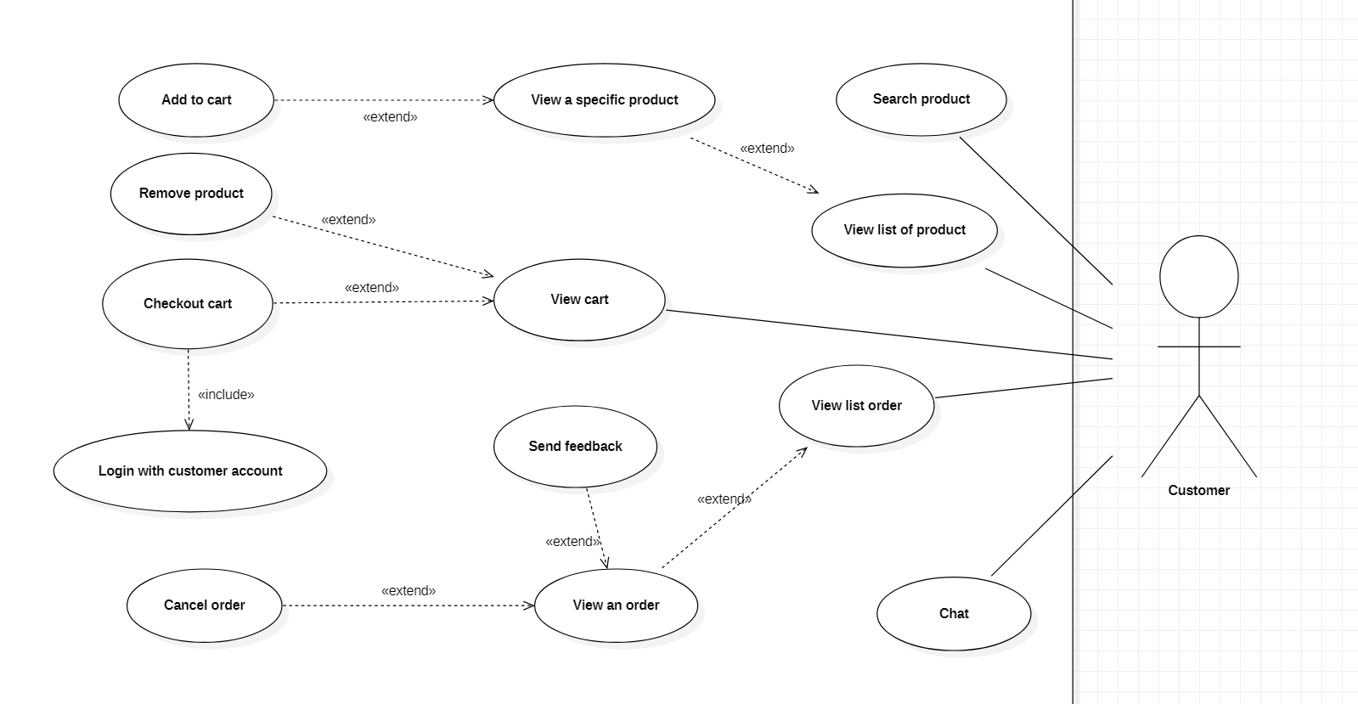

Figure 3.22 < Customer > Overview use case

## < Customer > View list order

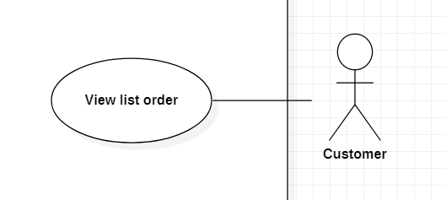

Figure 3.23 < Customer > View list order

Use Case Specification

|  |  |  |  |  |
| --- | --- | --- | --- | --- |
| USE CASE – sSs_UC_18 | | | | |
| Use-case No. | <UC018> | Use-case Version | | 1.0 |
| Use-case Name | View list order | | | |
| Author | Le Tien Dat | | | |
| Date | 04/07/2021 | Priority | Normal | |
| Actor:  Customer  Summary:  This use case allows Customer to view list order.  Goal:  Customer can view list order.  Triggers  Customer clicks “View list order”.  Preconditions:  Customer is on “View list order” screen.  Post Conditions:  Success: Customer views list order successfully.  Main Success Scenario:   |  |  |  | | --- | --- | --- | | Step | Actor Action | System Response | | 1 | Customer clicks on “List order” | + The system shows a table in which each row includes the information, as followed:  - orderID:  - dateOrder:  - total:  - statusName:  - DeliverymanName:  - vendorName:  “View more” hyperlink at the end of each row.  “Back” button |   Alternative:  - None.  Exceptions:   |  |  |  | | --- | --- | --- | | No | Actor Action | System Response | | 1 | List order is empty. | The system shows a message “List Order not found!”. |   Relationships:  - None.  Business Rules:  - None. | | | | |

## < Customer > View an order

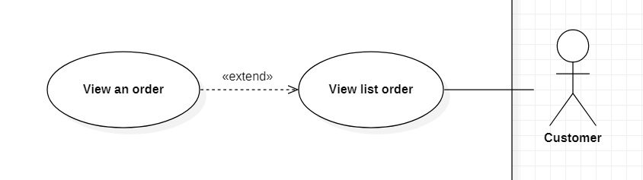

Figure 3.24 < Customer > View an order

Use Case Specification

|  |  |  |  |  |
| --- | --- | --- | --- | --- |
| USE CASE – sSs_UC_19 | | | | |
| Use-case No. | <UC019> | Use-case Version | | 1.0 |
| Use-case Name | View an order | | | |
| Author | Le Tien Dat | | | |
| Date | 04/07/2021 | Priority | Normal | |
| Actor:  Customer  Summary:  This use case allows Customer to view an order.  Goal:  Customer can view an order.  Triggers  Customer clicks “View more” on “View list order” screen.  Preconditions:  Customer is on “View an order” screen.  Post Conditions:  Success: Customer view an order successfully.  Main Success Scenario:   |  |  |  | | --- | --- | --- | | Step | Actor Action | System Response | | 1 | Customer clicks on hyperlink “View more” | The system shows a list:  - orderID:  - dateOrder:  - total:  - statusName:  - DeliverymanName:  - price:  - quantity:  - shoesName:  - address:  - phone:  “Send feedback” button  “Cancel order”  “Back” button  Exception[1,2] |   Alternative:  - None.  Exceptions:  - None.  Relationships:  - View an order extend from view list order.  Business Rules:  - None. | | | | |

## < Customer > Send feedback

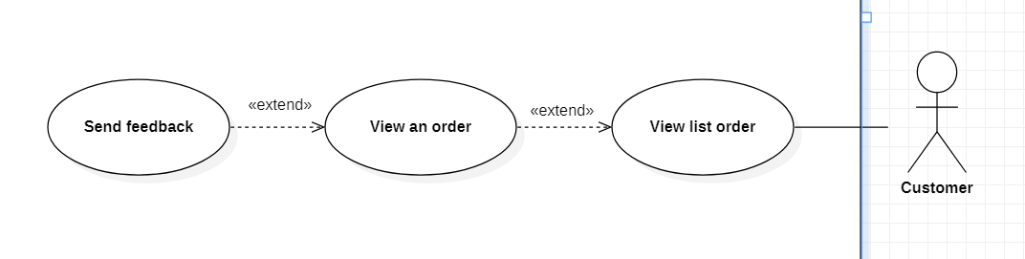

Figure 3.25 < Customer > Send feedback

Use Case Specification

|  |  |  |  |  |
| --- | --- | --- | --- | --- |
| USE CASE – sSs_UC_20 | | | | |
| Use-case No. | <UC020> | Use-case Version | | 1.0 |
| Use-case Name | Send feedback | | | |
| Author | Le Tien Dat | | | |
| Date | 04/07/2021 | Priority | Normal | |
| Actor:  Customer  Summary:  This use case allows Customer to sends feedback.  Goal:  Customer can sends feedback.  Triggers  Customer clicks “Send feedback” on “View an order” screen.  Preconditions:  Customer is on “Send feedback” screen.  Post Conditions:  Success: Customer sends feedback successfully.  Main Success Scenario:   |  |  |  | | --- | --- | --- | | Step | Actor Action | System Response | | 1 | Customer clicks on button “Send feedback” | The system shows:  - Feedback: Textarea, required.  “Send” button  “Cancel” button |   Alternative:  - None.  Exceptions:  - None.  Relationships:  - Send feedback extend from view an order.  Business Rules:  - | | | | |

## < Customer > Cancel order

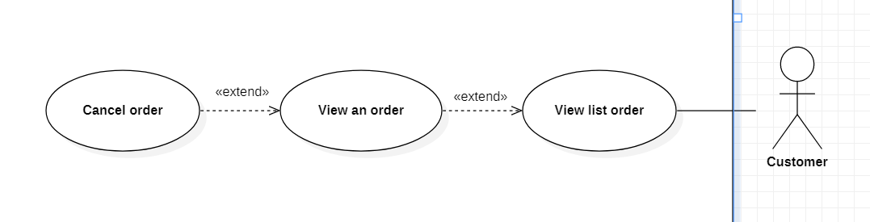

Figure 3.26 < Customer > Cancel order

Use Case Specification

|  |  |  |  |  |
| --- | --- | --- | --- | --- |
| USE CASE – sSs_UC_21 | | | | |
| Use-case No. | <UC021> | Use-case Version | | 1.0 |
| Use-case Name | Cancel order | | | |
| Author | Le Tien Dat | | | |
| Date | 04/07/2021 | Priority | Normal | |
| Actor:  Customer  Summary:  This use case allows Customer to cancel the order.  Goal:  Customer can cancel the order.  Triggers  Customer clicks “Cancel order” on “View an order” screen.  Preconditions:  Customer is on “Cancel order” popup.  Post Conditions:  Success: Customer cancel order successfully.  Main Success Scenario:   |  |  |  | | --- | --- | --- | | Step | Actor Action | System Response | | 1 | Customer clicks on button “Cancel order” | The system shows popup:  - Reason: Combobox[…,etc.]  “Accept” button  “Cancel” button | | 2 | Customer choose Reason on Combobox. |  | | 3 | Customer clicks on button “Accept” | The system closes the “Cancel order” popup.  The system sends message “Cancel order successfully!”.  The system changes status to “Cancelled”.  The system minus points of vendor. |   Alternative:  - None.  Exceptions:  - None.  Relationships:  - Cancel order extend from view an order.  Business Rules:  - None. | | | | |

## < Customer > Chat

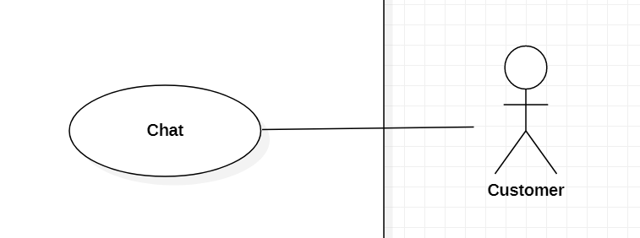

Figure 3.27 < Customer > Chat

Use Case Specification

|  |  |  |  |  |
| --- | --- | --- | --- | --- |
| USE CASE – sSs_UC_22 | | | | |
| Use-case No. | <UC022> | Use-case Version | | 1.0 |
| Use-case Name | Chat | | | |
| Author | Nguyen Lam Thanh Tu | | | |
| Date | 13//07/2021 | Priority | Normal | |
| Actor:  Customer  Summary:  This use case allows customer to chat with Vendors.  Goal:  Customer to chat with Vendors.  Triggers  Customer clicks “Chat”button  Preconditions:  Guest must login to system with Customer account.  Post Conditions:  Success: System sends message to Vendor.  Main Success Scenario:     |  |  |  | | --- | --- | --- | | Step | Actor Action | System Response | | 1 | Customer clicks button“Chat” | The system shows boxchat include:  VendorName:  TimeStart:  ShoesName:  SearchVendor: textbox  Message:textbox  “Send”button.  Exception[1] | | 2 | Customer inputs message and clicks button “Send” | The system send message to Vendor  Exception[2] |   Alternative:  None.  Exception:   |  |  |  | | --- | --- | --- | | No | Actor Action | System response | | 1 | Search Vendor is not found. | The system shows message “No Vendor found.” | | 2 | Internet is interrupted. | The system shows message “Internet error, please try again!” |   Relationships:   * Report feedback extend View feedback.   Business Rules:   * Use API for chat and filter for search. * Guest must login to system as Customer’s role. * Status of account is true. | | | | |

## < Vendor > Overview Use Case

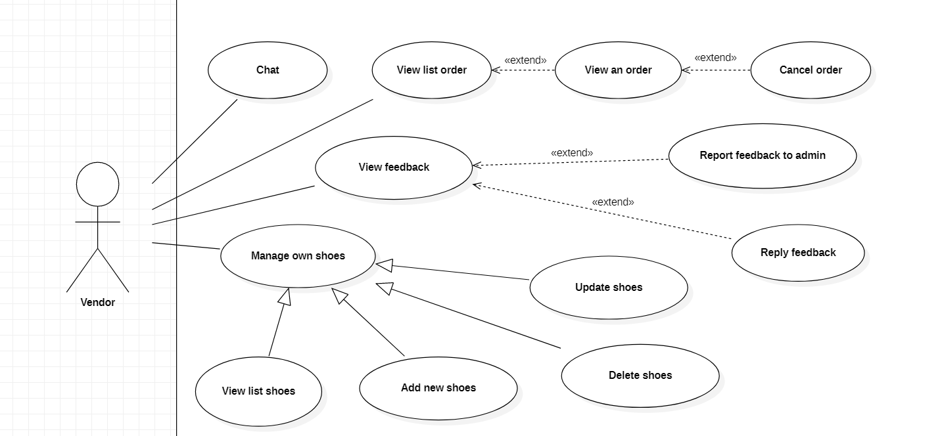

Figure 3.28 <Vendor> Overview use case

## < Vendor > View list order

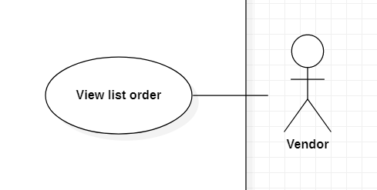

Figure 3.29 < Vendor > View list order

Use Case Specification

|  |  |  |  |  |
| --- | --- | --- | --- | --- |
| USE CASE – sSs_UC_23 | | | | |
| Use-case No. | <UC023> | Use-case Version | | 1.0 |
| Use-case Name | View list order | | | |
| Author | Le Tien Dat | | | |
| Date | 04/07/2021 | Priority | Normal | |
| Actor:  Vendor  Summary:  This use case allows Vendor to view list order.  Goal:  Vendor can view list order.  Triggers  Vendor clicks “View list order”.  Preconditions:  Vendor is on “View list order” screen.  Post Conditions:  Success: Vendor views list order successfully.  Main Success Scenario:   |  |  |  | | --- | --- | --- | | Step | Actor Action | System Response | | 1 | Vendor clicks on “List order” | + The system shows a table in which each row includes the information, as followed:  - orderID:  - dateOrder:  - total:  - statusName:  - DeliverymanName:  - customerName:  “View more” hyperlink at the end of each row.  “Back” button |   Alternative:  - None.  Exceptions:   |  |  |  | | --- | --- | --- | | No | Actor Action | System Response | | 1 | List order is empty. | The system shows a message “List Order not found!”. |   Relationships:  - None.  Business Rules:  - None. | | | | |

## < Vendor > View an order

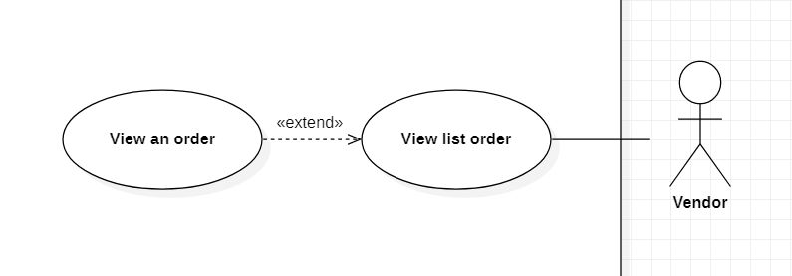

Figure 3.30 < Vendor > View an order

Use Case Specification

|  |  |  |  |  |
| --- | --- | --- | --- | --- |
| USE CASE – sSs_UC_24 | | | | |
| Use-case No. | <UC024> | Use-case Version | | 1.0 |
| Use-case Name | View an order | | | |
| Author | Le Tien Dat | | | |
| Date | 04/07/2021 | Priority | Normal | |
| Actor:  Vendor  Summary:  This use case allows Vendor to view an order.  Goal:  Vendor can view an order.  Triggers  Vendor clicks “View more” on “View list order” screen.  Preconditions:  Vendor is on “View an order” screen.  Post Conditions:  Success: Vendor view an order successfully.  Main Success Scenario:   |  |  |  | | --- | --- | --- | | Step | Actor Action | System Response | | 1 | Vendor clicks on hyperlink “View more” | The system shows a list:  - orderID:  - dateOrder:  - total:  - statusName:  - DeliverymanName:  - customerName:  - price:  - quantity:  - shoesName:  - address:  - phone:  “Back” button  Alternative[1]  Exception[1,2] |   Alternative:  - None.  Exceptions:  - None.  Relationships:  - View an order extend from view list order.  Business Rules:  - None. | | | | |

## < Vendor > Delete shoes

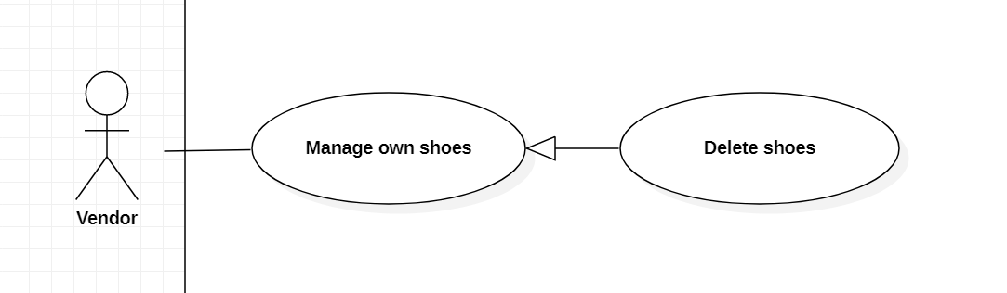

Figure 3.31 < Vendor > Delete shoes

Use Case Specification

|  |  |  |  |  |
| --- | --- | --- | --- | --- |
| USE CASE – sSs_UC_24 | | | | |
| Use-case No. | <UC024> | Use-case Version | | 1.0 |
| Use-case Name | Delete shoes | | | |
| Author | Nguyen Lam Thanh Tu | | | |
| Date | 13/07/2021 | Priority | Normal | |
| Actor:  Vendor  Summary:  This use case allows Vendor deletes a shoes.  Goal:  Vendor deletes a shoes  Triggers  Vendor clicks “Delete” button.  Preconditions:   * Login with Vendor account. * Vendor is viewing list shoes.   Post Conditions:   * Success: Status of shoes from True to False.   Main Success Scenario:   |  |  |  | | --- | --- | --- | | Step | Actor Action | System Response | | 1 | Vendor click button “Delete” | System ask Vendor to confirm the action with 2 button “Yes” or “No” with message from system ”Are you sure delete shoes!” | | 2 | Vendor choose “Yes”button | System show message “Shoes is deleted!”. |   Alternative:  - None.  Exception:  - None.  Relationships:  - Delete shoes generalization from Manage own shose.  Business Rules:  - Guest must login to system as Vendor’s role.  - Status of account is true.  - Vendor view a shoes before delete. | | | | |

## < Vendor > Add new shoes

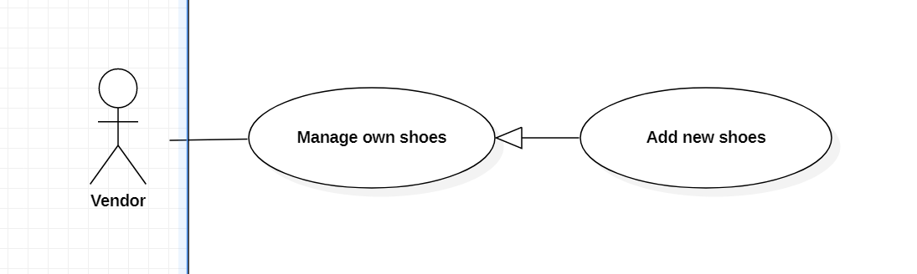

Figure 3.32 < Vendor > Add new shoes

Use Case Specification

|  |  |  |  |  |
| --- | --- | --- | --- | --- |
| USE CASE – sSs_UC_25 | | | | |
| Use-case No. | <UC025> | Use-case Version | | 1.0 |
| Use-case Name | Add new shoes | | | |
| Author | Nguyen Lam Thanh Tu | | | |
| Date | 13/07/2021 | Priority | Normal | |
| Actor:  Vendor  Summary:  This use case allows the Vendor to add new shoes.  Goal:  Vendor adds new shoes.  Triggers  Vendor clicks “Add new shoes” button.  Preconditions:   * Guest must login to system with Vendor account. * Vendor is viewing list shoes.   Post Conditions:  Success: System adds a new shoes successfully.  Main Success Scenario:   |  |  |  | | --- | --- | --- | | Step | Actor Action | System Response | | 1 | Vendor clicks “Add new shoes” | The system show form :  - Price: textbox, required.  - image: textbox,required.  - ShoesName: textbox, required.  - Quantity:textbox,required.  - Description:textarea,required.  - “Add” button.  - “Cancel”button. | | 2 | Vendor inputs all information to the form then clicks “Add”button | System show message “Add successfully”  Exception [1] |   Alternative:  None.  Exception :   |  |  |  | | --- | --- | --- | | No | Actor Action | System response | | 1 | Vendor inputs invalid field | System shows message with correspoding fields:  - Price: from 100 to 99999k.  - Image: image_URL not empty.  - Name: from 6 to 20 character.  - Quantity: quantity > 0 and must - be a number.  - Description: description must from 1 to 500 character. |   Relationships:  Add new shoes generalization from Manage own shose.  Business Rules:   * Guest must login to system as Vendor’s role. * Status of account is true. * Vendor can view detail shoes before click “Add”. | | | | |

## < Vendor > Update shoes

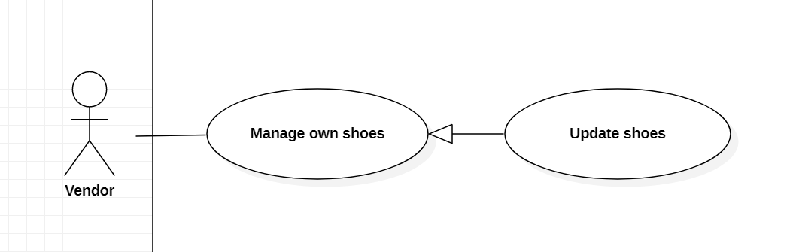

Figure 3.33 < Vendor > Update shoes

Use Case Specification

|  |  |  |  |  |
| --- | --- | --- | --- | --- |
| USE CASE – sSs_UC_26 | | | | |
| Use-case No. | <UC026> | Use-case Version | | 1.0 |
| Use-case Name | Update shoes | | | |
| Author | Nguyen Lam Thanh Tu | | | |
| Date | 13/07/2021 | Priority | Normal | |
| Actor:  Vendor  Summary:  This use case allows Vendor to update shoes.  Goal:  Vendor updates a shoes.  Triggers  Vendor clicks “Update shoes” button.  Preconditions:   * Guest must login to system with Vendor account. * Vendor is viewing list shoes.   Post Conditions:  Success: System updates shoes successfully.  Main Success Scenario:     |  |  |  | | --- | --- | --- | | Step | Actor Action | System Response | | 1 | Vendor clicks “Update Shoes”button | The system displays detailed information of shoes and edits include:  - Price: textbox, required.  - Image: textbox,required.  - ShoesName: textbox, required.  - Quantity: textbox,required.  - Description:textarea,required.  “Update” button.  “Cancel”button. | | 2 | Vendor clicks “Update”button | The system displays message “Update successfully!”  Exception[1] |   Alternative:  None.  Exception:   |  |  |  | | --- | --- | --- | | No | Actor Action | System response | | 1 | Vendor updates invalid field | System shows message with correspoding fields:  Price: from 100 to 99999k.  Image: image_URL not empty.  Name: from 6 to 20 character.  Quantity: quantity > 0 and must be a number.  Description: description must from 1 to 500 character. |   Relationships:  Update shoes generalization from Manage own shose.  Business Rules:   * Guest must login to system as Vendor’s role. * Status of account is true. | | | | |

## < Vendor > View list shoes

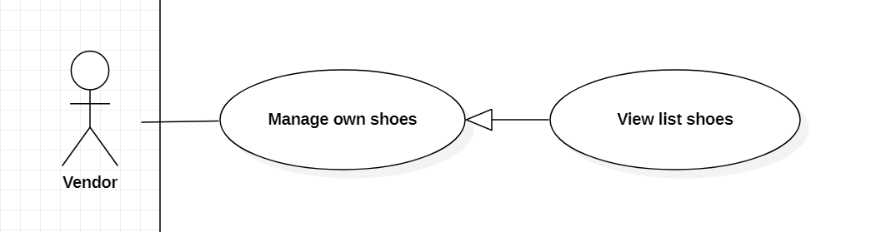

Figure 3.34 < Vendor > View list shoes

Use Case Specification

|  |  |  |  |  |
| --- | --- | --- | --- | --- |
| USE CASE – sSs_UC_27 | | | | |
| Use-case No. | <UC027> | Use-case Version | | 1.0 |
| Use-case Name | View list shoes | | | |
| Author | Nguyen Lam Thanh Tu | | | |
| Date | 13/07/2021 | Priority | Normal | |
| Actor:  Vendor  Summary:  This use case allows Vendor to view list shoes of own.  Goal:  Vendor views list shoes of own.  Triggers  Vendor clicks “View list shoes” button.  Preconditions:  Guest must login to system with Vendor account.  Post Conditions:  Success: System displays list shoes successfully.  Main Success Scenario:   |  |  |  | | --- | --- | --- | | Step | Actor Action | System Response | | 1 | Vendor clicks “View list shoes”button. | The system show list shoes of Vendor such as:  Price:  image:  ShoesName:  Quantity:  Description:  Date add shoes:  “Add a new shoes” button.  “Update a shoes”button.  “Delete a shoes”button.  “View list feedback”button.  Exception[1] |   Alternative:  None:  Exception :     |  |  |  | | --- | --- | --- | | No | Actor Action | System response | | 1 | List shoes is empty. | The system show message “You don't have shoes yet.” |   Relationships:  View list shoes generalization from Manage own shose.  Business Rules:   * Guest must login to system as Vendor’s role. * Status of account is true. * List all shoes of Vendor with status is true. | | | | |

## < Vendor > View feedback

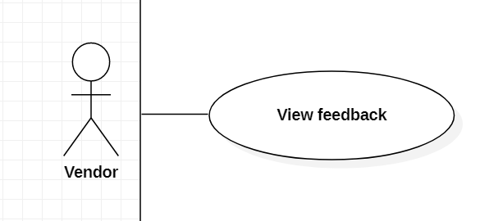

Figure 3.35 < Vendor > View feedback

Use Case Specification

|  |  |  |  |  |
| --- | --- | --- | --- | --- |
| USE CASE – sSs_UC_28 | | | | |
| Use-case No. | <UC028> | Use-case Version | | 1.0 |
| Use-case Name | View feedback | | | |
| Author | Nguyen Lam Thanh Tu | | | |
| Date | 13/07/2021 | Priority | Normal | |
| Actor:  Vendor  Summary:  This use case allows Vendor to view feedback of customer.  Goal:  Vendor views feedback of customer.  Triggers  Vendor clicks “View feedback” button.  Preconditions:   * Guest must login to system with Vendor account. * Vendor is viewing list shoes.   Post Conditions:  Success: System displays feedback of customer successfully.  Main Success Scenario:     |  |  |  | | --- | --- | --- | | Step | Actor Action | System Response | | 1 | Vendor clicks button “View feedback” | The system displays feedback such as.  - CustomerName:  - ContentFeedback:  - dateFeedback:  “Reply”button  “Report”button  “Back”button  Exception[1] |   Alternative:  None.  Exception:     |  |  |  | | --- | --- | --- | | No | Actor Action | System response | | 1 | List feedback is empty. | The system show message “You don't have feedback yet.” |   Relationships:  None.  Business Rules:   * Guest must login to system as Vendor’s role. * Status of account is true. | | | | |

## < Vendor > Reply feedback

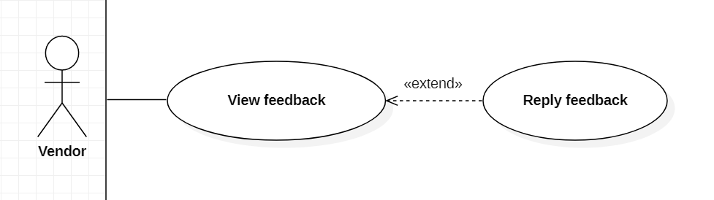

Figure 3.36 < Vendor > Reply feedback

Use Case Specification

|  |  |  |  |  |
| --- | --- | --- | --- | --- |
| USE CASE – sSs_UC_29 | | | | |
| Use-case No. | <UC029> | Use-case Version | | 1.0 |
| Use-case Name | Report feedback | | | |
| Author | Nguyen Lam Thanh Tu | | | |
| Date | 13/07/2021 | Priority | Normal | |
| Actor:  Vendor  Summary:  This use case allows Vendor to Report feedback to Admin.  Goal:  Vendor reports feedback to admin.  Triggers  Vendor clicks “Report feedback” button.  Preconditions:   * Guest must login to system with Vendor account. * Vendor is viewing feedback.   Post Conditions:  Success: System send report feedback to admin.  Main Success Scenario:   |  |  |  | | --- | --- | --- | | Step | Actor Action | System Response | | 1 | Vendor click button “Report feedback” | The system show table include:  Reason: textArea,required  “Send”button.  “Cancel”button. | | 2 | Vendor inputs reason and clicks button “Send” | The system shows message “Send successfully”.  Exception[1,2,3] |   Alternative:  None.  Exception:   |  |  |  | | --- | --- | --- | | No | Actor Action | System response | | 1 | Vendor inputs Reason empty | The system shows message “Reason not empty” |   Relationships:   * Report feedback extend View feedback.   Business Rules:   * Guest must login to system as Vendor’s role. * Status of account is true. | | | | |

## < Vendor > Report feedback to admin

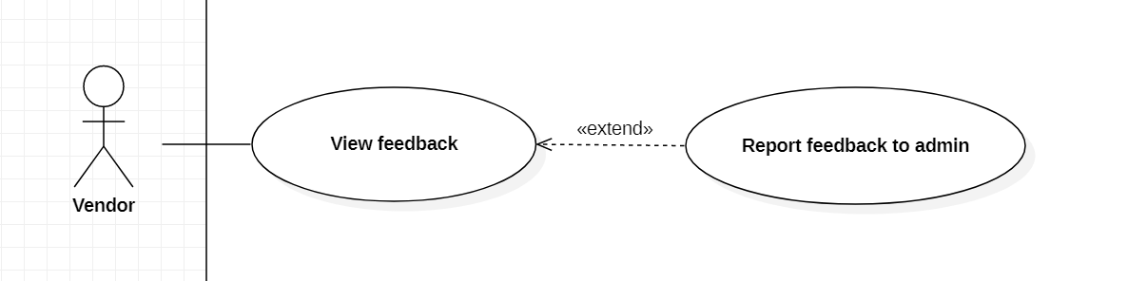

Figure 3.37 < Vendor > Report feedback to admin

Use Case Specification

|  |  |  |  |
| --- | --- | --- | --- |
| USE CASE – sSs_UC_30 | | | |
| Use-case No. | <UC030> | Use-case Version | 1.0 |
| Use-case Name | Report feedback | | |
| Author | Nguyen Lam Thanh Tu | | |
| Date | 28/05/2021 | Priority | Normal |
| Actor:  Vendor  Summary:  This use case allows Vendor to Report feedback to Admin.  Goal:  Vendor can report feedback to admin.  Triggers  Vendor click “Report feedback” button.  Preconditions:   * Guest must login to system with Vendor account. * Vendor is viewing feedback.   Post Conditions:  Success: System send report feedback to admin.  Main Success Scenario:   |  |  |  | | --- | --- | --- | | Step | Actor Action | System Response | | 1 | Vendor clicks button “Report feedback” | The system shows popup table include:  Reason: textArea,required  “Send”button.  “Cancel”button.  Exception[1] | | 2 | Vendor clicks button “Send” | The system shows message “Send successfully”. |   Alternative:  - None.  Exception:   |  |  |  | | --- | --- | --- | | Step | Actor Action | System Response | | 1 | Vendor inputs Reason empty | The system shows message “Reason not empty” |   Relationships:   * Report feedback extend View feedback.   Business Rules:  None. | | | |

## < Vendor > Chat

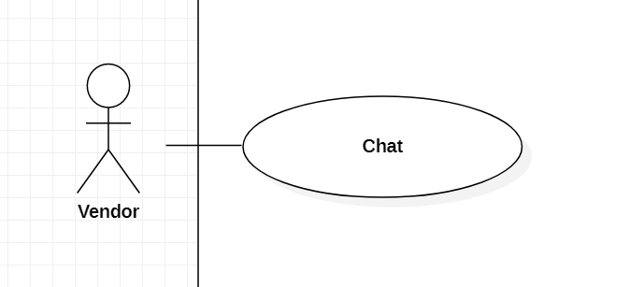

Figure 3.37 < Vendor > Chat

Use Case Specification

|  |  |  |  |  |
| --- | --- | --- | --- | --- |
| USE CASE – sSs_UC_31 | | | | |
| Use-case No. | <UC031> | Use-case Version | | 1.0 |
| Use-case Name | Chat | | | |
| Author | Nguyen Lam Thanh Tu | | | |
| Date | 13/07/2021 | Priority | Normal | |
| Actor:  Vendor  Summary:  This use case allows Vendor to chat with customers.  Goal:  Vendor to chat with customers  Triggers  Vendor clicks “Chat”button  Preconditions:  Guest must login to system with Vendor account.  Post Conditions:  Success: System sends message to Customers .  Main Success Scenario:     |  |  |  | | --- | --- | --- | | Step | Actor Action | System Response | | 1 | Customer clicks button“Chat” | The system shows boxchat include:  CustomerName:  TimeStart:  ShoesName:  SearchCustomer: textbox  Message:textbox  “Send”button.  Exception[1] | | 2 | Customer inputs message and clicks button “Send” | The system sends message to Customer  Exception[2] |   Alternative:  None.  Exception:   |  |  |  | | --- | --- | --- | | No | Actor Action | System response | | 1 | Search Customer is not found. | The system shows message “No Customer found.” | | 2 | Internet is interrupted. | The system shows message “Internet error, please try again!” |   Relationships:  None.  Business Rules:   * Use API for chat and filter for search. * Guest must login to system as Vendor’s role. * Status of account is true. | | | | |

## < Vendor > Cancel order



Figure 3.26 < Vendor > Cancel order

Use Case Specification

|  |  |  |  |  |
| --- | --- | --- | --- | --- |
| USE CASE – sSs_UC_32 | | | | |
| Use-case No. | <UC032> | Use-case Version | | 1.0 |
| Use-case Name | Cancel order | | | |
| Author | Le Tien Dat | | | |
| Date | 04/07/2021 | Priority | Normal | |
| Actor:  Vendor  Summary:  This use case allows Vendor to cancel the order.  Goal:  Vendor can cancel the order.  Triggers  Vendor clicks “Cancel order” on “View an order” screen.  Preconditions:  Vendor is on “Cancel order” popup.  Post Conditions:  Success: Customer cancel order successfully.  Main Success Scenario:   |  |  |  | | --- | --- | --- | | Step | Actor Action | System Response | | 1 | Vendor clicks on button “Cancel order” | The system shows popup:  - Reason: Combobox[…,etc.]  “Accept” button  “Cancel” button | | 2 | Vendor choose Reason on Combobox. |  | | 3 | Customer clicks on button “Accept” | The system closes the “Cancel order” popup.  The system sends message “Cancel order successfully!”.  The system changes status to “Cancelled”.  The system minus points of vendor. |   Alternative:  - None.  Exceptions:  - None.  Relationships:  - Cancel order extend from view an order.  Business Rules:  - None. | | | | |

## < Admin > Overview Use Case

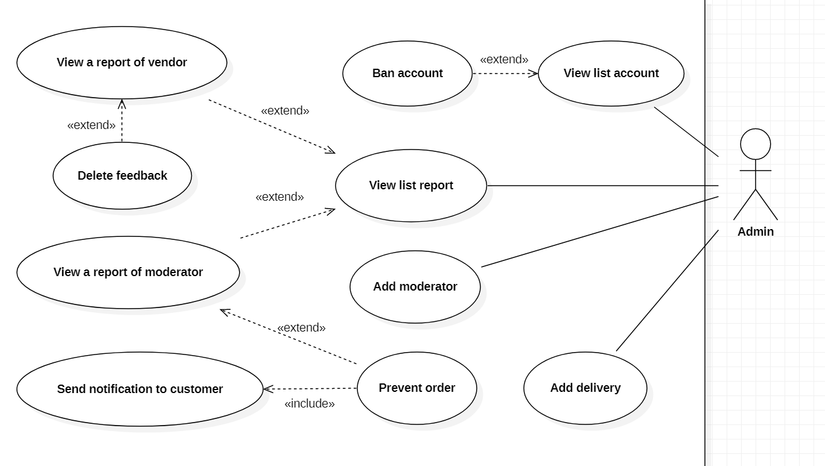

Figure 3.38 < Admin > View list account

## < Admin > View list account

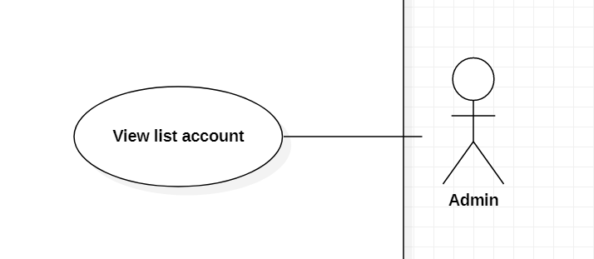

Figure 3.39 < Admin > View list account

Use Case Specification

|  |  |  |  |  |
| --- | --- | --- | --- | --- |
| USE CASE – sSs_UC_33 | | | | |
| Use-case No. | <UC033> | Use-case Version | | 1.0 |
| Use-case Name | View list account | | | |
| Author | Nguyen Le Anh Long | | | |
| Date | 7/03/2021 | Priority | Normal | |
| Actor:  Admin  Summary:  This use case allows Admin to View list account.  Goal:  Admin can View list account in the system.  Triggers  Admin click on button “View list account”.  Preconditions:  Have at least one user in the system.  Post Conditions:  Success: Admin View list account successfully.  Fail: Show error messages.  Main Success Scenario:     |  |  |  | | --- | --- | --- | | Step | Actor Action | System Response | | 1 | Admin stay  on the screen. |  | | 2 | Admin click on button “View list account”. | The system show list account:  + UserID  + Username  +Password  +Fullname  + Address  + Email  + Phone  + dateCreate  + roleID +”Ban” : button  Exception[1] |   Exception :   |  |  |  | | --- | --- | --- | | Step | Actor Action | System Response | | 1 | Admin click on button “View list account”. | If don’t have any user. The system show message: ”There aren't any account in the system”. |   Relationships: N/A  Business Rules: | | | | |

## < Admin > Ban account

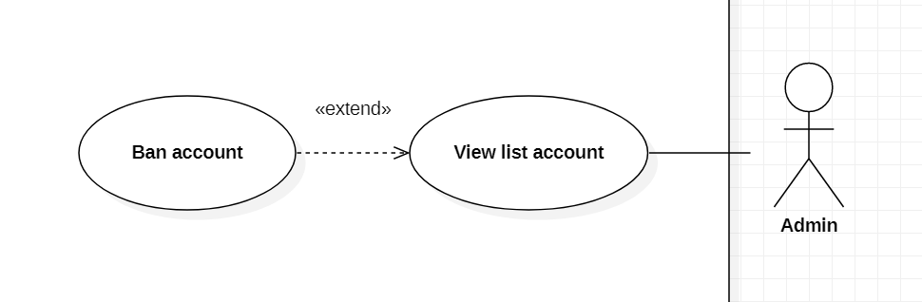

Figure 3.40 < Admin > Ban account

Use Case Specification

|  |  |  |  |  |
| --- | --- | --- | --- | --- |
| USE CASE – sSs_UC_34 | | | | |
| Use-case No. | <UC034> | Use-case Version | | 1.0 |
| Use-case Name | Ban account | | | |
| Author | Nguyen Le Anh Long | | | |
| Date | 7/03/2021 | Priority | Normal | |
| Actor:  Admin  Summary:  This use case allows Admin to Ban account.  Goal:  Admin can Ban account in the system.  Triggers  Admin click on button “Ban”.  Preconditions:  Admin stay on the View list account screen .  Post Conditions:  Success: Admin Ban account successfully.  Fail: Show error messages.  Main Success Scenario:     |  |  |  | | --- | --- | --- | | Step | Actor Action | System Response | | 1 | Admin stay on the View list account screen. |  | | 2 | Admin click on button “Ban”. | The system Ban the account successfully and change status button “Ban” to “StopBan”.  Alternative [1] |   Alternative Scenario :   |  |  |  | | --- | --- | --- | | Step | Actor Action | System Response | | 1 | Admin click on button “StopBan”. | The system Ban the account successfully and change status button “StopBan” to “Ban”. |   Relationships: N/A  Business Rules: | | | | |

## < Admin > Add moderator

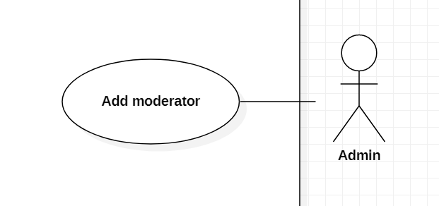

Figure 3.41 < Admin > Add moderator

Use Case Specification

|  |  |  |  |  |
| --- | --- | --- | --- | --- |
| USE CASE – sSs_UC_35 | | | | |
| Use-case No. | <UC035> | Use-case Version | | 1.0 |
| Use-case Name | Add moderator | | | |
| Author | Nguyen Le Anh Long | | | |
| Date | 7/03/2021 | Priority | Normal | |
| Actor:  Admin  Summary:  This use case allows Admin to Add moderator.  Goal:  Admin can Add moderator in the system.  Triggers  Admin click on button “Add moderator”.  Preconditions:  Admin must be log in .  Post Conditions:  Success: Admin can Add moderator in the system successfully.  Fail: Show error messages.  Main Success Scenario:     |  |  |  | | --- | --- | --- | | Step | Actor Action | System Response | | 1 | Admin stay on the screen. |  | | 2 | Admin click on button “Add moderator”. | The system show a list in table :  + Username: textbox, required.  + Password:password, required.  +Fullname:textbox, required.  +Address:textbox, required.  +Email:textbox, required.  + Phone:textbox, required.  “Create ” button.  Exception[1,2,3,4,5,6,7,8] | | 3 | Admin click on button “Create ”. | The system create new moderator and show message “Add successfully”. |   Exceptions:   |  |  |  | | --- | --- | --- | | Step | Actor Action | System Response | | 1. | Input field is empty. | System show error message” This field is not allow empty”. | | 2. | Internet is not available. | System show error message”Internet was interrupted. Please try again.” | | 3. | Phone number is wrong format. | System show error message “Phone number format is +84XXXXXXXXXX or  0XXXXXXXXX”. | | 4. | Length of Username is under 6 characters. | System show error message “Length of Username must be 6-50 characters”. | | 5. | Length of Username is over 50 characters. | System show error message “Length of Username must be 6-50 characters”. | | 6 | Length of Password is under 8 characters | The system show error message “Length of Password must be 8 – 30 characters”. | | 7 | Length of Password is over 30 characters | The system show error message “Length of Password must be 8 – 30 characters”. | | 8 | Password is included special character | The system show error message “Password is included special characters”. |   Relationships: N/A  Business Rules:  Admin must input all information. | | | | |

## < Admin > Add deliveryman

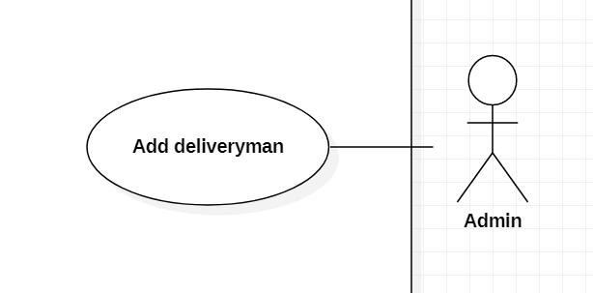

Figure 3.42 < Admin > Add deliveryman

Use Case Specification

|  |  |  |  |  |
| --- | --- | --- | --- | --- |
| USE CASE – sSs_UC_36 | | | | |
| Use-case No. | <UC036> | Use-case Version | | 1.0 |
| Use-case Name | Add deliveryman | | | |
| Author | Nguyen Le Anh Long | | | |
| Date | 7/03/2021 | Priority | Normal | |
| Actor:  Admin  Summary:  This use case allows Admin to Add deliveryman .  Goal:  Admin can Add deliveryman in the system.  Triggers  Admin click on button “Add deliveryman ”.  Preconditions:  Admin must be log in .  Post Conditions:  Success: Admin can Add deliveryman in the system successfully.  Fail: Show error messages.  Main Success Scenario:     |  |  |  | | --- | --- | --- | | Step | Actor Action | System Response | | 1 | Admin stay on the screen. |  | | 2 | Admin click on button “Add deliveryman ”. | The system show a list in table :  + Username: textbox, required.  + Password:password, required.  +Fullname:textbox, required.  +Address:textbox, required.  +Email:textbox, required.  + Phone:textbox, required.  “Create ” button.  Exception[1,2,3,4,5,6,7,8] | | 3 | Admin click on button “Create ”. | The system create new deliveryman and show message “Add successfully”. |   Exceptions:   |  |  |  | | --- | --- | --- | | Step | Actor Action | System Response | | 1. | Input field is empty. | System show error message” This field is not allow empty”. | | 2. | Internet is not available. | System show error message”Internet was interrupted. Please try again.” | | 3. | Phone number is wrong format. | System show error message “Phone number format is +84XXXXXXXXXX or  0XXXXXXXXX”. | | 4. | Length of Username is under 6 characters. | System show error message “Length of Username must be 6-50 characters”. | | 5. | Length of Username is over 50 characters. | System show error message “Length of Username must be 6-50 characters”. | | 6 | Length of Password is under 8 characters | The system show error message “Length of Password must be 8 – 30 characters”. | | 7 | Length of Password is over 30 characters | The system show error message “Length of Password must be 8 – 30 characters”. | | 8 | Password is included special character | The system show error message “Password is included special characters”. |   Relationships: N/A  Business Rules:  Admin must input all information. | | | | |

## < Admin > View list report

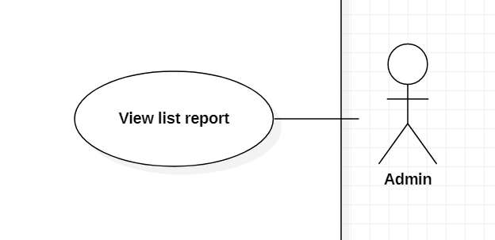

Figure 3.43 < Admin > View list report

Use Case Specification

|  |  |  |  |  |
| --- | --- | --- | --- | --- |
| USE CASE – sSs_UC_37 | | | | |
| Use-case No. | <UC037> | Use-case Version | | 1.0 |
| Use-case Name | View list report | | | |
| Author | Nguyen Le Anh Long | | | |
| Date | 7/03/2021 | Priority | Normal | |
| Actor:  Admin  Summary:  This use case allows Admin to view list report of vendor and moderator.  Goal:  Admin can view list report of vendor and moderator in the system.  Triggers  Admin click on button “View list report ”.  Preconditions:  Have at least one report in the system.  Post Conditions:  Success: Admin view list report the system successfully.  Fail: Show error messages.  Main Success Scenario:     |  |  |  | | --- | --- | --- | | Step | Actor Action | System Response | | 1 | Admin stay on the screen. |  | | 2 | Admin click on button “View list report”. | The system show two button:  + “View list report of vendor” button.  + “View list report of moderator” button.  Exception: [1] |   Exception:   |  |  |  | | --- | --- | --- | | Step | Actor Action | System Response | | 1 | Admin click on button “View list report ”. | If don’t have any report . The system show message: ”There aren't any report in the system”. |   Relationships: N/A  Business Rules: | | | | |

## < Admin > View list report of vendor

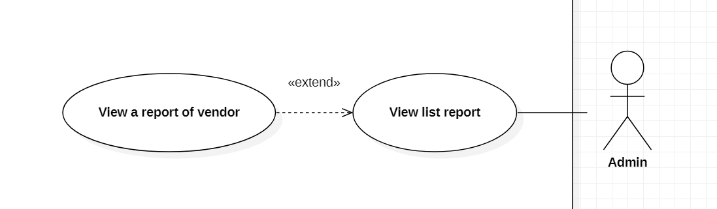

Figure 3.44 < Admin > View list report of vendor

Use Case Specification

|  |  |  |  |  |
| --- | --- | --- | --- | --- |
| USE CASE – sSs_UC_38 | | | | |
| Use-case No. | <UC038> | Use-case Version | | 1.0 |
| Use-case Name | View list report of vendor | | | |
| Author | Nguyen Le Anh Long | | | |
| Date | 7/03/2021 | Priority | Normal | |
| Actor:  Admin  Summary:  This use case allows Admin to view list report of vendor.  Goal:  Admin can view list report of vendor in the system.  Triggers  Admin click on button “View list report of vendor ”.  Preconditions:  Admin must click on button “View list report” before .  Have at least one report of vendor in the system.  Post Conditions:  Success: Admin view list report of vendor in the system successfully.  Fail: Show error messages.    Main Success Scenario:     |  |  |  | | --- | --- | --- | | Step | Actor Action | System Response | | 1 | Admin click on button “View list report of vendor”. | The system show list reports in DataGridView:  +reportID :  + vendorID:  + dateReport:  “Reason Detail ” button  “List Feedback” button  Exception[1] | | 2 | Admin click on button “Reason Detail”. | + The system show content of the report.  + The system show “Finish” button. | | 3 | Admin click on button “Finish” after view. | The system back to view list report of vendor  screen. |   Exception:   |  |  |  | | --- | --- | --- | | Step | Actor Action | System Response | | 1 | Admin click on button “View list report of vendor”. | If don’t have any report . The system show message: ”There aren't any report in the system”. |   Relationships: N/A  Business Rules: | | | | |

## < Admin > Delete feedback

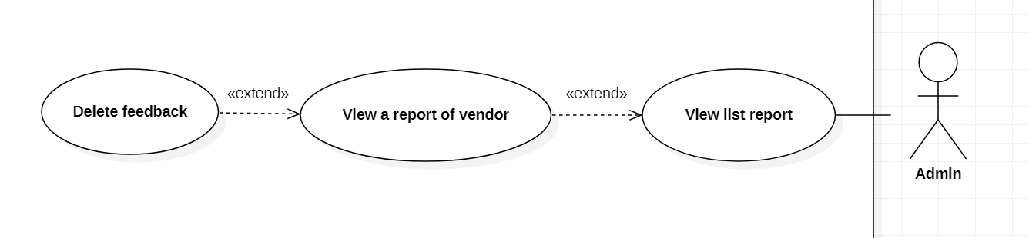

Figure 3.45 < Admin > Delete feedback

Use Case Specification

|  |  |  |  |  |
| --- | --- | --- | --- | --- |
| USE CASE – sSs_UC_39 | | | | |
| Use-case No. | <UC039> | Use-case Version | | 1.0 |
| Use-case Name | Delete feedback | | | |
| Author | Nguyen Le Anh Long | | | |
| Date | 7/03/2021 | Priority | Normal | |
| Actor:  Admin  Summary:  This use case allows Admin delete feedback of customer.  Goal:  Admin can delete feedback of customer in the system.  Triggers:  Admin click on button “Delete feedback”.  Preconditions:  Admin stay in view list report of vendor screen.  Have at least one feedback of customer in vendor report.  Post Conditions:  Success: Admin delete feedback of customer in the system successfully.  Fail: Show error messages.  Main Success Scenario:     |  |  |  | | --- | --- | --- | | Step | Actor Action | System Response | | 1 | Admin click on button “List Feedback”. | The system show list feedback in DataGridView:  + CustomerName:  +ContentFeedback:  +dateFeedback:  ”Delete Feedback” button  Exception[1] | | 2 | Admin click on button “Delete Feedback”. | The system delete the feedback and show message ”Delete successfully”. |   Exception:   |  |  |  | | --- | --- | --- | | Step | Actor Action | System Response | | 1 | Admin click on button “List Feedback”. | If don’t have any feedback . The system show message: ”There aren't any feedback in the system”. |   Relationships: N/A  Business Rules: | | | | |

## < Admin > View list of moderator

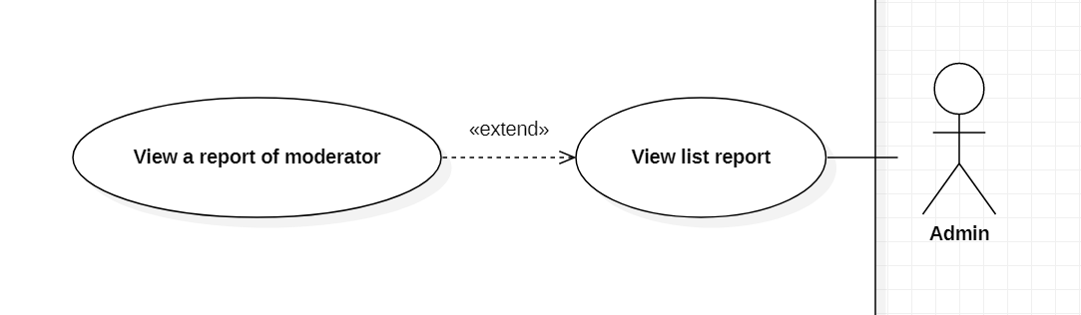

Figure 3.46 < Admin > View list of moderator

Use Case Specification

|  |  |  |  |  |
| --- | --- | --- | --- | --- |
| USE CASE – sSs_UC_40 | | | | |
| Use-case No. | <UC040> | Use-case Version | | 1.0 |
| Use-case Name | View list report of moderator | | | |
| Author | Nguyen Le Anh Long | | | |
| Date | 7/03/2021 | Priority | Normal | |
| Actor:  Admin  Summary:  This use case allows Admin to view list report of moderator.  Goal:  Admin can view list report of moderator in the system.  Triggers  Admin click on button “View list report of moderator”.  Preconditions:  Admin must click on button “View list report” before .  Have at least one report of moderator in the system.  Post Conditions:  Success: Admin view list report of moderator in the system successfully.  Fail: Show error messages.    Main Success Scenario:     |  |  |  | | --- | --- | --- | | Step | Actor Action | System Response | | 1 | Admin click on button “View list report of moderator ”. | The system show list reports in DataGridView:  - orderID:  - image:  - dateOrder:  - statusName:  - vendorName:  - customerName:  - shoesName:  - testShoes: [Real/ Fake]  - dateCheck:  - status:[Not Check]  “Prevent order” button  Exception [1] |   Exception:   |  |  |  | | --- | --- | --- | | Step | Actor Action | System Response | | 1 | Admin click on button “View list report of moderator ”. | If don’t have any report . The system show message: ”There aren't any report in the system”. |   Relationships: N/A  Business Rules: | | | | |

## < Admin > Prevent order

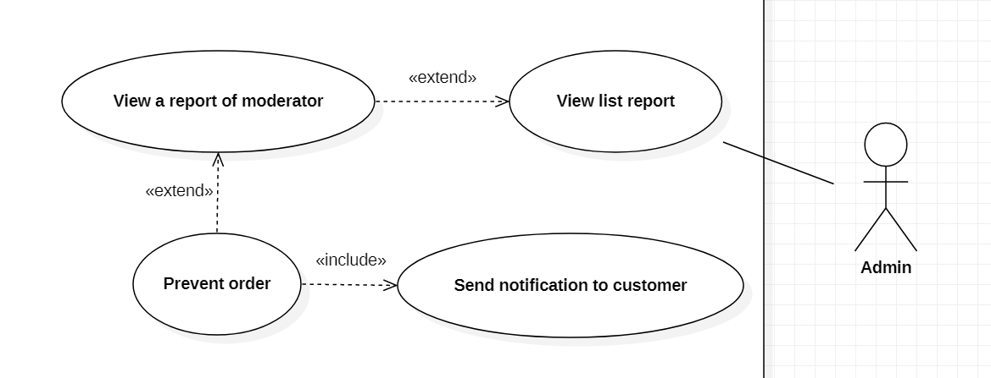

Figure 3.47 < Admin > Prevent order

Use Case Specification

|  |  |  |  |  |
| --- | --- | --- | --- | --- |
| USE CASE – sSs_UC_41 | | | | |
| Use-case No. | <UC041> | Use-case Version | | 1.0 |
| Use-case Name | Prevent order | | | |
| Author | Nguyen Le Anh Long | | | |
| Date | 7/03/2021 | Priority | Normal | |
| Actor:  Admin  Summary:  This use case allows Admin to prevent order.  Goal:  Admin can prevent order in the system.  Triggers  Admin click on button “Prevent order”.  Preconditions:  Admin stay in view list report of moderator screen.  Have at least one report of moderator in the system.  Post Conditions:  Success: Admin view prevent order in the system successfully.  Fail: Show error messages.  Main Success Scenario:   |  |  |  | | --- | --- | --- | | Step | Actor Action | System Response | | 1 | Admin click on button “Prevent order” | The system show clearly :  + image:  “Real” button  “Fake” button | | 2. | Admin click on button “Fake” | + The system send back notification to Deliveryman “Shoes was checked, turn back Shoes to the Vendor”.  + The system send notification to Customer “The shoes is fake, the order is prevent”.  +The system show message “Prevent order successfully”.  + The system back to the view list report of moderator screen.  + The system change change status “Not Check” to “Checked”. |   Alternative Scenario:   |  |  |  | | --- | --- | --- | | Step | Actor Action | System Response | | 1 | Admin click on button “Real ” | + The system send notification to Customer “The shoes is real , the order is ready for a few days ”.  +The system show message “Check the order successfully”.  + The system back to the view list report of moderator screen.  + The system change change status “Not Check” to “Checked”. |   Relationships: N/A  Business Rules: | | | | |

# NON-FUNCTIONAL RQUIMENTS

## Usability

* The User interface clearly shows the functions that the user can use. Users can easily use it for the first time.
* Admin, Deliveryman man, Moderator need less than 3 days of training to be shoesive with the system.

## Reliability

- If the website goes down, the administrator has the responsibility to restore the website in the shortest time.

- Comply with thae world's material safety regulations and shoe quality control procedures

- The system immediately disconnects login after 5 incorrect entries.

- Data is absolutely confidential.

## Performance

* System working 24/24.
* Time responding of system should be less than 3 second.
* Limit the number of people accessing the website system 5000 Users.

## Supportability

- Support multiple browsers

## Design Constraints

* Back-end: Java/Java-Web Application.
* Front-end: Bootstrap framework
* Database: SQL server

## On-line User Documentation and Help System Requirements

- The system provides a website to help users solve their problems.This page should be customized based on what pages that user is allowed to access.

* This help page should be accessible from all other pages.

## Purchased Components

* Domain name registration.
* Purchase cloud hosting.
* Testing tools.
* IDE.

## Interfaces

- The search tool

[Describe any communications interfaces to other systems or devices such as local area networks, remote serial devices, and so forth.]

## Licensing Requirements

- Business license.

## Legal, Copyright, and Other Notices

*(none)*

## Applicable Standards

# Supporting Information

*[The supporting information makes the SRS easier to use. It includes:*

*Table of contents*

*Index*

*Appendices*

*These may include use-case storyboards or user-interface prototypes. When appendices are included, the SRS should explicitly state whether or not the appendices are to be considered part of the requirements.]*