VIETNAM NATIONAL UNIVERSITY – HO CHI MINH CITY
INTERNATIONAL UNIVERSITY

SCHOOL OF COMPUTER SCIENCE & ENGINEERING

WEB APPLICATION DEVELOPMENT
IT093IU

PROJECT REPORT

CYBERSECURITY ONLINE LEARNING PLATFORM

Submitted by
Nguyễn Quốc Tuấn - ITITIU22177

Date Submitted: 21/10/2023
Date Performed: 3/5/2025
Course Instructor: Dr. Nguyen Van Sinh
MSc Tran Khai Minh

Table of Contents
List of Figures v
1 Introduction 1
2 Project Overview 1
2.1 Theory Lessons: 1
2.2 Interactive Labs: 1
2.3 Admin Dashboard: 1
3 Requirement analysis 2
3.1 Functional Requirement 2
a. User Management 2
b. Course Management 2
c. Learning Expierence 2
d. Interactive Labs 2
e. Administration Dashboard 2
3.2 Non-Functional Requirements 2
a. Performance 2
b. Security 3
c. Usability 3
d. Compatibility 3
3.3 Technical Requirements 3
a. Development Technologies 3
b. Potential Future Features 3
4 Design 4
4.1 Backend Architecture Design 4
a. System Architecture 4
b. Key Components Design 4
c. Controller Layer 5
d. Middleware Components 5
e. API Design 6
4.2 Frontend Design 9
a. Component Design 9
b. State Management 10
c. Routing Structure 10
d. API Integration 10
e. Performance Considerations 10
f. Service Layer Architecture 10
4.3 Database design 11
a. Entity-Relationship Diagram (ERD) 11
4.4 Use Case Diagram 13
a. Sequence Diagram 1: Log in 14
b. Sequence Diagram 2: Register 15
c. Sequence Diagram 3: Browsing Lesson 16
d. Sequence Diagram 4: Completing Lesson 17
e. Sequence Diagram 5: Browsing lab 18
f. Sequence Diagram: Starting a lab 19
g. Sequence Diagram 7: Submiting a flag 20
h. Sequence Diagram 8: Stopping a lab 21
i. Sequence Diagram 9: Managing Account 22
j. Sequence Diagram 10: Create Lesson 23
k. Sequence Diagram 11: Edit Lesson 23
l. Sequence Diagram 12: Reset password 24
5 Implementation 25
5.1 Authenticate Section: 25
a. Login: 25
b. Register Account 26
c. Reset Password 26
5.2 Labs Section: 27
a. Browsing lab: 27
b. Selecting and Finishing Lab 28
5.3 Lessons Section: 30
a. Browsing Lessons: 30
b. Starting Lessons 30
5.4 Account Section 33
a. Updating account 33
5.5 Admin Section 33
a. Creating Lesson: 34
b. Editing Lessons 35
6 Discussion and conclusion 37
6.1 Challenges Encountered 37
6.2 Future Work 37
a. AI-Powered Personalized Feedback Systems 37
b. Advanced Laboratory Environments 38
References 39

List of Figures
Figure 1. ERD 11
Figure 2. Use Case Diagram 13
Figure 3.Login Sequence Diagram 14
Figure 4. Register Sequence Diagram 15
Figure 5. Browsing Lesson Sequence Diagram 16
Figure 6. Finish Lesson Sequence Diagram 17
Figure 7. Browsing Labs Sequence Diagram 18
Figure 8. Starting Labs Sequence Diagram 19
Figure 9. Submitting Flags Sequence Diagram 20
Figure 10. Stopping Labs Sequence Diagram 21
Figure 11. Managing Account Sequence Diagram 22
Figure 12. Creating Lessons Sequence Diagram 23
Figure 13. Editing Lessons Sequence Diagram 23
Figure 14. Reset Password Sequence Diagram 24
Figure 15. Login Form 25
Figure 16. Login Successful 25
Figure 17. Register Form 26
Figure 18. Register Successful 26
Figure 19. Reset Password Email 27
Figure 20. Reset Password Form 27
Figure 21. Labs Section 28
Figure 22. A Lab Card 28
Figure 23. Starting a Lab 29
Figure 24. Submitting Flag 29
Figure 25. A completed Lab 30
Figure 26. Lessons Section 30
Figure 27. An example page 31
Figure 28. A Unfinished Lesson 31
Figure 29. Completing a Lesson 32
Figure 30. A completed Lesson 32
Figure 31.Editting Account Form 33
Figure 32. List of Lessons 33
Figure 33. General Information of a Lesson 34
Figure 34. Pages of Lesson Section 34
Figure 35. Creating a Lesson successful 35
Figure 36. Editting Lesson Section 35
Figure 37. Editting Pages 36
Figure 38. Editting Lesson successful 36
Figure 39. Editted Lesson 37

Introduction
- This report presents the design, development, and features of TS Academy, a cutting-edge online platform focused on delivering comprehensive cybersecurity education. As digital threats continue to evolve rapidly, the need for accessible, practical cybersecurity training has never been greater. TS Academy meets this demand by offering an engaging learning environment that blends foundational theory with hands-on practice.
- Catering to learners of all skill levels, from novices exploring digital security fundamentals to experienced users sharpening advanced techniques, TS Academy employs a dual learning approach. Its robust theoretical courses provide a deep understanding of cybersecurity principles, concepts, and best practices, while interactive labs enable learners to apply their knowledge in realistic, simulated environments.

Project Overview
TS Academy is built on three core pillars:

Theory Lessons:
The platform delivers structured, engaging lessons on essential cybersecurity concepts, principles, and best practices. These lessons provide learners with a strong knowledge foundation to comprehend digital threats and defense mechanisms, designed to be accessible and relevant for users at any stage of their learning journey.

Interactive Labs:
To complement theoretical learning, interactive labs offer a hands-on environment where users can put their knowledge into practice. These labs simulate real-world cybersecurity scenarios, allowing learners to test defensive strategies, detect vulnerabilities, and build practical skills in a secure, controlled setting, reinforcing their theoretical understanding.

Admin Dashboard:
A powerful admin dashboard equips platform administrators with tools to manage operations efficiently. Features include user management, content creation and organization for lessons and labs, progress tracking, and potential report generation, ensuring seamless maintenance and oversight of the learning ecosystem.

Requirement analysis

Functional Requirement

User Management
    - User registration and authentication system
    - Role-based access control (student,administrator)
    - User profile management with customization options

Course Management
    - Course creation and publishing
    - Content organization by categories, subjects, and difficulty levels

Learning Expierence
    - Interactive lesson modules with progress tracking

Interactive Labs
    - Hands-on virtual lab environments for practical exercises
    - Sandbox environments for experimentation
    - Lab exercise tracking and progress monitoring
    - Simulated environments for real-world scenario practice
    - Lab result submission and feedback system

Administration Dashboard
    - User activity monitoring and engagement metrics
    - Content management and moderation tools

Non-Functional Requirements

Performance
  - Page load times under 3 seconds
  - Efficient database queries to handle large datasets
  - Scalable architecture to accommodate growth

Security
  - End-to-end encryption for sensitive data

Usability
  - Intuitive, user-friendly interface design
  - Consistent navigation and interface patterns
  - Clear error messages

Compatibility
  - Support for major browsers (Chrome, Firefox, Safari, Edge)

Technical Requirements

Development Technologies
  - Front-end: Modern JavaScript framework (React)
  - Back-end: Scalable server-side technology (Node.js)
  - Database: Relational (MySQL)
  - Version control system for collaborative development(Github)

Potential Future Features
  - AI-powered learning path recommendations
  - Augmented reality/virtual reality learning experiences
  - Advanced analytics with predictive capabilities
  - Blockchain-based credential verification
  - Marketplace for educational resources
  - Peer-to-peer tutoring network
  - Content localization and internationalization

Design

Backend Architecture Design
The backend architecture of our online learning platform follows a modular, service-oriented approach built on Node.js. This design ensures scalability, maintainability, and separation of concerns through well-defined components.

System Architecture
The backend implements a classic MVC (Model-View-Controller) pattern with additional middleware components to handle cross-cutting concerns. The system is organized into logical modules that encapsulate specific functionality domains:
- Models: Data schemas and business logic
- Controllers: Request handling and response formatting
- Routes: API endpoint definitions and request routing
- Middleware: Cross-cutting concerns like authentication
- Config: Environment and application configuration
- Utils: Shared utility functions
- Content: Security-focused content resources

Key Components Design

Data Models
The platform's data layer is structured around these primary entities:

User Model
  - Manages user profiles, authentication credentials, and role-based permissions
  - Supports multiple user types (student, administrator)
  - Handles user-specific settings and preferences

Lesson Model
  - Represents structured learning content organized into courses
  - Supports versioning and content management
  - Includes metadata for categorization and discovery

LessonPage Model
  - Represents individual content pages within lessons
  - Supports multiple content formats (text, interactive elements)
  - Tracks content revisions and publishing status

UserLessonProgress Model
  - Tracks individual user progress through course materials
  - Records completion status

Lab Model
  - Defines interactive environments for hands-on practice
  - Specifies resource requirements and configuration parameters
  - Supports different scenario types and difficulty levels

Controller Layer
Controllers implement the application's business logic and mediate between the data models and API endpoints:

Authentication Controller
  - Manages user registration, login, and session management
  - Implements security measures including password hashing and token validation

User Controller
  - Manages user profile operations and settings
  - Handles role-based permission checks
  - Processes user activity and progress data
  - Handles credential updates

Lesson Controller
  - Delivers educational content based on user progress
  - Manages content sequencing and prerequisite enforcement

Lab Controller
  - Manages the lifecycle of interactive lab environments
  - Processes user actions within lab scenarios
  - Evaluates lab exercise completion and provides guidance

Docker Controller
  - Handles container provisioning and management for isolated lab environments
  - Manages resource allocation and cleanup
  - Ensures security boundaries between user environments

Middleware Components
The middleware layer handles cross-cutting concerns:

Authentication Middleware
  - Validates user session tokens
  - Implements role-based access control for protected resources
  - Maintains security context throughout request processing

Utility Services
Shared utilities provide common functionality:

JWT Utilities
  - Generates and validates JSON Web Tokens for authentication
  - Implements token refresh and expiration logic
  - Provides security context for authorized operations

File Utilities
  - Handles secure file operations
  - Manages content uploads and storage
  - Implements access control for protected resources

API Design
Our online learning platform implements a comprehensive RESTful API architecture organized by functional domains. The API is designed with security, performance, and maintainability as key priorities.

API Structure and Implementation
The API is built using Express.js with the following core components:

Authentication API
The authentication API handles user identity verification and session management:
router.post("/login", authController.login);
router.post("/register", authController.register);
router.get("/check-auth", checkAuth, authController.getAuthStatus);
router.post("/logout", authController.logout);
These endpoints manage:
- User registration with credential validation
- Secure authentication with JWT token issuance
- Session validation for protected resources
- Secure logout and session termination

User Management API
The user management API provides access to user profiles and account settings:
router.get("/home", (req, res) => {
res.json({ message: "valid", user_name: req.user_name });
});
router.get("/account", userController.getUser);
router.post("/update-account", userController.updateUser);
These endpoints handle:
- User profile retrieval
- Account settings updates
- User preference management

Learning Content API
The learning content API manages educational resources and user progress:
router.get("/", lessonController.getAllLessons);
router.get("/:id", lessonController.getLessonById);
router.post("/create", lessonController.createLesson);
router.put("/:id", lessonController.updateLesson);
router.delete("/:id", lessonController.deleteLesson);

router.get("/:lessonId/pages/:pageNumber", lessonController.getLessonPage);
router.get("/:lessonId/pages", lessonController.getAllLessonPages);
router.post("/:lessonId/pages", lessonController.createLessonPage);
router.put("/pages/:pageId", lessonController.updateLessonPage);
router.delete("/pages/:pageId", lessonController.deleteLessonPage);

router.post("/progress/:lessonId", lessonController.updateUserProgress);
router.get("/user/progress", lessonController.getUserLessonsWithProgress);
These endpoints provide:
- Comprehensive lesson CRUD operations
- Granular access to lesson content pages
- User progress tracking and management
- Content organization and sequencing

Interactive Lab API
The lab API handles the creation and management of hands-on learning environments:
router.get("/", labController.labsWithStatus);
router.get("/verify-flag", labController.verifyFlag);
router.post(
"/create-container",
labController.getLabName,
createContainerController
);
router.post("/getlabname", labController.getLabName);
router.post("/delete-container", deleteContainer);
These endpoints manage:
- Lab environment discovery and status checking
- Container-based lab environment provisioning
- Challenge verification and completion tracking
- Resource cleanup and management

API Security Features
The API incorporates several security measures:

Authentication Middleware:
All protected routes use the checkAuth middleware to validate user sessions:
app.use("/api/route", checkAuth, indexRoutes);
app.use("/api/labs", checkAuth, labRoutes);
app.use("/api/lessons", checkAuth, lessonRoutes);

CORS Protection:
Strict cross-origin resource sharing policies:
app.use(
cors({
origin: "http://localhost:4000",
methods: ["GET", "POST", "PUT", "DELETE"],
credentials: true,
})
);

Error Handling:
Consistent error responses for invalid routes:
app.use((req, res) => {
res.status(404).json({ message: "Route not found" });
});

Frontend Design
The frontend of our online learning platform is built as a single-page application (SPA) using React.js, providing a responsive and dynamic user experience. This is a well-structured React application built with TypeScript and Vite, organized with a feature-based approach.

Component Design
The frontend implements a component-based architecture with clear separation of concerns:

Core Components
- App Component: Serves as the application root, managing global state and routing
- Navigation Component: Provides consistent navigation across the platform
- Authentication Components: Handle user login, registration, and session management
- Protected Route Component: Ensures authenticated access to restricted areas

Feature Components

Lesson Components
- LessonView: Displays lesson content to users with navigation controls
- LessonEditor: Provides content creation and editing interface for admin
- LessonCreate: Facilitates the creation of new educational content
- LessonCards: Displays available lessons with progress indicators

Lab Components
- Lab: Container component for interactive lab environments
- LabCards: Selection interface for available lab exercises

Admin Interface
- Administrative dashboard for platform management
- User, lesson, and lab management controls

State Management
The application uses a combination of:
- Local component state with React's useState hook
- Context API for global state management (authentication, user preferences)
- Prop drilling for component communication within feature modules

Routing Structure
The frontend implements client-side routing with React Router:
- Public routes (Home, About, Login)
- Protected routes requiring authentication (Account, Lessons, Labs, Admin)
- Nested routes for complex features (lesson pages, lab exercises)
- 404 handling for invalid routes

API Integration
The frontend communicates with the backend through:
- RESTful API calls to the server endpoints
- Authentication token management
- Error handling and loading states

Performance Considerations
Several strategies are employed to optimize performance:
- Code splitting for route-based lazy loading
- Asset optimization for efficient delivery
- Memoization for expensive computations
- Efficient rendering of lists and dynamic content

Service Layer Architecture
The application implements a robust service layer that acts as an intermediary between the UI components and backend APIs:

Core Services
- authService: Manages authentication flows, token handling, and user session persistence
- accountService: Handles user profile operations, preferences, and account management
- adminService: Provides administrative functionality and system configuration operations

Feature Services
- lessonService: Facilitates CRUD operations for lessons, content retrieval, and progress tracking
- labService: Manages interactive lab environments, exercise submissions, and progress evaluation

Service Architecture Patterns
- Implementation of the repository pattern for data access abstraction
- Consistent error handling and response normalization
- Caching strategies for frequently accessed data
- Request interceptors for authentication header injection
- Response transformation for component-ready data structures

Database design

Entity-Relationship Diagram (ERD)
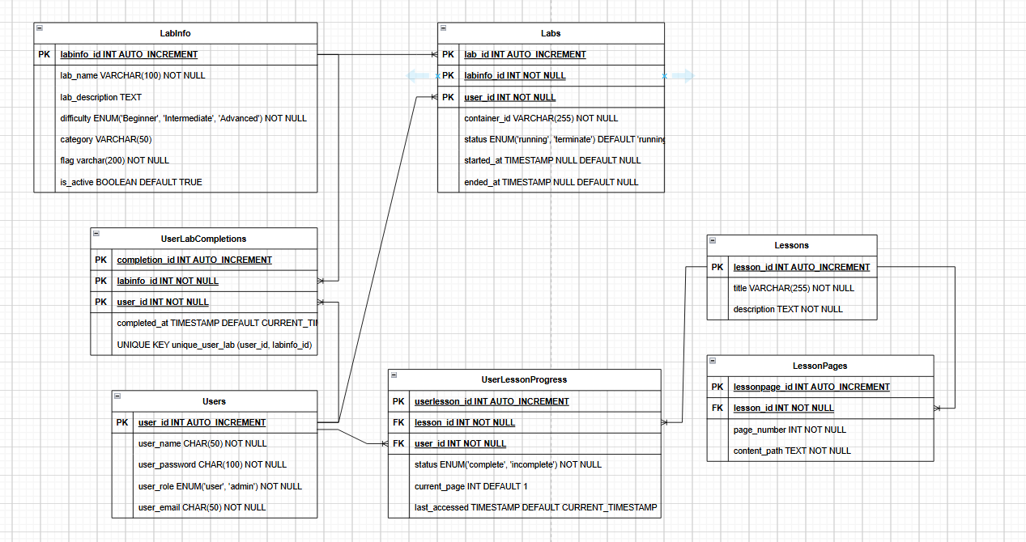
Figure 1. ERD

Users table
Users(user_id, user_name, user_password, user_role, user_email)

LabInfo table
LabInfo(labinfo_id, lab_name, lab_description, difficulty, category, flag, is_active)

Labs table
Labs(lab_id, user_id, labinfo_id, container_id, status, started_at, ended_at)
from Labs.user_id to Users.user_id
from Labs.labinfo_id to LabInfo.labinfo_id

UserLabCompletions table
UserLabCompletions(completion_id, user_id, labinfo_id, completed_at)
from UserLabCompletions.user_id to Users.user_id
from UserLabCompletions.labinfo_id to LabInfo.labinfo_id

Lessons table
Lessons(lesson_id, title, description)

LessonPages table
LessonPages(lessonpage_id, lesson_id, page_number, content_path)
from LessonPages.lesson_id to Lessons.lesson_id

UserLessonProgress table
UserLessonProgress(userlesson_id, user_id, lesson_id, status, current_page, last_accessed)
from UserLessonProgress.user_id to Users.user_id
from UserLessonProgress.lesson_id to Lessons.lesson_id

Use Case Diagram
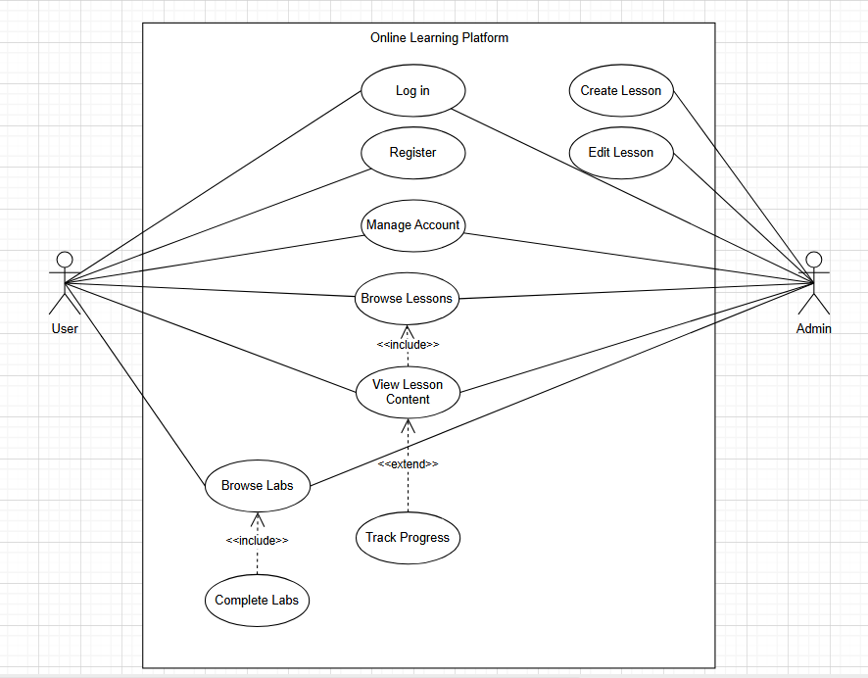
Figure 2. Use Case Diagram

Sequence Diagram 1: Log in
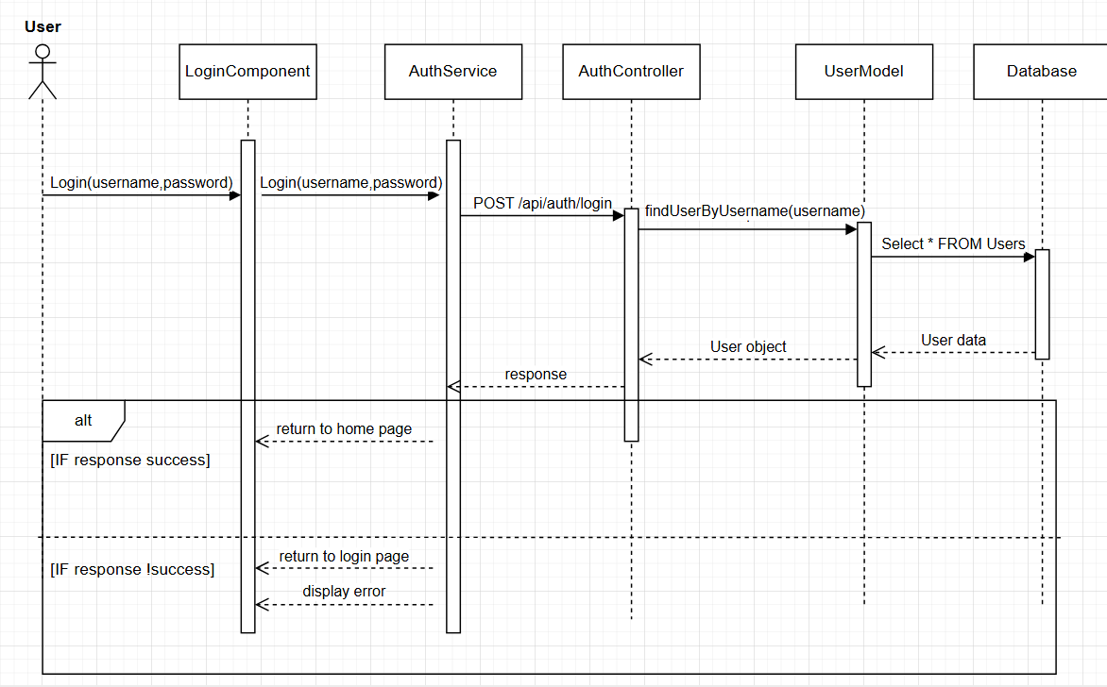
Figure 3.Login Sequence Diagram

Sequence Diagram 2: Register
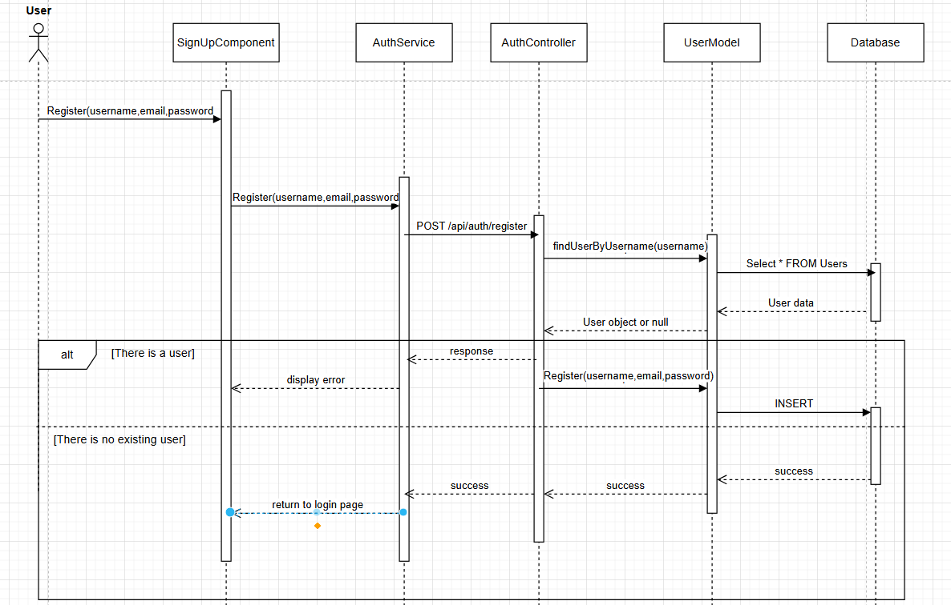
Figure 4. Register Sequence Diagram

Sequence Diagram 3: Browsing Lesson
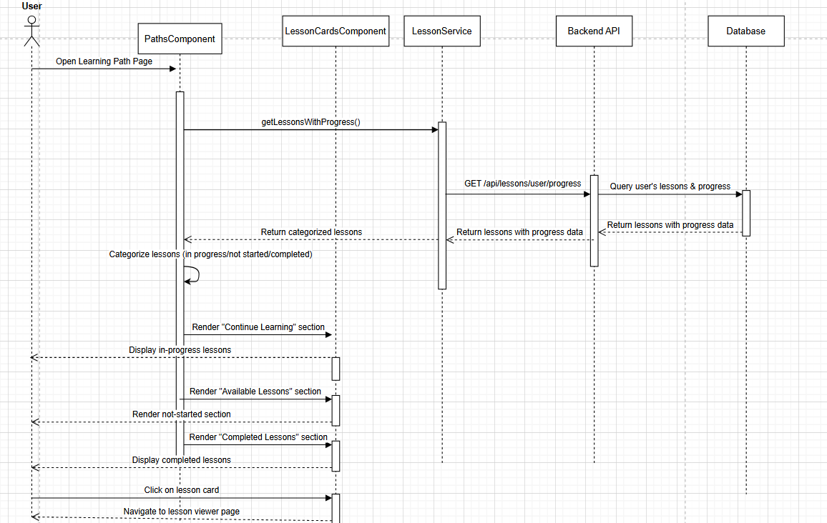
Figure 5. Browsing Lesson Sequence Diagram

Sequence Diagram 4: Completing Lesson
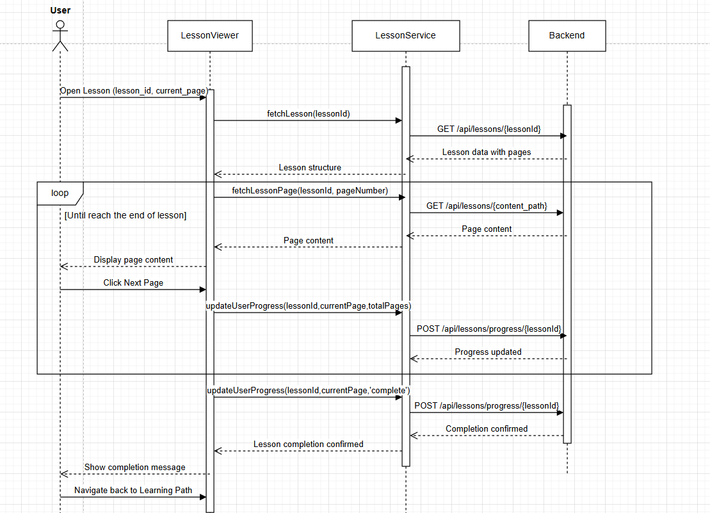
Figure 6. Finish Lesson Sequence Diagram

Sequence Diagram 5: Browsing Labs
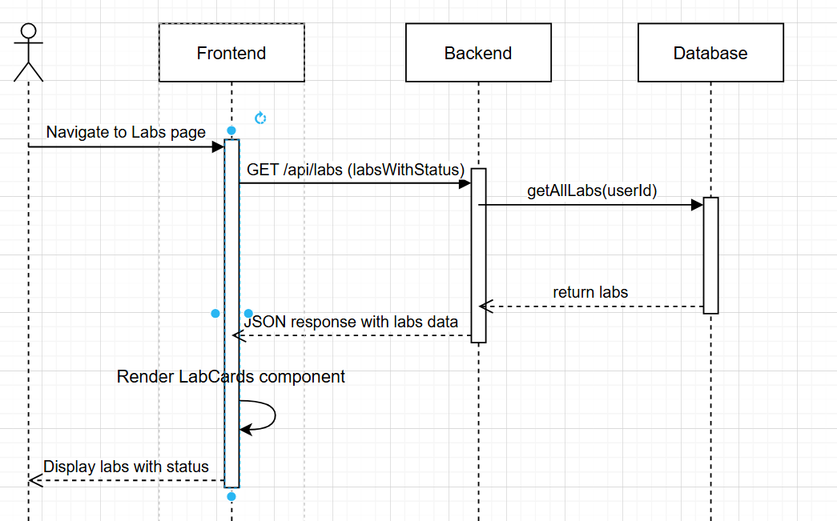
Figure 7. Browsing Labs Sequence Diagram

Sequence Diagram: Starting Labs
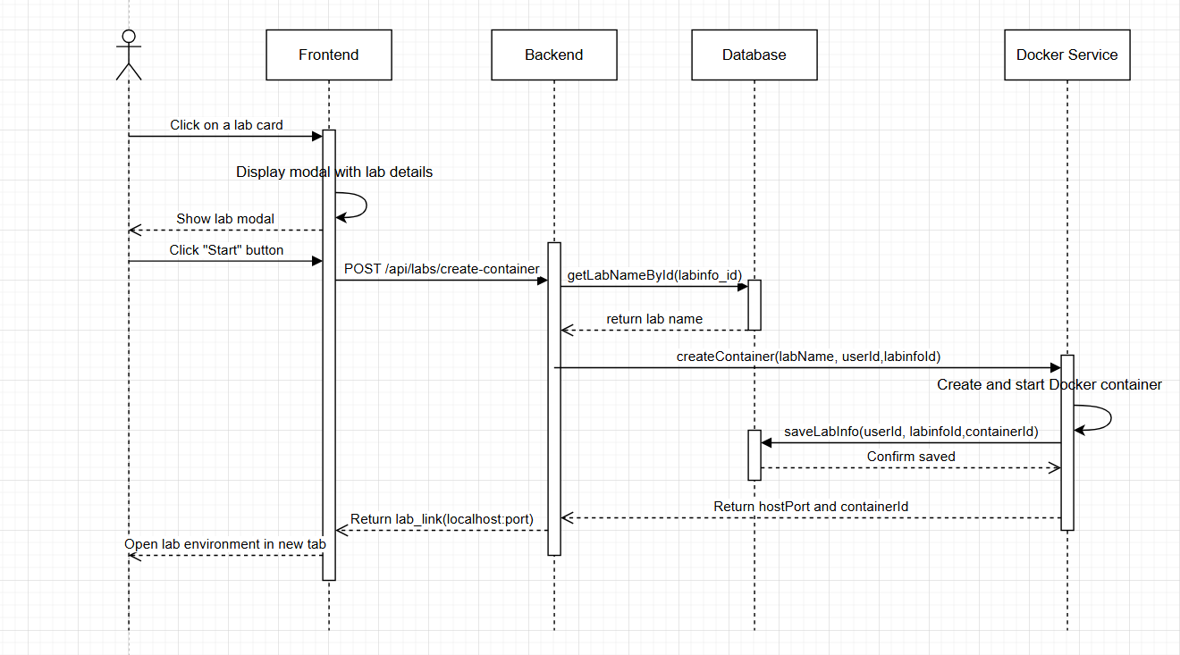
Figure 8. Starting Labs Sequence Diagram

Sequence Diagram 7: Submiting Flags
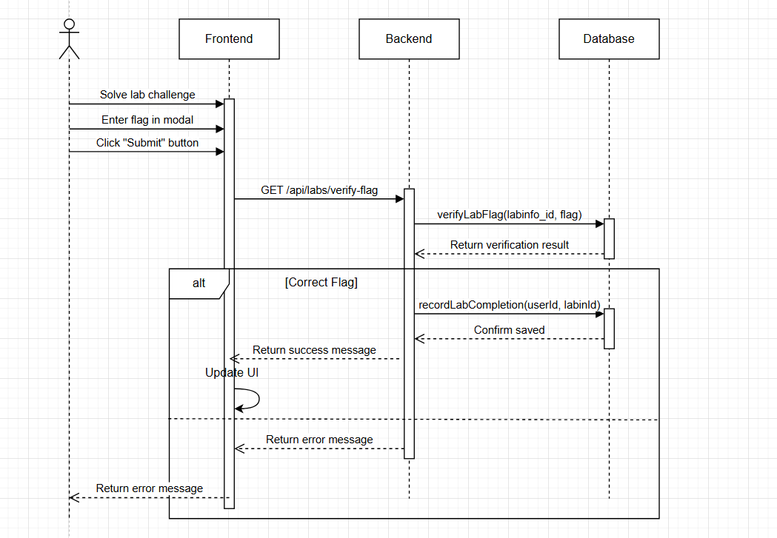
Figure 9. Submitting Flags Sequence Diagram

Sequence Diagram 8: Stopping Labs
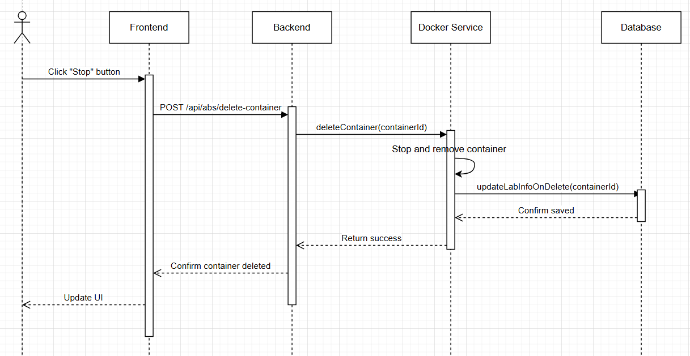
Figure 10. Stopping Labs Sequence Diagram

Sequence Diagram 9: Managing Account
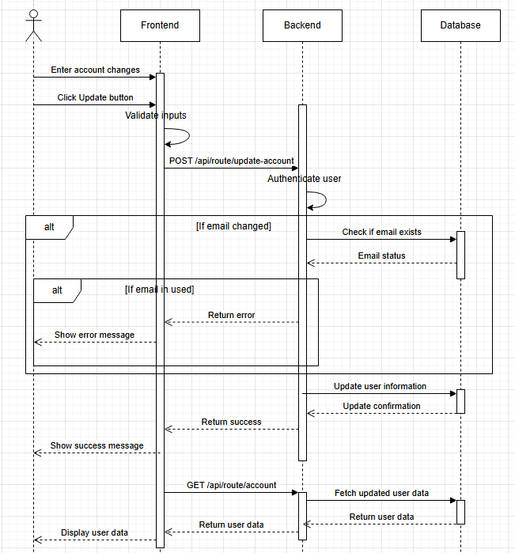
Figure 11. Managing Account Sequence Diagram

Sequence Diagram 10: Creating Lessons
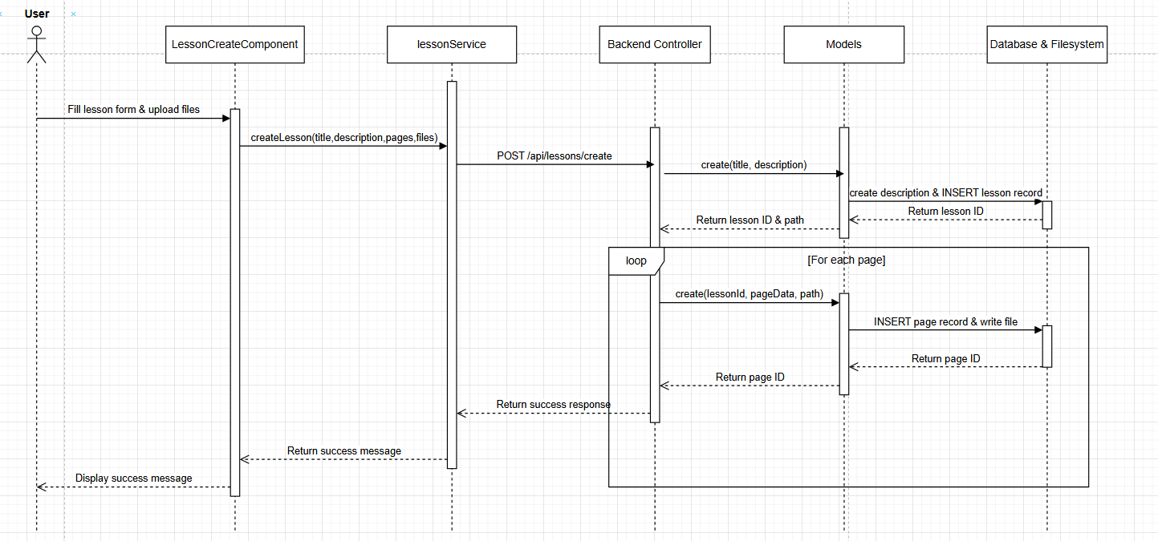
Figure 12. Creating Lessons Sequence Diagram

Sequence Diagram 11: Editing Lessons
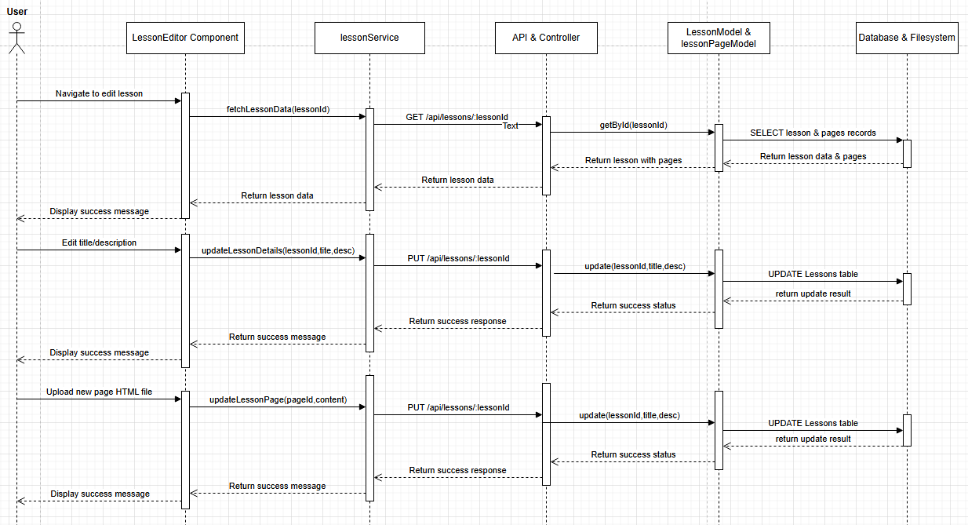
Figure 13. Editing Lessons Sequence Diagram

Sequence Diagram 12: Reset Password
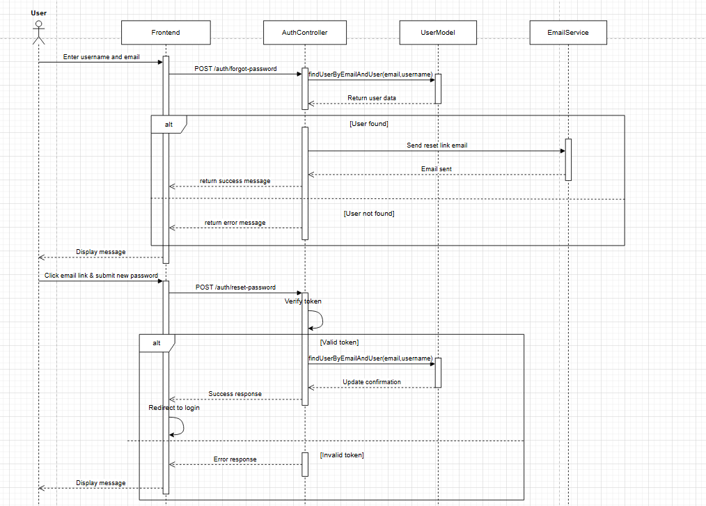
Figure 14. Reset Password Sequence Diagram

Implementation

Authenticate Section:

Login:
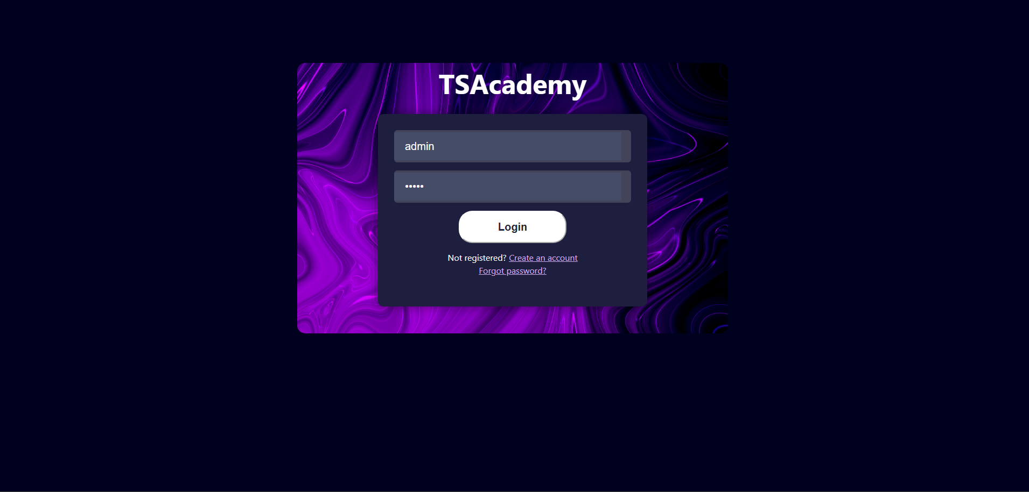
Figure 15. Login Form
If the credential is correct, user will be redirect to homepage.
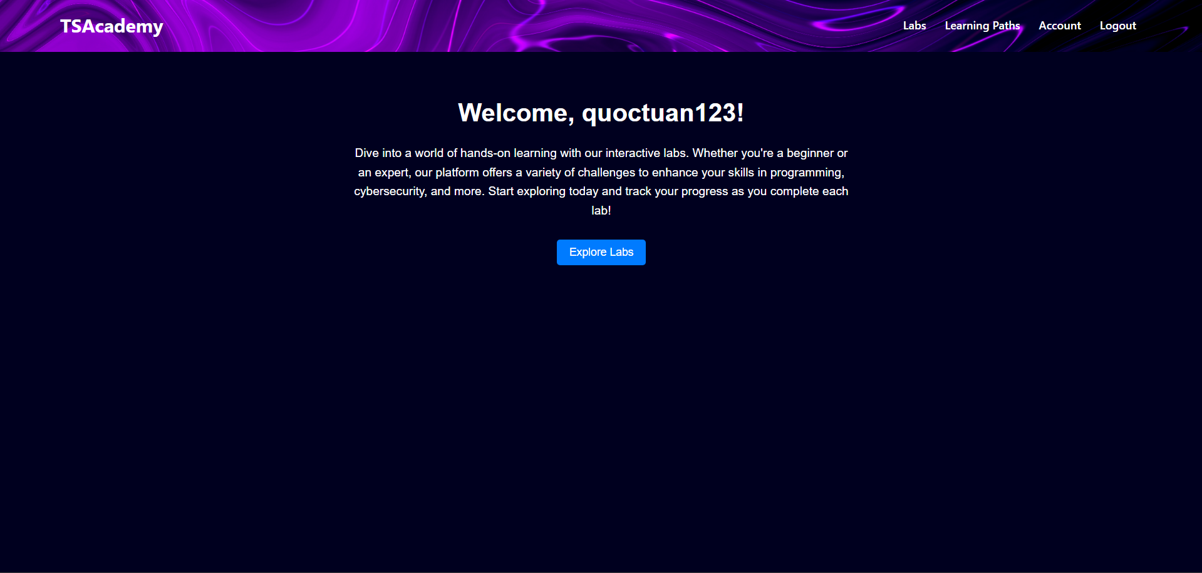
Figure 16. Login Successful

Register Account
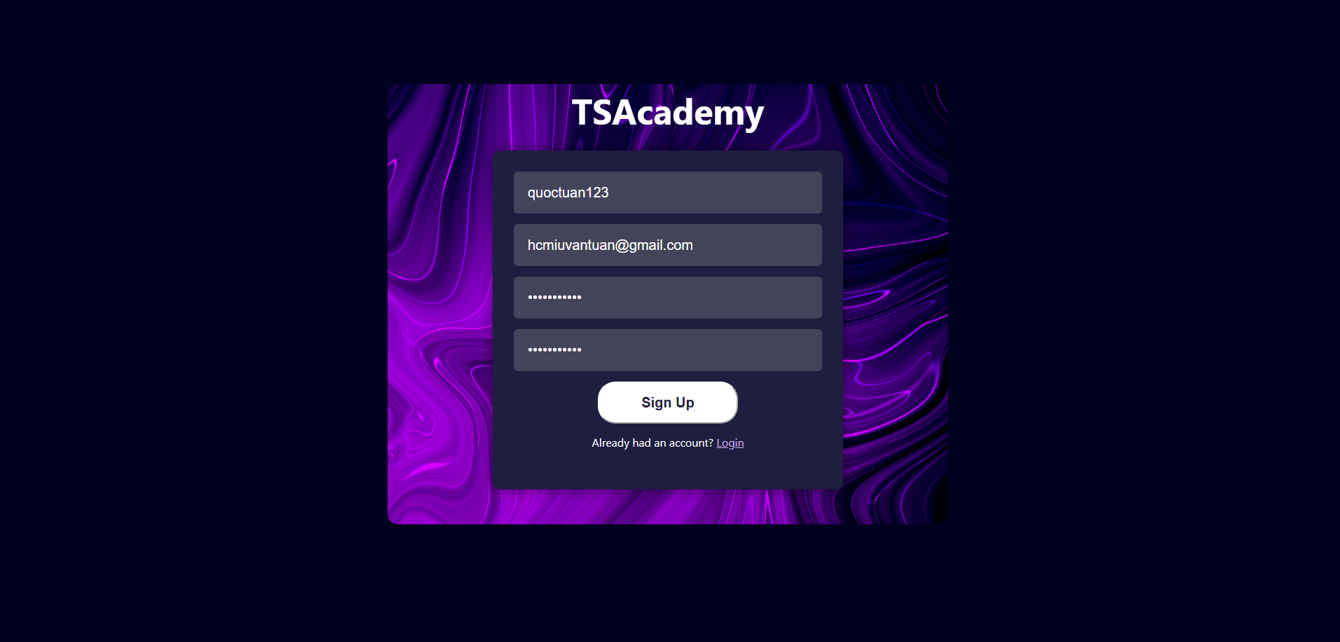
Figure 17. Register Form
If there is not an existing account, it will display success message and redirect to login page.

Reset Password
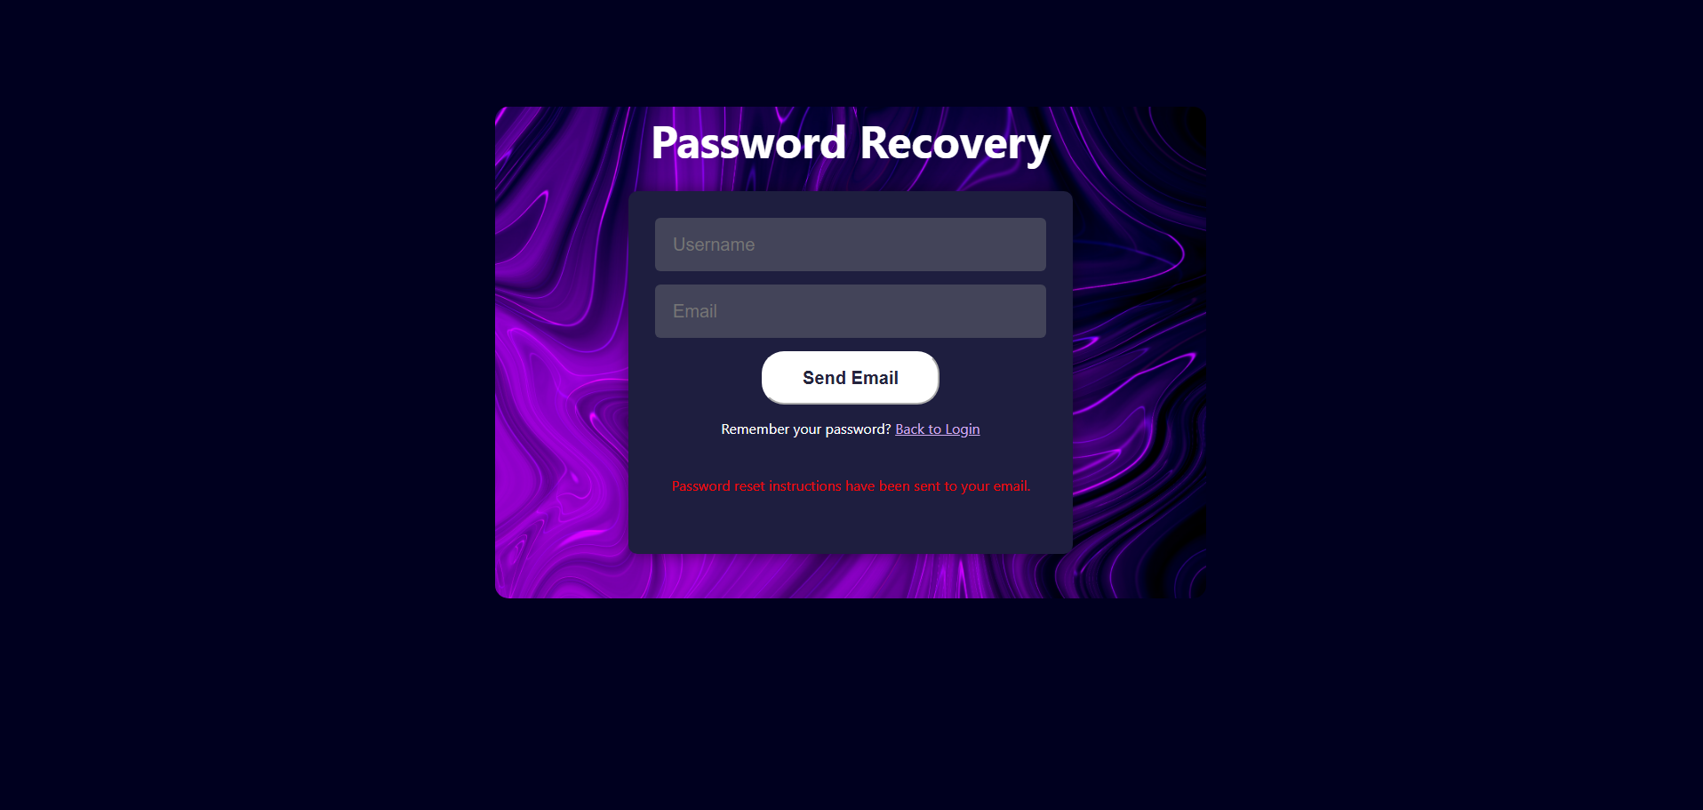
Figure 18. Register Successful
After submitting the right username and email, the server will send a email with a link to reset the password account.
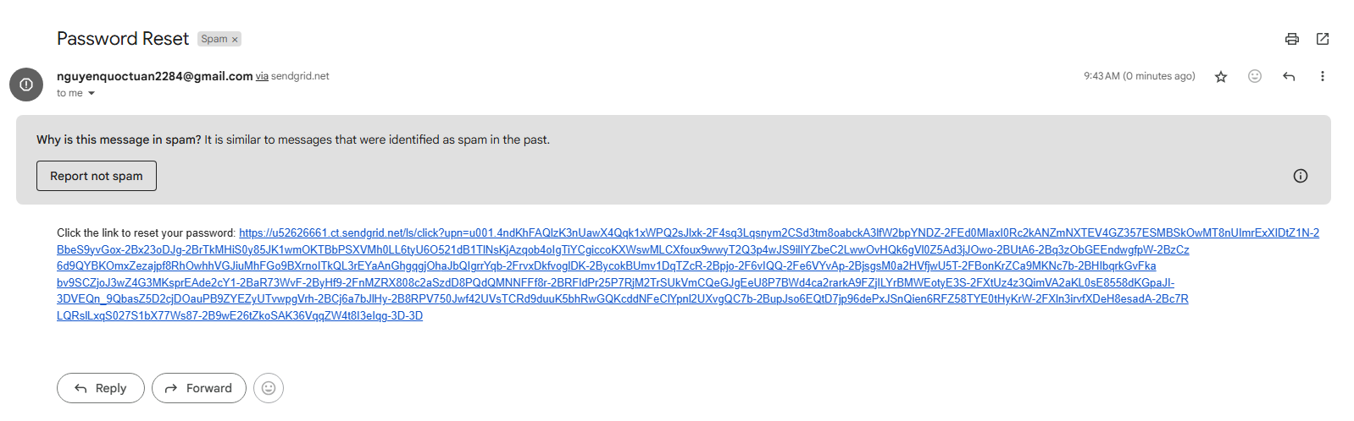
Figure 19. Reset Password Email
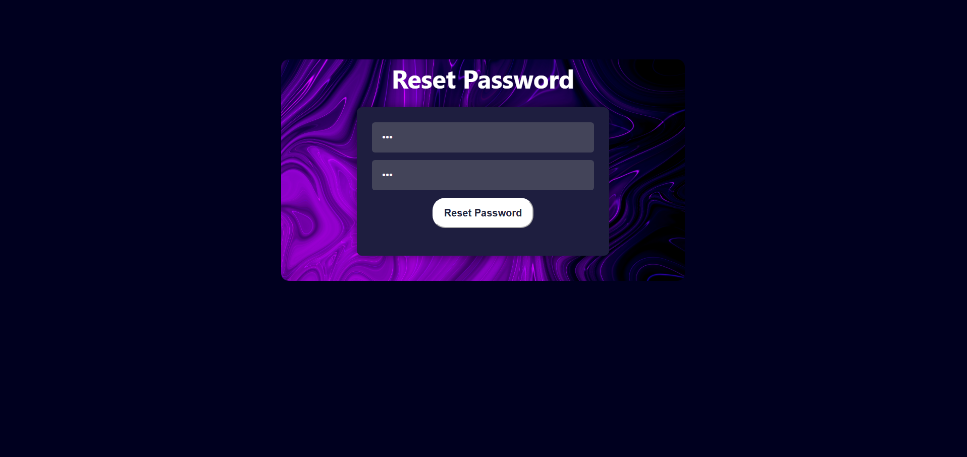
Figure 20. Reset Password Form
Then user will submit the new password then it will redirect to login page.

Labs Section:

Browsing lab:

After click Labs on the Navigate Bar:
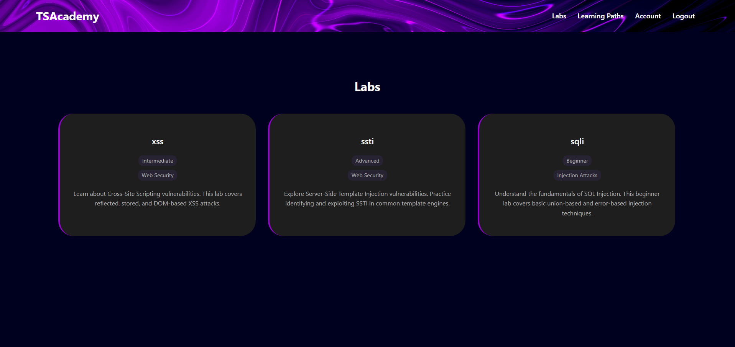
Figure 21. Labs Section

Selecting and Finishing Lab
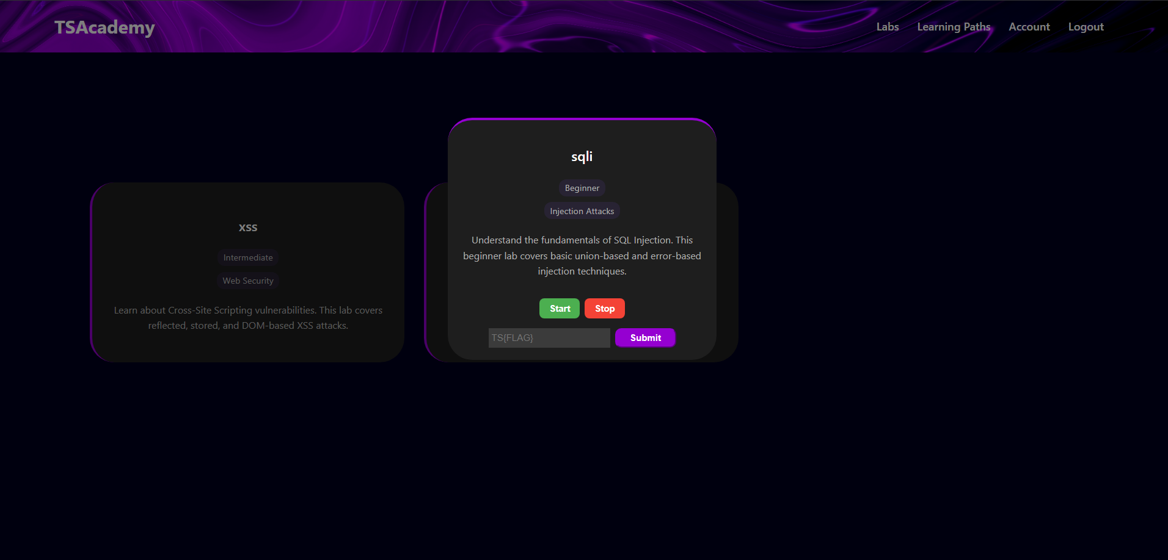
Figure 22. A Lab Card
Clicking one of the labs then press start.
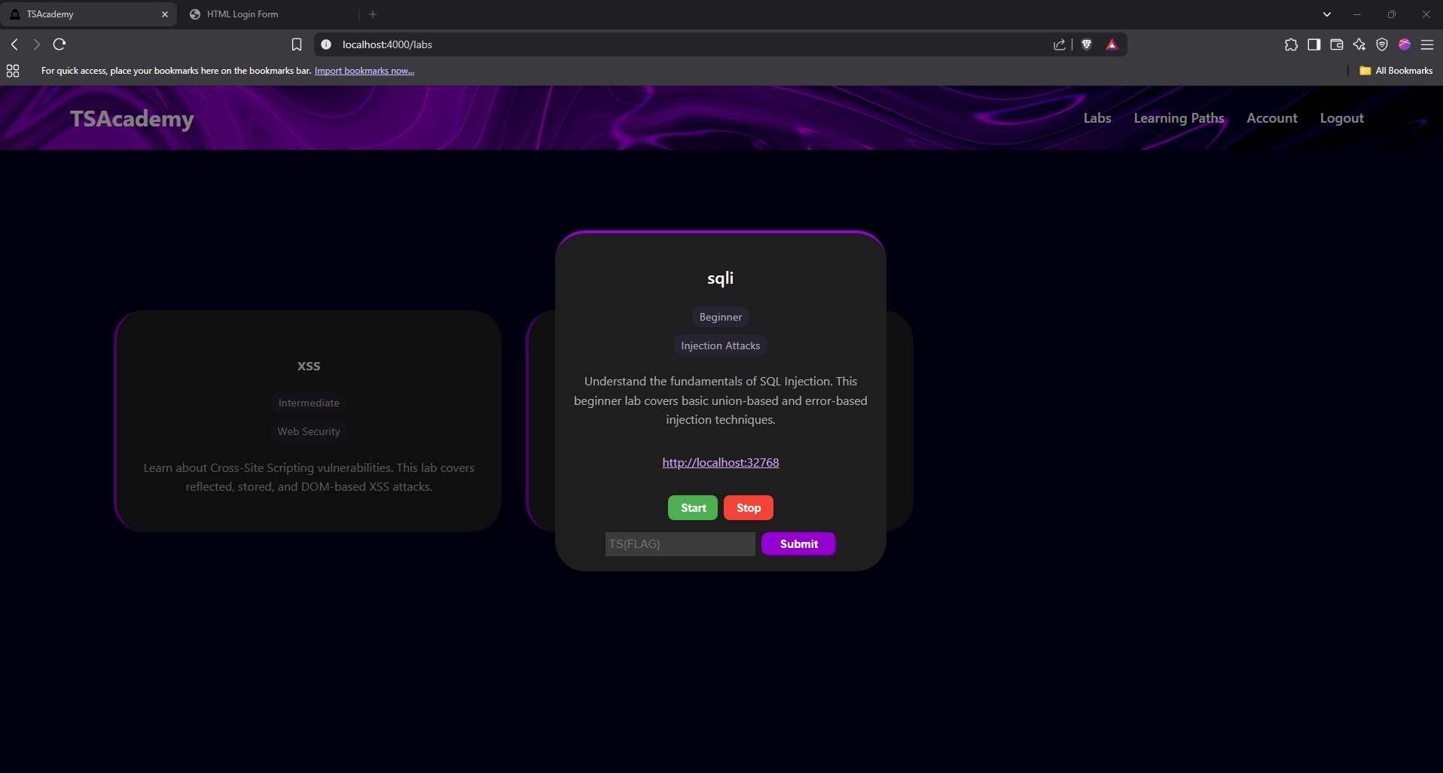
Figure 23. Starting a Lab
The app will open a new window the url of the lab and also display the url of the lab in the lab card.
The lab will stop after clicking stop button or will automatically stop after a period of time.
After solving the lab, submit the flag into the input area then submit.
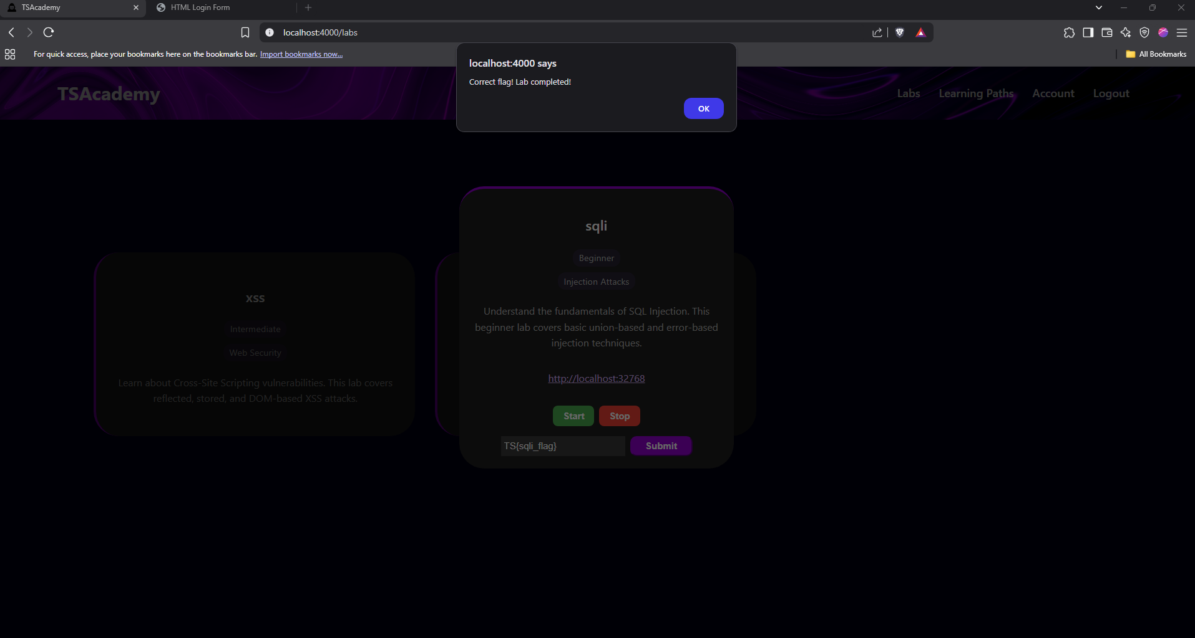
Figure 24. Submitting Flag
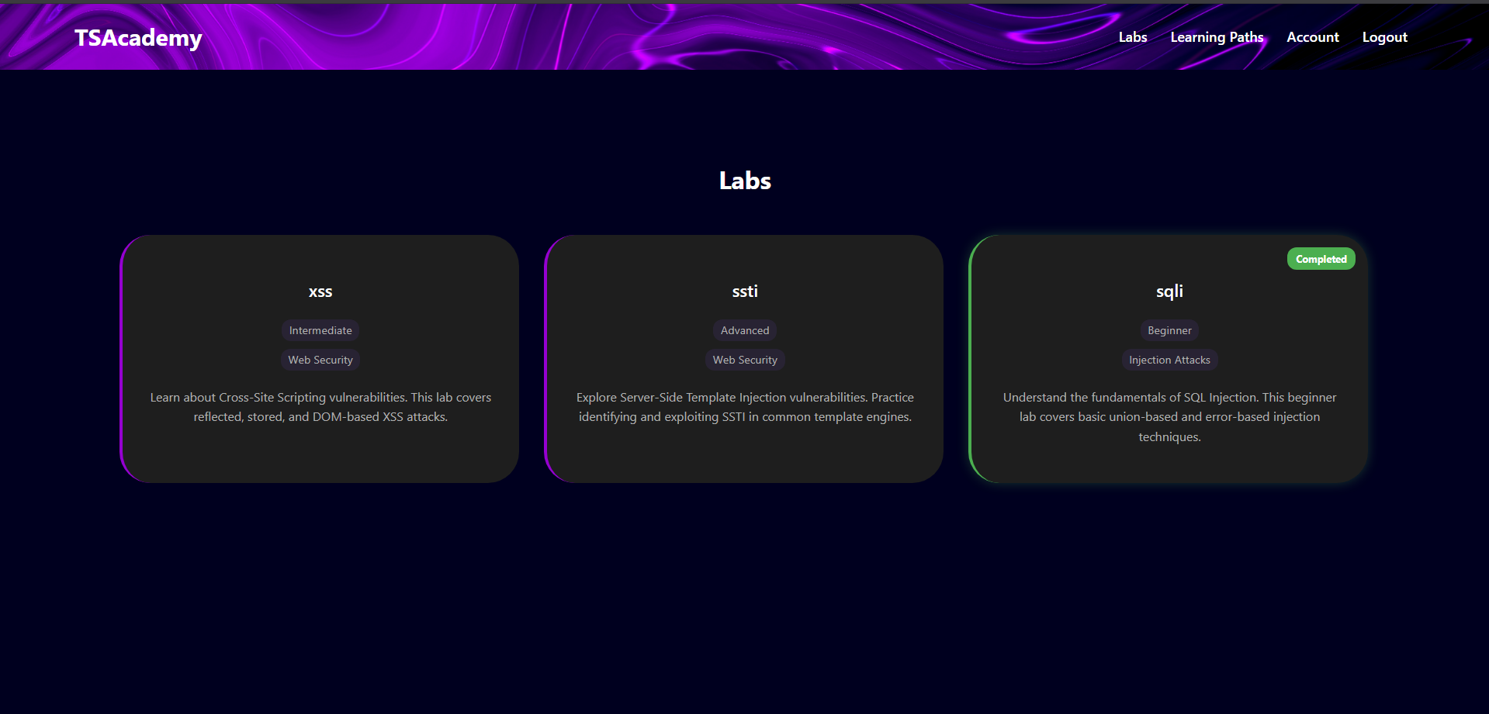
Figure 25. A completed Lab

Lessons Section:

Browsing Lessons:
After clicking on Learning Paths on the navigate bar
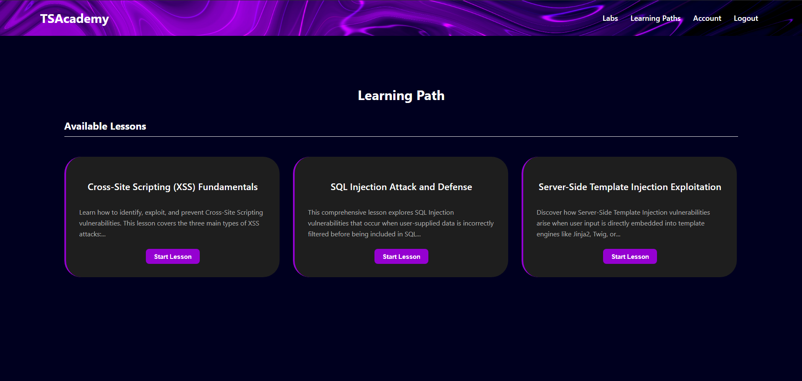
Figure 26. Lessons Section

Starting Lessons
Start one of the lessons
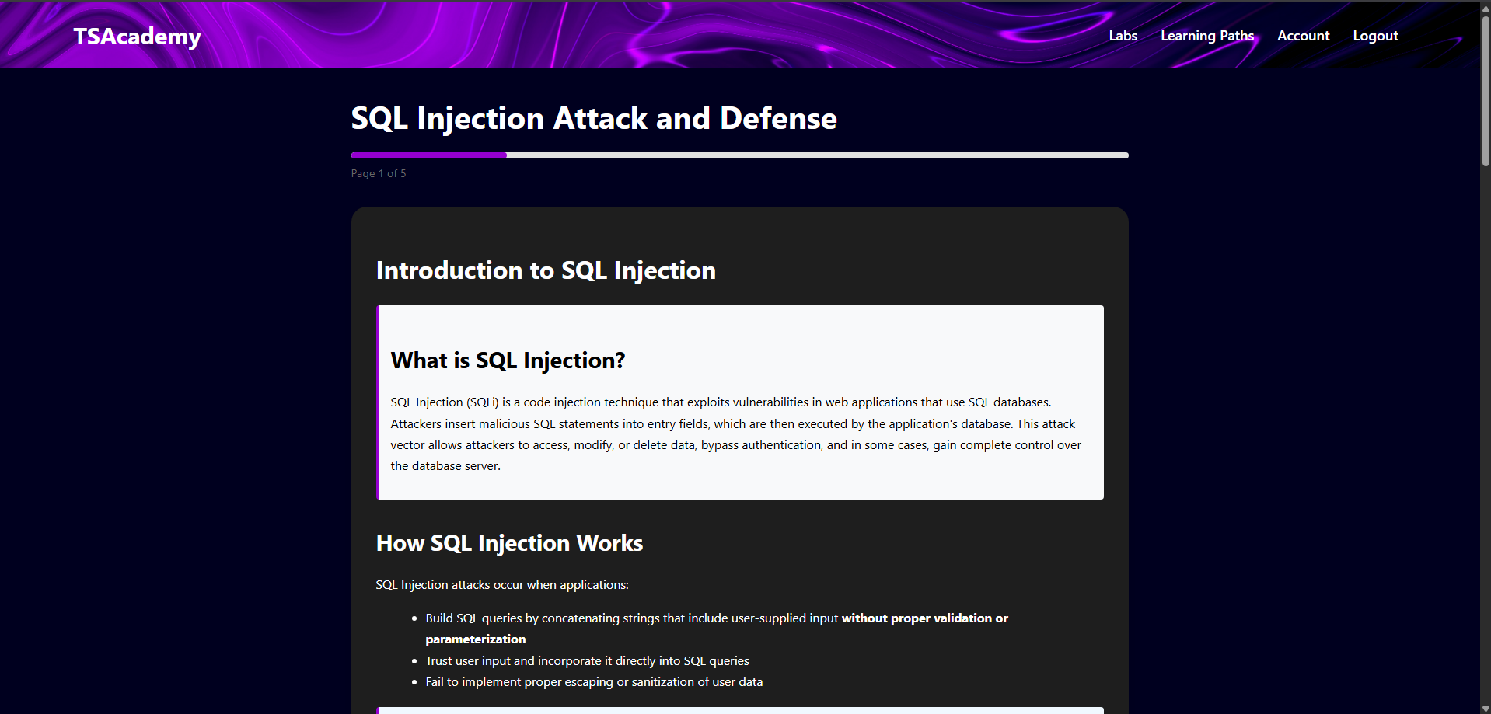
Figure 27. An example page
Click next at the end of the page to move to the next page. This also record the progress of the user for the next time access the lesson, it will start at the page were left at.
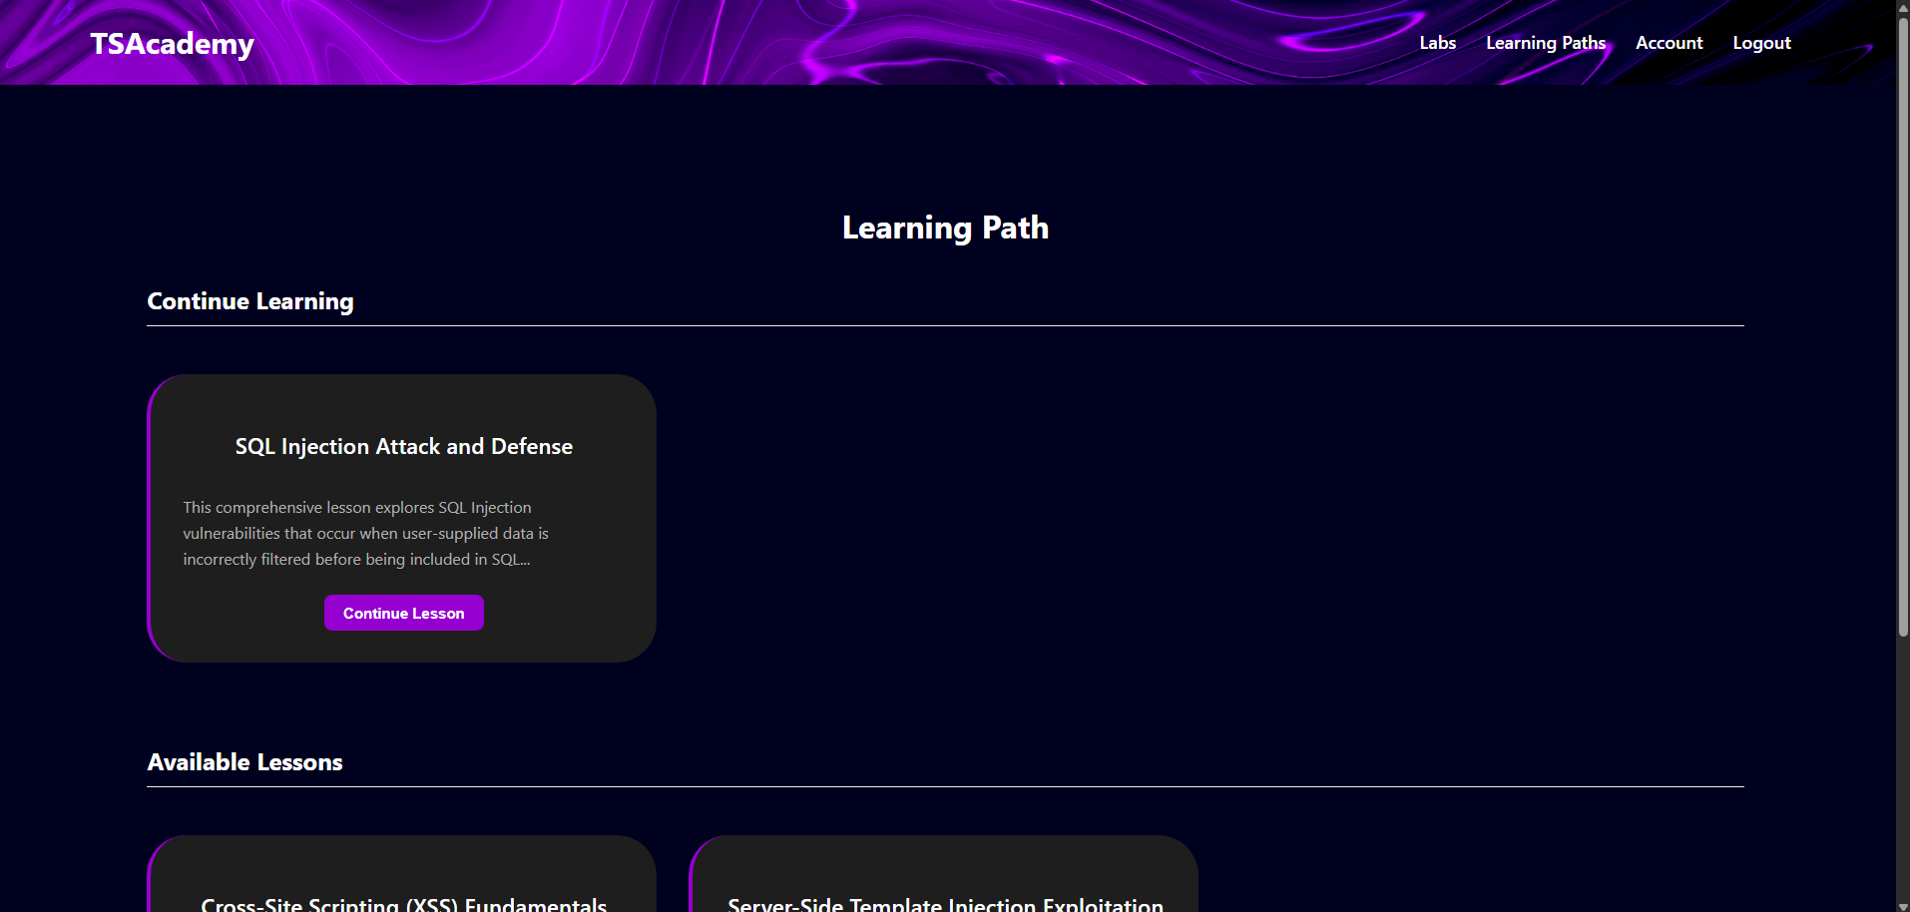
Figure 28. A Unfinished Lesson
Complete the lesson by pressing complete button at the end of the lesson.
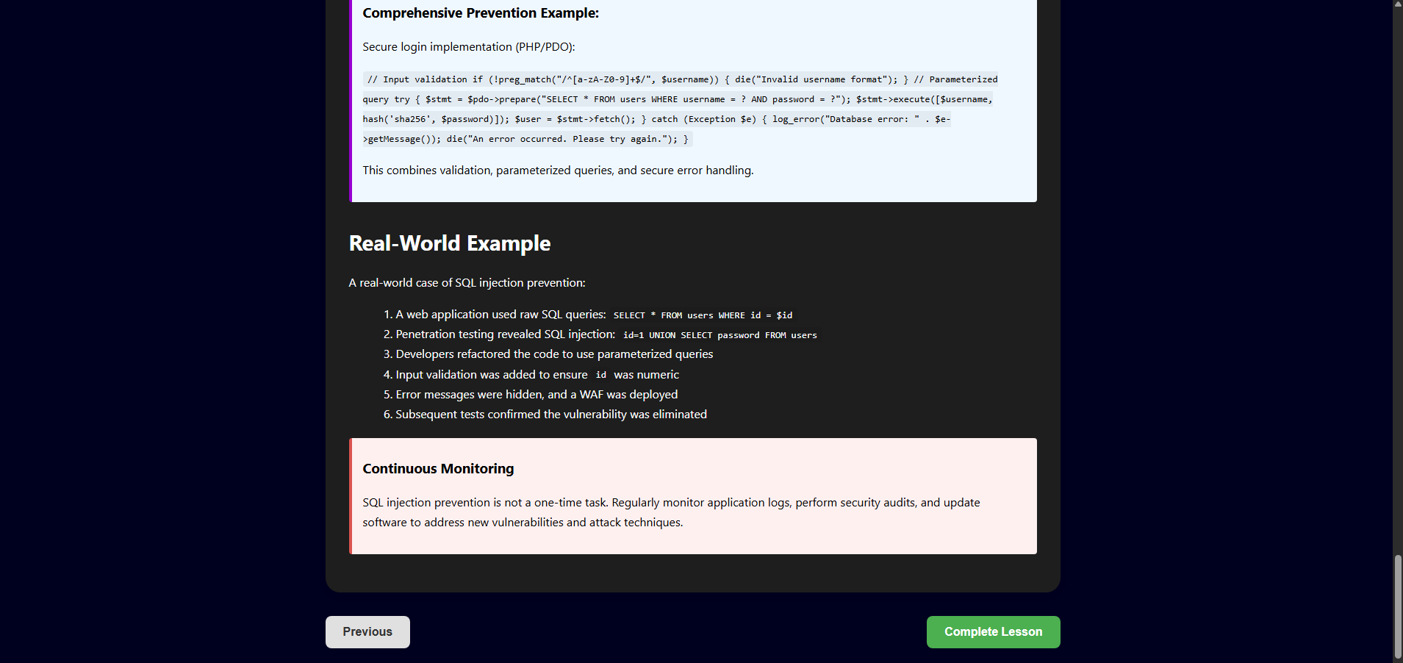
Figure 29. Completing a Lesson
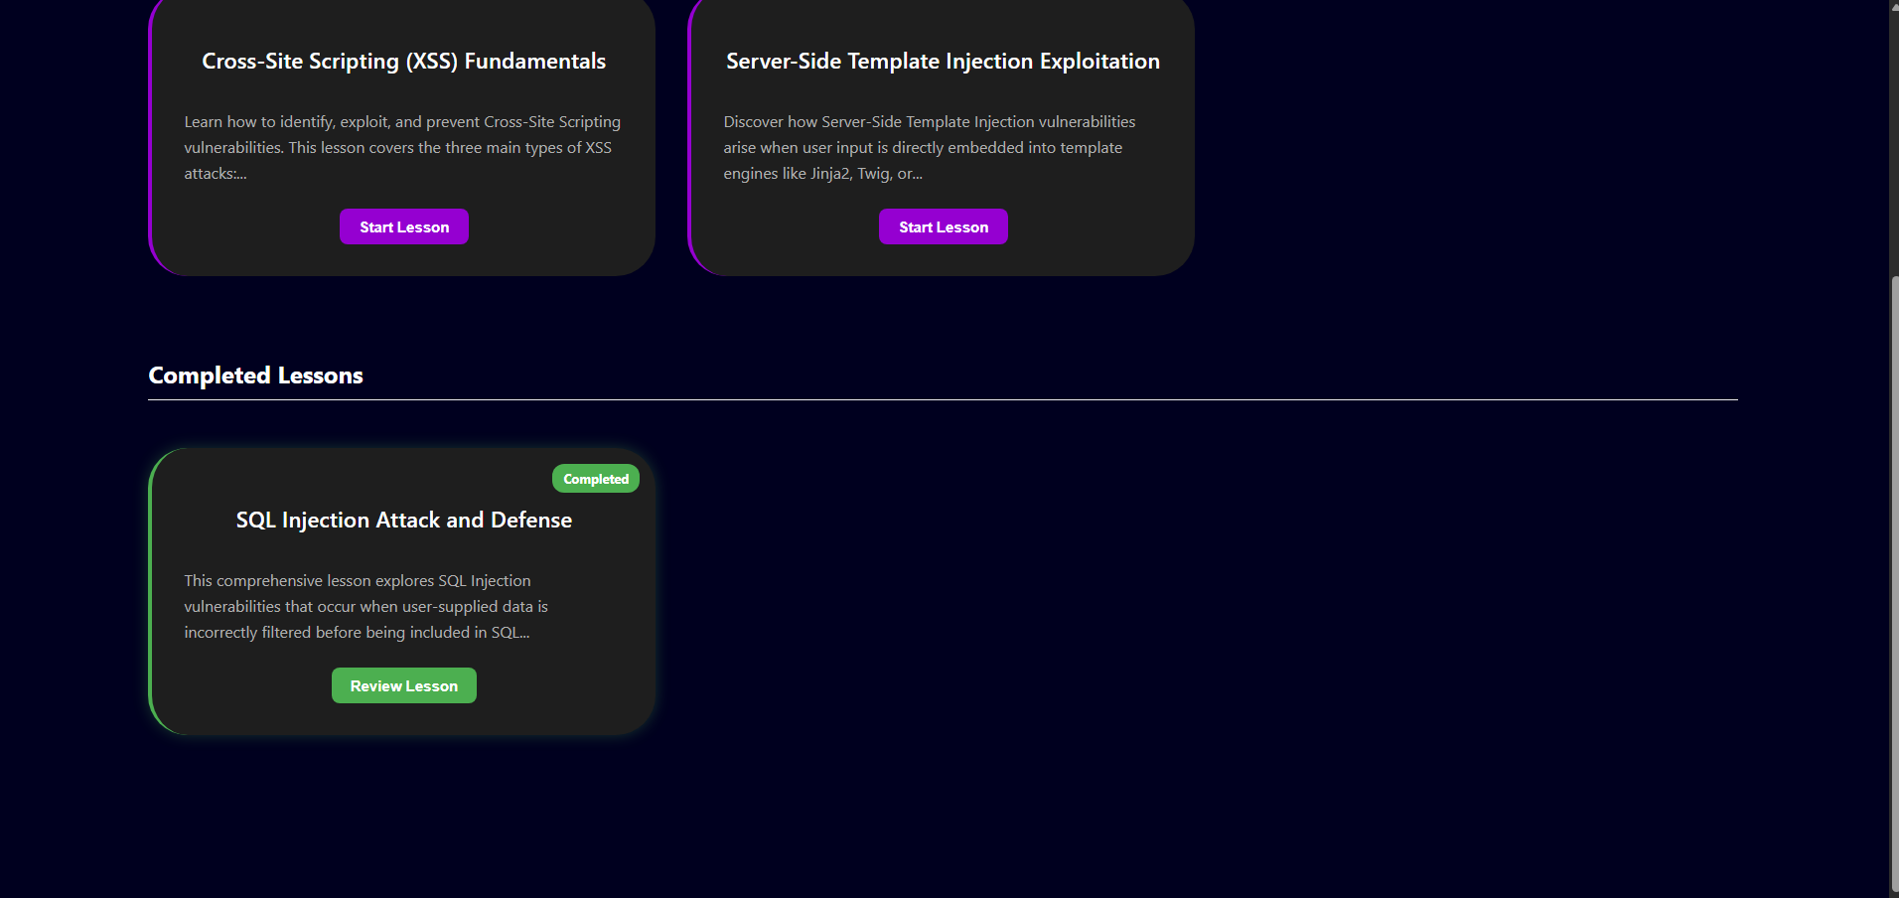
Figure 30. A completed Lesson

Account Section

Updating account
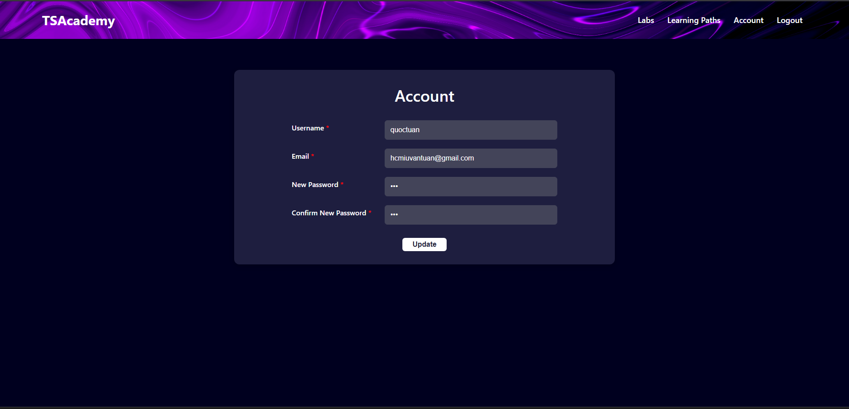
Figure 31.Editting Account Form
Input the value that needs to be update then click update.

Admin Section
After login as admin account:
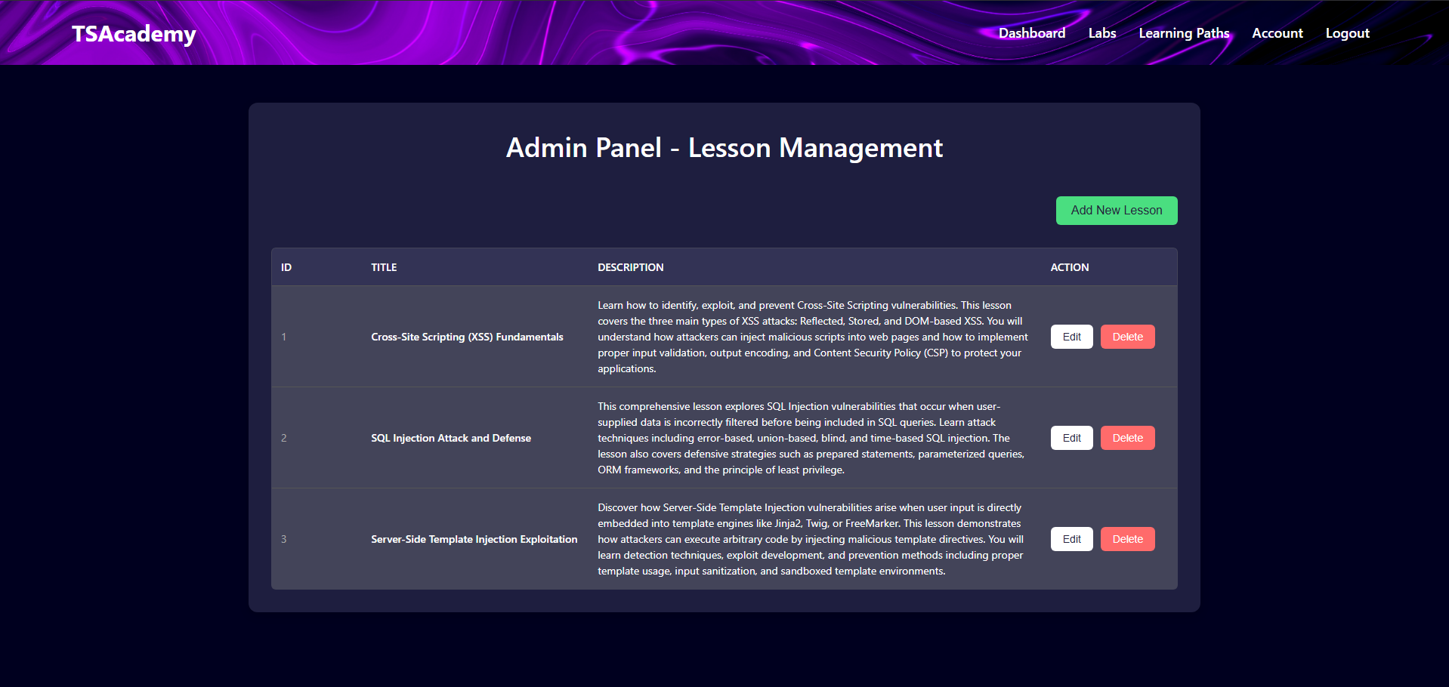
Figure 32. List of Lessons

Creating Lesson:
Input title, description.
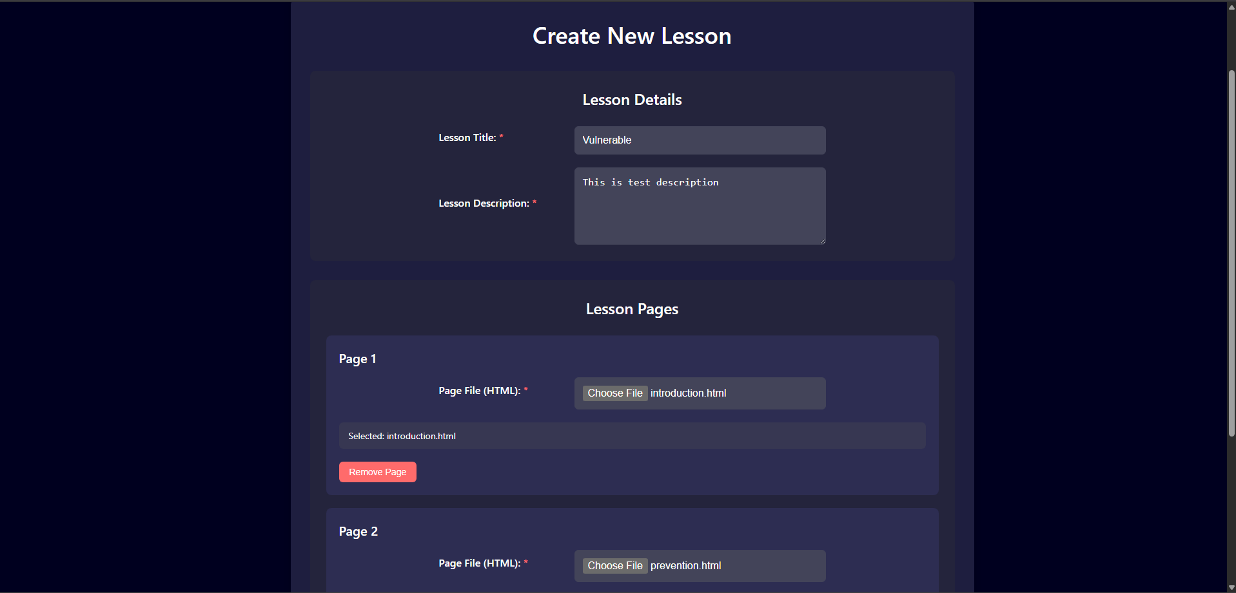
Figure 33. General Information of a Lesson
Upload html for each page
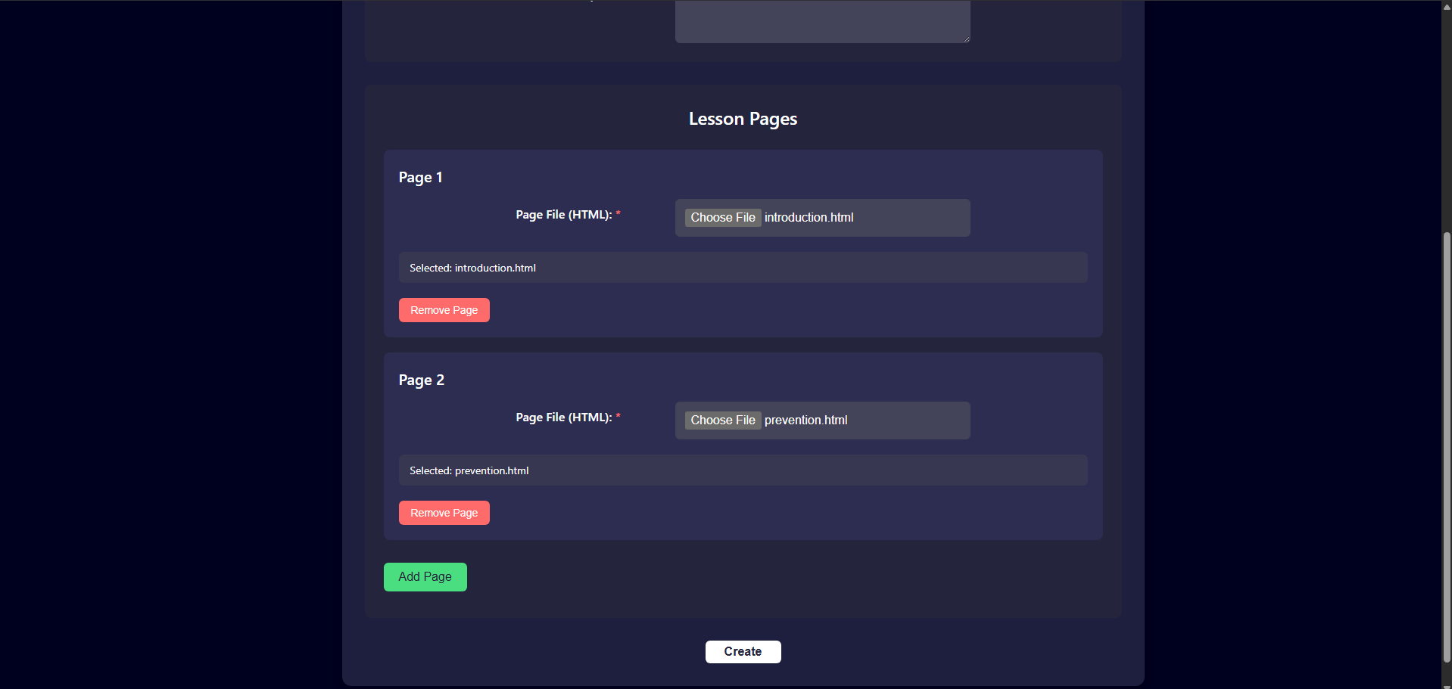
Figure 34. Pages of Lesson Section
After finish upload files, click Create. Then the server will display a success message. Now click back on Dashboard, the new lesson will appear.
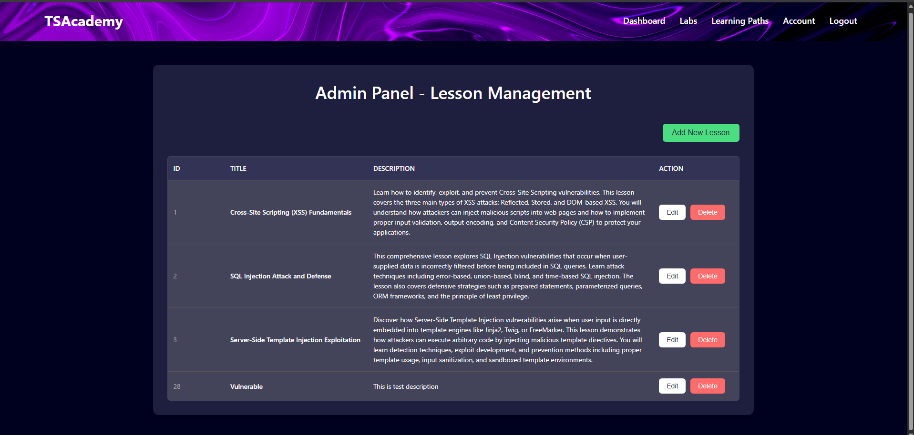
Figure 35. Creating a Lesson successful

Editing Lessons
Click edit in one of the lessons
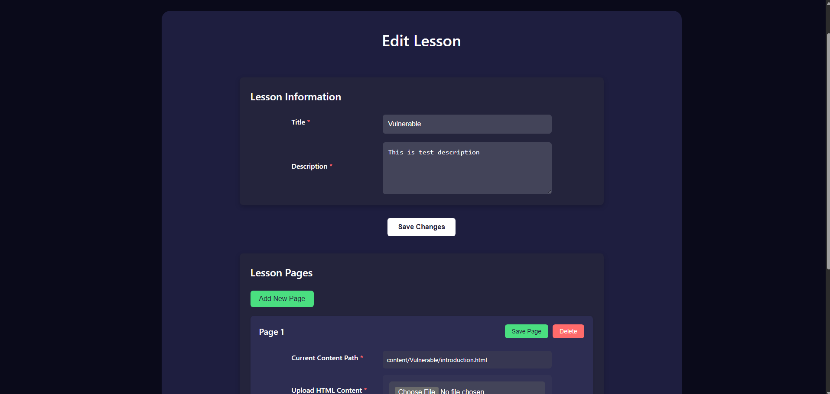
Figure 36. Editting Lesson Section
Changing the Lesson Information then click Save Changes to change the title and description.
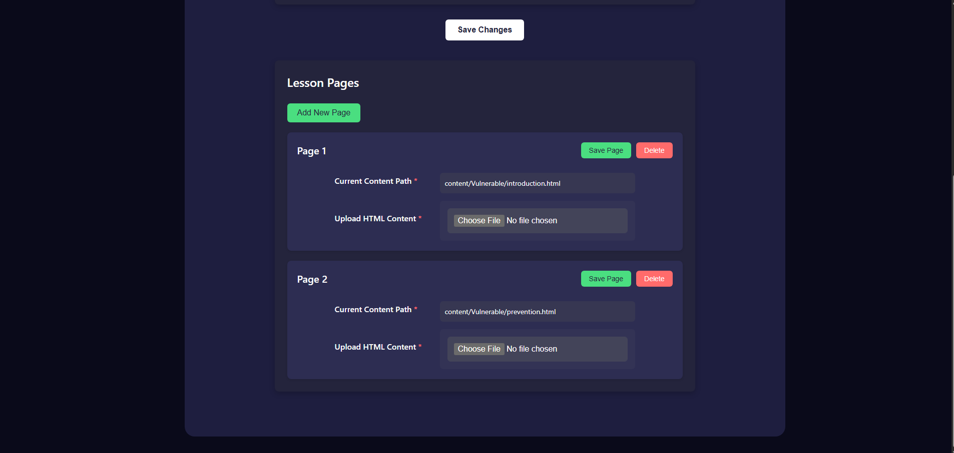
Figure 37. Editting Pages
Adding new page or change the existing pages by upload new html file. Then press Save Page for each page.
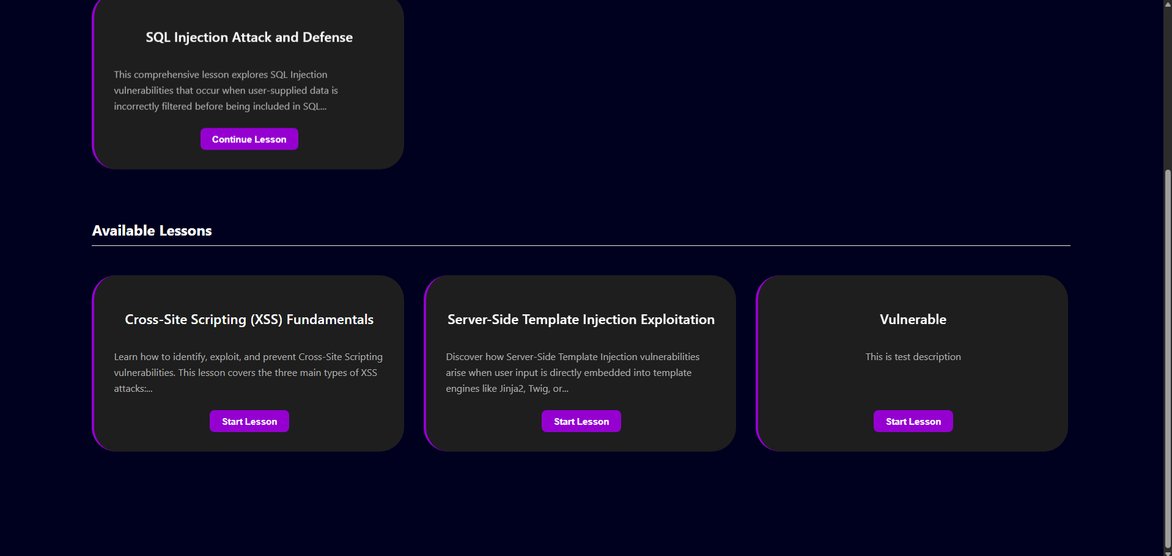
Figure 38. Editting Lesson successful
Checking the new lesson
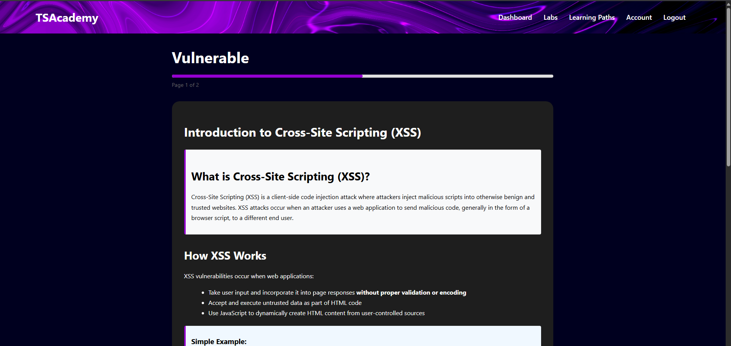
Figure 39. Editted Lesson

Discussion and conclusion
This project aimed to develop a comprehensive online learning platform focused specifically on cybersecurity education. In today's increasingly digital world, the demand for cybersecurity professionals continues to grow exponentially, creating a significant skills gap in the industry. Our platform represents a strategic response to this challenge by providing accessible, interactive, and up-to-date cybersecurity training content for learners at various skill levels. The web application leverages modern technologies and pedagogical approaches to create an engaging learning environment that prepares users for real-world cybersecurity scenarios.

Challenges Encountered
Despite careful planning, several challenges emerged during development. The creation of realistic yet controlled sandbox environments for practical exercises presented technical difficulties, particularly in balancing system security with the need for realistic training scenarios. Ensuring content remained current in the rapidly evolving cybersecurity landscape also proved challenging. Our solution involved implementing an agile content management system that facilitates regular updates.

Future Work
Expanding the range of specialized topics would increase the platform's utility for professionals seeking to develop expertise in specific security domains. Incorporating emerging technologies such as augmented reality could further enhance the realism and effectiveness of practical training scenarios.

AI-Powered Personalized Feedback Systems
A significant planned enhancement is the integration of artificial intelligence to provide personalized feedback for each user. This AI-driven system would analyze user interactions, code submissions, and exercise completions to offer tailored guidance beyond what predetermined response patterns can provide. The system could identify specific misconceptions, suggest alternative approaches to problems, and highlight areas for improvement in a learner's security methodology. This personalized feedback loop would substantially enhance the educational experience by mimicking the individualized attention of a human instructor while scaling across thousands of users simultaneously.

Advanced Laboratory Environments
Future work includes developing an expanded suite of specialized laboratory environments that simulate diverse cybersecurity scenarios with greater fidelity. These enhanced labs would include:
- Advanced Penetration Testing Environments: Configurable network topologies with various vulnerabilities that adapt based on user skill level
- Security Operations Center (SOC) Simulation: Real-time threat detection and incident response scenarios using industry-standard tools
- Secure DevOps Pipeline Labs: Environments to practice implementing security throughout the software development lifecycle
- Threat Hunting Workshops: Dynamic environments populated with subtle indicators of compromise for users to discover
- Forensic Analysis Laboratories: Comprehensive digital forensics scenarios with realistic artifacts and evidence chains

References
- Portswigger. (2018). Web Application Security, Testing, & Scanning. Portswigger.net. https://portswigger.net/
- Node.js v20.2.0 Documentation. (n.d.). Nodejs.org. https://nodejs.org/docs/latest/api/
- ‌Docker. (2019, October 31). Docker Documentation. Docker Documentation. https://docs.docker.com/
- ‌GeeksforGeeks. (2022, March 21). MVC Framework Introduction. GeeksforGeeks. https://www.geeksforgeeks.org/mvc-framework-introduction/
- ‌jwt. (2024). JWT.IO - JSON Web Tokens Introduction. Jwt.io. https://jwt.io/introduction
- ‌Meta Open Source. (2025). React. React.dev. https://react.dev/
- Node.js Tutorial for Beginners: Learn Node in 1 Hour | Mosh. (2018). [YouTube Video]. In YouTube. https://www.youtube.com/watch?v=TlB_eWDSMt4
- ‌Programming with Mosh. (2023, March 12). React Tutorial for Beginners. Www.youtube.com. https://www.youtube.com/watch?v=SqcY0GlETPk
- ‌MySQL :: MySQL 8.4 Reference Manual. (n.d.). Dev.mysql.com. https://dev.mysql.com/doc/refman/8.4/en/
- SendGrid | SendGrid Docs | Twilio. (2024). Twilio.com. https://www.twilio.com/docs/sendgrid

‌

