**Conceptual Question:**

False

Counter example:

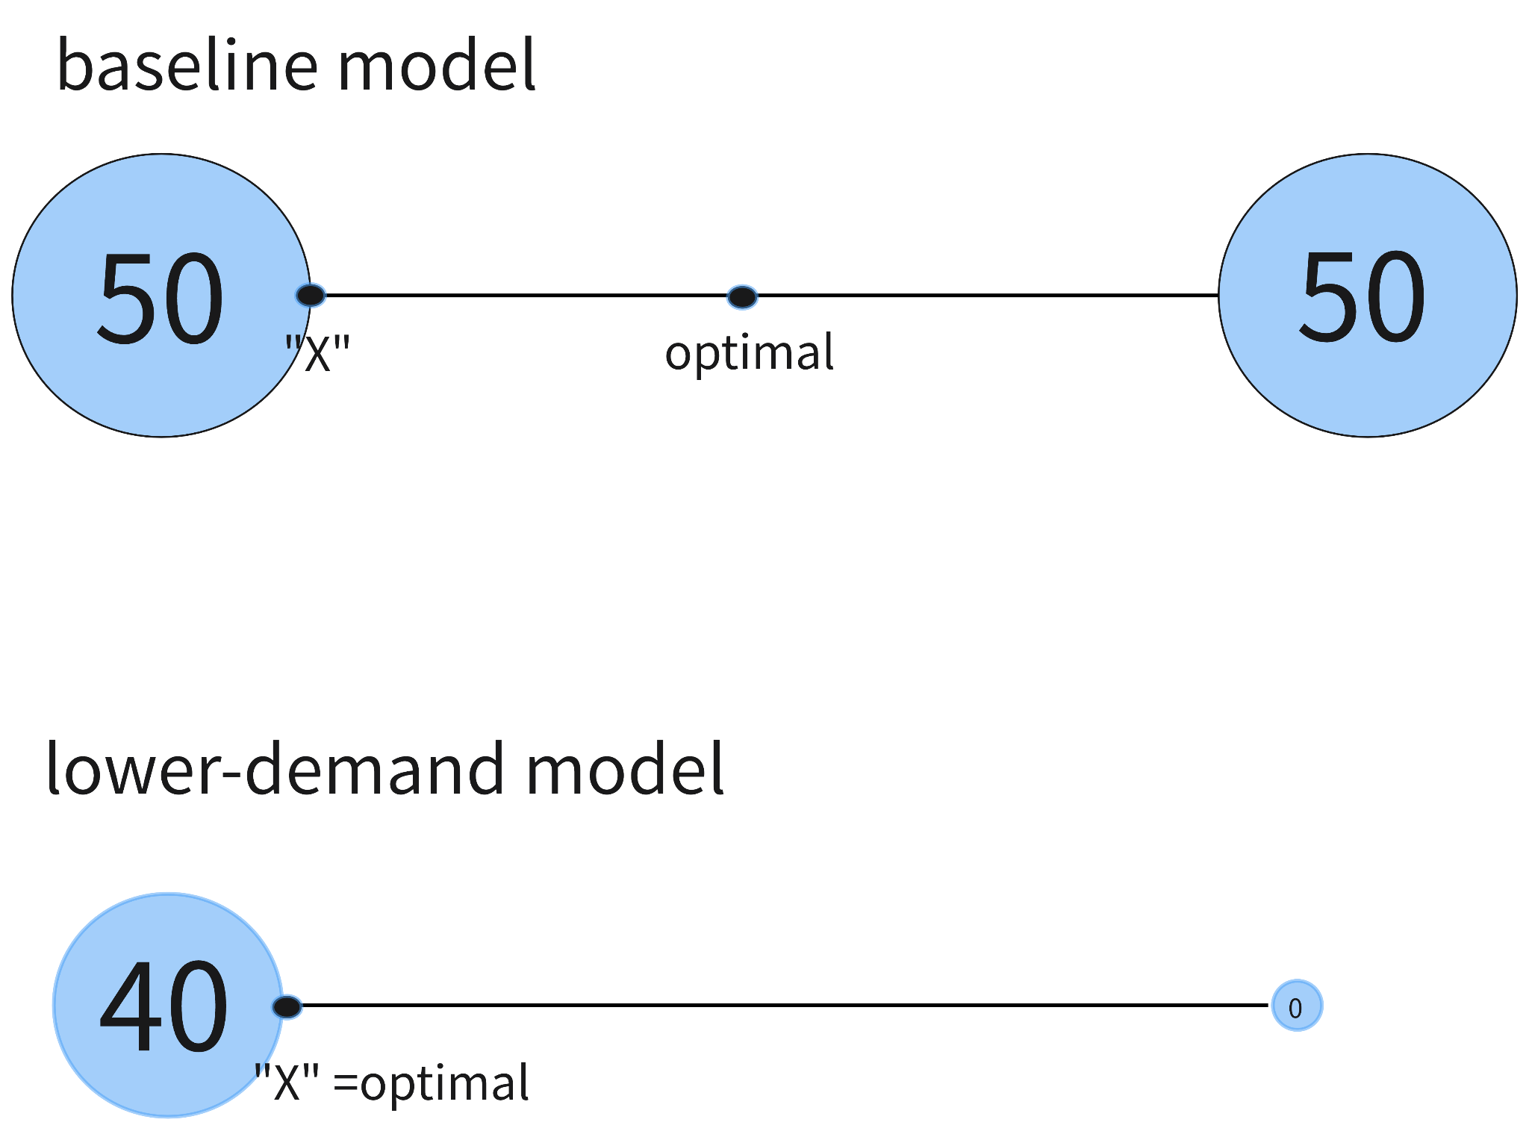

Let’s consider an extreme condition, only the building at X has burrito demands. In this case, X is the optimal solution.

**Application question:**

The whole analysis process and optimization scheme are written in the jupyter notebook.