**Question 1:**

This is prototype of flow of screen in book store or I will give you my linked file: [Bookstore Website UI Prototype – FigJam](https://www.figma.com/board/wYs0DzshcUdMlvHHWQeHYL/Bookstore-Website-UI-Prototype?node-id=0-1&p=f&t=wBsLvMTMziQ4zQWp-0)

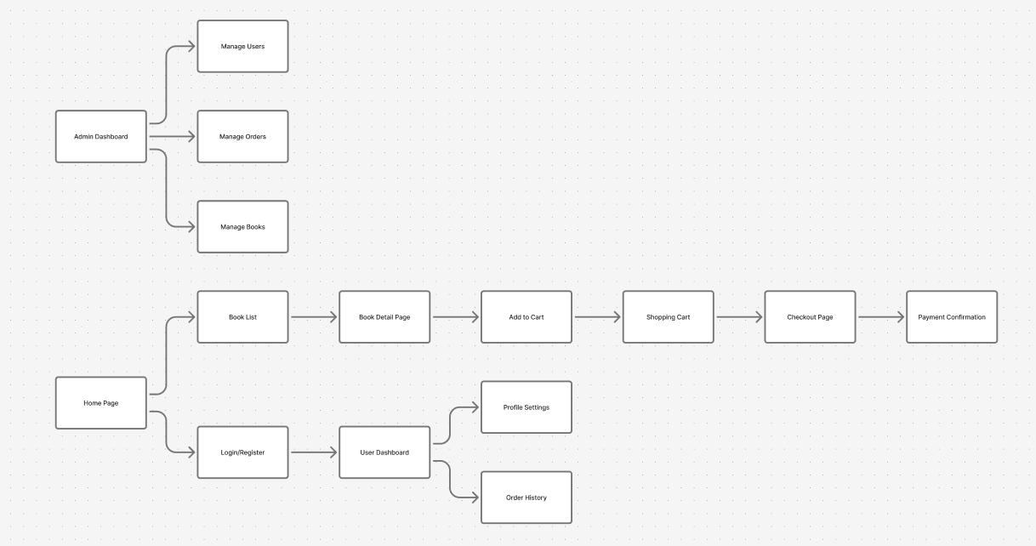

This is use case diagram for these and with link ([Use case diagram](https://drive.google.com/file/d/1NmAkpYmeLiimOyWKuCiUICSJCttZPM1u/view?usp=sharing)):

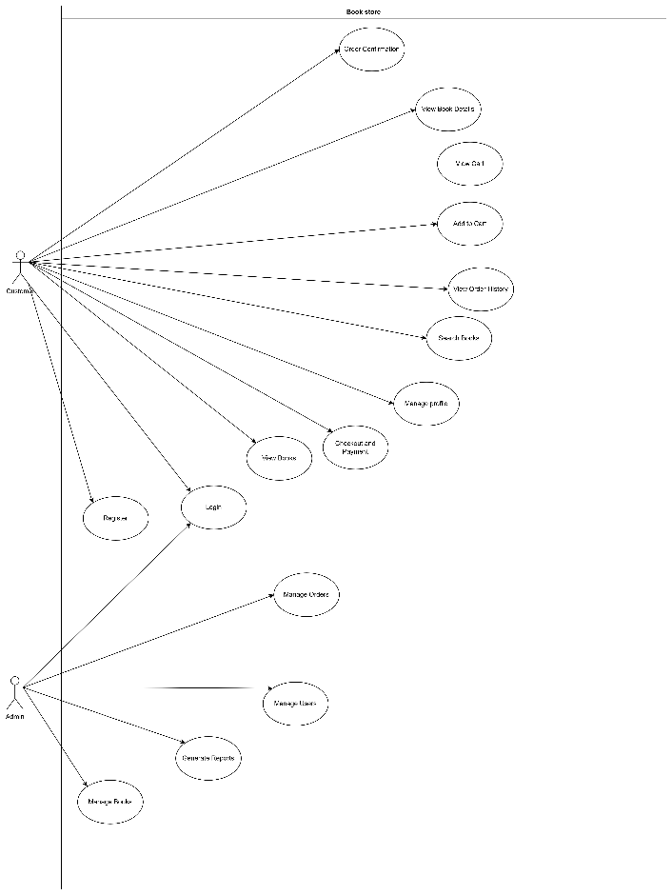

**Question 2:**

Products backlog:

The priority will start from P1 to P3 with P1 is lowest and P3 is largest

|  |  |  |  |  |
| --- | --- | --- | --- | --- |
| **ID** | **User Story** | **Description** | **Priority** | **Category** |
| PB1 | View Books | As a customer, I want to view a list of books so that I can browse available items. | P1 | Customer |
| PB2 | Search Books | As a customer, I want to search for books by title, author, or category. | P1 | Customer |
| PB3 | View Book Details | As a customer, I want to see detailed information about each book (price, author, description). | P1 | Customer |
| PB4 | Add to Cart | As a customer, I want to add selected books to my cart. | P1 | Customer |
| PB5 | View Cart | As a customer, I want to review the items in my shopping cart and total cost. | P1 | Customer |
| PB6 | Checkout & Payment | As a customer, I want to make secure payments for my orders. | P1 | Customer |
| PB7 | Order Confirmation | As a customer, I want to receive confirmation after completing my payment. | P2 | Customer |
| PB8 | View Order History | As a customer, I want to view my past orders and their statuses. | P2 | Customer |
| PB9 | Login / Register | As a customer, I want to register and log in to my account to track my orders. | P1 | Customer |
| PB10 | Manage Profile | As a customer, I want to update my personal details (name, phone, address, etc.). | P2 | Customer |
| PB11 | Manage Books | As an admin, I want to add, edit, or delete books in the system. | P1 | Admin |
| PB12 | Manage Orders | As an admin, I want to view and update order statuses (e.g., pending, shipped, completed). | P1 | Admin |
| PB13 | Manage Users | As an admin, I want to view and manage customer accounts (activate, deactivate). | P2 | Admin |
| PB14 | Generate Reports | As an admin, I want to generate sales and performance reports. | P2 | Admin |
| PB15 | Admin Authentication | As an admin, I want secure login and logout access. | P1 | Admin |
| PB16 | Responsive Design | As a user, I want the website to work well on mobile and desktop devices. | P3 | General |

**Question 3:**

Refer to BookStore_TestCases.xlsx