Lifecycle Aware and Evidence Grounded Retrieval Augmented Generation for Airworthiness Directive Question Answering
Anonymous Author(s)
Affiliations withheld for double-blind review
Abstract. Airworthiness Directives (ADs) are mandatory safety publications whose applicability, compliance times, revisions, and referenced maintenance data must be interpreted accurately. Conventional retrieval-augmented generation (RAG) can improve access to such documents, but safety-critical use additionally requires lifecycle awareness, source fidelity, leakage-controlled evaluation, and explicit abstention when evidence is insufficient. This paper presents a three-layer document-intelligence architecture for Airbus S.A.S. ADs issued by the European Union Aviation Safety Agency (EASA). Layer A builds a deterministic corpus manifest, preserves document lifecycle relationships, and creates verified page-level, section-aware source content. Layer B uses known-document routing or identifier-free discovery, hybrid BM25 and Qwen3 dense retrieval with reciprocal-rank fusion, Qwen3 reranking, and top-five evidence assembly. Layer C generates structured answers only from retrieved passages and validates every evidence identifier before display. On a locked 40-question final benchmark, the system achieved 97.22% Recall@5 on answerable questions and 95.0% strict end-to-end semantic accuracy. A separate five-document unseen evaluation achieved 100% Recall@5 after isolated ingestion, with 13 semantic passes, one semantic failure, and one provider failure across 15 questions. The results show that evidence-grounded RAG can support regulatory knowledge work while keeping document provenance and failure boundaries explicit.
Keywords: Airworthiness Directives · Aviation Maintenance · Retrieval-Augmented Generation · Information Retrieval · Document Intelligence · Evidence Grounding

1 Introduction
Airworthiness Directives (ADs) are mandatory safety publications that require actions to restore an acceptable level of aircraft safety when the existing safety level may otherwise be compromised [1]. For maintenance and engineering organizations, answering apparently simple questions—Which aircraft are affected? What must be completed, and by when? Which earlier directive is revised? Which Service Bulletin is referenced?—often requires tracing exact wording across structured regulatory sections and distinguishing the current document from earlier revisions, corrections, or superseded publications. The cost of a wrong answer is not merely informational: an unsupported compliance interpretation can misdirect maintenance planning or obscure the authoritative source that must ultimately govern the action.
Large language models (LLMs) offer a natural interface to technical corpora, and retrieval-augmented generation (RAG) reduces dependence on parametric memory by grounding generation in retrieved passages [2]. Yet generic PDF retrieval can struggle with regulatory maintenance documents. In the historical E0 experiment, a flat MiniLM dense-only baseline achieved 0/44 Recall@5 on answerable questions (Sect. 5.2). This result characterizes that model and benchmark; it does not establish that dense retrieval generally cannot resolve technical identifiers. First, physically separate PDFs may belong to the same directive lifecycle; retrieving across versions can mix obsolete and current requirements. Second, evidence must remain traceable to an exact AD, page, section, and source file rather than to a paraphrased intermediate representation. Third, corpus-wide discovery must be evaluated without leaking the target document identifier. Finally, the system must be able to say that evidence is insufficient when an AD points to an external approved publication instead of reproducing the procedure itself.
This work addresses these constraints through a lifecycle-aware and evidence-grounded RAG architecture specialized to Airbus S.A.S. ADs issued by EASA. The contribution is not a new foundation model; it is an engineering and evaluation method for turning a revision-rich regulatory corpus into a traceable question-answering system. The main contributions are: (1) a deterministic document-identity layer that detects and preserves revision/correction relationships before semantic retrieval; (2) a source-faithful page and section representation in which evidence quotations remain contiguous source passages; (3) a two-mode retrieval design separating known-document routing from identifier-free corpus discovery, with hybrid sparse/dense candidate retrieval and cross-encoder reranking; (4) an evidence-constrained generation contract with local citation validation and explicit insufficient-evidence outcomes; and (5) a locked evaluation protocol that separates extraction, retrieval, generation, unseen-document generalization, and later serving optimization.

2 Related Work
RAG combines non-parametric retrieval with neural generation so that knowledge-intensive answers can be conditioned on external evidence [2]. Dense Passage Retrieval (DPR) demonstrated the effectiveness of dual-encoder semantic retrieval for open-domain question answering [3], while BM25 remains a strong sparse baseline grounded in probabilistic relevance modeling [4]. Multi-stage information retrieval commonly improves candidate ordering with cross-encoder rerankers [5], and reciprocal-rank fusion (RRF) provides a simple score-independent method for combining heterogeneous ranked lists [6]. Qwen3 Embedding extends this pattern with instruction-aware embedding and reranking models across several parameter scales, including the 0.6B models used in this study [7].
Recent aviation work confirms that document retrieval and generation are useful but must respect certification and maintenance constraints. Zheng et al. proposed a RAG method for airworthiness certification regulations using structured document parsing, vector retrieval, reranking, and a 4,688-question dataset [8]. Their work demonstrates the value of hierarchy-aware processing for regulatory text, but the target documents are certification regulations rather than lifecycle-rich AD publications. Kontodimou et al. used generative AI to derive Engineering Orders from ADs and Service Bulletins and emphasized expert review of technical accuracy and usability [9]. Jo presented a compliance-preserving MRO task-search system that keeps certified source viewers authoritative while adding semantic retrieval and LLM reranking [10]. Shi et al. combined knowledge-graph retrieval and LLM generation for structured maintenance guidance documents [11].
This study focuses on EASA Airbus ADs, with explicit document identity, source-contained evidence, retrieval leakage controls, and post-ingestion evaluation. It freezes and audits extraction, retrieval, and generation separately, allowing failures to be attributed to extraction, candidate retrieval, passage selection, generation, or provider reliability.

3 Methodology
The architecture is organized into three logical layers (Fig. 1). Layer A establishes deterministic document identity and verified source content. Layer B performs query routing, hybrid candidate retrieval, reranking, and evidence assembly. Layer C generates a structured response from the retrieved evidence and validates citations locally before the response is exposed. The research evaluation is frozen before later serving optimization, and a separate five-document holdout is used for unseen-document generalization.
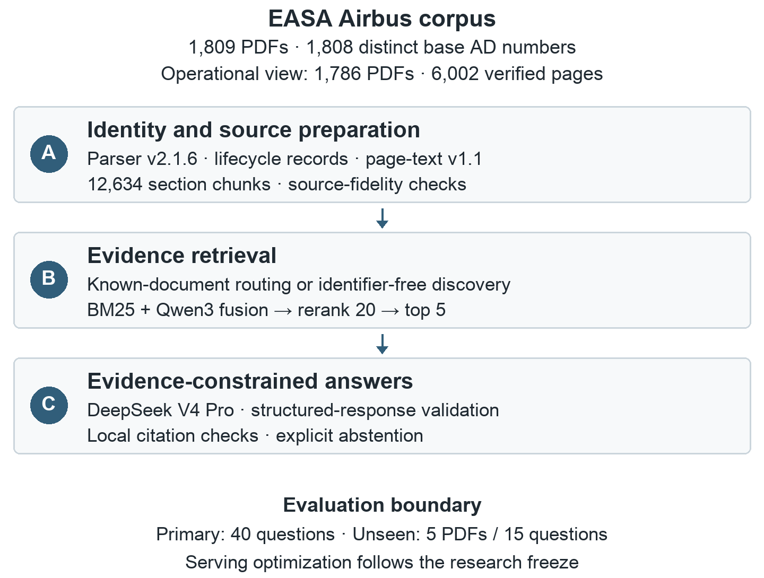
Fig. 1. Three-layer architecture. The primary benchmark and unseen study are evaluated separately; serving changes follow the research freeze.

3.1 Corpus Identity and Source Faithful Processing
The frozen snapshot contains 1,809 PDFs covering 1,808 distinct base AD numbers. AD 2009-0113 is represented by both its original publication and revision R1. The snapshot does not contain complete revision histories. Five PDFs are held out from all development and final-benchmark construction for a later unseen-document test. A strict Airbus operational view contains 1,786 documents and 6,002 verified pages; 18 external or mixed-holder records are retained physically but excluded from this retrieval view. Before indexing, a corpus manifest records normalized AD identifiers, file identity, revisions, corrections, and related lifecycle information. Lifecycle normalization is deterministic rather than inferred by the answer model, reducing the risk that passages from different revisions are silently combined.
Each PDF is converted to page-preserving text. Native extraction is used when quality is sufficient; weak pages are isolated for visual review and may receive a reviewed page-text override. In the final verified layer, all 1,786 operational documents were processed successfully and no unresolved weak pages remained. Source-derived evidence follows a strict fidelity rule: a quotation must be a contiguous passage that can be located in the declared source page, with only harmless whitespace, line-break, and line-end hyphenation normalization. The evidence store therefore remains an audit layer rather than a collection of model-generated summaries.

3.2 Section Aware Chunks and Query Routing
Verified pages are segmented using the recurring rhetorical structure of ADs, including applicability, reason, required actions and compliance times, referenced publications, effective dates, and remarks. The frozen E1 chunk source used by the final retriever contains 12,634 section-aware chunks, including 2,924 multi-page chunks. Every chunk retains a stable identifier, AD number, source PDF, page range, and section metadata.
Queries are routed deterministically into known-document and discovery conditions. The router parses exact AD identifiers without an LLM. An explicit AD number scopes retrieval to that directive; otherwise, retrieval searches the full operational corpus. For known-document questions, the detected AD number constrains the candidate scope, but the identifier itself is removed from the query string used for passage ranking to prevent trivial keyword bias. For discovery questions, no target identifier is supplied, forcing retrieval to identify the authoritative source across all 1,786 operational documents. The live assistant additionally permits one explicit AD context for conversational follow-ups, without injecting unrestricted conversational history into the frozen retrieval path.

3.3 Hybrid Candidate Retrieval and Reranking
The retrieval pipeline uses different strategies depending on whether the user asks about a specific Airworthiness Directive or performs corpus-wide discovery. For a known-document query, the user explicitly provides an AD identifier. The system deterministically recognizes that identifier and restricts retrieval to passages from the corresponding directive. This routing step does not require an LLM. For a discovery query, where no target AD number is provided, the system must search the complete operational corpus to identify both the relevant directive and the most relevant passages.
For identifier-free discovery, the E2-C candidate generator combines two complementary retrieval methods: BM25 sparse retrieval and Qwen3 dense retrieval. BM25 ranks documents according to lexical overlap between the user question and the indexed text. This is useful for exact engineering expressions such as part numbers, modification numbers, aircraft identifiers, and regulatory terminology. In parallel, the question is encoded using Qwen3-Embedding-0.6B, and the resulting vector is compared with precomputed chunk embeddings using cosine similarity. The dense retrieval branch is intended to capture semantic similarity when the user’s wording differs from the terminology used in the AD.
Because BM25 scores and cosine-similarity scores are produced on different numerical scales, they are not combined directly. Instead, their ranked results are merged using Reciprocal Rank Fusion (RRF) [6]. For a candidate document d, the fused score is
$$RRF(d) = \sum_{m ∈ M}{\frac{1}{k + r_{m}(d)}}$$
where M = {BM25, Dense}, rₘ(d) is the rank assigned to document d by retrieval method m, and k = 60 is the fixed RRF constant. A document receives a higher fused score when it appears near the top of one or both ranked lists. Using rank positions rather than raw scores allows lexical and dense retrieval to be combined without requiring their scoring scales to be directly comparable.
The highest-ranked ADs are then shortlisted, and retrieval is performed again at the passage level within those documents. BM25 and dense passage rankings are fused using the same RRF procedure. This second fusion stage produces a broad set of candidate passages that benefits from both exact lexical matching and semantic similarity. Dense embeddings are generated in advance for the frozen section-aware chunk collection, and the stored vector order and normalization are verified so that each embedding remains correctly associated with its original source chunk.
The hybrid E2-C stage is designed to maximize the quality of the candidate pool rather than to define the final evidence order. The 20 highest-ranked candidate passages are therefore passed to E2-D, which uses Qwen3-Reranker-0.6B for a second-stage relevance assessment. The reranker evaluates each candidate together with the user question and assigns a new relevance score. The candidates are then reordered according to these scores, and only the five highest-ranked passages are retained as the final evidence set supplied to Layer C for answer generation. In this design, E2-C identifies plausible candidate evidence, while E2-D determines which five passages are most relevant to the question.
The reranker operates under a fixed engineering-focused instruction that is not modified after the evaluation configuration is frozen. For reproducibility, the exact model revisions are also fixed: dense retrieval uses Qwen/Qwen3-Embedding-0.6B at revision 97b0c61, while reranking uses Qwen/Qwen3-Reranker-0.6B at revision e61197e. Pinning these revisions prevents later changes to the public model repositories from silently altering retrieval behavior.
Each of the five selected evidence passages retains its original provenance metadata, including the chunk identifier, AD number, page number, section, source PDF, and final rank. Therefore, the evidence passed to Layer C is fully traceable to the original regulatory source rather than being treated as anonymous text.

3.4 Evidence Constrained Generation
Layer C receives only the user question and the five retrieved evidence records. The hosted implementation uses DeepSeek V4 Pro with thinking enabled and a fixed structured-response contract. The model does not perform corpus search and cannot create new authoritative evidence. Its output is withheld until the complete response has been parsed, validated against the frozen schema, and checked to ensure that every cited evidence identifier belongs to the supplied evidence set. Unknown evidence identifiers, malformed output, or incomplete streaming are treated as technical errors rather than usable answers.
The response contract distinguishes answered and insufficient-evidence outcomes. This is important for ADs because detailed maintenance instructions may reside in referenced Service Bulletins or other approved data rather than in the AD itself. When dimensions, quantities, torques, or other procedure details are absent from the retrieved AD passages, the correct system behavior is to identify the boundary and reference publication, not to infer the missing values from general model knowledge.

4 Experimental Design

4.1 Layered Evaluation Sets
Evaluation is intentionally separated by application layer and by development/final boundaries. Layer A is evaluated on a human-reviewed extraction gold release. Historical retrieval development first used a 50-question QA-v2 set; these results are retained as development history but are not reused for E2 tuning. The E2 benchmark uses 40 new base AD families split into 24 development families and 16 final-test families, with QA-v2 target families and all five unseen families excluded. The 60-question E2 development set is the only set used to select the final retrieval and hosted-QA configuration. Publication labels E1 and E2 correspond to legacy artifact labels E4 and E5; original question IDs are retained.
Table 1. Evaluation partitions. The five unseen documents are excluded from all E2 development and final construction.
Evaluation component | Scope | Primary purpose
Layer A clean locked test | 17 ADs | Structured extraction + source fidelity
E2 development | 60 questions / 24 families | Retriever and hosted-QA selection
E2 final | 40 questions / 16 families | One-time locked primary benchmark
Unseen holdout | 5 PDFs / 15 questions | Post-final generalization after ingestion
The E2 final set contains 5 identity/lifecycle questions, 7 applicability questions, 14 required-action/compliance questions, 5 referenced-publication questions, 5 conditional or multi-passage questions, and 4 insufficient/conflict/abstention questions. Query modes comprise 24 known-document questions, 12 identifier-free discovery questions, and 4 abstention/conflict cases. Final questions were human reviewed and locked before the one-time primary run.

4.2 Metrics and Locking Rules
Layer A reports prediction coverage, schema validity, macro F1 for stable metadata, applicability-model F1, reference-number F1, superseded-AD-number F1, raw-section presence, and source containment. Retrieval reports Recall@1/3/5, MRR@5, nDCG@5, and correct source+page within the top five. Recall@5 is the principal evidence-availability metric because Layer C receives at most five passages. End-to-end semantic correctness is determined by human review of the generated answer, including answerability/status, completeness, grounding, and citation use.
The final benchmark is protected by explicit locking rules: parser v2.1.6 is not retuned from locked extraction-test outcomes; only E2 development can influence E2 configuration; final questions are not modified after the primary run; retrieval and hosted-QA settings are not changed using final or unseen outcomes; and oracle/reference-evidence diagnostics cannot replace the strict primary score. Technical failures and retries are preserved rather than silently converted into successful first-pass results.

5 Results

5.1 Extraction and Source Fidelity
On the clean locked Layer A test, prediction coverage and schema validity were both 1.0000 across all 17 evaluated ADs. The clean test partition excludes two non-Airbus approval-holder records and AD 2024-0038, which was excluded from clean scoring because of a disclosed development-use leak. Stable metadata macro F1 was 0.9831, applicability-model F1 was 0.9222, reference-number F1 was 0.9000, and superseded-AD-number F1 was 0.6667. All five difficult raw-section presence measures achieved 1.0000. For evidence grounding, all 74 evaluated source quotations were contained in the declared source with zero detected contamination. The lower supersedure score indicates that lifecycle normalization remains more difficult than direct stable metadata extraction, motivating the explicit document-family layer used downstream.
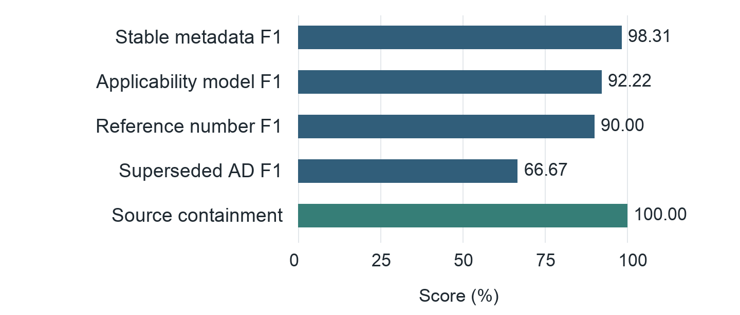
Fig. 2. Clean extraction test (17 ADs). F1 scores are shown as percentages; source containment is 74/74 audited quotations.

5.2 Retrieval Development and Frozen Final QA
The retrieval experiments progressed from E0 and E1 to four E2 development stages (Fig. 3). E0 used flat chunks (≤350 whitespace units), MiniLM-L6-v2 dense retrieval and no reranker. E1 used section-aware chunks (≤450 units), BM25–MiniLM fusion and a MiniLM cross-encoder. E2-A introduced deterministic AD routing, BM25 and section preferences. E2-B preserved known-document retrieval while adding two-stage sparse discovery and evidence assembly. E2-C added Qwen3-Embedding-0.6B document and passage fusion for discovery. E2-D reranked the fixed E2-C top-20 candidates using Qwen3-Reranker-0.6B. All E2 stages reused the E1 section chunks with an evidence depth of five; chunk units are whitespace units, not model tokens.
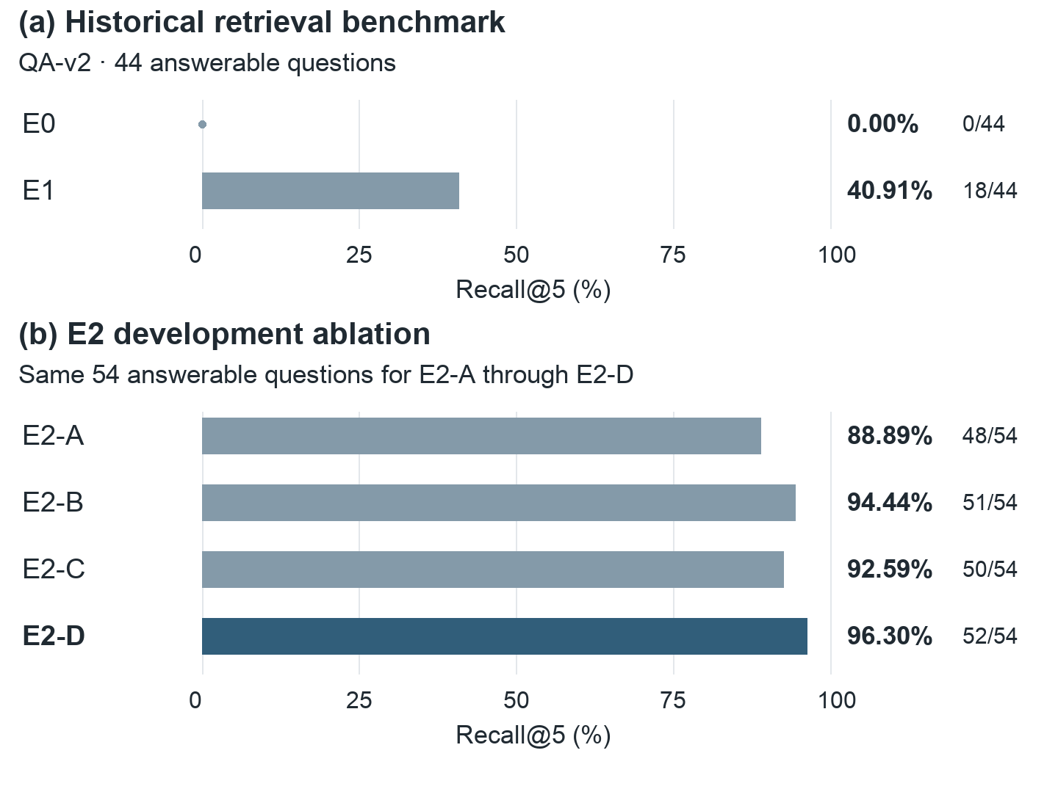
Fig. 3. Historical E0/E1 results and E2-A–D development ablations. Recall@5 uses 44 and 54 answerable questions, respectively. Comparisons across panels are not controlled ablations; the E2 final test is reported separately in Fig. 4.
On the common E2 development set, Recall@5 was 48/54 (88.89%) for E2-A, 51/54 (94.44%) for E2-B, 50/54 (92.59%) for E2-C and 52/54 (96.30%) for E2-D. The dense signal did not improve top-five recall over E2-B, although candidate source-and-page recall at depth 20 rose from 52/54 to 53/54. Reranking then improved the ordering of that fixed candidate pool. E2-D achieved MRR@5 of 0.8633 and nDCG@5 of 0.8884, with known-document Recall@5 of 36/36 and discovery Recall@5 of 16/18. E2-D was selected and frozen before the final test.
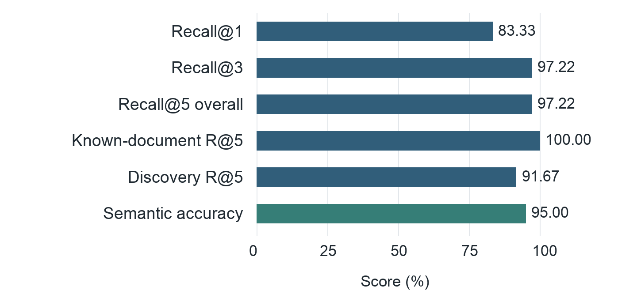
Fig. 4. Frozen E2-D final results. Overall retrieval uses 36 answerable questions; known-document and discovery subsets contain 24 and 12 questions. Semantic accuracy uses all 40 questions.
The separate final benchmark produced 35/36 Recall@5 (97.22%) on answerable retrieval questions and 38/40 human semantic passes (95.0%) end to end (Fig. 4). Known-document retrieval remained perfect at 24/24 (100%), while identifier-free discovery achieved 11/12 Recall@5 (91.67%). These final-test results are distinct from both the E2 development ablations and the historical QA-v2 experiment.
The two primary final failures had distinct origins: E5F-021 was a retrieval candidate-generation failure, whereas E5F-011 had sufficient retrieved evidence but failed in answer selection/completeness (the model generated lower-deck cargo door part numbers rather than specifying the required Manufacturer Serial Numbers (MSNs) up to 09287 and production modification 12046). A later oracle-evidence diagnostic made both cases answerable, confirming the retrieval bottleneck for E5F-021 and demonstrating that E5F-011 was sensitive to evidence focus. These diagnostics serve as explanatory audits and do not alter the authoritative 38/40 score.

5.3 Unseen Document Generalization
The five held-out PDFs cover correction, revision, supersedure, long-document, and simple-original cases. All five passed deterministic extraction, schema validation, isolated ingestion, exact source-hash checks, lifecycle logging, duplicate-rejection safeguards, and frozen-index non-mutation checks. The isolated derivative grew from 1,786 to 1,791 documents and from 12,634 to 12,670 chunks. Reconstructing the five documents with the frozen chunking policy produced an exact 5/5 chunk-count and chunk-ID match.
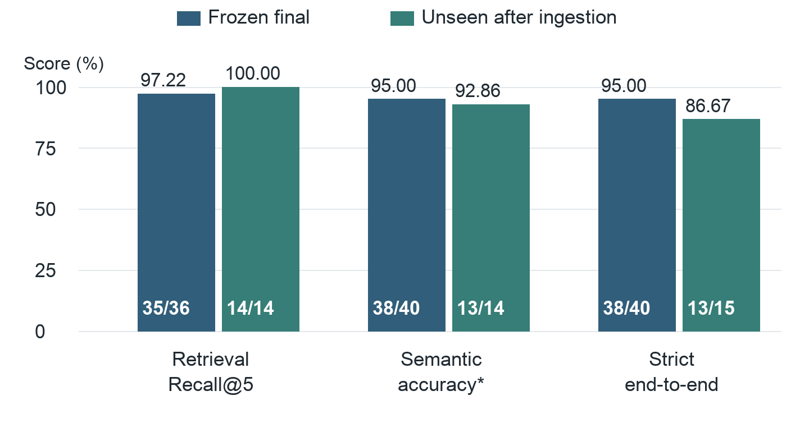
Fig. 5. Final and unseen results with numerator/denominator labels. *Semantic accuracy uses successful hosted responses. Strict end-to-end success also counts the unseen provider failure.
After permanent isolated ingestion, frozen E2-D retrieval reached 14/14 Recall@5 and 14/14 correct-source@1 on answerable unseen questions. Human review produced 13 semantic passes, one semantic failure, and one persistent provider failure, corresponding to 92.86% semantic accuracy among successful hosted responses and 86.67% strict first-pass end-to-end success. The semantic failure is instructive: the correct source page appeared in the top five, but the specific answer-bearing supersedure and applicability passages did not. Thus page-level retrieval success can overestimate the evidence actually available to the generator. The technical failure occurred despite complete evidence and was attributed to provider structured-output reliability.

5.4 Post Evaluation Serving Compatibility
After all research results were frozen, the embedding and reranking models were converted from repeated subprocess loading to persistent warm inference on Apple MPS. On a 10-question compatibility set, legacy and warm serving produced identical top-five chunk identifiers for all 10 questions. Median retrieval latency decreased from 26.87 s to 6.11 s, a 77.26% reduction. This is reported as a serving-engineering result only; it does not alter retrieval or semantic benchmark scores.
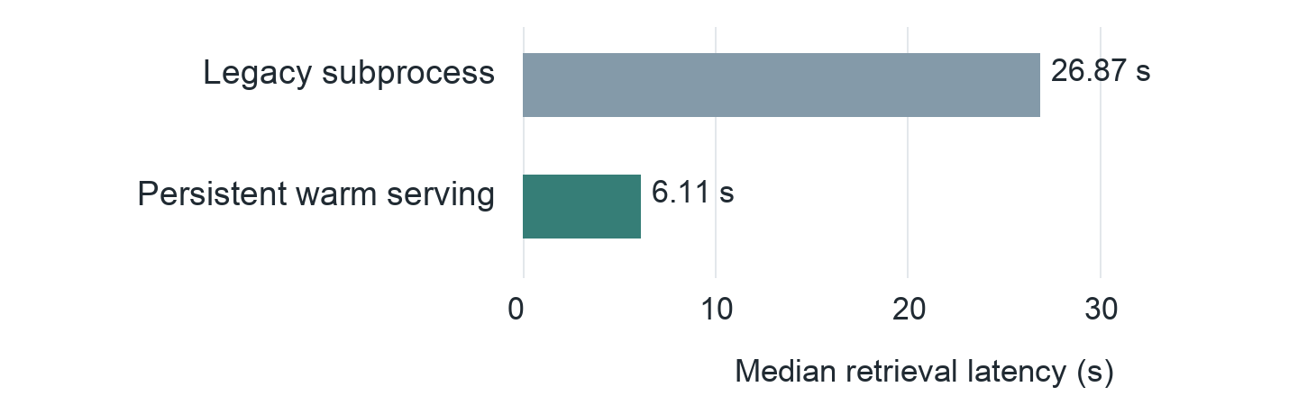
Fig. 6. Post-evaluation serving comparison on 10 questions. Median latency fell by 77.26%; all 10 retained identical top-five chunk identifiers.

6 Discussion
The experiments support three main observations. First, document identity should be treated as retrieval infrastructure in revision-rich regulatory corpora. The extraction benchmark shows that direct metadata can be recovered reliably, but lifecycle fields such as supersedure remain harder. Preserving revision/correction relationships deterministically therefore provides a guardrail that cannot be replaced by semantic similarity alone. This design aligns with compliance-preserving MRO retrieval approaches that keep certified sources authoritative [10], but extends the idea to AD-family identity and corpus-wide discovery.
Second, evidence granularity matters. The final E2 benchmark achieved strong source+page retrieval, yet the unseen failure demonstrates that a correct page can still omit the answer-bearing passage from the five contexts given to the generator. This distinction suggests that future safety-critical RAG evaluation should combine source/page recall with passage-support audits, especially for long documents or questions requiring multiple regulatory sections. The result also cautions against treating a high retrieval hit rate as equivalent to answerability.
Third, generation reliability has at least two separable dimensions: semantic interpretation and provider/structured-output reliability. The primary E2 failure E5F-011 shows that a model can under-select or incompletely synthesize available evidence, whereas the unseen provider failure shows that a request can fail despite complete retrieval. The application therefore validates citations and structured output locally and exposes insufficient-evidence or technical-error states rather than forcing every request into an answer. In maintenance decision support, this behavior is preferable to fluent but unsupported completion.
The approach also has implications beyond aviation. Many Web-accessible regulatory and technical corpora—safety notices, standards, policy circulars, and legal guidance—combine frequent revision with authoritative source requirements. A lifecycle-aware evidence layer can make LLM-assisted knowledge work more accountable by keeping the generative model downstream of document identity and retrieval rather than allowing it to define those facts implicitly.

7 Limitations and Responsible Use
The study is intentionally narrow: it covers Airbus S.A.S. ADs issued by EASA and does not claim equivalent behavior for FAA directives, Service Bulletins, Aircraft Maintenance Manuals, or mixed-manufacturer corpora. The final 40-question benchmark is human reviewed but modest in size, and its family-level isolation does not eliminate every form of linguistic similarity between development and test documents. Discovery performance remains lower than known-document performance, and the unseen study contains only five held-out documents.
The assistant is a decision-support interface, not an authority for maintenance release. Retrieved AD text remains authoritative only within the scope of the publication, and referenced Service Bulletins or approved maintenance data must be consulted when the AD delegates procedural detail. The system deliberately abstains rather than reconstructing missing maintenance instructions. Human engineering review remains necessary for operational decisions, applicability determination, and compliance planning.
Finally, hosted generation introduces external-provider availability and structured-output risks, as observed in the unseen evaluation. A production deployment would require provider-independent fallback, stronger monitoring, access control, audit logging, and organizational validation. The current results establish a controlled research and demonstration baseline rather than certification for operational use.

8 Conclusion
This paper presented a lifecycle-aware, source-faithful, and evidence-grounded RAG architecture for Airbus EASA Airworthiness Directives. The method separates deterministic document identity from semantic retrieval and constrains generation to five locally validated evidence records. On the locked final benchmark, retrieval achieved 97.22% Recall@5 and end-to-end semantic accuracy reached 95.0%. A separate five-document unseen evaluation achieved 100% Recall@5 after isolated ingestion while exposing two remaining failure modes: answer-bearing passage selection and hosted-provider reliability. The results indicate that RAG can reduce the friction of regulatory document search without hiding provenance or failure boundaries. Future work will expand the document scope to Service Bulletins and maintenance manuals, strengthen passage-level support evaluation, and investigate provider-independent generation while preserving the frozen evidence and lifecycle safeguards.

References
1. European Union Aviation Safety Agency: Airworthiness Directives – Safety Publications. https://www.easa.europa.eu/en/domains/aircraft-products/airworthiness-directives-ad (accessed 31 Aug 2026).
2. Lewis, P., Perez, E., Piktus, A., Petroni, F., Karpukhin, V., Goyal, N., Küttler, H., Lewis, M., Yih, W.-t., Rocktäschel, T., Riedel, S., Kiela, D.: Retrieval-Augmented Generation for Knowledge-Intensive NLP Tasks. In: Advances in Neural Information Processing Systems 33, 9459–9474 (2020).
3. Karpukhin, V., Oguz, B., Min, S., Lewis, P., Wu, L., Edunov, S., Chen, D., Yih, W.-t.: Dense Passage Retrieval for Open-Domain Question Answering. In: Proceedings of EMNLP 2020, pp. 6769–6781. Association for Computational Linguistics (2020). https://doi.org/10.18653/v1/2020.emnlp-main.550
4. Robertson, S., Zaragoza, H.: The Probabilistic Relevance Framework: BM25 and Beyond. Foundations and Trends in Information Retrieval 4(1–2), 1–174 (2009). https://doi.org/10.1561/1500000019
5. Nogueira, R., Cho, K.: Passage Re-ranking with BERT. arXiv:1901.04085 (2019).
6. Cormack, G.V., Clarke, C.L.A., Büttcher, S.: Reciprocal Rank Fusion Outperforms Condorcet and Individual Rank Learning Methods. In: Proceedings of SIGIR 2009, pp. 758–759. ACM (2009). https://doi.org/10.1145/1571941.1572114
7. Zhang, Y., Li, M., Long, D., Zhang, X., Lin, H., Yang, B., Xie, P., Yang, A., Liu, D., Lin, J., Huang, F., Zhou, J.: Qwen3 Embedding: Advancing Text Embedding and Reranking Through Foundation Models. arXiv:2506.05176 (2025).
8. Zheng, T., Shen, S., Zeng, C.: A Retrieval-Augmented Generation Method for Question Answering on Airworthiness Regulations. Electronics 14(16), 3314 (2025). https://doi.org/10.3390/electronics14163314
9. Kontodimou, K., Sentuc, N., Kostamis, D., Varsos, K., Kepaptsoglou, K.: Transforming Aviation Technical Authoring with Generative Artificial Intelligence: Toward Automation and Efficiency. Transportation Research Record (2026). https://doi.org/10.1177/03611981261420135
10. Jo, B.: A Compliance-Preserving Retrieval System for Aircraft MRO Task Search. In: Proceedings of the 19th Conference of the European Chapter of the Association for Computational Linguistics, Industry Track, pp. 317–329 (2026). https://doi.org/10.18653/v1/2026.eacl-industry.23
11. Shi, F., Chen, L., Zhou, M., Zhao, Y., Zheng, Y.: A Stepwise Intelligence Generative Method for Structured Maintenance Guidance Documents Based on Knowledge Graph Augmented LLM. Advanced Engineering Informatics 67, 103523 (2025). https://doi.org/10.1016/j.aei.2025.103523

