1.
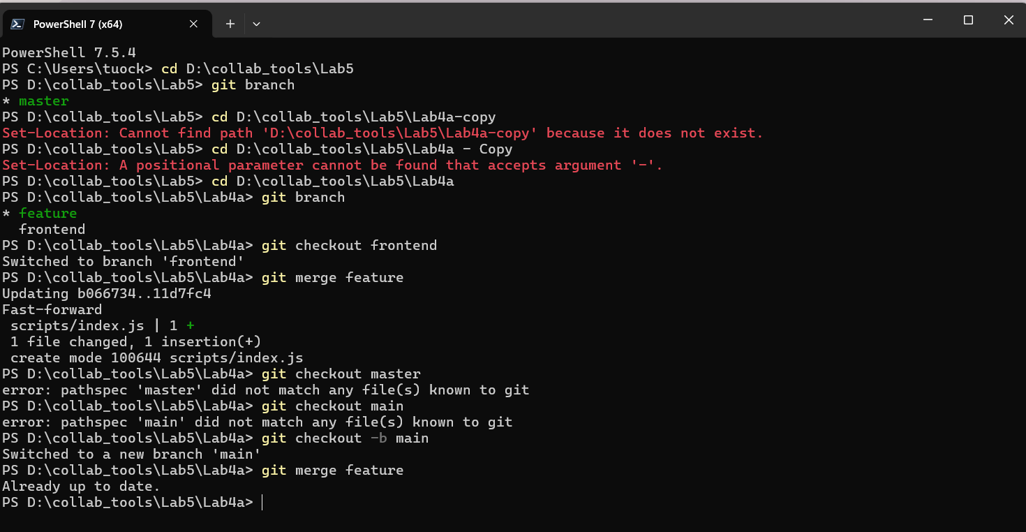
If we merged the feature branch directly into main instead of first merging it into frontend, the same changes would appear on main, but the frontend branch would not have those updates. In other words, the linear commit history would look almost the same because Git used fast-forward merges, but the frontend branch would not reflect the feature changes as a separate step.
2.
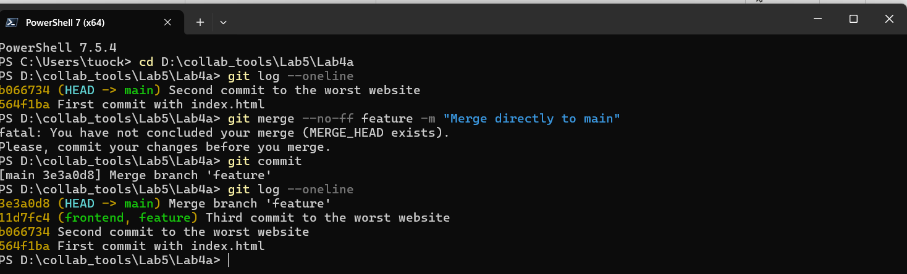
By merging feature directly into main using --no-ff, Git created a merge commit (3e3a0d8). This makes it clear in the history that feature was merged as a separate branch, unlike fast-forward merges where commits just move linearly without a distinct merge. The frontend branch is not involved, so this merge shows a direct connection between feature and main.
3.
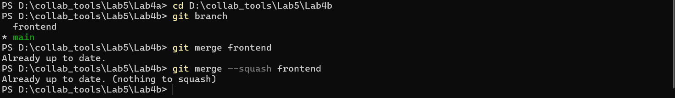
Git reported that the branch was already up to date, which means there were no new changes to merge. Normally, if there were conflicts, Git would pause and highlight the conflicting files, which I would then resolve before completing the merge with a commit.
4.

Squash merging combines all commits from a branch into a single commit. In this case, main already contained all changes from frontend, so nothing was squashed, and Git reported ‘Already up to date.
5.
Squashing a fast-forward merge combines all commits into a single commit without creating a merge commit, while squashing a three-way merge combines all commits from a diverged branch into one commit after resolving conflicts. In both cases, the main branch history becomes cleaner, but the detailed commit history of the feature branch is lost.

