SmartTree Electrical System Maintenance Plan

Francis Chen

Electrical PM of SmartTree

Introduction

According to the agreement between Engineers for a Sustainable World (ESW)’s project team SmartTree and the Office of Facilities Management here at Northwestern University, ESW’s personnel will be responsible for maintaining the functionality and safety of the SmartTree structural and electrical system in exchange of securing the installation location every year. This following maintenance plan, along with SmartTree Electrical System Design Documentation (Design Documentation), is aimed to provide guidance for future ESW members to carry out the necessary steps for checking, troubleshooting and repairing the electrical system. This document will be continuously developed throughout construction to make it more comprehensive.

System Overview

As documented in the Design Documentation, the overall system is shown in the below schematic. We will divide up the system into the three modules as shown below and perform periodic checking on the functionality of each of the modules.

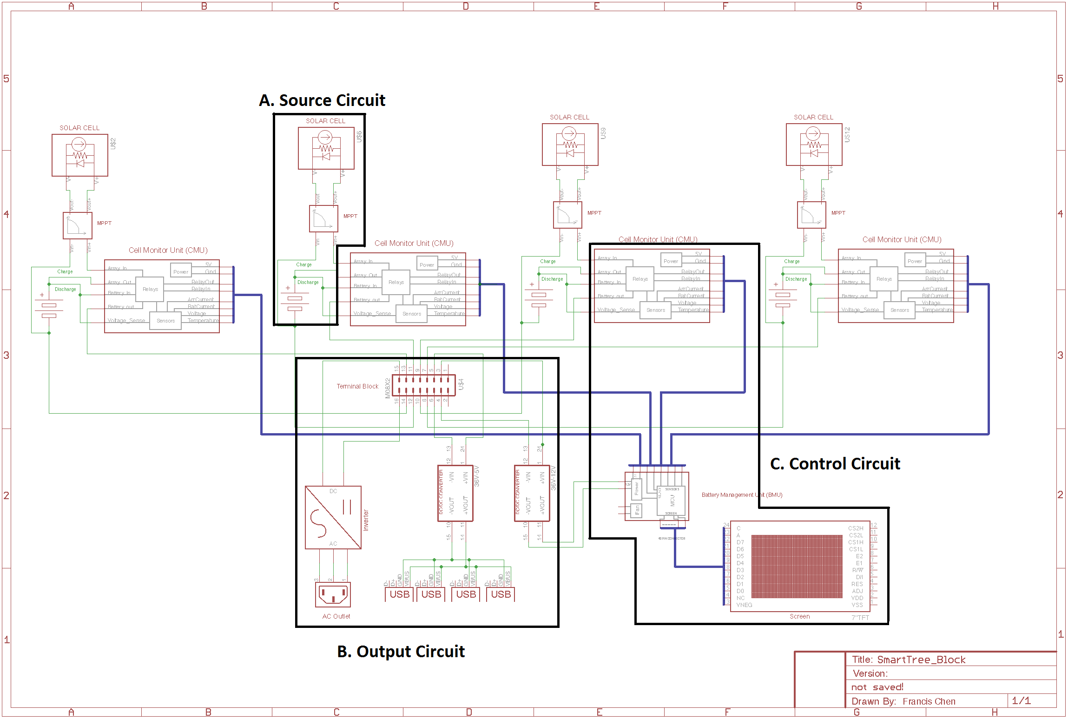

Figure 1. Electrical System Schematic

Maintenance Timeline

The electrical system should be checked by ESW personnel *every month,* in addition to after extreme weathers and/or receiving a maintenance request, on the functionality of the system,which include:

1. for source circuit: the output voltage and current of the solar panel and battery are within spec; there’s no mechanical damage to the parts (especially the solar panel); fuses are not activated.
2. for output circuit: the output voltage and current of the DC-DC converter and inverter are within spec; fuses are not activated.
3. for control circuit: the sensor measurements are consistent with the instrument measurements; the active control of the solid state relay is able to shut down the system when a fault condition occurs.

Every year, a more thorough examination of the system should take into account the following items in addition to what mentioned above:

1. Aging of the battery capacity
2. Weather proof and interconnects of the circuitry

Testing Procedure

1. Monthly Check
2. Quick Debug

For general debugging purposes, connecting the Arduino on our controller circuitry to a laptop will give out all the sensor reading of the system via serial (see below), any serial terminal program can be used as well as the Arduino serial monitor.

[Output from Serial]

In addition, datalogging is performed on an SD card every 15 seconds on the system which will provide a CSV file that maintenance personnel can use to check the overall performance of the system over the past month.

[Example Data Log]

These quick debug information will identify most of the problems within the system at a glance especially with respect to sensor failure or bad connections (short or open circuiting) or blown fuses.

1. Source Circuitry

If the problem is identified on the source circuitry side, the following measurement should be taken:

1. Output voltage of the Solar panel
2. Output voltage of the MPPT charge controller
3. Output voltage of the battery.

Any of the malfunctioning of the source circuit should be reflected on their voltage output and components will be replaced accordingly.

[Checking Source Circuit]

1. Output Circuitry

If the problem is identified on the output circuitry side, the following measurement should be taken.

1. Output voltage on the terminal bar
2. Output voltage of the 12V DC-DC Converter, this is powering all the digital circuitry of the system including sensors, datalogging, microcontroller and relays.
3. Output voltage of the 5v DC-DC Converter, this is powering the USB outlet.
4. Output voltage of the inverter and the AC outlet

If output voltage on the terminal bar is normal while there’s out-of-spec output from the power electronics as listed above, components will be replaced accordingly.

[Checking Output Circuit]

1. Control Circuitry

If the power electronics all function correctly individually, while there appear to be an open circuit / short circuit on the pathway of the power flow, it’s most likely to be a malfunction of the control circuitry.

Following checks should be performed on the control circuitry:

1. If the sensor reading from our controller is consistent with measurement using a multimeter. If not, system can be in tricked into a fault condition and cause open circuit. In this case, sensor need to be replaced.
2. If the fuses on the sensor board is connected. If not, examine the current output on each of the sensor board and replace the fuse.
3. If the relay on the sensor board is functioned correctly. If applied a voltage to the control input, the relay should close to allot current flow through. If the relayed is not functioning, replace the relay.
4. Annual Check
5. Battery Capacity: charge up the battery pack and discharge at a constant load to see if the capacity of the battery has degraded over the course of the year.

1. Interconnect: check the continuity between all the interconnects: which includes:
   1. Solar Panel to MPPT
   2. MPPT to CMU
   3. CMU to BMU
   4. 12V DC-DC converter to BMU
   5. CMU to switch box
   6. Switchbox to terminal block
   7. Terminal block to DC-DC converter
   8. Terminal block to inverter
   9. Inverter to AC Outlet

Emergency Contact

For debugging help of the system, designer of the system’s contact information is listed below.

Can Aygen: [canaygen2017@u.northwestern.edu](mailto:canaygen2017@u.northwestern.edu)

Francis Chen: [tuofeichen2017@u.northwestern.edu](mailto:tuofeichen2017@u.northwestern.edu)

Allen Tang: [allentang2018@u.northwestern.edu](mailto:allentang2018@u.northwestern.edu)

Kevin Tian: [kevintian2018@u.northwestern.edu](mailto:kevintian2018@u.northwestern.edu)

Afterwards, ESW should have a dedicated team responsible for maintenance for accomplished project. Contact ESW at eswnu@gmail.com.