**rated culated as belowt of the systme e refer to the SmartTree Electrical System Design Documentation)rt to the system.** SmartTree National Electric Code Compliance Report

**Introduction**

This document is intended to discuss the code compliance of the SmartTree electrical system in the context of meeting the National Electric Code (NEC). Specifically, this report will give a brief overview of the specification of the system (more about the detailed design please refer to the SmartTree Electrical System Design Documentation) and address the compliance status for the three relevant NEC Articles: Article 720 Circuits and Equipment Operating at Less than 50 Volts, Article 480 Storage Batteries, and Article 720 Solar Photovoltaic Systems. Article 690 and 480 will have an entry wise discussion; Article 720 will only address the applicable part to the system.

**System Specification**

As shown in the point to point schematic, the 8 solar panels are split up into 4 pairs. Each pair is charging a 36v battery pack, which consists of three 12V lead acid batteries. The four battery packs all connect to a terminal block (hence in parallel) before delivering current to the inverter. This PV system is a stand-alone system as defined by the NEC.

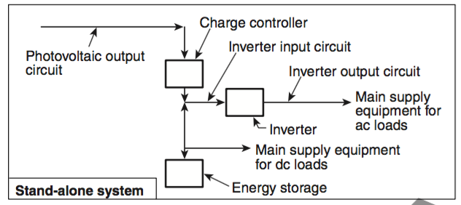  
Figure 1 NEC defined stand-alone system

In the table below, PV Output Voltage and Current refers to the voltage and current of each pair of solar panels. Battery output voltage is 36V due to the parallel connection, and the battery output current is the sum of current from the 4 packs.

|  |  |  |
| --- | --- | --- |
|  | Nominal | Maximum (w/ temperature correction) |
| PV Output Voltage (BP 275)1 | 34.0 V | 45.42 V |
| PV Output Current (BP 275) | 4.45 A | 4.65 A |
| PV Output Power (BP 275) | 70 W | 75 W |
| PV Output Voltage (VLS 85) | 36 V | 50.29 V |
| PV Output Current (VLS 85) | 4.72 A | 5.00 A |
| PV Output Power (VLS 85) | - | 85 W |
| MPPT Input voltage | 36V | 63 V |
| MPPT Input Current | 8 A | - |
| MPPT Output Voltage | - | 43.2 V |
| Battery Input Voltage | 43.2 V | 45 V |
| Battery Input Current | - | 6.6A @ 0.3C |
| Battery Output Voltage | 36 V | 40 V |
| Total Battery Output Current | 8.8 A @ 0.1C | 17.6 A @ 0.2C |
| Inverter Input Voltage | 36 V |  |
| Inverter Input Current | 8.33 A |  |
| Inverter Output Voltage | 110 V (AC) | - |
| Inverter Output Current | 5.46 A |  |
| Inverter Output Power | 300 W | - |

Table 1 System Specification

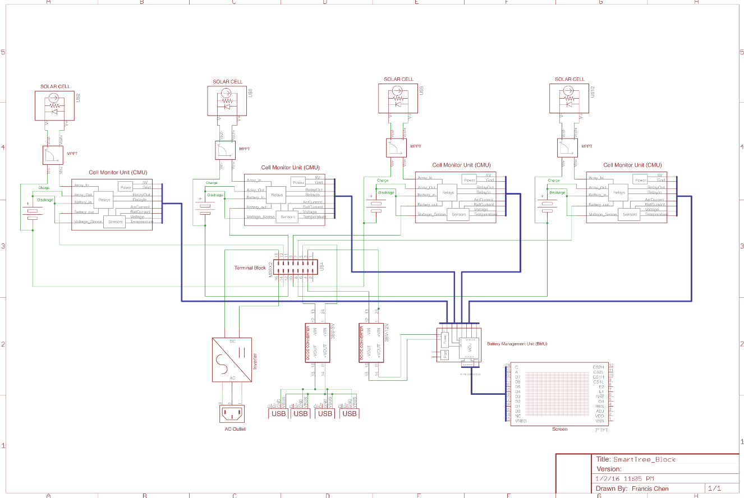

Figure 2* Point to Point Schematic

**ARTICLE 720**

**Circuits and Equipment Operating at Less Than 50 Volts**

[720.1 Scope] The SmartTree electrical system fit in the scope described by the NEC article 720. The highest DC voltage involved is the three serially connected 12V lead acid battery, stacking at to 36V.

[720.2 Other Articles] Other articles mentioned in NEC do not apply except Article 690, PV system, which will be discussed later.

[720.3 Hazardous Locations] System will not be installed in Class 1,2 or 3 hazardous locations.

[720.4 Conductors] All power bus conductors are rated 12 AWG or above.

[720.6-7 Receptacles] Receptacles for power bus are mainly three kinds: 2 pin Megafit Molex connector, 30Amp power pole Anderson connectors and 10-12AWG ring connectors. The Megafit can deliver 23A of current. Thus both can handle more than 15A of current.

[720.11 Mechanical Execution] All power electronics are enclosed in battery boxes where components and wirings are properly installed.

**ARTICLE 480**

**Storage Batteries**

[480.3 Cell terminations] Batteries are placed in battery boxes. Ring connectors are used to connect between different batteries and no mechanical strain is applied.

[480.6 Disconnecting Means] A switch box is in place for maintenance personnel to disconnect the battery system, in addition to the built in battery management system that implement overcurrent/under voltage protection.

[480.7 Insulation of Batteries Not Over 250 Volts] Batteries purchased for the system belong to class (D) Sealed Cells or Batteries and it doesn’t require additional insulation support.

[480.9 Battery Locations] Battery will be placed in a weatherproof battery box with ventilation. Live parts are properly mounted on the battery box.

[480.10 Vents.] Vents are available on the battery box which contains the sealed lead acid battery.

**ARTICLE 690**

**Solar Photovoltaic (PV) Systems**

I. General Requirement

SmartTree electrical system uses inverter, charge controller, and PV modules listed for PV applications, DC-DC Converters are not specified for PV application, but their input and output voltage range are within the limit of the system and the specification of the parts.

690.4(C) Qualified Personnel

The installation of equipment and all associated wiring and interconnections shall be per- formed only by *qualified persons*. **[ROP 4–188a]** Even though his is a low voltage off grid system, we still plan to have electrician present for the installation.

**(690.5)** As mentioned above, every circuit has only 2 parallel source circuits and all DC source and output are isolated from the structure. Thus no ground fault protection is required according to the code.

II. Circuit Requirements

690.8 Circuit Sizing and Current

1. **PV Module**

The maximum voltage and current of the PV module is calculated as below

Voltage:

For every pair of series BP275 PV Modules, for lowest Temperature in Chicago:

$$Max PV Voltage=OCV*2+C_{temperature}*\left({25}^{o}C-lowest {temperature}^{2}\right)$$

$$=21.4 V*2+\left(25-(-7.7\right))C*80mV/C=45.42V$$

For every pair of series VLS-85 PV Modules,

$$Max PV Voltage=OCV*2*C_{temperature}*\left({25}^{o}C-lowest temperature\right)$$

$$=22.3 V*2*(1+\left(25-(-7.7\right))C*0.39\%/C)=50.29V$$

Current:

Pair of BP- 275:

$$Max PV Current=I_{SC}*C_{temperature}*\left({25}^{o}C-lowest temperature\right)*1.25=5.81A$$

Pair of VLS-85:

$$Max PV Current=I_{SC}*C_{temperature}*\left({25}^{o}C-lowest temperature\right)*1.25=6.25A$$

1. **MPPT Charge Controller**

The selected charge controller is the GV-Boost 105-350W solar boost charge controller, which accepts max panel OCV of 63 V and rated current of 8 Amp. Therefore max source and output current/voltage is within input rating of the MPPT charge controller. The max DC voltage is below 1000 V and is permitted not have lamp holders and fixtures. However, the system is designed to be mounted on lamp holder like structures and won’t be accessible by general public.

1. **Inverter**

The selected inverter is NM300 Pure Sine Inverter. Inverter continuous output current is

$$300 W / 110 V*2 = 5.46 A$$

Inverter input current rating

$$300W / 36V = 8.3 A$$

1. **DC-DC converter output current rating**

According to datasheet,

36-5V DC-DC converter max current output is 3A,

36-12V DC-DC converter max current output is 8A.

**5. Conductor Ampacity**

Power wires are at least 12 gauge, thus more than enough to handle current of the max input and output current of the mentioned equipment

**6. Sizing of module interconnect**

Each parallel-connected modules had its own overcurrent protection.

690.9 Overcurrent Protection:

Active and passive overcurrent protections are both deployed. Hall effect current sensors are implemented to measure the PV output current and the battery output current. A microcontroller is used to monitor the output of the current sensor and controls two solid-state relays to disconnect the PV output and battery output circuits when overcurrent is detected. A fast reacting fuse is also implemented in case of the presence of spike or surge of power.

Current sensor has ratings roughly 2 times higher than the max output calculated in 690.8. Due to low voltage (36V) and small scale of the project, generic fuses and solid-state-relays are used as overcurrent protection device. However, all of them are consistent with the voltage current and interrupt ratings of the system.

690.10 Stand Alone System

As mentioned in the introduction, this system meets the NEC definition of a stand-alone PV system. Inverter nominal output is 300 W, which is greater than expected full load condition. The load condition includes powering two laptop chargers and most laptop chargers are below 100 W. Conductors are 12 gauge copper wires, which can handle the max current from the inverter. Backfed Circuit breakers is not used in the system. As discussed above, fuses and solid-state relay are used for overcurrent protection.

**III. Disconnecting Means**

690.13 Building/other structures supplied by a PV system

Due to the simplicity of this system, the only other conductors within the system are the loads that connect to the batteries. In the terminal block that 4 battery boxes join, one switch box that controls each battery is present. The 4 switches is max number of disconnection means and it will isolate the PV circuit before (include) the battery from possible loads.

690.15 Disconnection of Photovoltaic Equipment

In each battery box, one switch is used to disconnect the corresponding charging circuit from PV modules. The switches in each battery box and the switch box in the center control box is readily accessible by maintenance personnel. Labels are placed next to switches to indicate disconnection from PV modules. As four subsystems are implemented, only 4 switches are present in separate enclosures.

690.16 Fuses

The fuses on the BMU boards are separable from supply by disconnecting the input and output connector.

690.17 Disconnect Type

DC-rated enclosed switches are used for all the manual disconnection means. The disconnection means will open the + line of DC source and output circuits. The – line of the circuit will be grounded with the metal structure of the tree. The PV disconnecting means are well labeled both in the battery box and in the center control box. It’s accessible to maintenance personnel without exposing to live parts.

690.18 Installations and Service

During installation and servicing, two PV output terminals will be disconnected from the charge controller.

**IV. Wiring Method**

690.31 Methods Permitted

PV source circuits are installed in inaccessible locations (on the top of the tree branch) and will be connected via listed PV wires. The metal branch of the tree serve as the conduit for the PV wire until it reaches the battery box, which is also not accessible to general public. However, plastic conduit is still used for power cables between battery boxes.

PV system source and output circuits are not placed in the same junction. PV source circuits are labeled. (TODO). PV output and inverter circuits are labeled (TODO). When the battery output of the four subsystems join at the terminal block. The conductor and switch of every one of them is labeled. Within the central control box, AC and DC wires are well separated and grouped by cable ties.

UL listed PV wires are used for outdoor connection between the PV module and charge controllers. Mutli-Conductor cables are not used for the PV modules and high power components. Fine stranded cables are terminated with ring connectors or Anderson connectors Removal of module shouldn’t interrupt a grounded conductor to other PV source circuits, as PV modules should all be grounded to the metal structure of the tree.

690.32 Component Interconnections

Minimum interconnections are left open for on-site assembly, which includes the connection from array to charge controller, connection from battery banks to the terminal block, connection from inverter to the AC outlet and the connection from 5V DC-DC converter to the USB hub. All of these connections are complying with the corresponding standards in the code.

690.33 Connectors

As mentioned above, connectors for power bus are mainly three kinds: 2 pin Megafit Molex connector, 30Amp power pole Anderson connectors and 10-12AWG ring connectors. The Megafit can deliver 23A of current.

Connectors are polarized and is non interchangeable with other receptacles. Connectors are all commercially available, well-insulated power connectors that should guard against contact with live parts by person. Connectors all exceed the rating of 30 volts and the expected current of the specific terminal.

Connectors used are all latching/locking type connectors.

Molex Megafit and Anderson Powerpole are all UL listed current interruptible. The ring connector on the terminal block needs a tool to disconnect and has label (Do not disconnect under load).

**V. Grounding**

690.41 - 50 System Grounding

All negative terminals of solar arrays, batteries and other DC electronics are connected on a terminal bar, which is in turn grounded using a ground rod. The grounding conductor will be larger than 14 AWG. Metal frames of the solar panels will be tied to the entire metal structure, which is grounded via the foundation.

**VIII Battery**

690.71 Installation

System voltage is 36V and it has listed fuses and relays for overcurrent protection on the energy storage side of the system. The system is lower than 48V and most of the codes here do not apply.

690.72 Charge Control

The PV module (34V – 45V) matches the voltage of the sealed lead acid batteries (nominal 36V). A maximum power point tracker and charge controller is also applied for charging 36V devices.

690.73 Battery Interconnect

12 gauge wires and ring connectors are used to connect the 3x 12V SLA batteries together, and connect these 36v modules to the terminal block.

**rated culated as belowt of the systme e refer to the SmartTree Electrical System Design Documentation)rt to the system.**

**rated culated as belowt of the systme e refer to the SmartTree Electrical System Design Documentation)rt to the system.**