**RateMyCode: Documentation**

1. **Technology choices**
2. **Installation guide**
3. **User manual**
4. **Feature list and corresponding points**

**Tuomas Mustakallio**

Updated: 2023-03-06T2:44

<https://github.com/tuomasmustakallio/RateMyCode>

**1.Technology choices**

This web application is made with Node using an Express backend and a React frontend. Both of these frameworks are coded with Typescript. The application uses non-relational MongoDB as its database but with further development a relational database might suit this project better. The application also uses various node packages which we will go over shortly later.

The idea of this application is for its users to be able to post their code and for other users to comment and vote on them. Unauthorized users are also welcome to use the site, but they do not have access to interact with the posted code snippets.

Authorization is handled with JWT-tokens that give the user a 2h session from logging in. The client side is translated to two languages English and Finnish with i18next. The UI-components are made with the help of material-UI. The code snippets are also colour coded with highlightjs if they are marked as suggested. The client side also uses other core React packages like react-router-dom to handle routing for the application.

The application also has labels applied to all buttons and interactive so it can be used with screen-reader and only a keyboard.

Client App User



JWT Authorizatio

provided

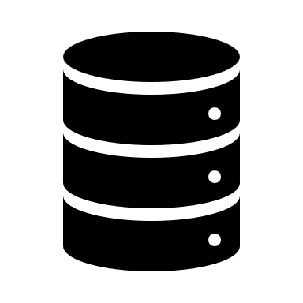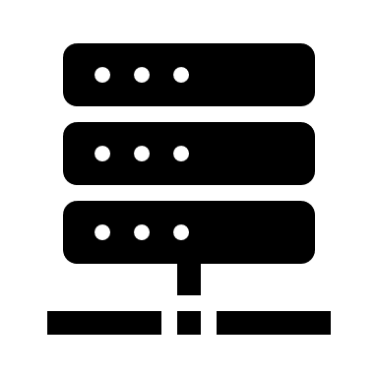REST API MongoDB

**2. Installation guide**

You can try the app yourself by copying this repository in a folder of your choosing with the command:

`**git clone https://github.com/tuomasmustakallio/RateMyCode.git**`

After that you should install the needed dependencies for the client and server side with commands:

`**npm run preinstall**`

`**npm run install**`

When the depencies have loaded you can selected either to run the server on production or development mode and the client side with the following commands:

`**npm run dev:server** | **npm run server**`

`**npm run client**`

These commands will start the server side in port 5000 and the client side on port 3000.

Note that the server side uses mongodb for storing user data and code snippets so you have to have it installed and runnning.

**3. User Manual**

Here is a short guide on how to use RateMyCode.

Front page not logged in. We can see post details from show more or we can register from the register button.

By pressing the register button we can register which will direct us to a login page where you should see similar textfield from where you can login with your new account

Front page logged in we see that there are 2 new buttons +-icon and the log out button.

Plus icons post page

Single post page

**4.Feature list and corresponding points**

Here are the points that I’m aiming to with my application

|  |  |
| --- | --- |
| **Feature** | **Points** |
| Basic features (as stated in the previous chapter)  with well written documentation | 25 |
| Utilization of a frontside framework, React. | 5 |
| Use some highlight library for the code snippets, for example https://highlightjs.org/ | 2 |
| Test software for accessibility; can it be used only with keyboard / voice command? Can screen readers work with your application? | 3 |
| Vote (up or down) posts (only one vote per user) | 2 |
| Translation of the whole UI in two or more languages | 2 |
| Test software for accessibility; can it be used only with keyboard / voice command? Can screen readers work with your application? | 3 |
| Total: | 42 |