**ASSIGNMENT 1 - Customer Management**

Your team is responsive to develop an application to manage your customers with below requirements.

1. Create a database with name **Laravel-Assignment** which contain a **customers** table is described as below figure:

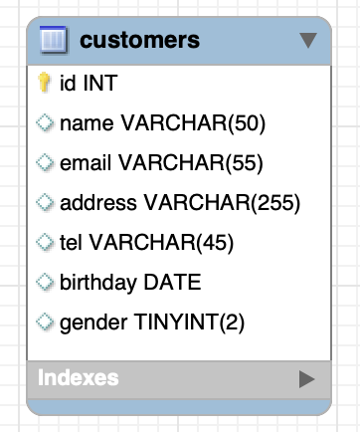

**Figure 1. Class Diagram**

Create **a customer** table and fill in some data.

1. Create an application use Laravel to manage customer with bellow tasks:

* Add a customer to the database
* List all the customers page
* In list customers page, add search are for :
  + Find a customer by email/name
  + Find customers by address
  + Find customers by phone
  + Find customers by gender
  + List all the customers who are men and years old from 20 to 30.

Hint :

