**ASSIGNMENT 2 - Order Management Application**

Your team is responsive to develop an application to save orders from an online order system as below:

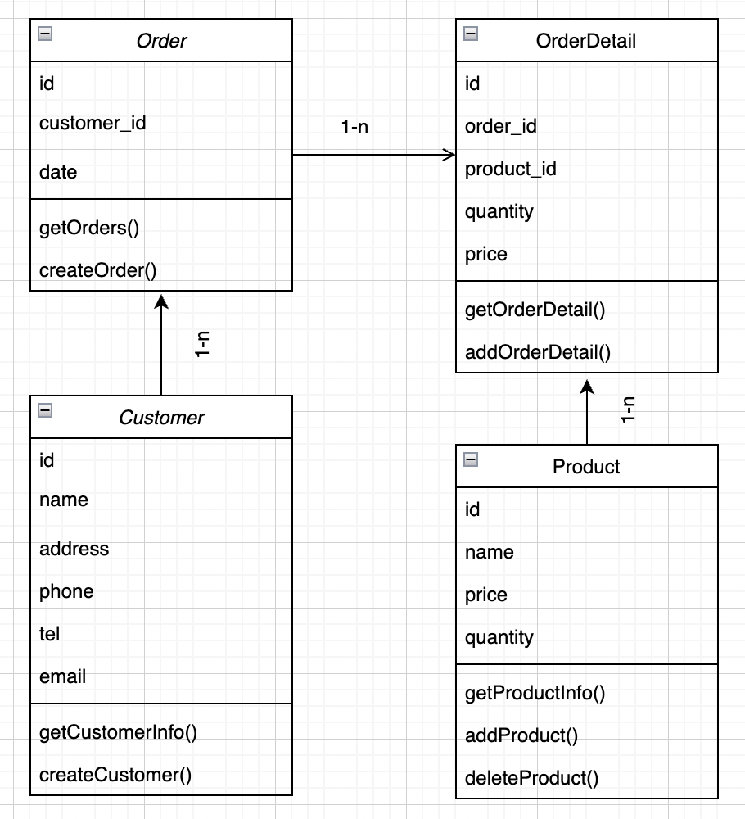

**Figure 1. Class Diagram**

Use Laravel to implement below requirements:

1. Create a database containing orders, order_details, products, customers tables. Fill some data for them.
2. Create model classes, implement relationships for them.
3. Create an application to permit user enter a new order and save it to database (include order details)
4. List all order and order details in the database
5. Get an order and order details by order id
6. List all the orders in the current month
7. List all orders by customer id
8. List all orders of customers that bought an Iphone.

The end.