**LARAVEL– SHOPPING CART APPLICATION**

Your team is asked to develop a Shopping Cart application for an e-commerce system as requirements below:

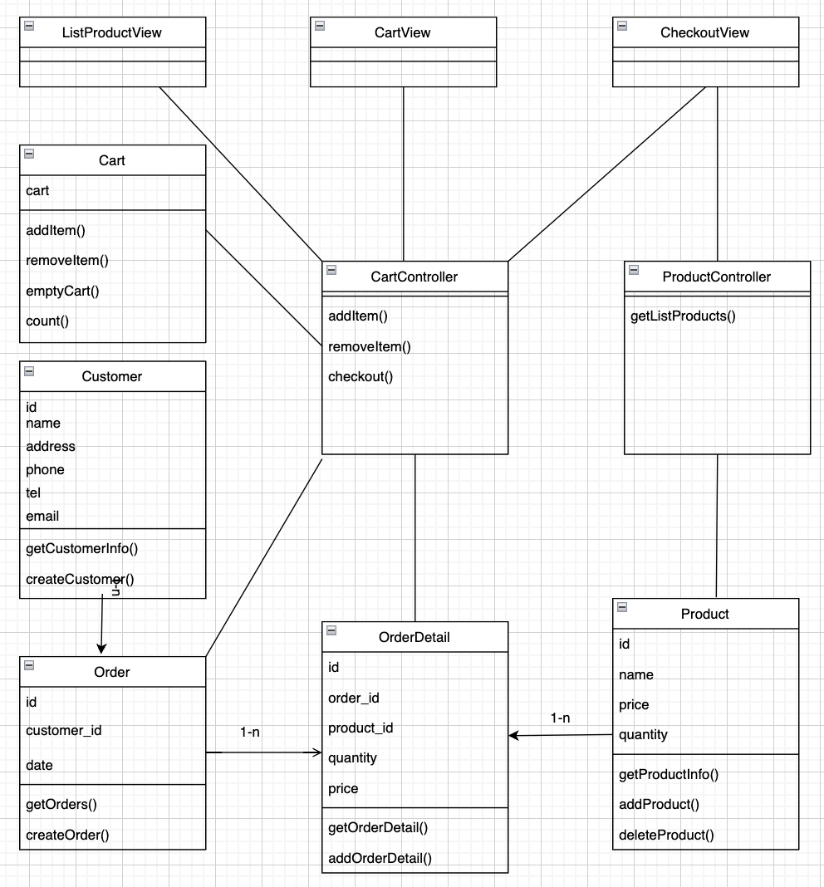

**Figure 1: Class Diagram for shopping cart application**

In this:

* **ListProductView**: list all products from database to screen and add an addToCart button for each product so the user can select this product.
* **CartView**: is a web page to manage a shopping cart like change quantity, add or remove product.
* **ProductController**: this will load the product information from the database to display on **ListProductView**.
* **Cart**: is a shopping cart.
* **CartController**: contains code control shopping cart.
* **CheckoutView**: When a user wants to order, save the order information to the database.

**Hint:**

* Create a database with 4 tables: products, orders, order_details, customers
* Website reference: *https://nama.vn*

**Example:**

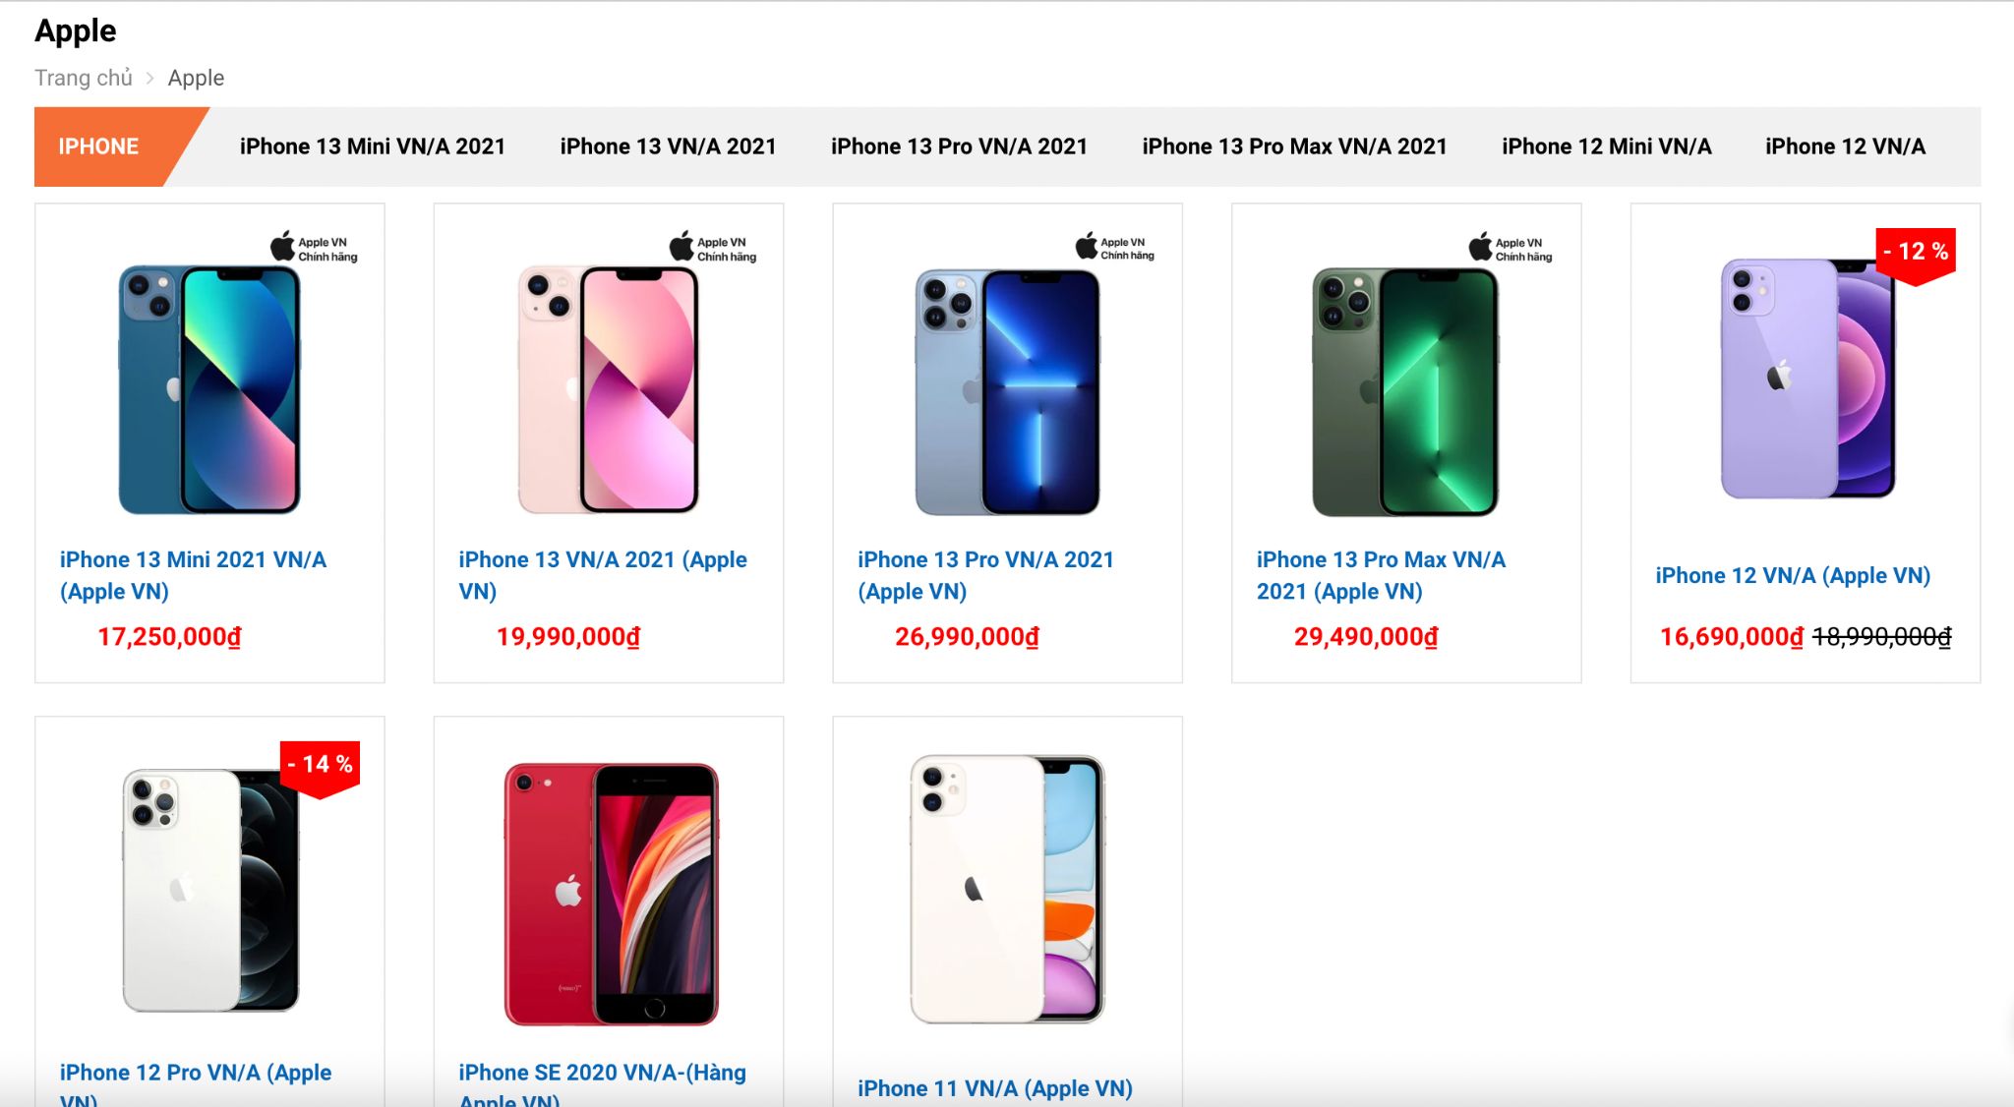

Figure 1. Product List

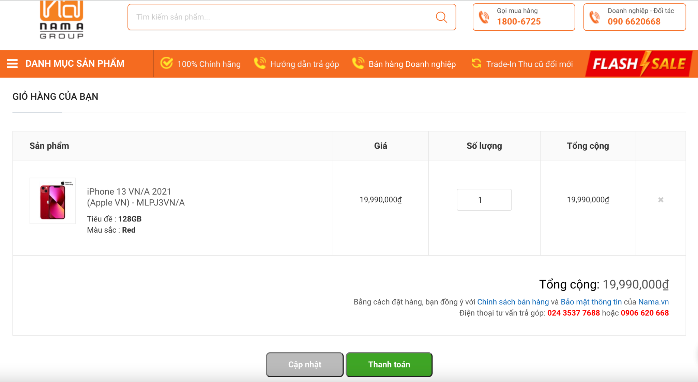

Figure 2. Shopping Cart Management

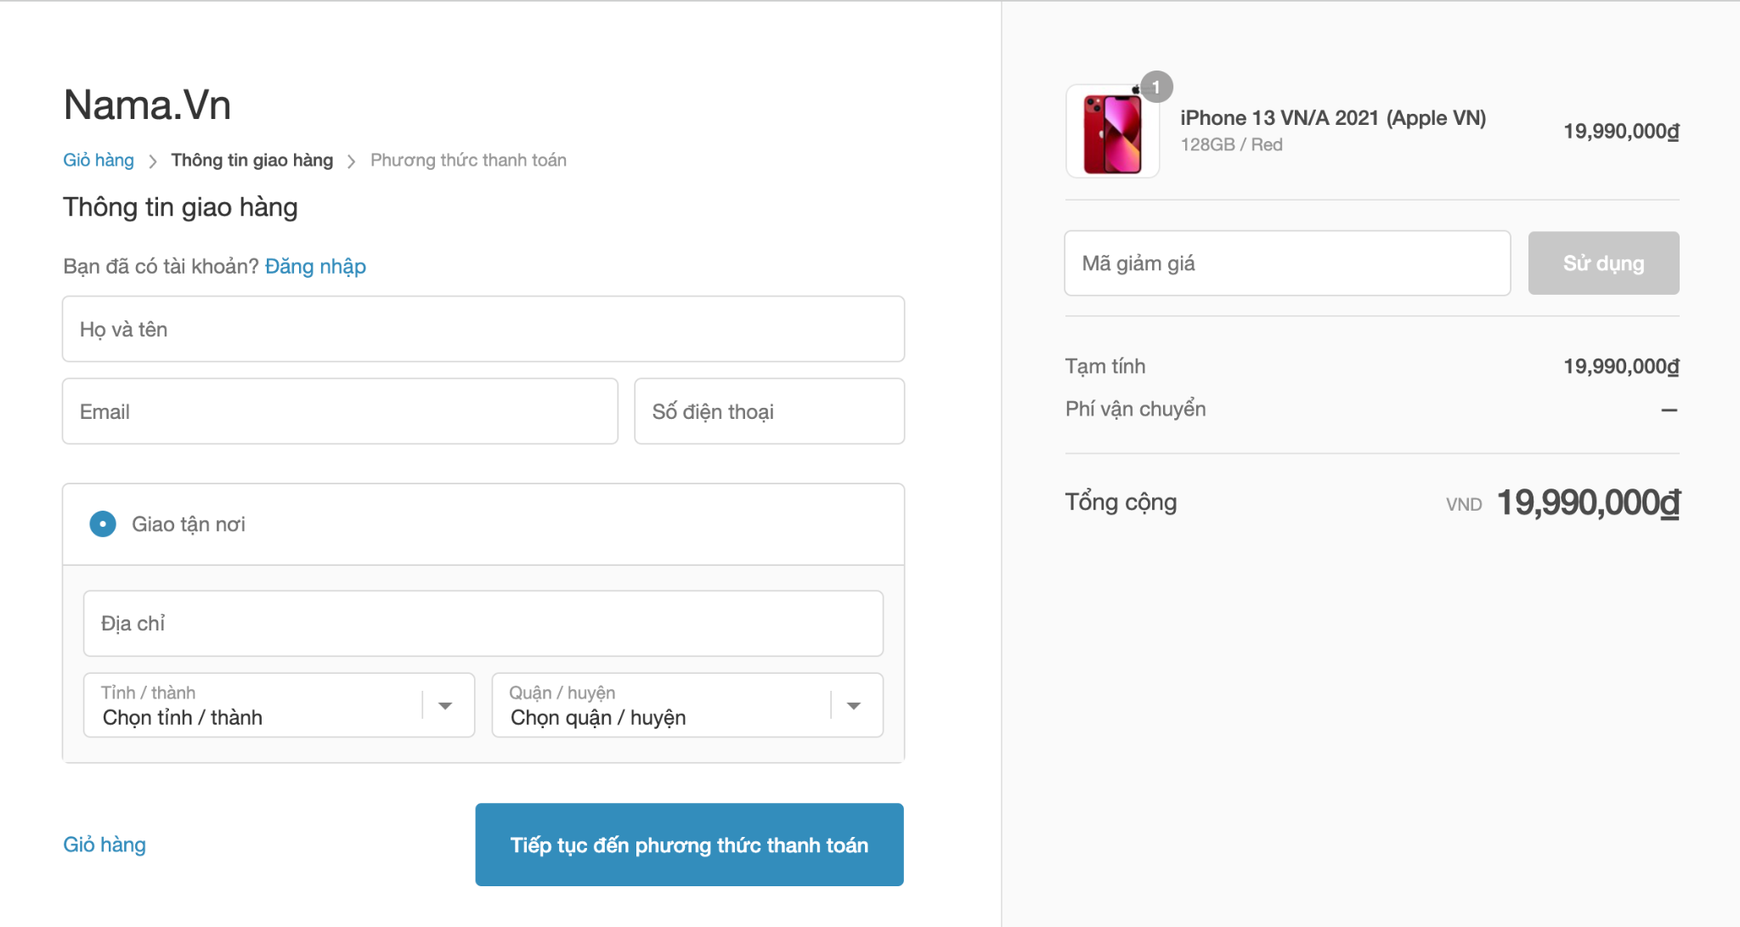

Figure 3. Check out page

**Hint :**

**Step 1:**

* Create DB with 4 tables: products, orders, order_details, customer according to below ERD

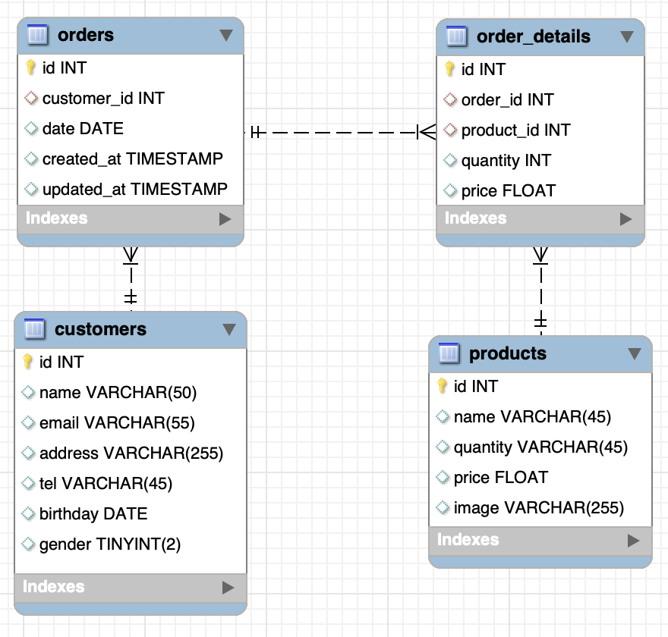

* Fill 10 data rows for the **products** table.

**Step 2:**

* Create model Product, Order, OrderDetail, Customer and define relationship between each model.
* Create ProductController
* Code to show list product page ,with button add to cart in each product

**Step 3:**

* Define **Cart** class with session scope
* Declare an cart object for this class to store shopping carts in session.
* Then define CartController with a session scope which controls add, remove item from cart. This class is working with a Cart file.

**Step 4:**

* Add a **checkout** button to the **CartView** file so the customer can request to check out their order.
* When a customer clicks the checkout button, the **CheckoutView** will display to require them to input their name and address.
* Then save checkout and shopping cart data to the orders and order_details table.

------ The end ------