**LARAVEL SECURITY FOR WEB APPLICATION**

Your team is responsible for developing a security module for a web application. This application has 03 roles: GUEST, USER and ADMIN. The GUEST role can access public resources and do not require authentication. The USER role can access resources in the user folder, public folder and require authentication. The ADMIN role can access resources in the admin folder, user folder and public folder and require authentication. The detail requirements are:

1. Create a web application with 03 folders: public, users, admin.

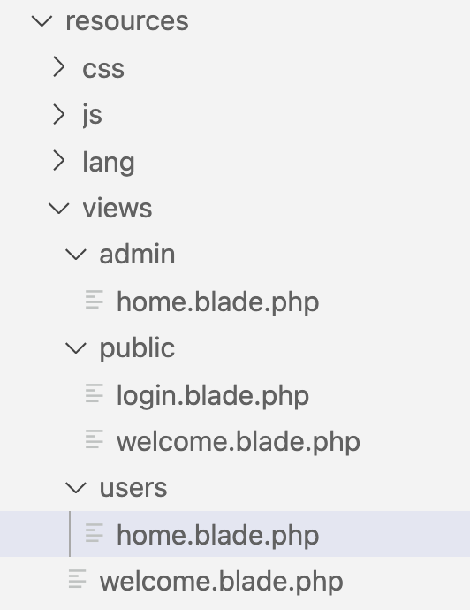

**Figure 1. Application folders for views**

1. Setup security to when user access resources in user and admin folder the login page will be displayed and require authentication. If the user enters the correct username/password, the destination page will display neither an error message.
2. Edit the question 2 to users and roles can be stored in the database.
3. Edit this application to when the user clicks the login page before accessing resources, if they login with user role the home.blade.php in users folder will be displayed. And if a user login with an admin role the home.blade.php in the admin folder will be displayed.

The End.