ASSIGNMENT FOR MVC

Create an Email application to request user login to the system before they want to use the functional of the system.

1. Create an UserDB database contains an Users table as below:

|  |
| --- |
| **Users Tabe** |
| email: char(50) |
| password: char(50) |
| firstName: char(50) |
| lastName: char(50) |

1. Create the MVC application like figure 2. Write a controller (user_controller.php) to accept data from login page and then call the method in uer_db.php to check login. If login success, user will be send to welcome page, if fail user will return to login page and a error message will be displayed.

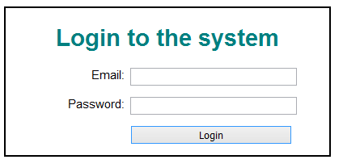

**Figure 1. Login page**



**Figure 2. MVC Diagram**