ASSIGNMENT FOR SESSION AND COOKIE

1. **Using Cookie to store username and password**

Edit a Email application in assignment 4 to add a “Remember me?” checkbook as figure 1. When the checkbox is selected, the email and password will be saved to the cookie in client machine. Whenever user login to the application, program will automatic detect cookie to fills the email and password to the login form.

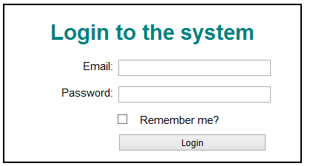

**Figure1. Login page**

1. **Using session object**

Continue edit a login application in assignment for chapter 5 to prevent user accept welcome page without login. When the user accesses the welcome page if he doesn’t login forward him to the login page.

Hint:

* Change the welcome.html to welcome.jsp file.
* When the user login to the system save email to an attribute of the session object.
* Whenever the user access the welcome page, check the email attribute in session object. If the email is exist in session object then display welcome page either display.