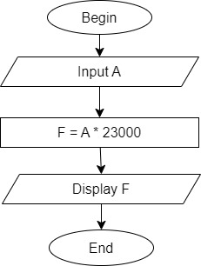

Begin

Input A

F = A \* 23000

Display F

End