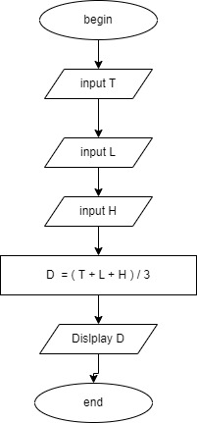

Begin

Input T

Input L

Input H

D = ( T + L + H ) /3