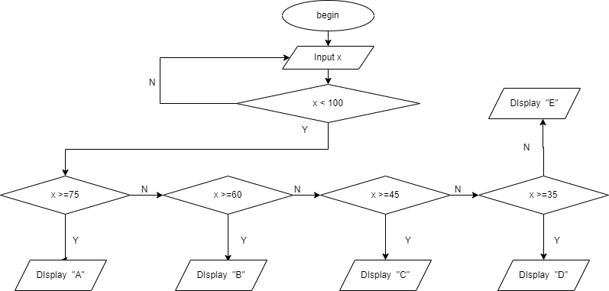

Begin

Input x

For

IF x < 100

And if x >= 75

Display A

Else x >= 60

Display B

Else If x>=45

Display C

Else if x>=35

Display D

Else if < 35 and if x >0

Display E

Else break

ENd