**Hardware test guideline**

**1. Introduction**

We will use ESP32-CAM as a WIFI transmitter. Control Computer can be connected to this WIFI, receiving images from the camera. Through the WIFI of the ESP32-CAM, the control computer can also connect to the Makerbot circuit to read the sensor values and control the motor. The Makerbot circuit will act as a client device, connecting to the ESP32-CAM's WIFI, receiving commands from the computer and transmitting back the sensor values it reads at the same time.

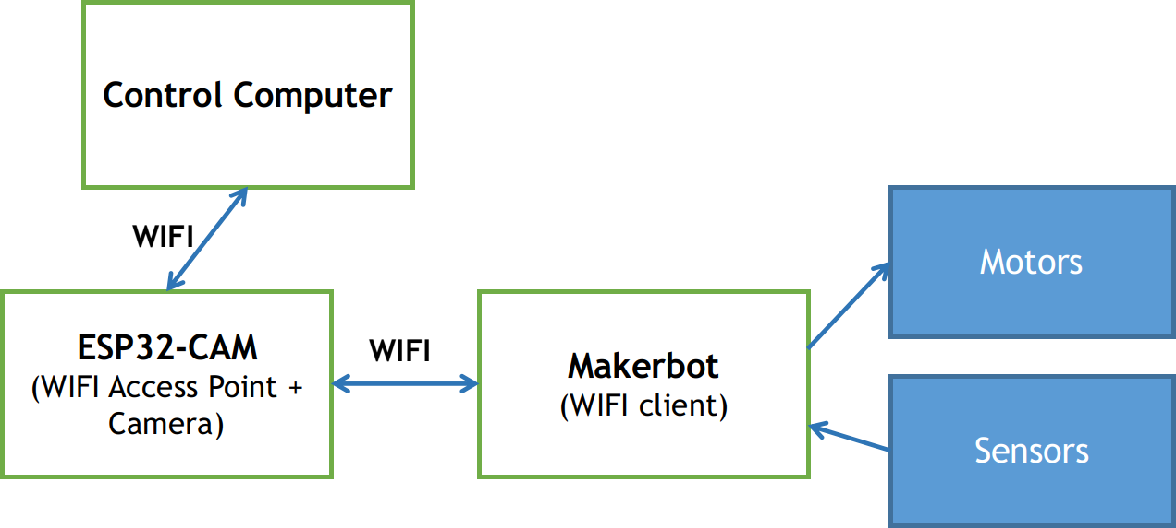

**ESP32-Cam’s Wifi information**

* SSID: VIA-MakerBot-01
* Password: makerbotisfun

**2. Load code with PlatformIO**

We recommend using PlatformIO installed on the code editor Visual Studio Code. After that, you can compile and upload the code to the circuits using PlatformIO.

* Step 1: Open VS Code
* Step 2: Open Extension tab

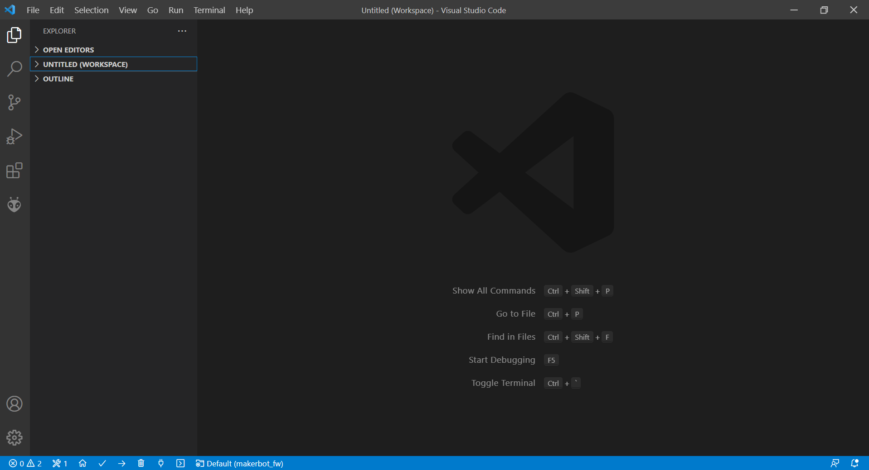

SIDE BAR

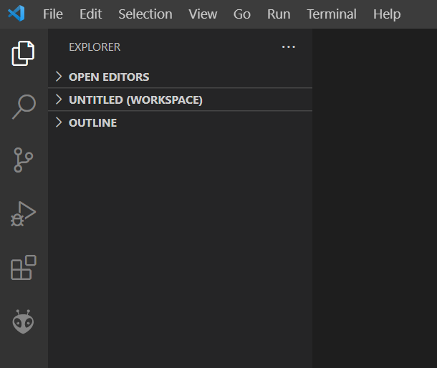

EXTENSION

* Step 3: Search “Platform IO’’ then install

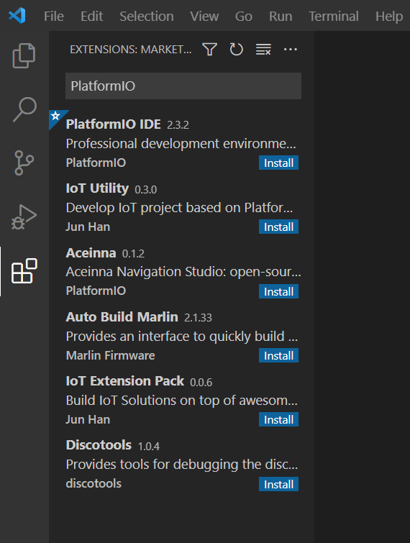

* Step 4: click to icon “Bee head” on Slide Bar



* Step 5: click to ‘’Upload’’ or ‘’Upload and Monitor’’ then code will be loaded to circuit.

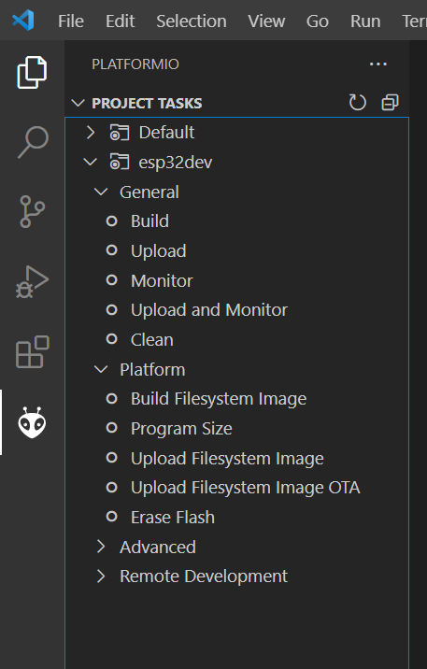

You can view instruction video: <https://www.youtube.com/watch?v=tpS330kW68I>

### 3. Test hardware

**a. Read image from ESP32-CAM using Python code**

To read image from the camera using Python code, your computer needs to install Python and the OpenCV package.

Use Pip to install OpenCV: pip install opencv-python.

You should install Anaconda / Miniconda to manage environments for Python.

Connect to Wifi of ESP32-CAM, then run code in folder: read_esp32_cam/read_cam.py

python read_cam.py

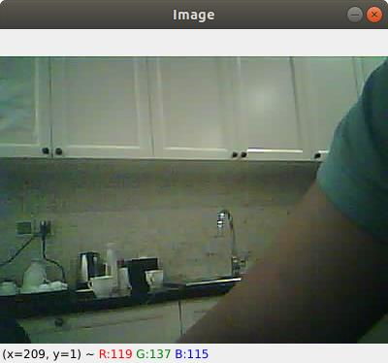

**Image from ESP32-CAM**

**b. Keyboard control**

Install Python environment from file: “keyboard_control/requirements.txt”:

pip install -r requirements.txt.

Run the keyboard control example:

python keyboard_control.py

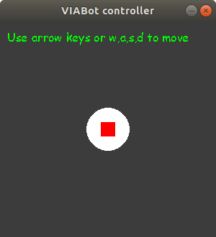

A control window appears as above. Use the arrow keys to try to control Makerbot's motors.

**c. Keyboard control and image reading**

###### python keyboard_control_with_cam.py

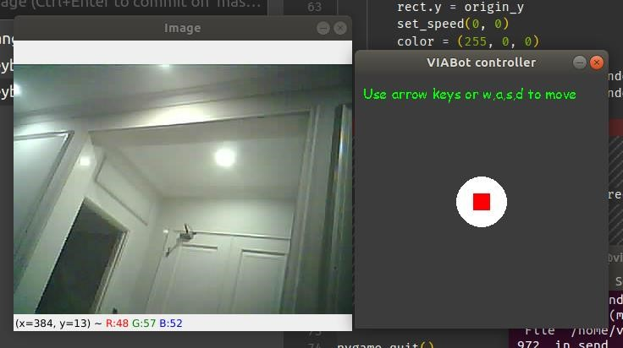

**4. Develop your code**

Based on source code in folder “auto_drive”, you can develop code for your auto-driving car.