 | A | B | C | D | E | F | G | H | I | J
A | 0 | 1 | 1 | 1 | 0 | 1 | 0 | 0 | 0 | 0
B | 1 | 0 | 0 | 1 | 1 | 0 | 1 | 0 | 0 | 0
C | 1 | 0 | 0 | 1 | 0 | 1 | 0 | 0 | 0 | 0
D | 1 | 1 | 1 | 0 | 1 | 1 | 1 | 0 | 0 | 0
E | 0 | 1 | 0 | 1 | 0 | 0 | 1 | 0 | 0 | 0
F | 1 | 0 | 1 | 1 | 0 | 0 | 1 | 1 | 0 | 0
G | 0 | 1 | 0 | 1 | 1 | 1 | 0 | 1 | 0 | 0
H | 0 | 0 | 0 | 0 | 0 | 1 | 1 | 0 | 0 | 0
I | 0 | 0 | 0 | 0 | 0 | 0 | 0 | 1 | 0 | 0
J | 0 | 0 | 0 | 0 | 0 | 0 | 0 | 0 | 1 | 0

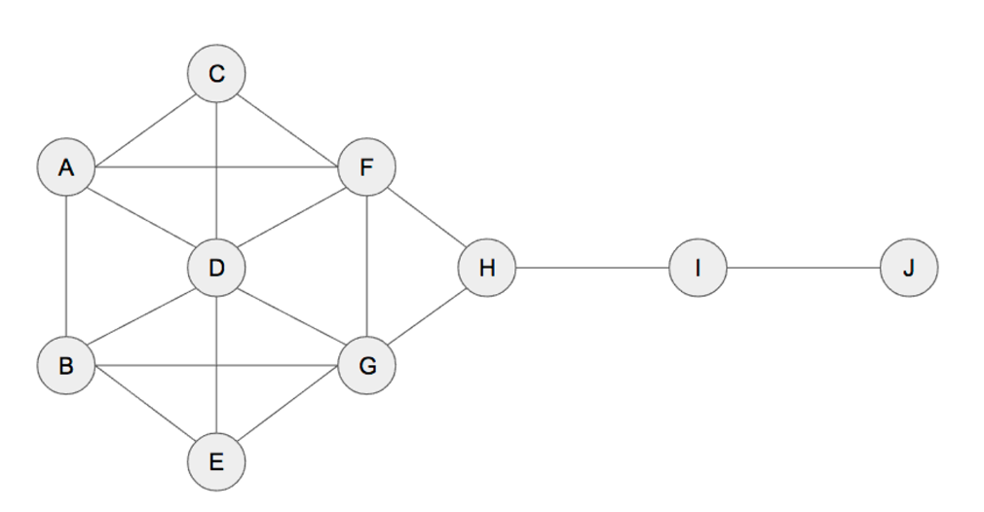
Ta có (n-1)*(n-2) / 2 = (10-1) * (10-2)/ 2 = 36
CB(A)
BC = 1/2 BI = 0 CH = 0 DH = 0 EI = 0 GH = 0
BD = 0 BJ = 0 CI = 0 DI = 0 EJ = 0 GI = 0
BE = 0 CD = 0 CJ = 0 DJ = 0 FG = 0 GJ = 0
BF = 1/3 CE = 0 DE = 0 EF = 0 FH = 0 HI = 0
BG = 0 CF = 0 DF = 0 EG = 0 FI = 0 HJ = 0
BH = 0 CG = 0 DG = 0 EH = 0 FJ = 0 IJ = 0

CB(A) = (1/2 + 1/3) / 36 = 0.0231
CB(B)
AC = 0 AI = 0 CH = 0 DH = 0 EI = 0 GH = 0
AD = 0 AJ = 0 CI = 0 DI = 0 EJ = 0 GI = 0
AE = 1/2 CD = 0 CJ = 0 DJ = 0 FG = 0 GJ = 0
AF = 0 CE = 0 DE = 0 EF = 0 FH = 0 HI = 0
AG = 1/3 CF = 0 DF = 0 EG = 0 FI = 0 HJ = 0
AH = 0 CG = 0 DG = 0 EH = 0 FJ = 0 IJ = 0
CB(B) = (1/2 + 1/3) / 36 = 0.0231
CB(C)
AB = 0 AI = 0 BH = 0 DH = 0 EI = 0 GH = 0
AD = 0 AJ = 0 BI = 0 DI = 0 EJ = 0 GI = 0
AE = 0 BD = 0 BJ = 0 DJ = 0 FG = 0 GJ = 0
AF = 0 BE = 0 DE = 0 EF = 0 FH = 0 HI = 0
AG = 0 BF = 0 DF = 0 EG = 0 FI = 0 HJ = 0
AH = 0 BG = 0 DG = 0 EH = 0 FJ = 0 IJ = 0
CB(C) = 0
CB(D)
AB = 0 AI = 0 BH = 0 CH = 0 EI = 0 GH = 0
AC = 0 AJ = 0 BI = 0 CI = 0 EJ = 0 GI = 0
AE = 1/2 BC = 1/2 BJ = 0 CJ = 0 FG = 0 GJ = 0
AF = 0 BE = 0 CE = 1 EF = 1/2 FH = 0 HI = 0
AG = 1/3 BF = 1/3 CF = 1/2 EG = 0 FI = 0 HJ = 0
AH = 0 BG = 0 CG = 0 EH = 0 FJ = 0 IJ = 0
CB(D) = (1/2 + 1/3+1/2+1/3+1+1/2+1/2) / 36 = 0.1019
CB(E)
AB = 0 AI = 0 BH = 0 CH = 0 DI = 0 GH = 0
AD = 0 AJ = 0 BI = 0 CI = 0 DJ = 0 GI = 0
AC = 0 BC = 0 BJ = 0 CJ = 0 DG = 0 GJ = 0
AF = 0 BD = 0 CD = 0 DF = 0 FH = 0 HI = 0
AG = 0 BF = 0 CF = 0 DG = 0 FI = 0 HJ = 0
AH = 0 BG = 0 CG = 0 DH = 0 FJ = 0 IJ = 0
CB(E) = 0
CB(F)
AB = 0 AI = 1 BH = 0 CH = 1 DI = 1/2 GH = 0
AD = 0 AJ = 1 BI = 0 CI = 1 DJ = 1/2 GI = 0
AC = 0 BC = 0 BJ = 0 CJ = 1 EG = 0 GJ = 0
AE = 0 BD = 0 CD = 0 DE = 0 EH = 0 HI = 0
AG = 1/3 BE = 0 CE = 0 DG = 0 EI = 0 HJ = 0
AH = 1 BG = 0 CG = 1/2 DH = 1/2 EJ = 0 IJ = 0
CB(F) = (1/3+1+1/2+1+1+1+1/2+1/2+1/2) / 36 = 0.2315
CB(G)
AB = 0 AI = 0 BH = 1 CH = 0 DI = 1/2 FH = 0
AD = 0 AJ = 0 BI = 1 CI = 0 DJ = 1/2 FI = 0
AC = 0 BC = 0 BJ = 1 CJ = 0 EF = 1/2 FJ = 0
AE = 0 BD = 0 CD = 0 DE = 0 EH = 1 HI = 0
AF = 0 BE = 0 CE = 0 DF = 0 EI = 1 HJ = 0
AH = 0 BF = 1/3 CF = 0 DH = 1/2 EJ = 1 IJ = 0
CB(F) = (1+1+1+1/3+1/2+1/2+1/2+1/2+1+1+1) / 36 = 0.2315

CB(H)
AB = 0 AI = 1 BF = 0 CF = 0 DI = 1 GF = 0
AD = 0 AJ = 1 BI = 1 CI = 1 DJ = 1 GI = 1
AC = 0 BC = 0 BJ = 1 CJ = 1 EG = 0 GJ = 1
AE = 0 BD = 0 CD = 0 DE = 0 EF = 0 FI = 1
AG = 0 BE = 0 CE = 0 DG = 0 EI = 1 FJ =1
AF = 0 BG = 0 CG = 0 DF = 0 EJ = 1 IJ = 0
CB(H) = 14 / 36 = 0.3889
CB(I)
AB = 0 AH = 0 BF = 0 CF = 0 DH = 0 GF = 0
AD = 0 AJ = 1 BH = 0 CH = 0 DJ = 1 GH = 0
AC = 0 BC = 0 BJ = 1 CJ = 1 EG = 0 GJ = 1
AE = 0 BD = 0 CD = 0 DE = 0 EF = 0 FH = 0
AG = 0 BE = 0 CE = 0 DG = 0 EH = 0 FJ =1
AF = 0 BG = 0 CG = 0 DF = 0 EJ = 1 HJ = 1
CB(I) = 8 / 36 = 0.2222

CB(J)
AB = 0 AH = 0 BF = 0 CF = 0 DH = 0 GF = 0
AD = 0 AI = 0 BH = 0 CH = 0 DJ = 0 GH = 0
AC = 0 BC = 0 BI = 0 CI = 0 EG = 0 GI = 0
AE = 0 BD = 0 CD = 0 DE = 0 EF = 0 FH = 0
AG = 0 BE = 0 CE = 0 DG = 0 EH = 0 FI =0
AF = 0 BG = 0 CG = 0 DF = 0 EI = 0 HI = 0

CB(H) = 0
NODE | KẾT QUẢ
A | 0.0231
B | 0.0231
C | 0
D | 0.1019
E | 0
F | 0.2315
G | 0.2315
H | 0.3889
I | 0.2222
J | 0

CLOSENESS CENTRALITY
CC(A)
AB = 1, AC = 1, AD = 1, AE = 2, AF = 1, AG = 2, AH = 2, AI = 3, AJ = 4
CC(A) = 9/17
CC(B)
BA = 1, BC = 2, BD = 1, BE = 1, BF = 2, BG = 1, BH = 2, BI = 3, BJ = 4
CC(B) = 9/17
CC(C)
CA = 1, CB = 2, CD = 1, CE = 2, CF = 1, CG = 2, CH = 2, CI = 3, CJ = 4
CC(C) = 9 / 18
CC(D)
DA = 1, DB = 1, DC = 1, DE = 1, DF = 1, DG = 1, DH = 2, DI = 3, DJ = 4
CC(D) = 9 / 15
CC(E)
EA = 2, EB = 1, EC = 2, ED = 1, EF = 2, EG = 1, EH = 2, EI = 3, EJ 4
CC(E) = 9/18
CC(F)
FA = 1, FB = 2, FC = 1, FD = 1, FE = 2, FG = 1, FH = 1, FI = 2, FJ = 3
CC(F) = 9/14
CC(G)
GA = 2, GB = 1, GC = 2, GD = 1, GE = 1, GF = 1, GH = 1, GI = 2, GJ = 3
CC(G) = 9 / 14
CC(H)
HA = 2, HB = 2, HC = 2, HD = 2, HE = 2, HF = 1, HG = 1, HI = 1, HJ = 2
CC(H) = 9 / 15
CC(I)
IA = 3, IB = 3, IC = 3, ID = 3, IE = 3, IF = 2, IG = 2, IH = 1, IJ = 1
CC(I) = 9/21
CC(J)
JA = 4, JB = 4, JC = 4, JD = 4, JE = 4, JF = 3, JG = 3, JH = 2, JI = 1
CC(J) = 9/29
 | A | B | C | D | E | F | G | H | I | J
A | 0 | 1 | 1 | 1 | 2 | 1 | 2 | 2 | 3 | 4
B | 1 | 0 | 2 | 1 | 1 | 2 | 1 | 2 | 3 | 4
C | 1 | 2 | 0 | 1 | 2 | 1 | 2 | 2 | 3 | 4
D | 1 | 1 | 1 | 0 | 1 | 1 | 1 | 2 | 3 | 4
E | 2 | 1 | 2 | 1 | 0 | 2 | 1 | 2 | 3 | 4
F | 1 | 2 | 1 | 1 | 2 | 0 | 1 | 1 | 2 | 3
G | 2 | 2 | 2 | 1 | 1 | 1 | 0 | 1 | 2 | 3
H | 2 | 2 | 2 | 2 | 2 | 1 | 1 | 0 | 1 | 2
I | 3 | 3 | 3 | 3 | 3 | 2 | 2 | 1 | 0 | 1
J | 4 | 4 | 4 | 4 | 4 | 3 | 3 | 2 | 1 | 0

NODE | SUM | CC(V)
A | 17 | 9/17 = 0.5294
B | 17 | 9/17 = 0.5294
C | 17 | 9/18 = 0.5
D | 15 | 9/15 = 0.6
E | 15 | 9/18 = 0.5
F | 14 | 9/14 = 0.6429
G | 15 | 9/14 = 0.6429
H | 15 | 9/15 = 0.6
I | 21 | 9/21 = 0.4286
J | 29 | 9/29 = 0.3103

