SegDSee 4
User’s Manual

Contents

Contents 1
Introduction 2
Starting the program 2
Using the program 3
Open folder to browse SEG-D, SEG_B files 3
Display mode selection. 5
Scaling and Gain Setup 6
Scale Panel 6
Change scale and gain by mouse wheel 7
Zoom buttons. 7
Seismic Channel Sets Display 8
Display seismic file headers 10
Seismic Data Processing 12
Processing parameters setup 12
Band pass filter 13
Automatic gain control (AGC) 14

Introduction
The SegDSee program displays headers and seismic data from disk SEG-D or SEG-B file
- Single shot file and Lacey Tape on Disk (LTOD) encapsulation is supported
- Currently supported formats: SEG-D Rev 0 - 3.1 and Standard SEG-B

Starting the program

Double click program icon by mouse:  Main window will be shown | 

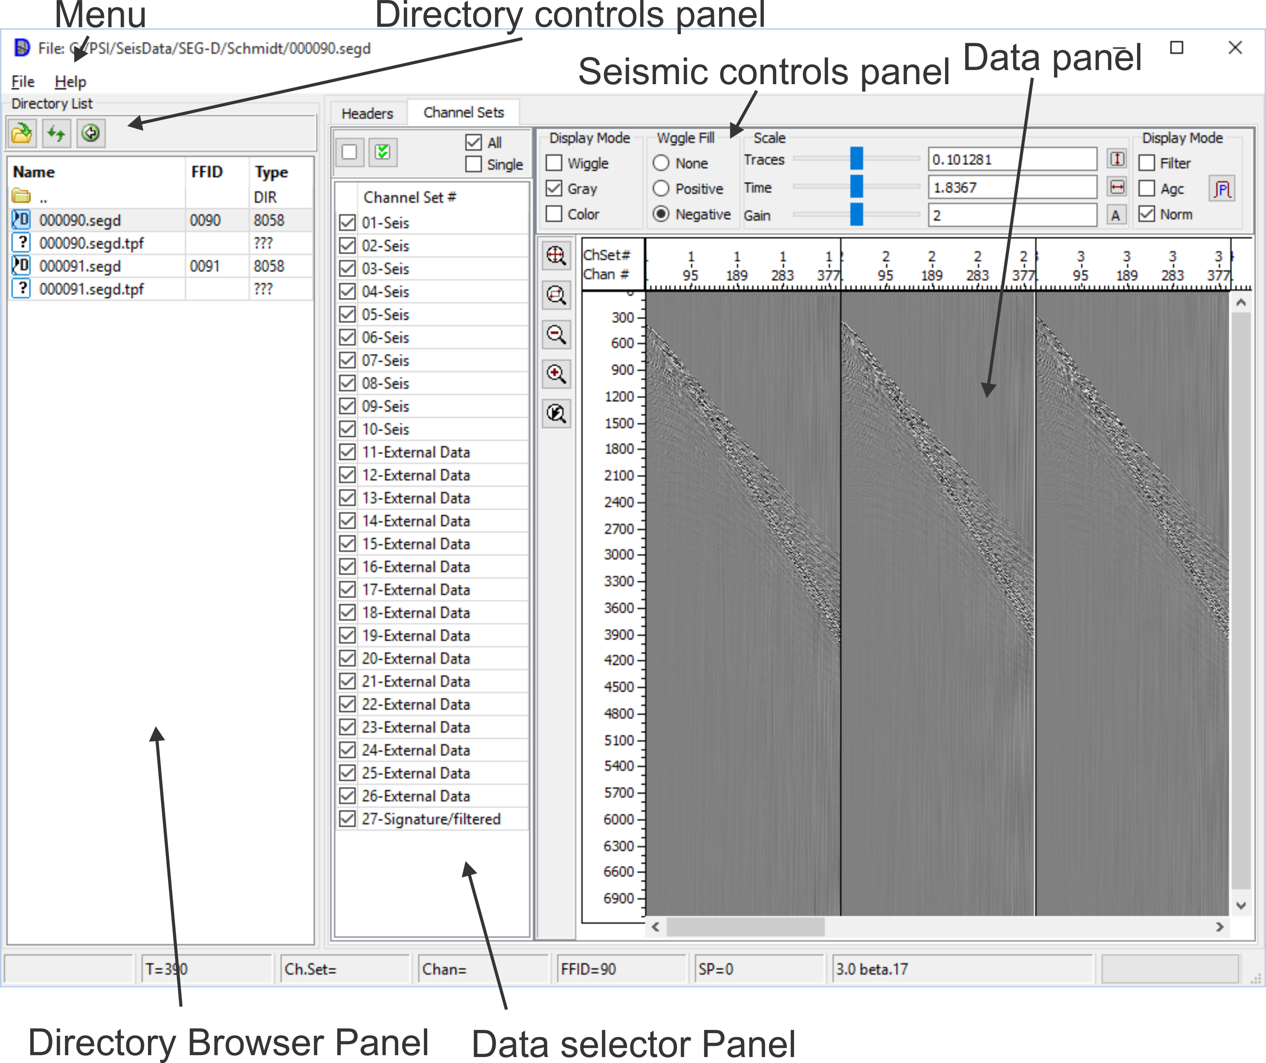

Using the program

Open folder to browse SEG-D, SEG_B files

Select “File” → “Open Directory” menu item. “Open” dialog will be shown.
Use it for directory selection.

Buttons in file browser panel:

- Return to the previous directory
- Refresh directory list
- Open directory selection dialog

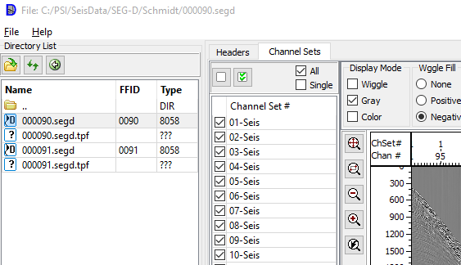

To display needed file select it by mouse. Also it is possible to select file by ↑ and ↓ arrow keys from keyboard.

Selected valid SEG-D or SEG-B file will be displayed in Data Panel.

For going to upper directory level double click or press Enter on item in the list.

LTOD file content is opening by double clicking or pressing Enter on corresponding item.

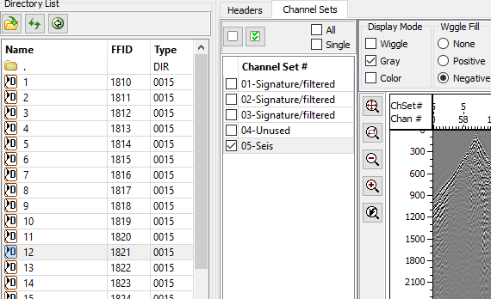

To exit from LTOD content list double click or press Enter on item.

Display mode selection.

“Display mode” and “Wiggle Fill” panels

The modes and corresponding controls’ positions are shown in the following table

 | Mode | Controls position | Seismic sample
1 | Wiggle | 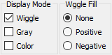 | 
2 | Wiggle + Positive Fill (Variable area) | 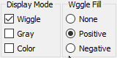 | 
3 | Wiggle + Negative Fill | 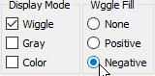 | 
4 | Variable density (Gray levels) | 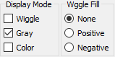 | 
5 | Color | 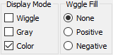 | 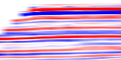
6 | Color + Wiggle | 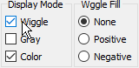 | 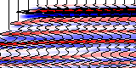

Display Mode panel controls | Description
Wiggle | Wiggle mode
Gray | Variable density mode
Color | Color mode

Wiggle Fill panel controls | Description
None | No wiggle fill
Positive | Positive fill
Negative | Negative fill

Scaling and Gain Setup

Scale Panel

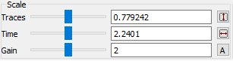

Scale panel controls | Description
Traces | Set trace number per centimeter
 | Fit seismic section to window horizontally
Time | Set time scale (cm/sec)
 | Fit seismic section to window vertically
Gain | Wiggle Gain control
 | Automatically adjust current wiggle gain, using maximal amplitude values of selected trace
Gain | Gain control

To adjust a value by mouse, move mouse cursor to the corresponding slider (), then press left mouse button, and (keeping it pressed) move the slider. Current value of the parameter will be shown in edit control that is on the right of the slider, and seismic image will be repainted to reflect the changes.

Change scale and gain by mouse wheel

Mouse Position during Wheel rotating | Action
In the Traces input filed,  In the Time Axis | Change horizontal scale
In the Time input field,  In the Headers Axis | Change vertical scale
In the Seismic Section window | Zoom-In/Zoom-out in both directions
It the Gain-w input field | Change Wiggle mode gain
In the Gain-с input field | Change Color mode gain

Zoom buttons.

Button | Description
 | Fit all the image to seismic window size
 | Zoom by window. Press this button then draw a rectangle on the seismic window (move mouse cursor to first corner of the rectangle, press left mouse button, and keeping it pressed, move mouse to set desired size). Selected region will be zoomed to size of the seismic window.
 | Return to previous zoom
 | Zoom in (1.5 times)
 | Zoom out (1.5 times)

Seismic Channel Sets Display

To display seismic view panel select “Channel Sets” tab.

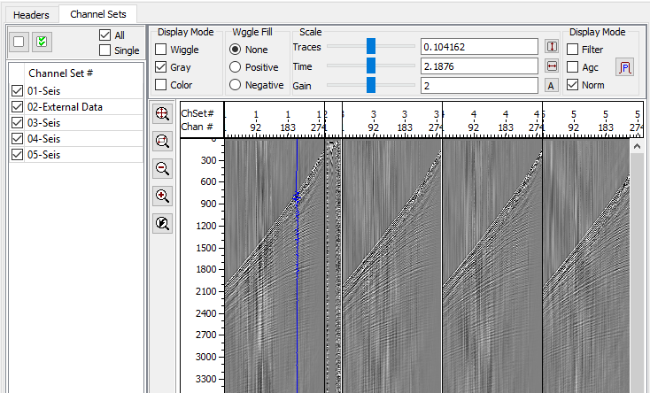

When you move mouse pointer in the seismic window, values corresponding current position will be shown in status bar at the bottom of the main window

T | Time (ms) | on mouse moving
Ch.Set | Channel set # | on trace selecting
Chan | Cannel # | on trace selecting
FFID | FFID # | on trace selecting
SP | Shot Point # (if exists) | on trace selecting

Left panel contains channel set list:

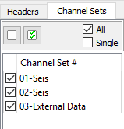

The panel has the following controls:

Control | Name | Description
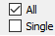 | Selection mode | All – all channel sets are always selected , Single – only marked
 | unmark all sets | in Single mode
 | mark all sets | in Single mode

In “All” selection mode all channel sets always will shown

In “Single” mode you should check channel sets, which need to be shown and uncheck others.

Display seismic file headers

To activate headers panel select “Headers” tab.

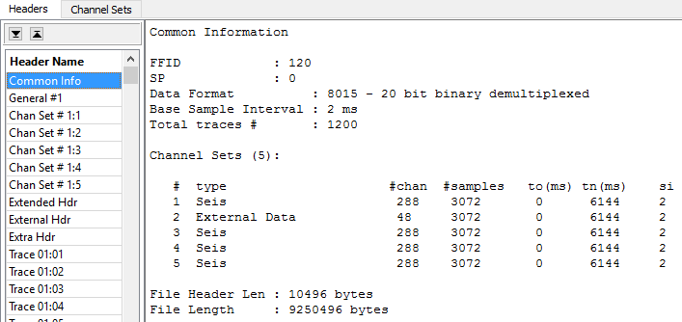

In the left panel, headers list is shown, at the right – content of the selected header.

“Common info” item is not a header, it holds common description of current SEG-D or SEG-B file.

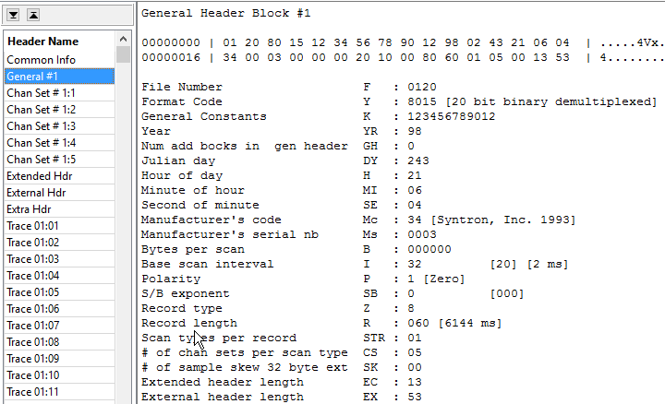

At the top of content window selected header bytes are displayed (in hexadecimal and ASCII formats), and after that these data are shown in parsed form.

Header name
General Header Block #1

Data Dump
00000000 | 01 20 80 15 12 34 56 78 90 12 98 02 43 21 06 04 | .....4Vx....C!..
00000016 | 34 00 03 00 00 00 20 10 00 80 60 01 05 00 13 53 | 4.........`....S

Parsing
File Number F : 0120
Format Code Y : 8015 [20 bit binary demultiplexed]
General Constants K : 123456789012
Year YR : 98
Num add bocks in gen header GH : 0
Julian day DY : 243
Hour of day H : 21
Minute of hour MI : 06
Second of minute SE : 04
Manufacturer's code Mc : 34 [Syntron, Inc. 1993]
Manufacturer's serial nb Ms : 0003
Bytes per scan B : 000000
Base scan interval I : 32 [20] [2 ms]
Polarity P : 1 [Zero]
S/B exponent SB : 0 [000]
Record type Z : 8
Record length R : 060 [6144 ms]
Scan types per record STR : 01
# of chan sets per scan type CS : 05
# of sample skew 32 byte ext SK : 00
Extended header length EC : 13
External header length EX : 53

Seismic Data Processing

Processing is applied to trace before it will be shown on screen. Here is the processing modules list:

- band pass filter
- automatic gain control (AGC)

Processing parameters setup
To set the processing parameters press button or select “Processing” → “Parameters” menu item, after that “Processing” dialog appears. Enter parameters needed. To accept the parameters press “Apply” or “OK” button. “OK” also closes the dialog. “Close” button discards any changes and closes the dialog.

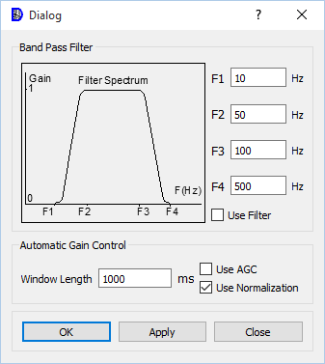

Band pass filter

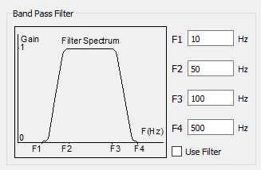

Enter filter cut frequencies as it is shown in the picture and check “Use filter”, if you want to use the filter.

Original data | Filtered data
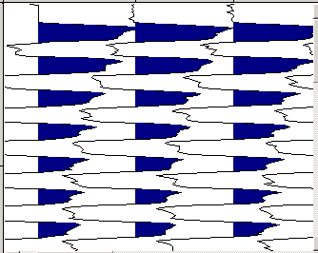 | 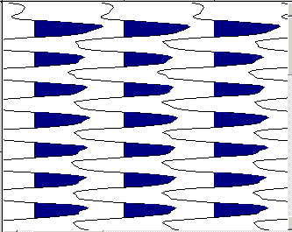

Automatic gain control (AGC)

In “Use Normalization” mode maximum amplitude value is calculated for trace and each sample is divided to its value.

In “Use AGC” mode “Window length” parameter sets AGC window length. AGC module moves the window down the trace sample-by-sample and calculates a scale factor at each location. The scale factor is equal to the RMS amplitude in the window.

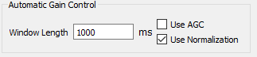

Enter “Window length” and check “Use AGC”, if you want to use the AGC.

Original data | AGC applied
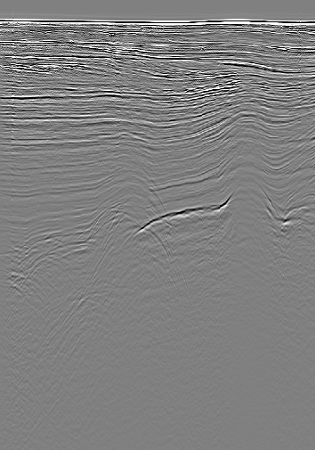 | 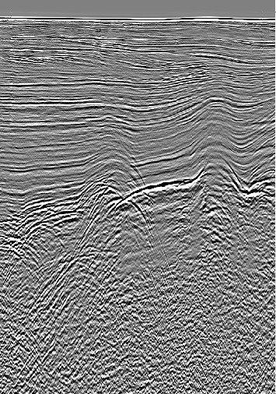

© Sergey Pavlukhin
Yuzhno-Sakhalinsk, Russia
2026

