Robo-Wars

User Manual

Contents

Introduction 2

Part A - How to Use the Application Interface 2

Starting the Application 2

Title Screen 2

Starting a New Game 3

The Player Selection Screen 3

Part B – The Game Interface 6

The Confirmation Screen and Dialog 6

The Main Game Screen 7

Performing Actions 8

Moving 8

Shooting 8

Canceling 8

Player Elimination 9

Declaring a Winner 9

Part C - Game Rules 10

Team Colors 10

Starting Spaces 10

A Game Turn 11

Moving a Piece 11

Shooting with a Piece 11

A Game Round 11

Fog of War 11

Winning the Game 11

Pieces and Their Points 11

Application Requirements 12

Known Issues 12

# Introduction

Welcome to Robo-Wars! Robo-Wars is a simple game that can be played by 2, 3, or 6 players, of any mix of human and AI players. This document is divided into three (3) main sections: How to Use the Application Interface (including how to Start the Application); How to Use the Game Interface; and the Game Rules.

# Part A - The Application Interface

This section of the document deals with how to run the game and how to set up and start a game. It covers Starting the Application and the various Menus used before a game begins. First is starting the application.

## Starting the Application

To start the application, locate the downloaded executable Java jar file called **RoboWars.jar**. Simply double-clicking the **RoboWars.jar** file should start the application. If it does not, right-click the **RoboWars.jar** file and select **Open with…,** find the **Java(TM) Platform SE Binary**, select it, and click the **OK button**. Note the application has been designed for the Windows operating system and requires a Java installation (see Application Requirements) to work properly. Starting the application may be different for other operating systems not documented here.

## Title Screen

After starting the application, you should see the Title screen. The Title screen should look similar to Figure 1 below:

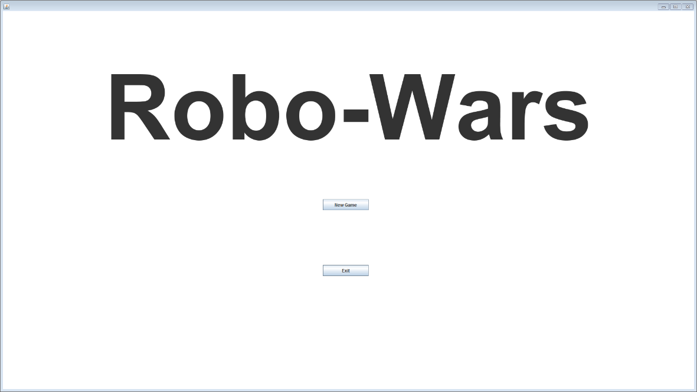

Figure : Robo-Wars Title Screen

The Title screen is the starting screen of the application and welcomes you with the name of the application, **Robo-Wars**, and is also the screen from which to begin a new game. Starting a new game can be accomplished by clicking the **New Game button**. Exiting the application can be accomplished by clicking the **Exit button**. Note that you may also exit the application at any time by simply clicking the **Close button** (the red “x”) in the top right corner of the application window.

### Starting a New Game

After the application has started and the Title Screen has appeared, the **New Game button** will be present just below the title on the Title screen. The **New Game button** is circled in red in Figure 2 below. Click the **New Game button** to begin a new game.



Figure : Selecting New Game on Title Screen

### The Player Selection Screen

After clicking the **New Game button**, the Player Selection screen will appear. The Player Selection Screen is where the game is established before beginning. The Player Selection screen should look similar to Figure 3 below.

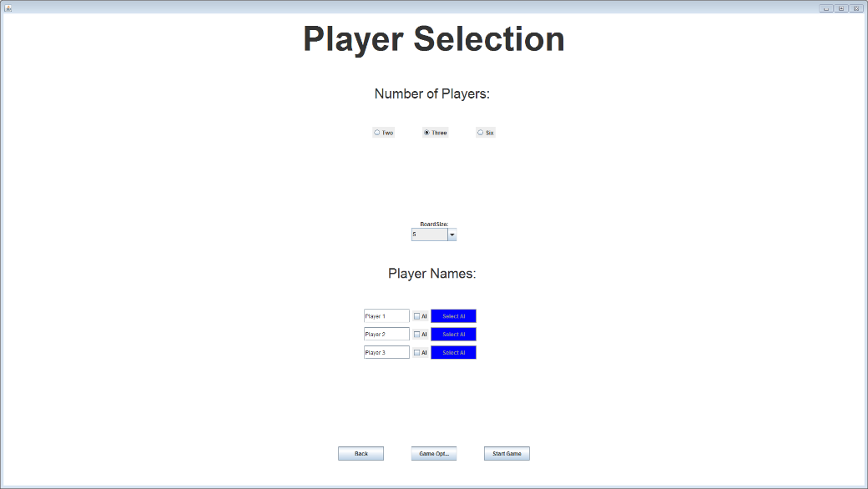

Figure : Player Selection Screen

Within the Player Selection Screen, the number of players may be selected by selecting one of the **radio buttons** near the top of the screen just below the Number of Players heading, which is itself just below the title of the Player Selection screen. The collection of **radio buttons** are circled in red in Figure 4 below. Select one of the **radio buttons** to change the number of players.

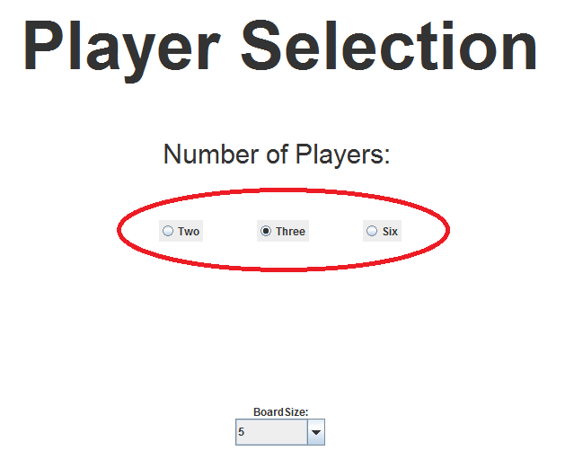

Figure : Number of Player Radio Buttons

After selecting the number of players, the size of the board may be selected. To do this, select one of the board sizes from the **drop-down menu** below the **radio buttons** that were used to select the number of players. The **drop-down** menu should be immediately below the Board Size heading. Note the board size may only be changed when the chosen number of players is three. The **drop-down menu** is circled in red in Figure 5 below. Select one of the board sizes from the **drop-down menu** to change the board size.

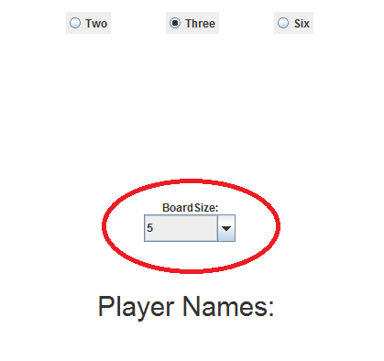

Figure : Board Size Selection Dropdown Menu

Next, the names of each of the players may be entered and the players may all be chosen to be Human or AI controlled. Each player has one **textbox** to enter the name of the player and one **checkbox** to indicate if the player is AI controlled or Human controlled. Note the number of **textboxes** and **checkboxes** depends on the chosen number of players and there is only one of each per player. The **textboxes** and **checkboxes** for each player will be just below the board size **drop-down menu**, if it is visible, and above the three **buttons** near the bottom of the screen. The **textboxes** and **checkboxes** are circled in red Figure 6 below. Enter each player’s desired name in the player’s corresponding **textbox** to change the player’s name and check the player’s corresponding **checkbox** to change the player to being controlled by AI or uncheck the **checkbox** to change the player to being Human controlled.

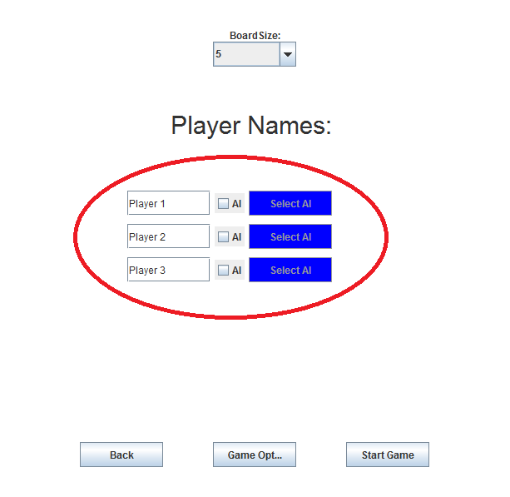

Figure : Player Information Menus

Once the desired number of players, the size of the board, the name of each player, and the control style of each player has been set, a game may be started by clicking the **Start Game button**. The **Start Game button** will begin a new game based on the parameters in the Player Selection screen. However, to cancel the selections and return to the Title screen, click the **Back button**. The **Back button** will cancel the selections within the Player Selection screen and the application will return to the Title Screen. The **Start Game button** and the **Back button** are circled in red in Figure 7 below. Note the **Game Options button** is also circled in red and not explained here because the game options are not functioning (see Known Issues). Click the **Start Game button** to start the game with the selected parameters.

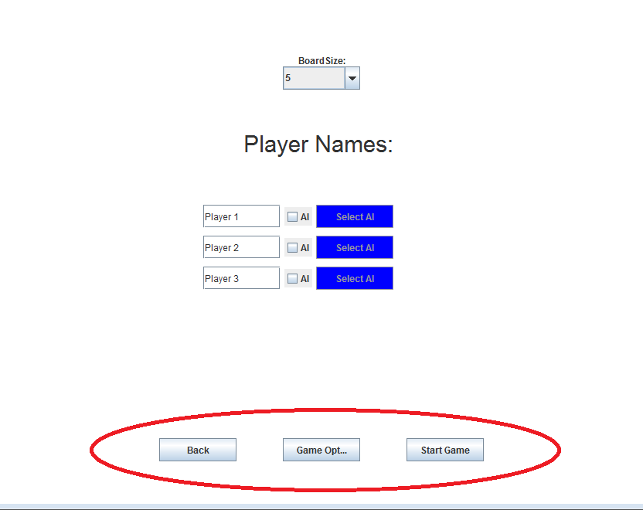

Figure : Start Game Button

# Part B – The Game Interface

Now that you have started a game, you doubtless will want to know how to play it. This section deals with the mechanics of using the game interface, while the rules and the logic of the game are handled in Part C.

## The Confirmation Screen and Dialog

When the game starts, you will see the **confirmation screen.** It will display a **confirmation dialog** stating whose turn is about to start. The game will not resume until the **OK button** is clicked. The confirmation dialog is circled in red in Figure 8 below. This screen will also be displayed after a player ends their turn. To continue the game and begin the next player’s turn, click the **OK button**.

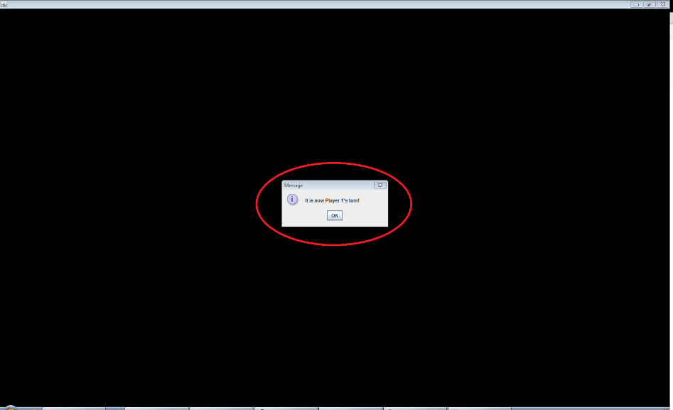

Figure : Confirmation Screen

## The Main Game Screen

After clicking the **OK button** within the **confirmation dialog**, the named player’s turn will begin. The Game screen will appear and the game board will be within it. On the left side of the screen is the **Player bar**, which shows the active player’s active piece and lists its attributes. The Game screen should look similar to Figure 9 below. The active piece of the active player within the **Player bar** has been circled in red in the image below.

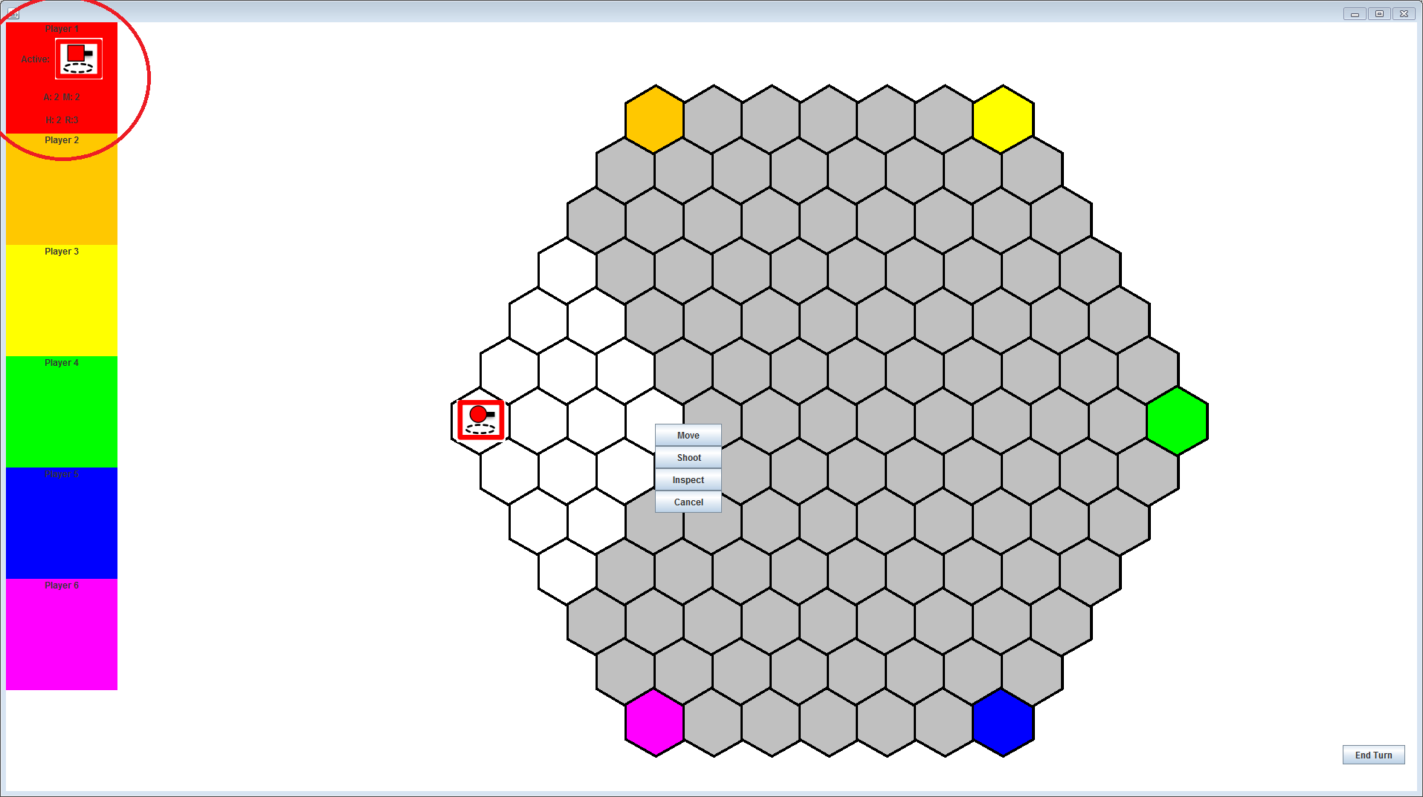

Figure : The Game Screen

The active piece of the active player within the **Player bar** should look similar to Figure 10 below where the active piece of the active player has been circled in red and indicates which piece is currently active. This is located on the left side of the Game screen. The **Player bar** will change after each turn to show the correct active piece for the active team and its attributes.

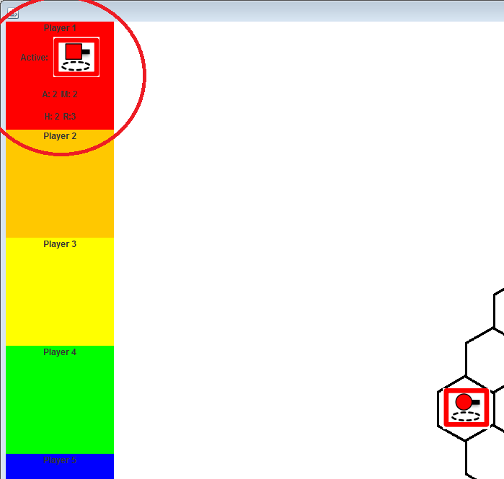

Figure : The Player Bar

## Performing Actions

To perform any action during a player’s turn, **left click** on a **hexagon** on the **game** **board** within the Game screen. Upon **clicking** a **hexagon**, the **Context menu** will appear. The **Context menu** contains all the **buttons** for performing all the allowable actions.

### Moving

The **Move button** will move the active player’s active piece to the **clicked hexagon**, provided the active piece has enough remaining mobility points to move to the **clicked hexagon** (see Game Rules).

### Shooting

The **Shoot button** will shoot the **clicked hexagon** using the active player’s active piece and damage all robots occupying the hexagon, provided the active piece has the necessary range and has not yet shot (see Game Rules).

### Canceling

Finally, the **Cancel button** will simply hide the **Context menu**. Note the **Inspect button** is not mentioned because it does not function (see Known Issues). The **Context menu** is circled in red in Figure 11 below. **Left click** a **hexagon** to bring up the context menu, and then click one of the **action buttons** to perform an action.

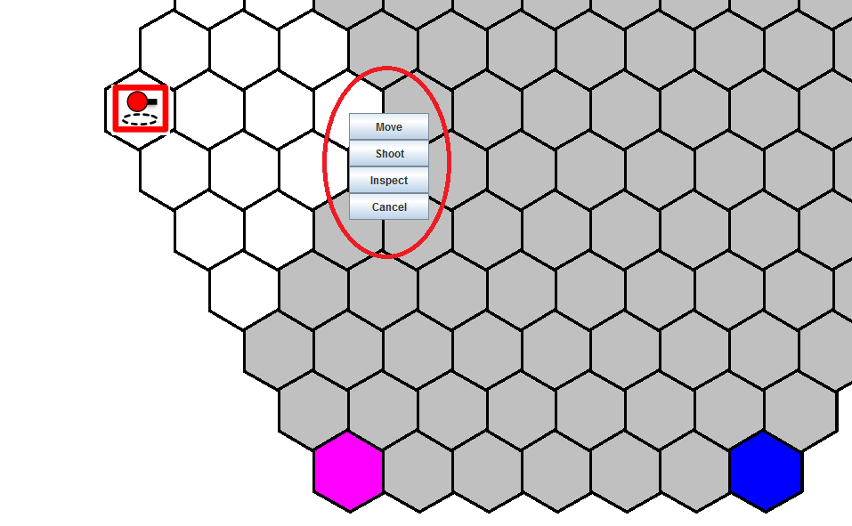

Figure : The Context Menu

## Player Elimination

If at any moment while the match is being played a player is eliminated, a **confirmation dialog** will appear indicating which player has been eliminated. A player is eliminated when the health of all their pieces has been depleted to zero. If a player is eliminated, they are no longer part of the game and will be skipped in subsequent rounds (see Game Rules). Once a player is eliminated, a screen similar Figure 12 below should appear. Click the **OK button** within the **confirmation dialog** to continue the game with the remaining players.

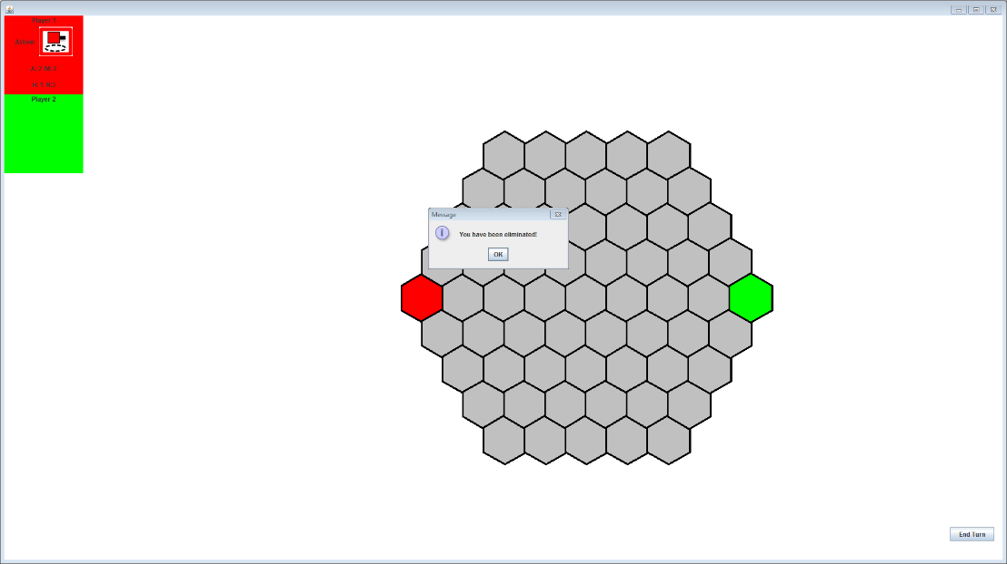

Figure : Player Elimination Dialog

## Declaring a Winner

If after a player has been eliminated there is only one player remaining, then the game is over and the remaining player has won (see Game Rules). A screen similar to the black screen that appears prompting the currently active player to begin their turn will appear indicating that the game is over and the last remaining player has won. The screen will be completely black and a **confirmation dialog** will appear naming the winner of the match. The screen should look similar to the screen shown in Figure 13 below. Click the **OK button** within the **confirmation dialog** to return to the Title Screen.

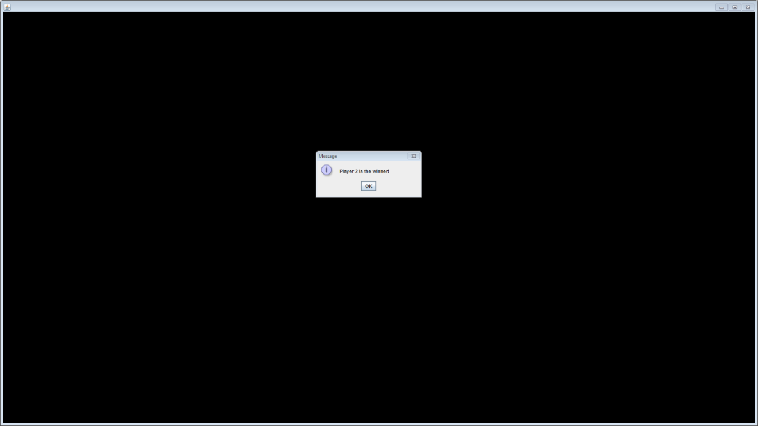

Figure : The Victory Screen

# Part C - Game Rules

In order to play the game, it is useful to know the rules and logic of the game. This section is meant to explain the rules of the game to a new player sufficient for them to understand what is going on as they play a game. First, team color will be discussed.

## Team Colors

The team color of each player during the match is dictated by the number of players and the positioning of each team’s home space is dictated by the color of the team. The colors used for each team are listed below for each number of allowable players. Each player is assigned a color in the order that the team names are entered on the Player Selection screen (see the Player Selection screen in the Starting a New Game section).

* Two players: The red and green team colors are used.
* Three players: The red, yellow, and blue team colors are used.
* Six players: All colors are used. The colors are: red, orange, yellow, green, blue, and purple, in that order.

## Starting Spaces

Each robot of each team will enter the game at their respective home space. A team’s home space is dictated by the team’s color (see the Game screen in the Playing the Game section to see the positioning of each home space) and any number of any robots, including those from opposing teams, may occupy the same hexagon space.

## A Game Turn

A game turn consists of one team player moving their active piece (if desired) and shooting a space with their active piece (if desired).

### Moving a Piece

The active piece’s mobility points are decreased by one each time that piece is moved one space. A move covering more than one space will consume one mobility point for each space covered by the move. The active piece is not allowed to continue moving once it has spent all of its mobility points.

### Shooting with a Piece

The active piece may shoot once during its turn and may shoot spaces in any direction within range of its range points. A space is within range if the distance, measured by the number of spaces, between the space the active piece is occupying and another space is less than or equal to the active piece’s range points. When the active piece shoots a space, the health points of any piece from any team occupying the shot space will be decreased by the attack points of the shooting piece. A piece is considered to be alive if it has at least one health point. If a piece’s health points deplete to zero, it is eliminated and is no longer part of the match. At the end of the turn, the active piece’s mobility points are restored.

## A Game Round

A game round consists of each player taking a turn with each of the pieces, as follows. First, the red player (or next player in turn order if the red player has been eliminated) takes a turn using its piece possessing the highest mobility points. The next team in turn order will likewise take its turn using its piece possessing the highest mobility points. This continues until each player still in the game has done this. After this, the first player that still has a piece left to take a turn takes a turn with their next highest-mobility piece. Play then proceeds in this manner until there are no players with robots left to move. When all live pieces have taken their turn, the game round ends. A new round then begins.

## Fog of War

Each team can see all of its own pieces and will also be able to see any pieces belonging to their opponents that are within range of at least one of their own pieces, which is dictated by each piece’s range points. As a piece moves, the visibility of pieces belonging to opponent teams may change depending on the positioning and range points of each piece of the active team.

## Winning the Game

As the match proceeds, teams will be eliminated once all of their pieces are eliminated. When a team is eliminated and there is only one team remaining, the match is over and the last remaining team has won the match.

## Pieces and Their Points

The different types of pieces that each team will possess and the points assigned to each attribute of each type of piece is listed here. Note the pieces shown are the images of the pieces for the red team. The color of each piece will match the color of its team.

* **Scout**:
  + 
  + Health Points: 1
  + Attack Points: 1
  + Mobility Points: 3
  + Range Points: 2
* **Sniper**:
  + 
  + Health Points: 2
  + Attack Points: 2
  + Mobility Points: 2
  + Range Points: 3
* **Tank**:
  + 
  + Health Points: 3
  + Attack Points: 3
  + Mobility Points: 1
  + Range Points: 1

# Application Requirements

In order to run the application, the computer system being used to run the application must have Java 8 (Java 1.8) installed. The application has been designed to run on the Windows operating system, and it is recommended the application be run on the Windows operating system. It also recommended that a minimum screen resolution of 1920x1080 be used to fully enjoy the application as the larger board size will require a larger amount of screen space. A functional mouse will also be required to perform clicks and a keyboard will be necessary to enter minimal amounts of textual information.

# Known Issues

1. The **Game Options button** within the Player Selection screen is functional and will show the Game Options screen, but the functionality of the game options has not been implemented. That is, clicking the **Game Options button** will display the Game Options screen, but changing the game options and clicking the **Save button** in the bottom right corner of the Game Options screen will have no impact on how the game is played. Thus, this functionality has been omitted from the manual.
2. The **Select AI buttons** one the Player Selection screen do not function. The purpose of the **Select AI buttons** is to allow users to select the AI program that will control a specific AI controlled player. The interfaces for selecting the AI have mostly been implemented, but the functionality of retrieving the AI program and applying its program to the AI controlled player have not been implemented. The application currently uses a default AI program to control all AI controlled players.
3. The Fog of War (only showing the pieces of other opponents within visible range of the active player’s pieces) malfunctions during gameplay for reasons yet to be discovered. The Fog of War normally functions well and only displays the pieces of opponents within the visible range of the active player’s pieces, but periodically malfunctions and displays pieces on the game board that should not be visible to the active player.
4. The Shot animation does not animate. The animation is supposed to animate a yellow star-like image for half of a second when a piece shoots to mimic a shot and then a mushroom cloud appears on the space that was shot for another half of a second. This animation was lost during integration. Work is being done to regain the shot animation.
5. Other promised functionality is not included within the manual or within the application because it has not been completed. The list of incomplete features are as follows:
   1. The **Robot Archive button** as well as the **Settings button** is missing from the Title screen because they do not function.
   2. The multi-colored Results screen displayed at the end of a match is not shown because it has not been completed.
   3. The log window does not exist within the Game Screen because it has not been completed.
   4. The **Inspect button** on the **context menu** does not function because the functionality has not been completed.
   5. The game board cannot be zoomed because this functionality was removed during construction.
   6. The game board cannot be panned because this functionality was removed during construction.
   7. There is no prompt message when a player clicks the **End Turn button** within the Game screen because it was deemed unnecessary.
   8. There is no **End Game button** in the top left corner of the Game Screen because it was not completed.
   9. The left side Players bar within the Game screen does not rotate because it was not completed.
   10. There is no functionality to view any game logs because the functionality was not completed.