Python and Bash Assignment
Name: Sushant
Course: DevOps (Tutedude)
Topics: Python conditionals, dictionaries and file handling
Environment: Windows with WSL2 (Ubuntu 26.04.1 LTS), Python 3.14.4, Git 2.53.0, VS Code (WSL extension)
GitHub Repository Link: https://github.com/tupesushant201/Python_and_Bash_Sushant
Project folder: /mnt/d/Sushant/DevOpsAssignment/Python/Python_and_Bash_Sushant

Task 1: Grade Checker
Objective: Take a score as input and print the grade using if/else conditions.
Grading rules: 90 and above = A, 80 to 89 = B, 70 to 79 = C, 60 to 69 = D, below 60 = F.
File: grade_checker.py

Explanation
- The program asks the user to enter a score using input().
- The score is converted to a number, then checked with if / elif / else from the highest grade to the lowest.
- The first condition that is true decides the grade, and the grade is printed.

Command used
python3 grade_checker.py

Screenshot : Code - grade_checker.py
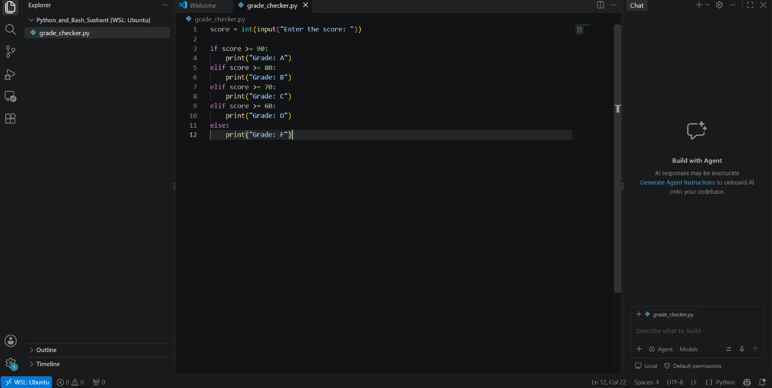

Screenshot : Output - grade_checker.py
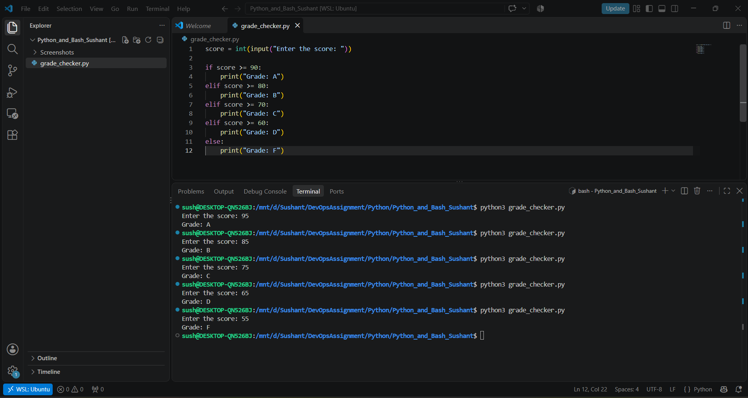

Task 2: Student Grades
Objective: Store student names and grades in a dictionary. The user can add a student, update a grade and print all grades.
File: student_grades.py

Explanation
- A dictionary stores each student name as the key and the grade as the value.
- The program shows a menu in a loop so the user can choose an option.
- Add student: a new name and grade are added to the dictionary.
- Update grade: if the name exists in the dictionary, its grade is changed; otherwise a message says the student was not found (if/else).
- Print all grades: every name and grade in the dictionary is printed.

Command used
python3 student_grades.py

Screenshot : Code - student_grades.py
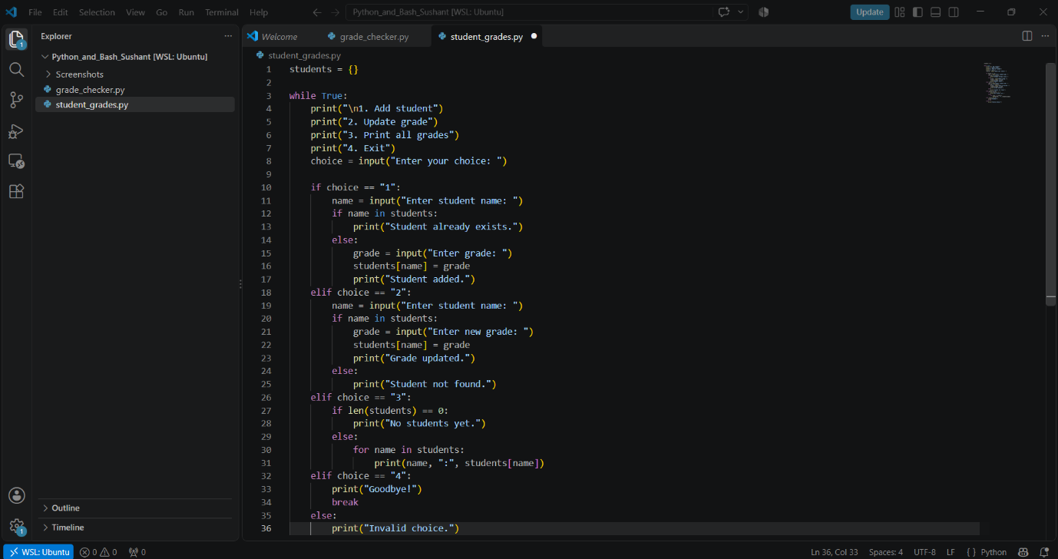
Screenshot : Output - student_grades.py
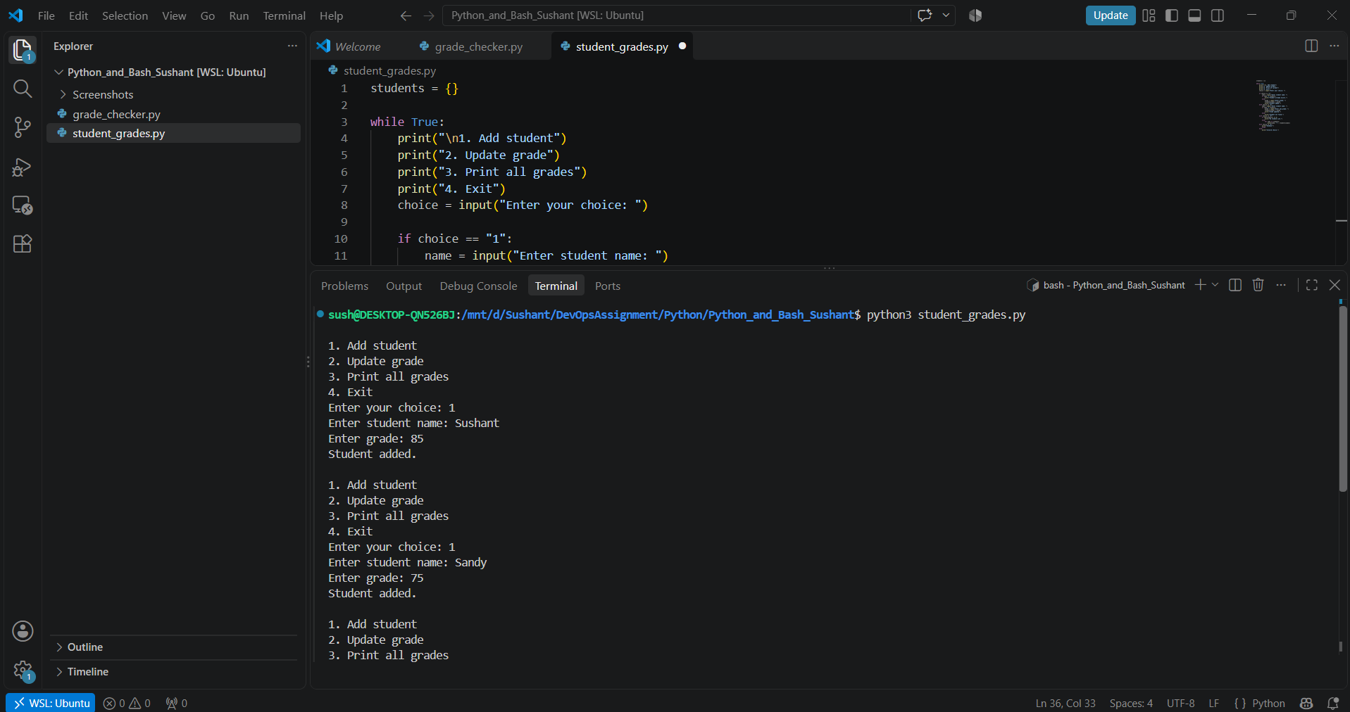
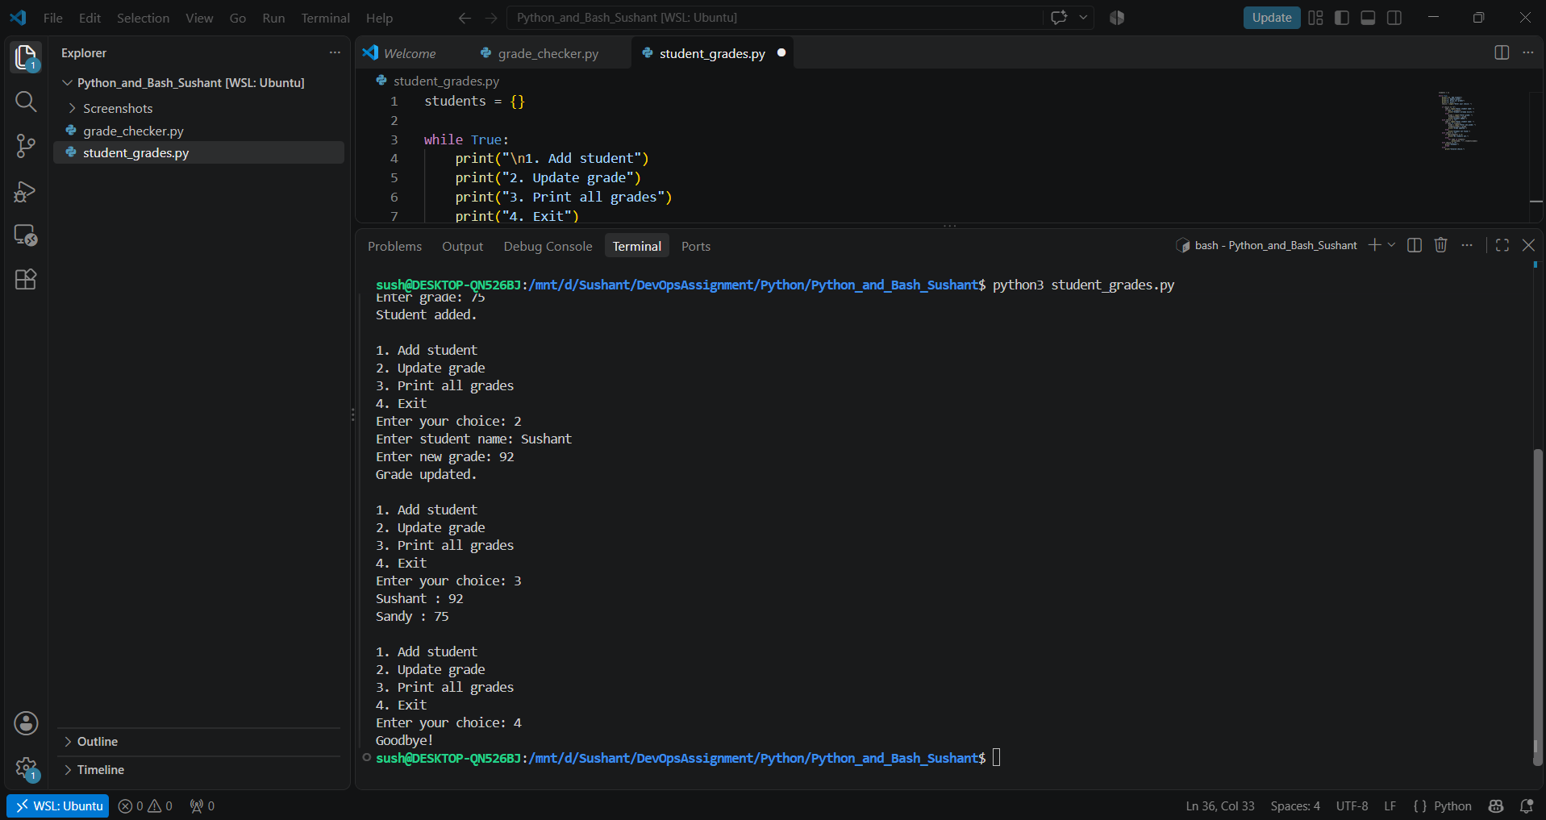

Task 3: Write to a File
Objective: Create a text file and write content into it using open() and write().
File: write_file.py (creates notes.txt)

Code
# Task 3: Write to a file

file = open("notes.txt", "w")

file.write("Hello, this is my first file written using Python.\n")
file.write("I am learning Python and Bash.\n")
file.write("This is Task 3 of my assignment.\n")

file.close()

print("File notes.txt created and written successfully.")

Explanation
- open("notes.txt", "w") opens the file in write mode. It creates the file if it does not exist and replaces the content if it does.
- file.write() writes text into the file. \n starts a new line.
- file.close() saves and closes the file.

Command used
python3 write_file.py

Screenshot : Code - write_file.py
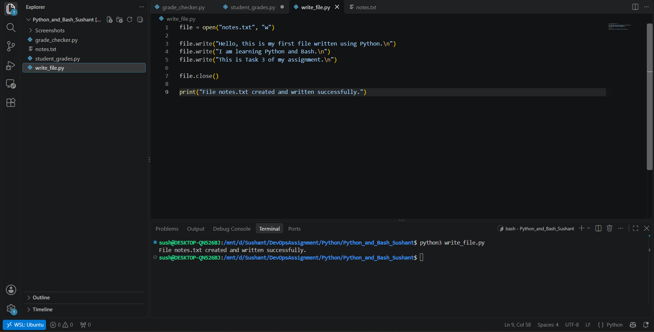
Screenshot : Output - write_file.py
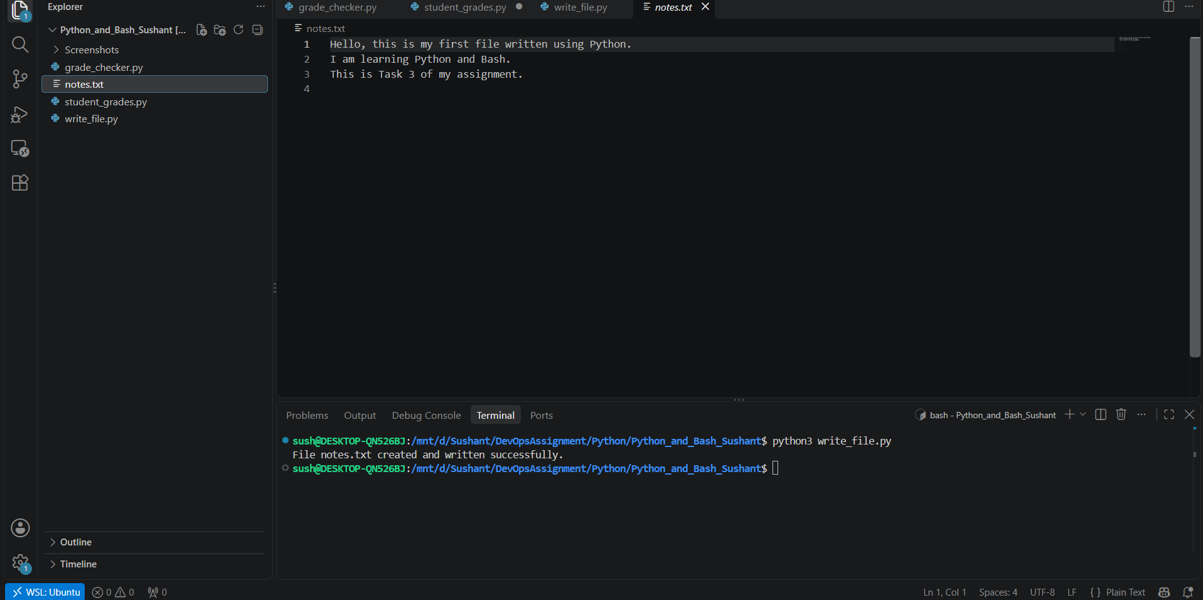

Task 4: Read from a File
Objective: Open the file in read mode, read it using file.read() and display the content.
File: read_file.py (reads notes.txt created in Task 3)

Code
# Task 4: Read from a file

file = open("notes.txt", "r")

content = file.read()

file.close()

print("Content of notes.txt:")
print(content)

Explanation
- open("notes.txt", "r") opens the file in read mode.
- file.read() reads the whole file as one piece of text, stored in the variable content.
- The content is then printed on the screen.

Command used
python3 read_file.py

Screenshot : Code and output - read_file.py
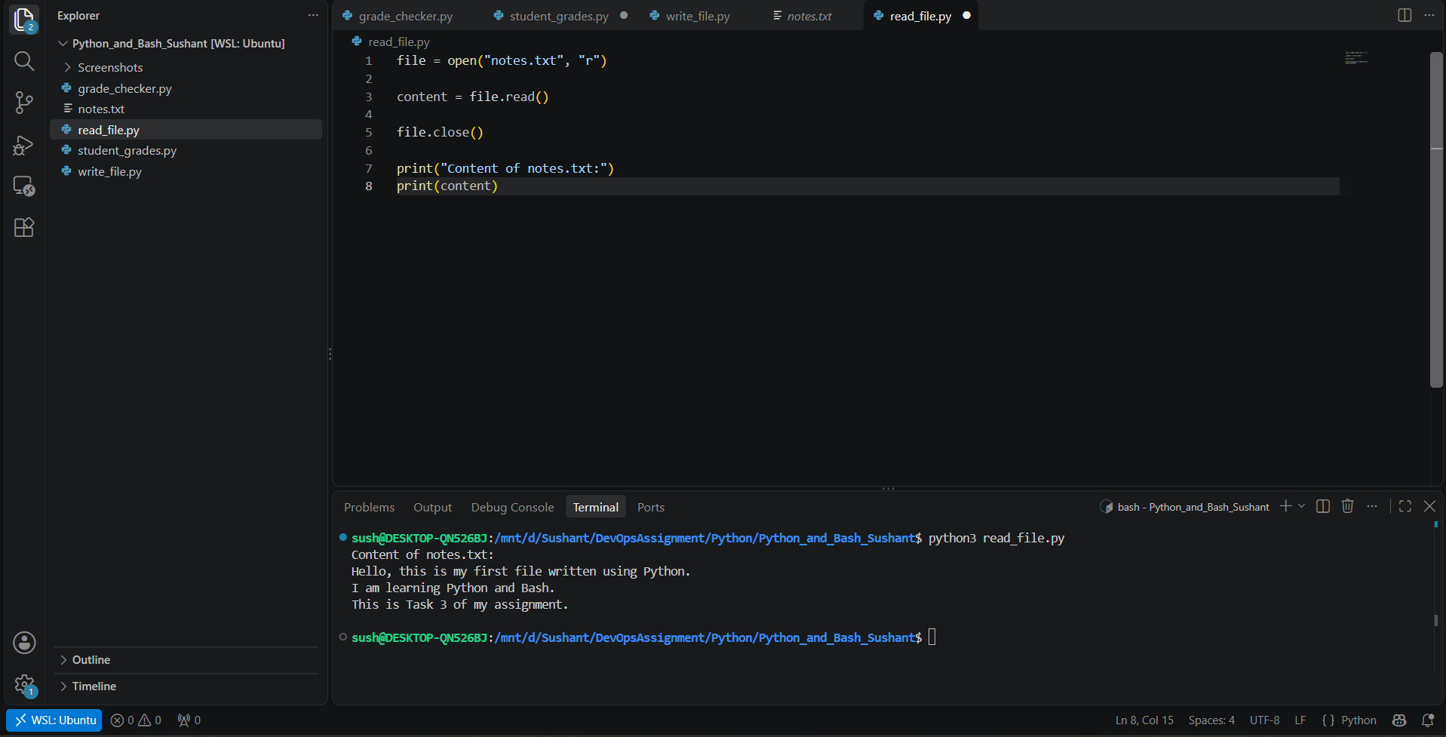

GitHub Upload
The project folder was turned into a Git repository, committed and pushed to GitHub using these commands:
git init
git add .
git commit -m "Add Python and Bash assignment tasks 1 to 4"
git branch -M main
git remote add origin https://github.com/tupesushant201/Python_and_Bash_Sushant.git
git push -u origin main

Repository link: https://github.com/tupesushant201/Python_and_Bash_Sushant

