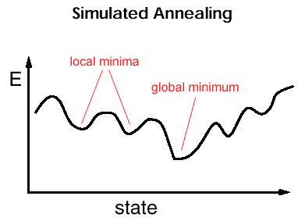

Objective function:

**Cost = Number of student cannot be in the class due to conflict schedule && do not fit in the classroom due to insufficient space.**

Universities have thousands of students enrolled and offer hundreds of courses from different schools. However, universities have limited classrooms to hold lectures and discussion for these courses. They are tasked with assigning a number of courses to classrooms, taking into consideration certain constraints, such as the size of a classroom and conflicting times. The class-scheduling problem is a nonlinear, multivariable problem.

CLASS SCHEDULING OPTIMIZATION

WITH SIMULATED ANNEALING