Mathematics Placement System 2.0

Software Requirements Specification

Dr. Dennis S. Martin

February 28, 1999

Submitted in partial fulfillment
Of the requirements of
A Sabbatical Project
<<Annotated Edition>>

Annotation Information

<<Please note that all comments in double diamond brackets (such as these) are comments about the paper and are not part of the paper. They are intended to help clarify how this report meets the requirements of the documentation standards. Also note that double-spacing has been suppressed for better viewing on the screen.

<< The project described here is an actual project produced by the author in the time frame stated in the proposal. These documents are faithful to the spirit of the project but were created to help clarify the application of the standards that they accompany. They have been edited to enhance their usefulness as models for documentation at the expense of being useful documents for the project. In fact, this set of documents does not fully or accurately describe the project. Several critical features of that project protecting security and any data that might identify individual students have been changed. In addition, the project has evolved since it was created and several of the items discussed here no longer apply.
<<The reader is further warned that the author takes the stipulation Fall 2001 Version very seriously. This is always a work in progress. As problems are pointed out in either these documents or the standards that they exemplify, changes will be made immediately and, possibly, without notice. On the other hand, this is an opportunity for students to edit a faculty work to improve it. Turnabout is fair play in this instance! Comments such as “I read the section on … and it still does not make sense.” are actually useful at this stage. >>
© 2001 by Dr. Dennis S. Martin.

The following policy applies to this document:
Permission to copy without fee all or part of this material is granted provided that the copies are not made or distributed for direct commercial advantage, this copyright notice is included and notice is given that copying is by permission of the author. Derivative works are permitted without fee provided that they contain a similar copyright notice and that the original author is acknowledged.
Table of Contents
E
1. Introduction 1
1.1. Purpose 1
1.2 Scope of Project 1
1.3 Glossary 2
1.4 References 3
1.5 Overview of Document 3
2. Overall Description 5
2.1. System Environment 5
2.2. Functional Requirements Definition 7
Survey Description 7
Prepare System Use Cases 8
Use Case: Archive 8
Use Case: Initialize (System) 9
Use Case: Modify Persistent Data 9
Load Data Use Cases 10
Use Case: Load CRN Data 10
Use Case: Load Student Data 12
Use Case: Load Test Data 13
Use Case: Enter Student 15
Use Case: Enter Test Data 16
Create Reports Use Cases 17
Use Case: Create Student List 17
Use Case: Report Session 18
Use Case: Create Custom Report 19
Use Case: Create Master Report 19
Use Case: Create Upload List 21
2.3. User Interface Specification 22
2.4. Non-Functional Requirements 23
2.5. System Evolution 24
3. Requirements Specification 25
3.1. External Interface Requirements 25
File Format: CRN File 25
File Format: Student Data File 25
File Format: Test Data File (Raw) 25
File Format: Test Data File (Modified) 26
3.2. Functional Requirements 26
Archive 26
Initialize (System) 27
Modify Persistent Data 27
Persistent Data Items 27
Load CRN Data 28
Load Student Data 30
Load Test Data 32
Enter Student 34
Enter Test Data 35
Create Student List 36
Report Session 36
Create Custom Report 36
Create Master Report 37
Create Upload List 37
3.3. Detailed Non-Functional Requirements 37
Index 39
Appendix — User Interface Specifications 40
Main Menu Screen: 40
File Menu: 40
Edit Menu: 41
Report Menu: 41
Help Menu: 41
Add Student/Test: 42
Custom Report Screen: 44
Testing Information: 45

Table of Figures
Figure 1 - System Environment 5
Figure 2 - Overview of System 7
Figure 3 - Load CRN State Chart 28
Figure 4 - Load Student State Chart 30
Figure 5 - Load Test Data State Chart 32
Figure 6 - Enter Student State Chart 35
Figure 7 - Main Menu Screen 40
Figure 8 - File Menu Screen 40
Figure 9 - Edit Menu Screen 41
Figure 10 - Report Menu Screen 41
Figure 11 - Help Menu Screen 41
Figure 12 - Add Student Form 42
Figure 13 - Add Test Data Form 43
Figure 14 - Custom Report Form 44
Figure 15 - “Should Take " Form 45

1. Introduction

1.1. Purpose
This Software Requirements Specification provides a complete description of all the functions and constraints of the Mathematics Placement System, Version 2, developed for the University of Scranton. The expected audience of this document includes faculty members in the Department of Mathematics who will use the system, the software developer and persons desiring a model for software development documentation.
<<Note the purpose of this document and the intended audiences. >>

1.2 Scope of Project
The Mathematics Placement System is used to grade multiple-choice mathematics-content examinations given to all incoming freshmen in the day schools and to many evening students of the University of Scranton. Based on test results, the system makes recommendations for mathematics course placement and produces a number of different reports for various campus stakeholders. The system is designed replace a previous system created and used on a mainframe computer. The previous system has proved very valuable for its intended purpose but has an awkward user interface, requires reprogramming to make minor changes and relies on the academic mainframe computer. The academic mainframe computer was chosen as only it had the power to run this program when first created but the mainframe environment is no longer the sole, or even the preferred, environment for such programs today.
Two test versions are supported. One is called The Placement Test and is used for placement into the Calculus sequence. The other is called The Diagnostic Algebra Test and is given to students whose majors do not have a high-level mathematics requirement. It is used for recommendations for the General Education Quantitative Reasoning requirement.
The previous system was written in Ada and used a menu-driven text interface and flat files and required minor reprogramming to modify the advisement information. This version of the project adapts the system for use on a Personal Computer using a Visual interface and the Access database management system. The revised system must have at least all the functionality of the previous system with some noted problems corrected and an enhanced ability to easily produce new reports on demand.
<<This is an overview of the project including need, context and rationale. Specific functionalities of the system are below. >>

1.3 Glossary
Administrator | Faculty member in charge of Mathematics Placement System
Archive Database | Students from past years stored for reference
CRN | Course Registration Number — primary key used by the University to identify courses; unique within one academic year
CRN Info File | File with information about mathematics sections offered
Current Database | Active students (incoming freshman)
Current Students | Current grouping of students in one session.
DAT | Diagnostic Algebra Test – used for placement in General Education Quantitative Reasoning courses.
Functional Requirements | A detailed list of all the services provided by the system. Information about what the system does not do is also in this category.
Local File System | Files available on PC on which the Placement System resides
Major | Code for academic major/program
MPS | Mathematics Placement System — this system
Non-Functional Requirements | Constraints on product (e.g., performance or memory restrictions) and process (e.g., development paradigm or documentation standards)
Persistent Data | Certain tables retained from one year to another; can be modified; see Supplemental Requirements
Placement System | Mathematics Placement System or MPS
PT | Placement Test – used for placement in calculus sequence
Recommendation | Analysis of student test result with reference to student's academic major with suggested course placement
Remote File System | Files available on the academic mainframe
Session | Group of students tested at one time
Student | Information about a student including all tests taken
Student Data File | File with information about incoming freshmen from University Database
Student ID | Primary key identifying student
Student Name | Field in last name, first name order
System Databases | Contain all data for current year and archives of previous years
Test | Consists of version number and answer key; at least two versions must be supported; versions are stable during one administration year
Test Data File | File with information from test scan sheets from one session
Test Results | Score on test and all subtests and/or indicated areas of weakness
Transient Data | Information for one academic year
<<This contains all the technical words that the user and the developer must have in common to read this document. Technically, it is a table with the grid lines hidden. >>

1.4 References
<<At the beginning, only the Proposal was listed. As the other documents were created, they were added and the Proposal was removed. >>
- Martin, Dennis S. Mathematics Placement System 2.0, Software Design Description. University of Scranton, 1999.
- Martin, Dennis S. Mathematics Placement System 2.0, Test Design Manual. University of Scranton, 1999.
- Martin, Dennis S. Mathematics Placement System 2.0, User Manual. University of Scranton, 1991.
- Martin, Dennis S. Mathematics Placement System, User Manual. University of Scranton, 1988.

1.5 Overview of Document
This document contains two additional chapters. The first (Overall Description) is designed to be understandable to faculty members in the Department of Mathematics (“the customers”). It lists all the functions performed by the system and the constraints under which it is to operate. The second chapter (Requirements Specification) is a list of all the constraints on and functions performed by the system in full detail to define the product fully for the software developer. The two lists of functions are cross-referenced to allow easy comparison.
<<Note that this is not a Table of Contents but a “guide to better reading.” >>

2. Overall Description
The Mathematics Placement System utilizes information from the University Database and from a Test Scanner to accomplish its goal. Communication is currently through the file system of the University Academic Computer (Tiger). Most printing is done with the local file system but very large reports are printed remotely on Tiger.

2.1. System Environment
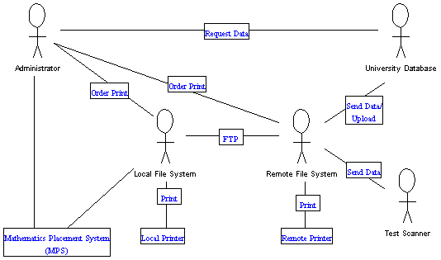
Figure 1 - System Environment
<<This diagram was created in ArgoUML using a use case blank, adding actors, and using graphical tools (lines and text boxes for the rest. Most system environments will not be this complicated but the project determines the diagrams. >>
The Mathematics Placement System is embedded in a larger system involving several University systems. In this section, we describe this environment. To reduce risk, we have grafted the new system onto the communications structure of the old system. Therefore, we can develop this system without having to coordinate with the people running the other systems. The new system will be transparent to them. With the old system based on the academic mainframe (Tiger), it was proper that this computer be the sole link to the outside environment. It is anticipated that several of the file transfers described here may soon be removed.
The MPS Administrator requests CRN data files and freshmen data files from the University Database when needed. These are sent in text format to the Pretest account on Tiger (the Remote File System). Student answer sheets are scanned and a text file with the test answers is sent to the Pretest account on Tiger. (Preliminary work has shown that this file must then be converted into a standard text file format on Tiger.) The Administrator uses FTP to move these files to the file system of the PC (Local File System) where the Mathematics Placement System software is located. All grading and report generation is done on this PC with reports stored as text files in its file system. Originally, all reports were to be transferred to Tiger for printing but the users have requested a change. Most reports are now to be printed on a printer networked directly with this PC. One large file is sent via FTP to Tiger, formatted there, and printed on the printer attached to Tiger at the end of the summer. An additional text file is mailed from Tiger to the University Database for uploading into the prerequisite-checking software of the registration system.
<<Note that a diagram is essential but is not sufficient. We add whatever text is needed to explain the diagram. The purposes of this diagram are to limit the system (show what is contained and what is external) and to serve as a help to explain the functions of the system below. >>

2.2. Functional Requirements Definition
Functional Requirements are those that refer to the functionality of the system, i.e., what services it will provide to the user. Nonfunctional (supplementary) requirements pertain to other information needed to produce the correct system and are detailed separately.
<<This really needs to be stated here for the customer to understand. >>
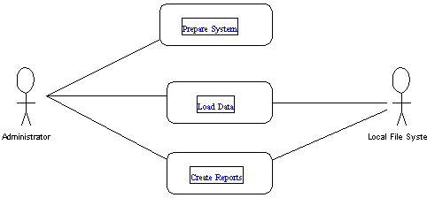
Figure 2 - Overview of System

<<This diagram was created using a blank use case diagram, adding the actors, and using graphics tools (rounded rectangles, lines and text boxes.) >>

Survey Description
- The Administrator uses the Prepare System package to archive the previous year’s students, clear the current database for a new semester, and update academic majors, placement recommendations, test versions and answer keys.
- The Administrator uses the Load Data package to add/update a file of semester CRN's with course information and instructors, add/update a file of persistent (non-testing) student information to the System, and to add a file of student test data to the System.
- The Administrator uses Create Report to generate test results for students in the current session or for various reports on all students in the database.
<< Note that we use text to explain the diagram again. We use this overview to group the use cases below. >>

Prepare System Use Cases

Use Case: Archive
Diagram:
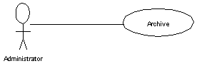
<<Use cases show actor(s) involved in a use case. All actors are mentioned below. >>
Brief Description
The Administrator removes all previous students from the active database and stores non-transient information about tested students in an Archive database. This is done so that the size of the active database remains as small as possible for efficiency purposes.

Initial Step-By-Step Description
No precondition needed. If the database is empty, nothing will happen.
1. The Administrator selects Archive from the File menu.
2. The system reports completion.
<<Note that Initial Step-By-Step Description is basically in the form of User action/System response pairs. Two sequential system actions suggest that you are into Design already. >>
See also detailed use case: Archive.
<<Cross-references must be explicit. >>

Use Case: Initialize (System)
Diagram:
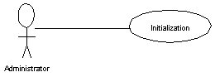
Brief Description
The system is prepared for use for an academic year. (Usually done in June when the previous group of freshmen has become sophomores.)
Initial Step-By-Step Description
Before this use case can be initiated, the Administrator has already archived any previous year’s students.
1. The Administrator selects New from the File menu.
2. The system reports completion

See also detailed use case: Initialization

Use Case: Modify Persistent Data
Diagram:
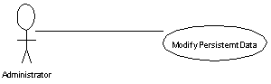

Brief Description
The administrator updates test version, tests, recommendations, etc.
This is not part of the MPS software system as the Administrator is expected to be familiar enough with Access to do this. More details are in the Data Description in the Software Design Description and in the User Manual.

Initial Step-By-Step Description
This should be done before loading any data, however, persistent data can be corrected at anytime.
- The Administrator opens the Placement.mdb Access database and changes field values directly.

See also detailed use case: Modify Persistent Data

Load Data Use Cases

Use Case: Load CRN Data
Diagram:
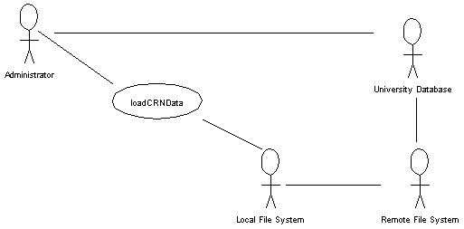
<<Use cases show actor(s) involved in a use case. All actors are mentioned below. >>
Brief Description
The use case Load CRN Data File is used by the Administrator to add/update all course and section data to the database.
It must be done after Initialize and it must be done at least once before Load Student.
If a CRN is not in the database, it is added with the relevant information. If the CRN is in the database, the relevant information is updated, thus this operation may be performed several times as needed.

Initial Step-By-Step Description
Before this use case can be initiated, the Administrator has already initialized the system.
- The Administrator requests a CRN file from the University Database either through the telephone or email.
- The University Database deposits the file in the Pretest account on Tiger.
- The Administrator transfers the file from Tiger to the local file system through FTP.
- The Administrator selects the Load CRN Data option from the File menu.
- The system presents the local file directory to the Administrator.
- The Administrator selects the correct file.
- The system loads the CRN (course and section) data and notifies completion.
See also detailed description of use case: Load CRN Data.

Use Case: Load Student Data
Diagram:
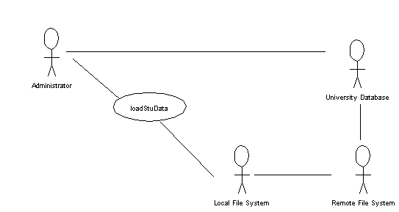
Brief Description
The use case Load Student Data File is used by the Administrator to add/update all student data (identification number, name, college, major, math course enrolled) to the database.
This use case must be done after Load CRN data and before Load Test Data.
The primary key is the student identification number. If a student is not in the database, s/he is added with the relevant information. If the student is in the database, the relevant information is updated, thus this operation may be performed several times as needed.
If a student has a CRN not known to the system, the unknown CRN is reported to the Administrator.
This use case will allow generation of a student list report (names with identification numbers).

Initial Step-By-Step Description
Before this use case can be initiated, the Administrator has already loaded CRN data.
- The Administrator requests a Student file from the University Database either through the telephone or email.
- The University Database deposits the file in the Pretest account on Tiger.
- The Administrator transfers the file from Tiger to the local file system through FTP.
- The Administrator selects the Load Student Data option from the File menu.
- The system presents the local file directory to the Administrator.
- The Administrator selects the correct file.
- The system loads the Student data and notifies completion.
See also detailed description of use case: Load Student Data.

Use Case: Load Test Data
Diagram:
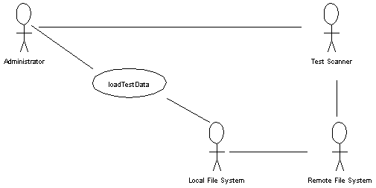
Brief Description
The use case Load Test Data File is used by the administrator to add student test results to the database.
It must be done after CRN and Student data are entered.

Initial Step-By-Step Description
Before this use case can be initiated, the Administrator has already loaded CRN and Student data.
- The Administrator takes the scan sheets to the test scanning facility on campus.
- The Tests are scanned and the results file is deposited in the Pretest account on Tiger.
- The Administrator modifies the results file into standard format.
- The Administrator transfers the file from Tiger to the local file system through FTP.
- The Administrator selects the Load Test Data option from the File menu.
- The system presents the local file directory to the Administrator.
- The Administrator selects the correct file.
- The system loads the Test data allowing the Administrator to correct any problems.
  - If an identification number cannot be matched, the administrator will have to identify the student either by providing a correct identification number or by adding the student to the database.
  - The system notifies completion.
  - The system reports all students who need to take a second test.
- The system notifies completion.
See also detailed description of use case: Load Test Data.

Use Case: Enter Student
Diagram:
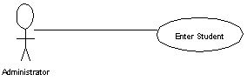

Brief Description
This use case allows the easy hand entry of an individual student.

Initial Step-By-Step Description
Before this use case can be initiated, the Administrator has already initialized the system.

- The Administrator chooses Add New Student from the Edit menu.
- The system provides a form to fill in student information.
- Steps 1 and 2 are repeated until done.

See also detailed use case: Enter Student

Use Case: Enter Test Data
Diagram:
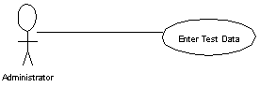

Brief Description
This use case allows the easy hand entry of student test results. It is used for students taking tests at other than standard times when using the optical scanner is overkill.

Initial Step-By-Step Description
Before this use case can be initiated, the Administrator has already initialized the system.

- The Administrator chooses Add Test Grades from the Edit menu.
- The system requests a student ID number.
- The Administrator provides the ID number.
- The system requests the test results and the test version.
- The Administrator provides the data.
- Steps 2 through 5 are repeated until done.
In step 3, if the ID number is not matched, the Administrator is prompted to enter full student information.

See also detailed use case: Enter Test Data

Create Reports Use Cases

Use Case: Create Student List
Diagram:
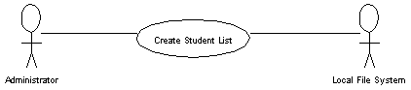

Brief Description
The Administrator prints a list of student names and identification numbers. The list is alphabetical by name. This is used for the proctors to assist students while taking the test if they are not sure about their identification number.
<<These comments must be meaningful to the user. >>
Initial Step-By-Step Description
Before this use case can be initiated, the Administrator has already loaded the Student data.
- The Administrator selects Student List from the Report menu.
- The system creates a file containing the list and puts it into the Local File System.

See also detailed use case: Create Student List

Use Case: Report Session
Diagram:
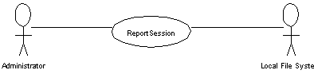
Brief Description
The administrator creates a fixed series of reports for all students tested in the current session, that is, all students tested since the last Report Session was performed. The system also reports students who should take an additional test. (See detailed list below.)
Initial Step-By-Step Description
Before this use case can be initiated, the Administrator has already added student test data since the last session was reported.
- The administrator selects the Report Session option from the Report menu.
- The system selects all students added since the last session was reported, grades their tests, decides recommendations based on stored criteria, adds this information to files and reports to the screen any student who needs further testing.
- The administrator directs that the list of students who need further testing be placed in a file.
- All files created are placed in the Local File System.
See also detailed use case: Report Session

Use Case: Create Custom Report
Diagram:
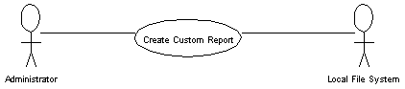
Brief Description
The administrator selects a report from a menu of options covering all the students in the database.
Initial Step-By-Step Description
Before this use case can be initiated, the Administrator has already initialized the database and added student data.
1. The administrator selects the Custom Report option from the Report menu.
2. The system presents a screen of options for possible.
3. The administrator selects the options desired.
4. The system creates the report and stored it in the local File System.
See also detailed use case: Create Custom Report

Use Case: Create Master Report
Diagram:
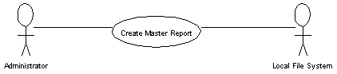

Brief Description
At the end of the summer, there is a fixed set of reports that must be generated. This option generates them all automatically. (See detailed list below.)

Initial Step-By-Step Description
Before this use case can be initiated, the Administrator has already initialized the database and added student data.

- The administrator selects the Master Report option from the Report menu.
- The system creates the reports and stored them in the local File System.

See also detailed use case: Create Master Report

Use Case: Create Upload List
Diagram:
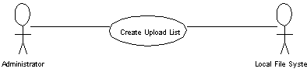
Brief Description
The administrator creates a file of all students in the database who have been tested to upload to the University Database for checking prerequisites for registration for classes.
Initial Step-By-Step Description
Before this use case can be initiated, the Administrator has already added all currently tested students to the database.
1. The administrator selects the Upload File option from the Report menu.
2. The system creates a file containing the list and puts it into the Local File System.
See also detailed use case: Create Upload List
As the reports are to be equivalent to those produced by Version 1 of this system, the user is referred to the old User Manual for more details.
The contents of the reports to be printed are as follows:
Report | When Generated | Description
Class List | Create Master Report | For each CRN, report on each student; analysis of class by question and topic.
Individual Student Results | Create Master Report | One sheet per student with full diagnostic information.
Student Scores | Create Master Report | Lists of student names, scores and recommendations listed by school, major, etc.
Students Not Tested | Create Master Report | All students not yet tested.
Student List | Create Student List | Names and ID numbers of all incoming freshmen.
Upload File | Create Upload List | ID and test scores to upload to University Database.
Current Student List | Report Session | Student names with scores by school.
Individual Student Results | Report Session | One sheet per student with full diagnostic information.
Retest Students | Report Session | Students in session who should take other list.

2.3. User Interface Specification
The anticipated users are faculty members in the Mathematics Department at the University.
- They have accounts on Tiger with which they are familiar.
- They are familiar with using FTP to move files.
- They are comfortable with the concept of a database and will need minimal training to utilize the Access features to update persistent information about courses, majors and faculty.
The system will have a standard Windows type interface with pull-down menus on a top menu bar and buttons and dialogue boxes for communications. No pull-down menu will have more than seven choices. Unavailable choices will be faded out.
The Help System will display sections of the User Manual, as the users are familiar with using computers.
See Appendix for example screens.

2.4. Non-Functional Requirements
These are requirements that are not functional in nature, that is, these are constraints within which the system must work.
<<This really must be stated here so the user will understand what is intended. >>
The program must be self-contained so that it can easily be moved from one PC to another. It is assumed that Access will be available on the PC on which the program resides. It is not required that a Visual language be available on that computer.
The database must be small enough when it holds an entire class to be stored on one 3.5” disk (at most 1.4 megabytes). This is for backup purposes and for transportability. The Archive database may be a separate database for size considerations. It will not have to hold more than four years of student records.
The program must be efficient. We require that any operation other than report generation must be completed with five minutes 100% of the time. Within any operation, responses to an entry must be done within 15 seconds 100% of the time. Report printing for the session reports must be completed with 15 minutes 100% of the time. Report printing for other reports must be completed within 1 hour 100% of the time.
The User Manual will include all Tiger instructions as well as instructions for correct use of the MPS.

2.5. System Evolution
Only the essential requirements have been listed here other than the Archive functionality. Currently, Archive stores data only. There is no functionality to either use this data or to remove data by year.
The next goal is to remove all usage of Tiger from the system as Tiger will be removed at a future date. This would involve mailing files directly to the Royal Mail account of the Administrator. As the scan files are currently a problem to read directly, this would be a high-risk item that should be handled first.
When this system was devised, it was assumed that most of the printing would be on the Remote Printer. As this is no longer the case, it would be desirable to use the report generation subsystem of Access rather than to create text print files. Currently, these files must be brought into a word processor and reformatted, a wasted step.
Version 3.0 is planned to be available in Summer 2002.
<<Be as complete as possible here but do not write science fiction. Record future plans, as they will influence the Design. >>

3. Requirements Specification
<<This section is primarily for the software developer but must also be understandable for the user. The user would use this section to obtain more details. The developer would refer to the previous section to see the context for the fuller descriptions here. >>

3.1. External Interface Requirements
Input File Formats are pre-defined by past usage. This project must use the previously existing file formats so that the system will be transparent to the external actors. The file formats follow.
<<Normally, the SRS would not have as detailed information as this. All fields would be named and described but their size and position would be determined at Design time. However, the constraint on transparency forces us to record these details here and now. Please note that we do not describe the database tables. That is a Design decision. >>

File Format: CRN File
Field | Location
CRN | 1-5
Course Number | 6-8
Section Number | 9-10 (left justified)
Faculty Name | 12-31

File Format: Student Data File
Field | Location
ID Number | 1-9
Name | 10-29
CRN | 31-35
Major | 36-39
School | 40

File Format: Test Data File (Raw)
This file is one long line divided logically into 4 line records (without end-of-line markers). The four records have 49 characters each and are logically divided as follows:
Record Number | Field | Location
1 | Name | 1-20
1 | ID Number | 33-41
1 | Test Version Code | 49
2 | Test Data | 1 - # questions
3 | Blank
4 | Blank

File Format: Test Data File (Modified)
The Pascal program Modify on the remote file system converts the raw file into a standard text file with this format:
Record Number | Field | Location
1 | Name | 1-20
1 | ID Number | 33-41
1 | Test Version Code | 32
2 | Test Data | 1 - # questions

3.2. Functional Requirements
<<Note that these are in the same order as the brief descriptions above. Although this is not required, the order should be meaningful, not random. >>
Use Case Name | Archive
Priority | Desired
Trigger | Selection from menu.
Precondition | None.
Basic Path | The system copies data on all tested students to the Archive database.  - The data pointer is set to the first student in the database.  - If the student is tested, the student name, identification and test results are copied to the Archive database. (The student’s major and math course are not copied.)  - The student is deleted from the database.  - Steps 2 and 3 are repeated until the database is empty of students.  - The system reports completion to the user.
Alternative Paths | None
Postcondition | There are no students in the database.
Exception Paths | None
See Also | Brief description: Archive
Other

Use Case Name | Initialize (System)
Priority | Essential
Trigger | Selection from menu.
Precondition | Student table is empty.
Basic Path | - All non-student transient information is deleted.  - Default entries are updated.  - User is notified of completion.
Alternative Paths | None.
Postcondition | All transient data is deleted. System is ready to accept new data.
Exception Paths | If the student data is not empty, the operation stops, notifies the user, and returns control to the main screen.
See Also | Brief description: Initialize (System)
Other

Use Case Name | Modify Persistent Data
Priority | Essential
Trigger | Administrator opens Placement database.
Precondition | Database exists.
Basic Path | Administrator uses database tools to modify persistent data.
Alternative Paths | None.
Postcondition | Placement database is modified as desired.
Exception Paths | None.
See Also | Brief description: Modify Persistent Data
Other

Persistent Data Items
Item Name | Description | Modification Info
Courses | Numbers and names of math courses | Add new courses or changed names
DAT Recommendations | Question numbers and topics | Must agree with DAT
CRNs | List of CRN, Instructor name, course number and section number | Created by system; may be modified for changes
Defaults | Various default values | See User Manual
Majors | Major number, name, abbreviation and recommendation type | Add new majors or changed information
PT Recommendations | Topics, masks, messages | Must agree with PT
Recommendations | Major types and recommendations | See User Manual
Schools | College and abbreviation | Update as needed
Test Information | Version number, name, answer key and abbreviation of tests | Must agree with tests given

<<Use new pages to keep units logically together for easier reading. >>
Use Case Name | Load CRN Data
Priority | Essential
Trigger | Selection from menu.
Precondition | System is initialized.
Basic Path | See State Transition Diagram below.
Alternative Paths | See State Transition Diagram below.
Postcondition | CRN data is in CRN table.
Exception Paths | If file has wrong format, operation is aborted.
See Also | Brief description: Load CRN Data
Other
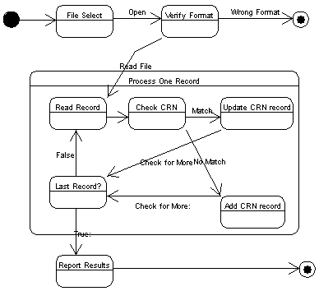
Figure 3 - Load CRN State Chart

<<When the sequence is complicated consider a state transition diagram to help with the explanation. >>
Comments on Load CRN State Chart
- Since all files are text files, it is essential that the system check to make sure that a file being loaded has the correct format or it could corrupt the entire database. Each file has some characteristic data record feature that can be tested.
- The basic process in this operation is a sequential access of the CRN data file, transferring each record to the database.
- If the CRN is already in the database, the record is updated; otherwise, the record is added. This allows the same operation to be used whenever an updated CRN file is available.
<<Note that a diagram is very valuable but it needs accompanying text. >>

Use Case Name | Load Student Data
Priority | Essential
Trigger | Selection from menu.
Precondition | CRN Data is loaded.
Basic Path | See State Transition Diagram below.
Alternative Paths | See State Transition Diagram below.
Postcondition | Student data is loaded into Student table.
Exception Paths | If file has wrong format, operation is aborted.
See Also | Brief description: Load Student Data
Other | If there are unmatched CRN’s, the report creators will not work.

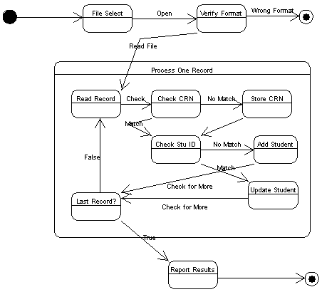
Figure 4 - Load Student State Chart

Comments on Load Student State Chart
- Since all files are text files, it is essential that the system check to make sure that a file being loaded has the correct format or it could corrupt the entire database. Each file has some characteristic data record feature that can be tested.
- The basic process in this operation is a sequential access of the Student data file, transferring each record to the database.
- Each student can have a tentative schedule before the download from the University database is made. It may contain an already recommended mathematics course (by CRN) or a designation that s/he is not scheduled (or not scheduled for a mathematics course). If the student’s CRN is not in the database, the report generator cannot report the mathematics course scheduled for the student. At present, the student record is placed in the database with the unmatched CRN but the user is notified that there is a problem.
- If the Student is already in the database, the record is updated; otherwise, the record is added. This allows the same operation to be used whenever an updated Student file is available.

Use Case Name | Load Test Data
Priority | Essential
Trigger | Selection from menu.
Precondition | Student Data is loaded.
Basic Path | See State Transition Diagram below.
Alternative Paths | See State Transition Diagram below.
Postcondition | Student Data is updated.
Exception Paths | If file has wrong format, operation is aborted.
See Also | Brief description: Load Test Data
Other

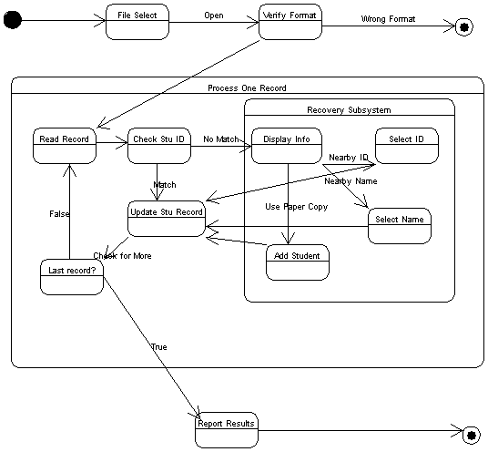
Figure 5 - Load Test Data State Chart
Comments on Load Test Data State Chart
- Since all files are text files, it is essential that the system check to make sure that a file being loaded has the correct format or it could corrupt the entire database. Each file has some characteristic data record feature that can be tested.
- The basic process in this operation is a sequential access of the Test data file, transferring each record to the database.
- If the student ID matches a student in the database, the student record is updated with the testing information and a report with the student name is written to the screen.
- If the student ID does not match, it is necessary to identify the student. This may occur because the student is not in the database but is much more likely to occur because the student filled in the “bubbles” incorrectly or not at all. The Recovery Subsystem is then used. In the Recovery Subsystem,
  - The information about the student (the student name and ID as scanned) is displayed.
  - A similar ID is one that matches a predetermined number of the digits in the scanned ID. A list of similar ID’s and student names is displayed. If a name is a reasonable variation, the user may select it. That student’s record is then updated.
  - An alphabetical listing of students is available. The user may select a student from this list. That student’s record is then updated.
  - The paper copies of the tests have been returned to the user and they match the electronic file in the order of the tests. Since the student names have been written to the screen as they were processed, the paper copy can be located. From the paper copy, the student’s ID can be ascertained. It can be entered directly. If the student is in the database, his/her record is updated. Otherwise, a form is presented to add information about the student, which is then put into the database, and the new student record is updated.
- When updating a student record, the information about the test replaces any previous information for that test version. This allows the same student to have two tests entered or a test data file to be reentered if needed without corrupting the database.

Use Case Name | Enter Student
Priority | Essential
Trigger | Selection from menu.
Precondition | System is initialized.
Basic Path | - Administrator chooses Enter New Student from menu.  - System provides form to fill in.  - Administrator fills in form and pushes enter button.  - Repeat 2 and 3 until signaled done.
Alternative Paths | If duplicate ID, student information is replaced.
Postcondition | Student is added to database.
Exception Paths | Operation may be canceled.
See Also | Brief description: Enter Student
Other

Use Case Name | Enter Test Data
Priority | Essential
Trigger | Selection from menu.
Precondition | Student Data is loaded.
Basic Path | See State Transition Diagram below.
Alternative Paths | See State Transition Diagram below.
Postcondition | Student Data is updated.
Exception Paths | None.
See Also | Brief description: Enter Test Data
Other | Uses Enter Student use case above.

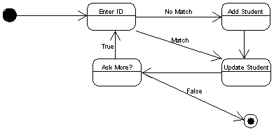
Figure 6 - Enter Student State Chart
Comments on Enter Test Data State Chart
- If a student is not in the database, a form is presented to add information about the student, which is then put into the database, and the new student record is updated, otherwise the student record is updated.
- When updating a student record, the information about the test replaces any previous information for that test version. This allows the same student to have two tests entered or a test data file to be reentered if needed without corrupting the database.
Use Case Name | Create Student List
Priority | Essential
Trigger | Selection from menu.
Precondition | Student data is in database.
Basic Path | - Administrator selects Student List from the menu.  - System produces an alphabetical list by name of all students’ names and ID numbers. This is placed in a file in the Local File System.
Alternative Paths | None.
Postcondition | File is in Local File System.
Exception Paths | None. (If there are no students in the database, a file with just a heading is produced.)
See Also | Brief description: Create Student List.
Other | Name of file is fixed as only latest version should be stored.

Use Case Name | Report Session
Priority | Essential
Trigger | Selection from menu.
Precondition | At least one student test data set has been added since the last time this operation was called.
Basic Path | - Administrator selects Report Session from the menu.  - System produces files required (see User Manual).  - System reports students who should take the other test version to the screen and reports completion.
Alternative Paths | None.
Postcondition | The reports are stored in the local file system.  The system is reset for the next session.
Exception Paths | If a student CRN is not matched in the CRN data, the operation aborts. The partial file created can be scanned to see where it ended and to correct the database.
See Also | Brief description: Report Session.  User Manual for description of reports.
Other | A session is all the student test information added since the last Report Session operation (or from the beginning if no prior operation).  Each file produced is uniquely identified as to contents (by prefix) and version (by number). It is expected that all reports generated will remain available for the use of the mathematics faculty.

Use Case Name | Create Custom Report
Priority | Essential
Trigger | Selection from menu.
Precondition | The system is initialized.
Basic Path | - Administrator selects Create Custom Report rom the menu.  - System presents a form to create a filter for the report.  - Administrator chooses desired report characteristics.  - System produces report and reports completion.
Alternative Paths | None.
Postcondition | The report is stored in the local file system.
Exception Paths | None.
See Also | Brief description: Create Custom Reports
Other | Each file produced is uniquely identified as to contents (by prefix) and version (by number). It is expected that all reports generated will remain available for the use of the mathematics faculty.

Use Case Name | Create Master Report
Priority | Essential
Trigger | Selection from menu.
Precondition | There is test data in the database.
Basic Path | - Administrator selects Create Master Reports from the menu.  - System produces files required (see User Manual).
Alternative Paths | None.
Postcondition | The reports are stored in the local file system.
Exception Paths | None.
See Also | Brief description: Create Master Reports  User Manual for description of reports.
Other | Normally done once at the end of the entire testing process just before the start of the semester.

Use Case Name | Create Upload List
Priority | Essential
Trigger | Selection from menu.
Precondition | Test data is in the database.
Basic Path | - Administrator selects Create Upload List from the menu.  - System produces files required (see User Manual).
Alternative Paths | None.
Postcondition | The file is stored in the local file system.
Exception Paths | None.
See Also | Brief description: Create Upload List
Other

3.3. Detailed Non-Functional Requirements
Hardware:
The system needs an IBM compatible Pentium-based PC with standard or better keyboard, mouse and monitor. A color monitor is assumed but not required. It also needs sufficient main memory to run the version of Access used and at least 4M of available disk memory to store the program and databases.
Operating System:
Windows that can support Access version used.
Software Needed:
Access 98 or better needed. Visual interface provided by executable file.
Performance:
No noticeable delays in performance — see section 2.4.
<<Cross-reference rather than repeat. Stating the same thing in two places can cause an inconsistency if one is updated. >>
Software Standard:
Every function will have a cancel option if logically permissible. Cancel will restore to a previous safe system state.
Network Interface:
Need access to Tiger for FTP and Telnet capabilities.
Code Standards:
Each code module fully documented using departmental standards.
Documentation standards:
Each document follows departmental standards.

Index

Academic Major, 3, 29, 32
Administrator, 2, 7, 8, 9, 10, 11, 12, 13, 14, 15, 16, 17, 18, 19, 20, 21, 22, 23, 24, 27, 31, 39, 41, 42
Archive, 2, 8, 9, 10, 27, 30, 31
Course Registration Number (CRN), 2, 7, 9, 12, 13, 14, 15, 16, 25, 29, 32, 33, 34, 35, 36, 41, 46
Functional Requirements, 3, 8, 30
Local File System, 3, 6, 7, 13, 15, 17, 20, 22, 24, 41, 42, 43
Mathematics Placement System (MPS), 1, 2, 3, 4, 6, 7, 11, 27
Non-Functional Requirements, 3, 26, 43
Persistent Data, 3, 11, 12, 31, 32
Placement (Current) Database, 2, 8, 31
Recommendation, 1, 2, 3, 9, 11, 21, 25, 32
Remote File System (Tiger), 3, 6, 7, 13, 15, 17, 26, 27, 30, 44
Session, 2, 3, 4, 9, 21, 22, 25, 27, 41, 51
Student, i, 2, 3, 4, 7, 8, 9, 11, 12, 14, 15, 16, 17, 18, 19, 20, 21, 22, 23, 24, 25, 27, 29, 30, 31, 35, 36, 37, 38, 39, 40, 41, 46, 48, 49, 51
Student Data File, 3, 14, 29
Student ID, 3, 19, 25, 29, 30, 38, 39, 41, 49
Test, 1, 2, 3, 4, 6, 7, 9, 11, 14, 16, 17, 18, 19, 20, 21, 25, 29, 30, 32, 37, 38, 39, 40, 41, 42, 48, 49, 51
Test Data File, 4, 16, 29, 30
Test Results, 1, 3, 4, 9, 16, 19, 30
Transient Data, 4, 31

Appendix — User Interface Specifications

Main Menu Screen:
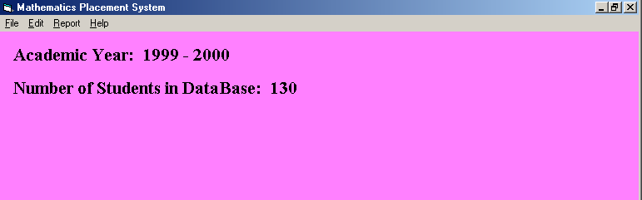
Figure 7 - Main Menu Screen
This is what the screen might look like during the middle of the testing process.

File Menu:
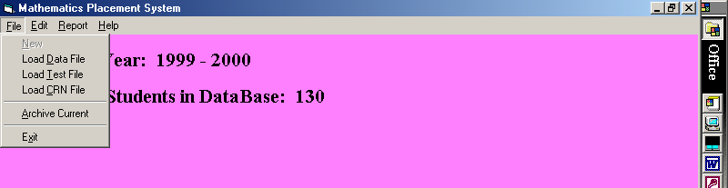
Figure 8 - File Menu Screen
Note that New is unavailable, as the current students have not been archived. We have already loaded of CRN and Student files so all the Loads are available.

Edit Menu:
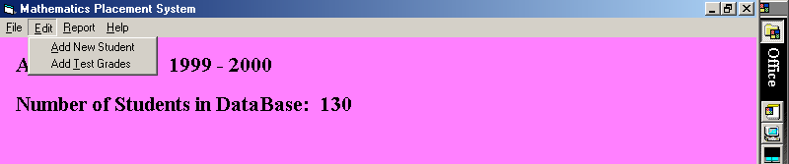
Figure 9 - Edit Menu Screen
For details on these two choices, see below.

Report Menu:
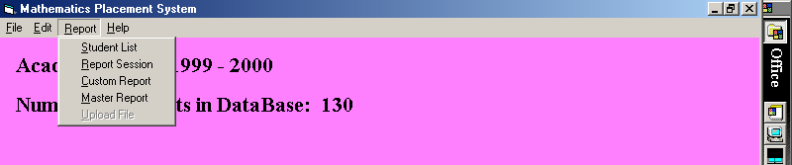
Figure 10 - Report Menu Screen
This is the basic report menu. Upload List is unavailable until Master Report is run. For the Custom Report options see below.

Help Menu:
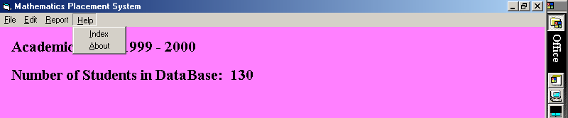
Figure 11 - Help Menu Screen
This is a minimal Help System that accesses the User Manual.

Add Student/Test:
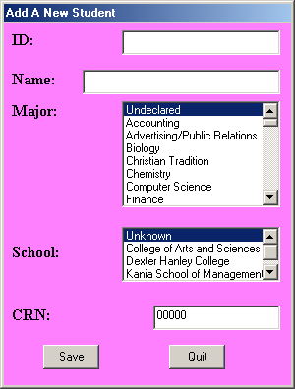
Figure 12 - Add Student Form
This can be used directly to add a student manually.
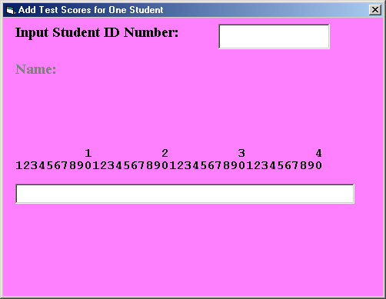
Figure 13 - Add Test Data Form
When a valid student ID is inputted, the student name appears on the screen. If a valid ID is not entered, the Add a New Student screen above is available. After typing in the answers, buttons pop up to allow the user to choose the test version.

Custom Report Screen:
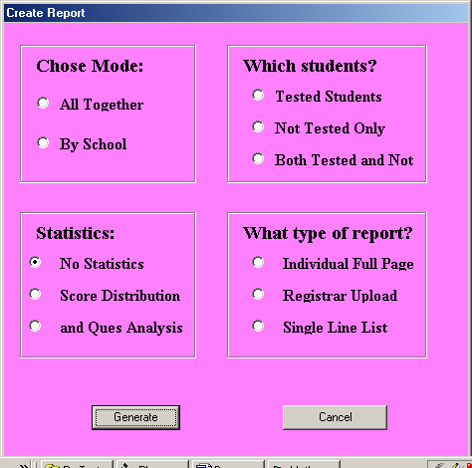
Figure 14 - Custom Report Form
These are the options to design a report. Although the Registrar Upload is available here, it is also available directly from the Report Menu.

Testing Information:
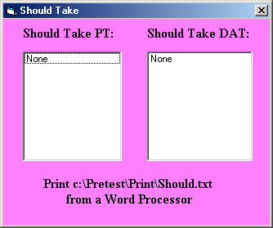
Figure 15 - “Should Take " Form
When adding test scores, if a student scores very high on the easier test or very low on the harder test, s/he is asked to take the other test also for diagnostic purposes. Most students do this in response to an announcement during the testing session. This reports on those who do not but should do so.

