Mathematics Placement System
Version 2.0

User Manual

Dr. Dennis S. Martin

Spring 1999

<<Annotated Edition>>
Annotation Information

<<Please note that all comments in double diamond brackets (such as these) are comments about the paper and are not part of the paper. They are intended to help clarify how this report meets the requirements of the documentation standards. Also note that double-spacing has been suppressed for better viewing on the screen.

<< The project described here is an actual project produced by the author in the time frame stated in the proposal. These documents are faithful to the spirit of the project but were created to help clarify the application of the standards that they accompany. They have been edited to enhance their usefulness as models for documentation at the expense of being useful documents for the project. In fact, this set of documents does not fully or accurately describe the project. Several critical features of that project protecting security and any data that might identify individual students have been changed. In addition, the project has evolved since it was created and several of the items discussed here no longer apply.
<<The reader is further warned that the author takes the stipulation Fall 2001 Version very seriously. This is always a work in progress. As problems are pointed out in either these documents or the standards that they exemplify, changes will be made immediately and, possibly, without notice. On the other hand, this is an opportunity for students to edit a faculty work to improve it. Turnabout is fair play in this instance! Comments such as “I read the section on … and it still does not make sense.” are actually useful at this stage. >>
© 2001 by Dr. Dennis S. Martin.

The following policy applies to this document:
Permission to copy without fee all or part of this material is granted provided that the copies are not made or distributed for direct commercial advantage, this copyright notice is included and notice is given that copying is by permission of the author. Derivative works are permitted without fee provided that they contain a similar copyright notice and that the original author is acknowledged.
Table of Contents
1. Introduction 1
1.1. Glossary 2
1.2. History 3
2. The Mathematics Placement System Instructional Manual 5
2.1. System Environment 5
2.2. System Parts 7
2.3. Normal System Usage 8
2.3.1. Getting Started Each Testing Cycle 8
2.3.2. Modifying Persistent Data 9
2.3.3. Initializing the Program 14
2.3.4. The File Menu 16
2.3.5. The Edit Menu 29
2.3.6. The Report Menu 30
2.3.7. The Help Menu 37
2.4. Unusual Events 37
3. User Reference Manual 39
3.1. Installation 39
3.2. Listing of Services 39
3.3. Error Messages and Error Recovery 40
Appendix 41
Example Student List 41
Example Individual Student Report 42
Example Multi-Line Report 43
Example “Should Take” List 44
Example Upload List 45
Example Section (CRN) Information – DAT Distribution 46
Example Section (CRN) Information – PT Distribution 47
Example Section (CRN) Information – DAT Question Analysis 48
Example Section (CRN) Information – PT Question Analysis 49
Index 50

Table of Figures
Figure 1 - System Environment 5
Figure 2 - Splash Screen 9
Figure 3 - Main Menu During Testing Cycle 14
Figure 4 - The File Menu 16
Figure 5 - Report After Load Student Data File 18
Figure 6 - Example Test Screen 1 20
Figure 7 - Example Test Screen 2 21
Figure 8 - Example Test Screen 3 22
Figure 9 - Add New Student Screen 23
Figure 10 - Example Test Screen 4 24
Figure 11 - Example Test Screen 5 25
Figure 12 - Unknown Test Version Screen 26
Figure 13 – Main Menu Screen After Loading Tests 27
Figure 14 - The Edit Menu 29
Figure 15 - Add Test Scores Screen 30
Figure 16 - The Report Menu 30
Figure 17 - Should Take Another Test Screen 34
Figure 18 - Create Custom Report Screen 35
Figure 19 - The Help Menu 37

Introduction
The Mathematics Placement Testing System (MPS) is designed to accept downloads of information from the University database, to grade optically scanned answer sheets and to generate reports to assist advisors in the initial placement of students into appropriate mathematics courses by making recommendations based on the student’s major and on the student’s test(s) results. An Administrator, a faculty member in the Mathematics Department, who also has the responsibility to ensure the accuracy of the recommendations, uses this system. This User Manual is the only document that the Administrator will need to properly run this system. We assume that the Administrator is computer literate and is knowledgeable about how to edit data in a relational database.
<<We are written the Purpose section without labeling it as such. The user is not familiar with terms such as Purpose and Scope used in our technical sense but s/he needs the information of these sections. >>
The Mathematics Placement Testing System Version 1.0 was originally designed to sit on the main academic computer (currently Tiger). It was written in Ada using flat files and the printers attached to that computer. It was menu driven with a single screen that scrolled as needed. Modifications to the set of recommendations required modifying (i.e., minor reprogramming) the program. The revised system, version 2.0, was designed to sit on a PC using a Windows environment. It uses a Database Management System for its data and criteria maintenance. It has kept much of the external environment of the older system (i.e., Tiger connections) to make its development easier. On the other hand, modifying recommendations now only requires modifying database tables. In addition, we have enhanced the ability of the system to help identify students when student ID numbers are incorrect on a scan sheet.
<<This is the Scope section. >>
This document is organized into several parts. The remainder of this section includes a Glossary of the technical terms used throughout the manual. It ends with a brief history of our mathematics placement testing and the development of the current system. The next section is an Instructional Manual with a step-by-step explanation of how to use the system and why it works as it does. The final section is a Reference Manual for quick look-up of information about the system. The Reference Manual is also available through the on-line Help System of the program.
<<This is the Overview section. >>

Glossary

Administrator | Faculty member in charge of Placement System
Archive Database | Students from past years stored for reference
Current Database | Active students during freshman year
Current Students | Current grouping of students tested; retrievable
DAT - Diagnostic Algrbra Test
File System | Files available on PC on which the Placement System resides
Major | 2 digit code for academic major/program
Persistent Data | Certain tables retained from one year to another which can be modified
Placement System | Software to perform activities detailed in this document
PT - Placement Test | Designed for placement into the Calculus sequence.
Recommendation | Analysis of student test result with reference to student's academic major
Student | Information about a student including all tests taken
Student Data File | ASCII file with information from University Database
Student ID | 9 digit primary key identifying student
Student Name | 20 character field
System Database | Contains all data for current year and archives of previous years
Test | Consists of version number and answer key; at least two versions must be supported; versions are stable during one administration year
Test Data File | ASCII file with information from test scan sheets
Test Results | Score on test and all subtests and/or indicated areas of weakness
Test Session | Records group when a test was entered
Testing Cycle | Usually starts about July 1 and lasts until the first week of the fall semester.
Transient Data | Data for one testing cycle.

History

The original Mathematics Placement test was developed by Dr. Dennis Martin for use with his Calculus I classes at the State University of New York College at Brockport before he moved from there to the University of Scranton in Fall 1985. The test was used by a number of faculty there and was hand-scored.

At the University, the Department of Mathematics and Computer Science, of which Dr. Martin and Dr. Paul Perdew were members, adopted the test intending to administer it to all students in the first calculus course. It was significantly changed at the request of department members to the point that the current version is really their test rather than the imported test. At that time, a program to grade the test on the computer was developed by Dr. Martin in Modula-2. The language was chosen partly to give Dr. Martin extensive experience in Modula-2, the principle language of instruction at the University. The program also eliminated the hand-grading bottleneck that delayed feedback to the students. The program was rewritten in Ada when the department moved to that language partly due to the problems with Modula-2 and partly to provide Dr. Martin with extensive programming experience in Ada. This was in Summer 1988.

The University decided to test all incoming freshmen students the weekend before fall classes began. This eliminated the problem that had been occurring because some students were starting calculus in their freshman year and some in their sophomore year—students who had had much time to forget their high school mathematics. Standardization of the time when the test was taken was thought to increase reliability of the test results. An easier placement test (just arithmetic and algebra) called the Diagnostic Algebra Test was added for students who might take a mathematics course other than Calculus or Discrete Mathematics. Dr. Perdew and Professor Mariellen Layton had developed this test primarily for nontraditional students who might need remedial instruction in mathematics. Depending on their major, students took one or the other of the tests. Dr. Martin was hired to rewrite the program to incorporate large scale testing, many new reports and two tests. When the University instituted Summer Pre-Orientation the testing as moved from one large administration in late August to four smaller administrations during June and July.

Small modifications in the program were routinely and easily made by non-experts in order to keep up with new majors and with changing mathematics requirements for existing majors. Dr. Martin has also cooperated with the mathematics faculty to maintain the program. The largest change was a transition from a VAX to a RISC-based machine as the binary file formats differed. During Spring 1999, Dr. Martin was granted a Sabbatical to rewrite the program once again into a Windows-based environment. This was partly to make the program easier to use and to modify but also to provide Dr. Martin with extensive experience using the Access DBMS with a Visual front-end, a common way to develop programs today. Dr. Martin has made minor modifications to the program after its beta release in Summer 1999.

The Mathematics Placement System Instructional Manual
In this section, we first look at the system environment to obtain an overview of how the MPS fits into the University systems and the two major parts of the system – the database that holds both persistent information (recommendations by major, for example) and transient information (information about the students in this testing cycle) and the program itself. We will be concerned with both normal system usage and with unusual events, that is, error situations.

<<As you read this, constantly ask yourself if the explanation is very clear to the expected reader. It must be as clear as possible but not more so. That is, it should not take a lot of text to tell an obvious step. The user manual is always finalized after the prospective user has had a chance to read it, preferably while working the system. >>

System Environment

Consider the following diagram:
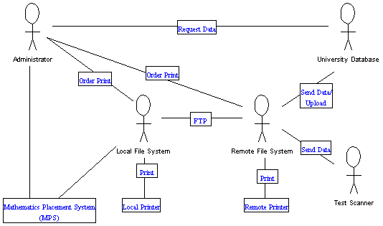
Figure 1 - System Environment
The Mathematics Placement System is embedded in a larger system involving several University systems. In this section, we describe this environment. To reduce risk, we have grafted the new system onto the communications structure of the old system. We were able to develop this system without having to coordinate with the people running the other systems. With the old system based on Tiger, the academic mainframe (called the Remote File System in the diagram), it was reasonable that this computer be the sole link to the outside environment. During initial usage of the new system, several of the file transfers described here were easily removed.
The MPS Administrator requests CRN data files and freshmen data files from the University Database when needed. These traditionally had been sent in text format to the Pretest account on Tiger (the Remote File System). With the new system, the CRN and student files can be mailed directly from the University Database (Banner) to the PC of the Administrator (Local File System). The request for these files is made by telephone or email.
Student answer sheets are scanned and a text file with the test answers is sent to the Pretest account on Tiger. (Preliminary work has shown that this file must then be converted into a standard text file format on Tiger.) The Administrator uses FTP to move these files to the Local File System where the Mathematics Placement System software is located. All grading and report generation is done on this PC with reports stored as text files in its file system. Originally, all reports were to be transferred to Tiger for printing on the remote printer but the users have made a change. Most reports are now printed on a printer networked directly with this PC (the local printer). One large file is sent via FTP to Tiger, formatted there, and printed on the printer attached to Tiger at the end of the summer. An additional text file is mailed from Tiger to the University Database for uploading into the prerequisite-checking software of the registration system. This requirement for this file upload was added while the new system was under development.
<<Note that we copied this almost directly from the SRS. We are starting globally and working to the details. >>

System Parts
The Mathematics Placement Testing System itself consists of two parts: the program proper and the data storage mechanism. The program cannot be altered without using Visual Basic while the data storage mechanism allows easy editing of many of the rules governing the system including course recommendations. The system developer would do changes in the program whenever maintenance of the basic program is needed. Some database modifications by the Administrator are required to ensure proper running of the system. Since the databases are separate from the program, the program may be altered after the start of the testing cycle without risk to the data. The database can also be selectively modified after the testing cycle starts. Indeed, some of the medications are required to ensure correct system functioning as noted below in this document.

Normal System Usage
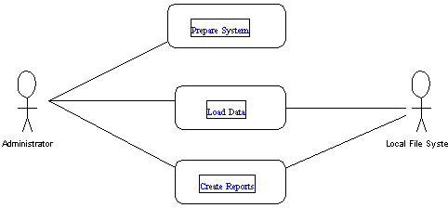
There are three primary operations that the system performs.
- The system must be prepared for use at the start of each testing cycle. In addition, minor modifications can also be made during the testing cycle.
- Data in the form of CRN files, student data files and test can files are added as available.
- Reports are generated as needed for many purposes during the testing cycle.

Getting Started Each Testing Cycle


Figure 2 - Splash Screen
To prepare for a testing cycle, the Administrator needs to initialize the program as well as update the persistent data in the database table. After that, the program needs to be initialized for the testing cycle.

Modifying Persistent Data
First, it is necessary to update the persistent data tables. Open the Access database named Placement.mdb. In the following, the designation “used by Banner” indicates that that field will be used on information files downloaded from Banner and must be understandable to the system through these tables.

      - The Courses Table

Course | CourseName
005 | Algebra
101 | Math Discovery I
103 | Precalculus Math
106 | Quant Methods I
107 | Quant Methods II
109 | Quant Methods/Behav
114 | Analysis I
142 | Discrete Structures

A section of this table is displayed here. Any course into which a freshman might be registered must be in this table. Extra courses are no problem. New courses may be added anywhere. It is easiest to add them at the bottom.

      - The Schools Table

School | SchoolName | Number | SchoolAbbr
A | College of Arts and Sciences | 2 | CAS
D | Dexter Hanley College | 3 | DHC
H | Panuska College of Professional Studies | 5 | CPS
M | Kania School of Management | 4 | KSOM
X | Unknown | 1 | Sch??

The first column has school codes as used by Banner, the second and fourth are names used for printing the various reports. The Number code is no longer used.

      - The Majors Table

Major | MajorName | MajorAbbr | RecType
1 | Accounting | ACC | SOM
2 | Advertising/Public Relations | AP | NonSci
47 | Alcohol/Drug Counseling | AD | NonSci
8 | Associate of Arts | FA | NonSci
57 | Biochemistry | BCHM | HardSci
3 | Biology | BIOL | HardSci
73 | Biomathematics | BMAT | MthCmp
12 | Biophysics | BPHY | HardSci
55 | Business Area | BUSB | SOM
41 | Business Undeclared | BUSA | SOM
86 | CAS Common Curriculum | CASC | SecEd
49 | CAS Economics | ECO | SOM

A section of this table is displayed here. The first column is no longer used but must have unique numbers. The second column is the major name used for printing reports. The third column is the major abbreviation used by Banner. The fourth column is the type of recommendation to be used for that major based on level of performance in that test. It relates to the Recommendations table. Any major into which a freshman might be registered must be in this table. Extra majors are no problem. New majors may be added anywhere but filing in non-used slots is easiest.

      - The Recommendations Table

MajorType | Level | ShouldTake | DATRec | PTRec
HardSci | 0 | 2 | Take PT | Math 103 w/LRC
HardSci | 1 | 2 | Take PT | Math 103 or Math 114
HardSci | 2 | 2 | Take PT | Math 114
HardSci | 3 | 2 | Take PT | Math 114 (Test for Math 221)
MthCmp | 0 | 2 | Take PT | Math 142 and Math 103 w/LRC
MthCmp | 1 | 2 | Take PT | Math 142 and (Math 103 or Math 114)
MthCmp | 2 | 2 | Take PT | Math 142 and Math 114
MthCmp | 3 | 2 | Take PT | Math 142 and Math 114 (Test for Math 221)
NonSci | 0 | 1 | Math 101 | Take DAT
NonSci | 1 | 1 | Math 101 or Math 106 | Math 107 or Math 204 (Not Required by Major)
NonSci | 2 | 1 | Math 101 or Math 106 | Math 114 (Not Required by Major)
NonSci | 3 | 1 | Math 106 or Math 204 | Math 114 (Test for Math 221; Not Required)

A section of this table is displayed here. The names in the first column are suggestive but arbitrary. They correspond to the RecType field in the Majors table. There are two tests, the PT and the DAT. If students in a major will take a Calculus-type course, they should take the PT, otherwise they should take the DAT. In the ShouldTake Field, 1 represents the DAT and 2 the PT. The scores on each test fall into four levels (0 – 3). For each level for each test, there is a message to be printed about mathematics course placement. New recommendation schemes may be added at any time and placed into the Majors field for reference.

      - The TestTable

Version | Name | NumbQues | AnsKey | Abbr
1 | Diagnostic Algebra Test | 25 | … | DAT
2 | Placement Test | 40 | … | PT

This table associates the version number with the name of the test for printing (both the Name and Abbr fields) with the number of questions and the answer key. When the tests are modified, the answer key must also be modified but so must the following two tables that are used to print out diagnostic messages to the students. In addition, the levels may be redefined in the Defaults table.

      - The DATRecs Table

Numb | Topic
1 | Add Fractions
2 | Subtract Fractions

A section of this table is displayed here. The student receives a list of all topics for which a question was answered wrong or left blank. This table must correspond with the topics of the questions on the test.

      - The PTRecs Table

Numb | Category | Mask | Minimum | ErrorMsg | GoodMsg
11 | calc | 0000000000000000000000000000000001111111 | 4 |  | Test for MATH 221 if student believes s/he can skip Math 114
7 | dist | 0000000000000000000100000000000000000000 | 1 | Distance Formula
1 | exp | 0000011000000000000000000000000000000000 | 1 | Exponents
9 | func | 0000000000000000000000111110000000000000 | 3 | Concept of a Function

A section of this table is displayed here. This test is divided into (non-contiguous and overlapping) sections by topic. The mask is used to identify the questions for that topic (0 = not, 1 = part). The ErrorMsg is printed if the student scores less than the Minimum and the GoodMsg if the student scores at or above the minimum. This table must correspond with the test.

      - The Defaults Table

This one has the DAT and PT level cuts, among other modifiable information, and is probably only understandable to the Administrator. It is too complex for an example document. It is in the real User Manual.

In addition, the following transient table can be modified during the testing cycle:

      - The CRNTable

CRN | FacName | Course | Section
10367 | Johns Bernie | 005 | 31
10368 | Monks Kenneth | 101 | 1
10370 | Eichelsdorfer Gary | 103 | 2
10371 | Otarod Masood | 103 | 31
A section of this table is displayed here. It contains the unique identifier of the course, the CRN, as well as the Faculty Name, course number and section number. This allows reports to be generated for each section properly labeled for easy distribution. This table is created or updated using the Load CRN File operation. It can also be edited manually. An unknown CRN will cause a fatal error while generating reports.

Initializing the Program

To initialize the system, the Administrator will run the program Placement.exe on his/her PC. The splash screen appears with the name of the program and its developer. After a few seconds (or by clicking in the lower center of the screen), the Main Menu appears. If the Main menu contains last year’s date and indicates that there are students in the database (such as the figure labeled Main Menu During Testing Cycle), the system needs to have the previous year’s students archived. Use the File/Archive command (below). The Archive Command can be run after the end of the testing cycle at the start of the fall semester.

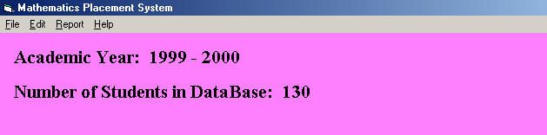
Figure 3 - Main Menu During Testing Cycle

The Placement Database is uninitialized when the main screen says "No current year is set." Use the File/New command (below). As the date of the Academic year is picked up from the system clock, the New command should issued done after January 1.

After initializing the program, the Administrator needs to start loading data into it. The first thing that has to be loaded is the CRN data. Before students come to campus for pre-orientation, a tentative schedule is created for them by the summer advising staff. When student data is downloaded from the University database for use by this system, it includes the CRN of any mathematics section for which the student is registered. In order to identify the course, the MPS will look the CRN up in the CRNTable. While the CRN data is available during the preceding spring semester and used for registration then, new sections may be added during the summer as the needs of the incoming freshmen are better identified. Therefore, either a new CRN data file should be loaded during the summer or new CRN information manually added when new sections are created.

After the CRN data is loaded, student data is next to be loaded. The student data includes the student’s major and the CRN of any registered math course. Either or both of these may be modified during the summer. New student files should be loaded at least for each testing session. Changed information updates the placement database so that reports are always printed with the most recent information. If an unknown CRN or major is encountered, it will be reported. It is essential to add this CRN or major to the database.

During each testing session, students are assigned to take the version of the test indicated for their major. Students taking the DAT who do well are asked to also take the PT. Students who are uncomfortable with the PT are asked to also take the DAT. The program will list students who should take an additional test but who have not yet done so. This includes students who take the wrong test version by mistake.

The File Menu

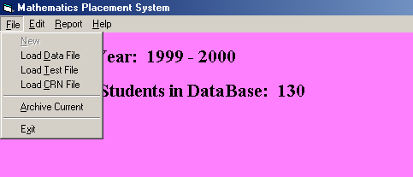
Figure 4 - The File Menu

The choices on this menu are

New | Initializes program for testing cycle, can only be run after Archive or the very first time that the program is used.
Load Data File | Loads a student data file from the Local File system. Can only be run if some CRN information is in the database.
Load Test File | Loads a test scan file from the Local File System. Can only be run if some student information is in the database.
Load CRN File | Loads a file of CRN information. Can be run or rerun whenever the system is initialized.
Archive Current | Removes all students from Current Database and places them into the Archive Database.
Exit | Exits the program. Can also be accomplished by using the terminate button in the upper right of screen.

      - New
This choice initializes the system for a testing cycle. It can only be run if there are no students in the database. Use Archive to clear the database. If it is run before January 1, it will pick up the wrong Academic year. Correct this by modifying the CurrYear field in the SysDefs table.

      - Load Data File
First, you need to the file to be loaded to be in your local file system (your own PC). Contact the University database people for the file. Either have the file mailed to you directly or to the Pretest account on Tiger. If it is mailed to Tiger, use ftp (text mode) to move it to your local file system.

This choice will prompt for a file name using a form that allows you to browse your file directory. Select the correct file. The MPS will check that the file has the correct format. If the MPS suggests that the file has the wrong format, be very careful. As these are text files, loading the wrong file can cause serious corruption of the database.

Load Data File will allow the function Load Test File to be performed.

If a student is not in the database, the student will be added. If the student is in the database, the student’s record will be checked to see if the student’s CRN or Major has been changed. If either has, the record is updated. If a CRN is not matched from the CRN table or a major is not in the major table, these facts will be reported to the user. (See Figure. If either of these problems is not detected, the respective error message will not appear.) This information MUST be added to the respective tables. This operation can be repeated with new files when needed.

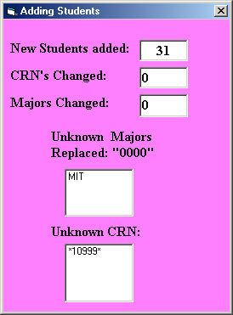
Figure 5 - Report After Load Student Data File

      - Load Test File
First, you need to the file to be loaded to be in your local file system (your own PC). The program used to scan the test sheets automatically places the file in the Pretest account on Tiger. It will need to be modified on Tiger before it is transferred to your local file system (your own PC). Log into Tiger and give the command “RUN MODIFY” (Tiger commands are not case sensitive). The program will ask for the file name. Provide it. If you provide an incorrect file name, the program will crash. Try again with the correct name. When finished, there will be a new file with a modified name in your Tiger directory. It will have the same extension as the old file but with “_MOD” appended to the base part of the file name. Use ftp (text mode) to move the new file to your local file system.
This choice will prompt for a file name using a form that allows you to browse your file directory. Select the correct file. The MPS will check that the file name has the correct format. If the MPS suggests that the file name has the wrong format, be very careful. As these are text files, loading the wrong file can cause serious corruption of the database.

Have the physical scan sheets available as you run this option. You will need them as they are in the same order as the electronic versions in the test file. The students have been instructed to print their names and ID numbers on the sheet in the designated locations and then to darken the accompanying bubbles. The scan process only reads the bubbles and they may not accurately reflect the total information on the sheet. As the test records are processed, the MPS takes the ID from the test record and checks it against the students in the database. If there is a match, it is assumed that the correct student has been identified and the test record is processed. If there is not a match, the MPS waits for the Administrator to identify the student.

In these examples, the names are either obviously false or are staff or faculty at the University. The ID numbers are based on student ID numbers but have been edited so that they are not correct ID numbers of anyone at the University. Testing of this system was done with real student data but we have created example files here to protect student privacy.

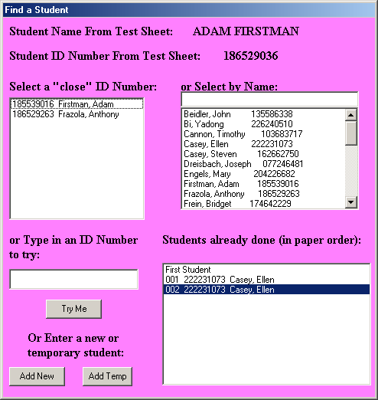
Figure 6 - Example Test Screen 1
Look at Example Test Screen 1. This form will remain on your screen as the tests are processed. In the lower right is the list of students already successfully processed in the order that they were processed. The MPS has placed “First Student” at the start of the list for your information. Note that the same student appears twice. This system processes tests and if a student takes both versions of the test, the student will be processed twice. At the top of the screen appears the student name and ID as read from the bubbles. In the upper left is a list of all students with “similar” ID numbers. Click on the name/ID there to select the student. The record will then be processed.

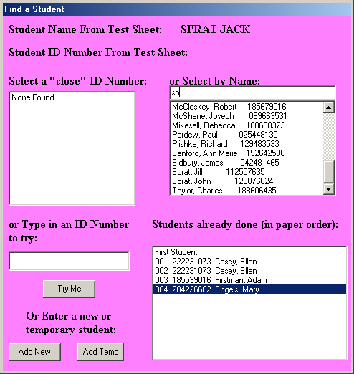
Figure 7 - Example Test Screen 2
Look at Example Test Screen 2. We note that Adam Firstman has been processed and is recorded at the bottom right. Jack Sprat has failed to fill in the bubbles under the ID number. We are using the top right combo box to type letters of his name until the correct part of the alphabetical student list scrolls in sight. We can then click on the name to select it.

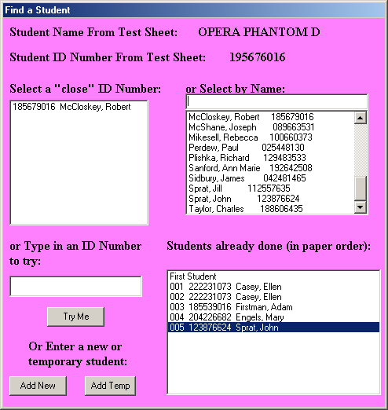
Figure 8 - Example Test Screen 3
Look at Example Test Screen 3. We note that Jack Sprat has been processed and is recorded at the bottom right. The alphabetical search is still set on the last scrolling. As we type this student's name into the combo box, we note that he is not in the database. A check of the student list previously printed out confirms this. The student has been added to the system since the last download of student information. We push the Add New button on the lower left.

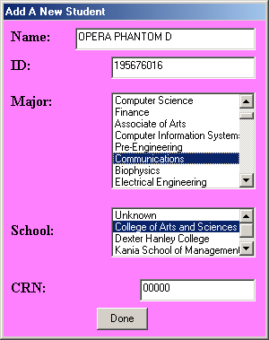
Figure 9 - Add New Student Screen
Look at the Add New Student screen. The name and ID have been transferred from the previous screen (but may be edited). Add or correct whatever information you have. (You have the physical scan sheet to look at.) Lately, the instructions to the students have been to write their majors at the top of the scan sheet. This allows that field to be filled in. We have made selections for both major and school here. When the Done button, is pushed, the student is added to the database and the test record processed.

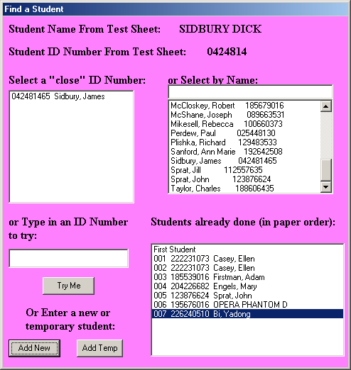
Figure 10 - Example Test Screen 4
Look at Example Test Screen 4. You will have to decide if this student goes by a different first name or if there has been a problem with giving the student his ID number at the test session. (If the ID number had matched, the test record would have been automatically processed.) If the ID number is incorrect and your have the correct ID number (from the printed student list, for example), type it into the ID Number to Try and push the Try Me button.

If a student has filled in neither the ID nor the name bubbles, use the physical scan sheet to find out who the student is and type the ID number in the box to try. If the student has filled in neither the written name nor ID, the student cannot be identified. The proctors should have caught this one. Use the Add Temp button to add a temporary new student record. The MPS will then process the rest of the record. This is most likely to occur when a blank answer sheet has gotten into the pile.

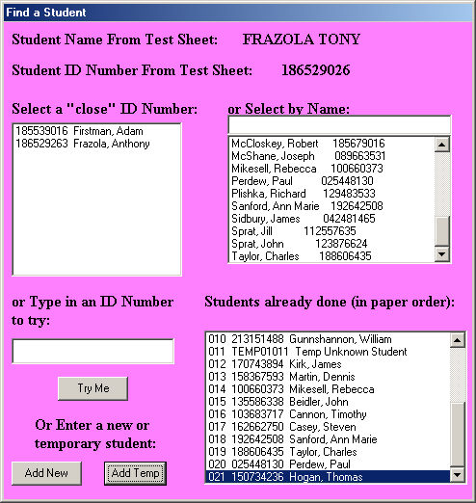
Figure 11 - Example Test Screen 5

Look at Example Test Screen 5. The eleventh student processed was the unknown student above. The MPS has created a new student record with ID TEMP01011 (first test session, eleventh student) and name Temp Unknown Student.

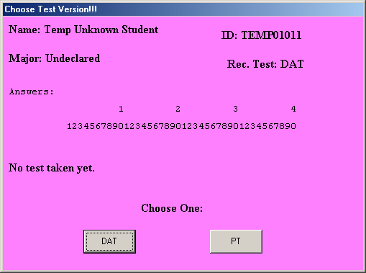
Figure 12 - Unknown Test Version Screen

Another screen that may appear is the Unknown Test Version Screen. The answer sheets are manually premarked to indicate the test version. If one is missed, this screen may appear. Note that it displays the student name and ID and the answer key (the two versions differ in number of questions) and asks the Administrator to choose the most likely test version. The blank sheet triggered this screen, which is why there are no answers displayed.

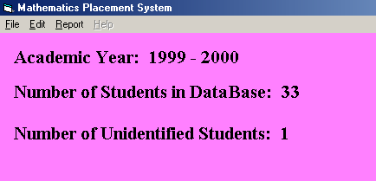
Figure 13 – Main Menu Screen After Loading Tests

The Main Menu screen will record the number of identified students. Their temporary names and ID numbers are in the ProbStus table in the database.

      - Load CRN File
First, you need to the file to be loaded to be in your local file system (your own PC). Contact the University database people for the file. Either have the file mailed to you directly or to the Pretest account on Tiger. If it is mailed to Tiger, use ftp (text mode) to move it to your local file system.

This choice will prompt for a file name using a form that allows you to browse your file directory. Select the correct file. The MPS will check that the file has the correct format. If the MPS suggests that the file has the wrong format, be very careful. As these are text files, loading the wrong file can cause serious corruption of the database.

While loading, if a CRN is not in the database, it will be added. If the CRN is in the database, no change will occur. Therefore, this operation can be repeated with new files when needed.

The system will report any unidentified course numbers from the file. They will have "999" as their course number in the table. This table can be edited to correct this or if new sections are added, teaching assignments are changed or any other activity that affects the printing on section reports. Revised files can be reloaded as the system does not duplicate entries. More CRN's can be added for Intersession or Spring semester as CRN numbers are unique within an academic year.

      - Archive Current Year
This choice will remove all student and CRN information from the database. The student information will be moved to the Archive database. It was originally envisioned that the Create Master Report option at the end of the test cycle would pick up any students from previous years and include their statistics in the report for each mathematics course section. This is not implemented and probably will not be, as the student taking an intervening mathematics course would invalidate the relevance of the test data for that student and we have no way to detect that.

      - Exit
This choice will do a normal exit from the program. As we are using a database, all new data has already been saved so a Quit option would be meaningless.

The Edit Menu
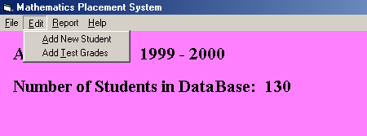
Figure 14 - The Edit Menu
This menu is probably poorly named. The choices on this menu are
Add New Student | Manually adds a student.
Add Test Grades | Manually adds a test answer sheet.

      - Add New Student

When this choice is selected, the Add a New Student screen shown above is placed on the screen and the Administrator provides the information. This is most likely to be called from the Add Test Grades operation below.

      - Add Test Grades
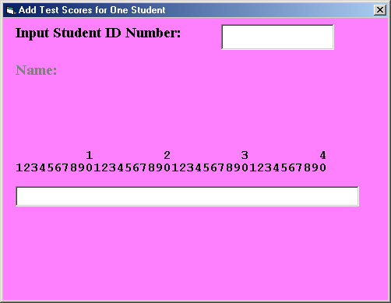
Figure 15 - Add Test Scores Screen
When this choice is selected the Add test Scores screen appears. When the Administrator inputs the ID number and uses a return or tab, the MPS looks up the student and puts his/her name in the appropriate location. If there is no match on the ID, the Add New Student operation is invoked. After the Administrator inputs the test answers, two buttons appear identical to the ones on Unknown test Version screen requesting the Administrator to select which test version the answers for which have just been added.

The Report Menu
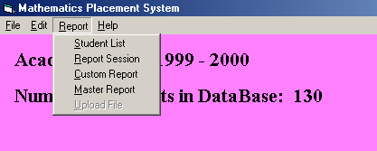
Figure 16 - The Report Menu
The choices on this menu are
Student List | Alphabetical list of student name and ID number.
Report Session | Generates reports for one testing session during pre-orientation.
Create (Custom) Report | Allows a custom report to be created.
Master Report | Generates a number of reports for the end of the testing cycle.
Upload File | Generates a file to upload test results to banner. Can only be used after Master Reports.

All reports are generated freshly from the database as requested. Recommendations are not stored in the database. Thus, any changes in major, CRN or recommendation criteria will be reflected in the newly generated report.

The major reports mentioned below have these formats:

Alphabetical (Multi-line) lists
- Heading at top of sheet: School/All, date, legend (abbreviations in recommendations)
- Name, ID number, major, math course registered (or none)
- Test version, grade, recommendation (recommended test first)
- Test version, grade, recommendation
Individual student report
Each student gets a page with each test version taken reported on it.
- Name, ID number, date
- Major, School
- Legend
- Test Results (recommended test first)
- For PT test:
- Number correct
- recommendation
- Items for review
- Cross-reference other version if taken
- Numbers of questions answered wrong
- For DAT test:
- Number correct
- Recommended placement
- Numbers of questions missed and topics to be reviewed
- Cross-reference other version if taken
- Other version: If a student does well on DAT or poorly on PT and the other version has not been taken then the system will recommend doing so based on major.
Faculty section report
For each CRN (course section), a faculty member gets an alphabetical (multi-line as above) list of the students tested up until then, a distribution chart of the DAT scores, a distribution chart for the PT scores, a question analysis for the DAT test and a question analysis for the PT test.

      - Student List
When this choice is selected, an alphabetical list of student names and IDs is generated. It is stored in the file named StudentList.txt on the local file system. This list is intended for use by the proctors at the testing area to help students who do not remember their ID numbers. As only the latest list should be used, every time that this report is generated, it is placed in the same named file. See an example list in the Appendix.

      - Report Session
When this choice is selected, it generates four fixed format reports. They are individual reports for each student tested, a multi-line report for all students tested, a multi-line report for all students tested sorted by school (alphabetical lists by school containing student name, recommendation and registered mathematics course, and a list of students who should take an additional test. This is run at the end of each day of the two-day testing session. Each time the operation is invoked, the system resets the session number. At the end of the first day, the individual reports are distributed to the advisors who will be meeting with the students early on the second day. These reports are used to adjust mathematics placement and to advise students of the support facilities available, if needed. Pre-orientation managers use the multi-line reports to detect possible problems. The list of students who should take another test is used to assure that the students do take the other version of the test on the second day. The operation is rerun at the end of the second day to complete the records and to reset the system for the next testing session.

Each of the first three documents produced has a unique name for the testing cycle. This allows the documents to be retained in the local file system for reference. The individual reports are in a file named IndividualXXX.txt where the XXX is the session number. The two multi-line reports are in files with the names MultiAllXXX.txt and MultiBySchoolXXX.txt. The list of students who should take another test is in the file Should.txt. As this file is only valuable for a limited number of hours, its name need not be unique. See example documents in the Appendix.

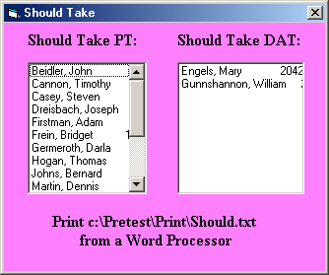
Figure 17 - Should Take Another Test Screen

The Should Take Another Test screen lists the students who should take another test. It is displayed to remind the Administrator to print off the report and to follow up on it. While the test data used for these examples has produced a large number of such students, this is atypical. We made no attempt to ensure that the majors in our file corresponded with the test version taken. Also, in practice, many students take both tests.

      - Create Custom Report

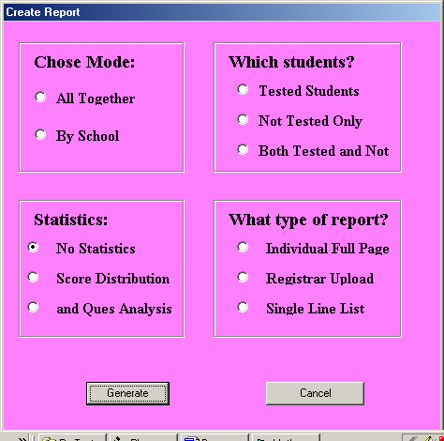
Figure 18 - Create Custom Report Screen
When this choice is selected, the Create Custom Report Screen appears. The four parts of this form provide a filter to determine the content and format of the report. The first choice is for all reports or by school reports. As each school has its own freshman advising center, requests for reports from one school need to be handled (generate for all schools by school and only print the needed part). The next choice is for tested or non-tested students. The third choice allows statistics to be printed for the selected students (see Master Report below for a description). The last part allows a detailed one student to a page or a condensed report. The Registrar Upload is the same as the Upload File option. It was developed here and access was provided directly on the Report menu for convenience. As each of these reports is similar to standard reports, see the standard reports in the appendix for examples.
All reports whose names are not otherwise recorded here are named Rpt_XXX.txt where the XXX is a unique number indicating when it was generated with regard to all other such named reports.

      - Master Report
This choice is normally run at the end of the testing cycle in late August. It produces several standard reports.

The reports include individual sheets for each student tested. One copy is mailed to the student and one is placed into the student’s advisement folder. If the student data has been recently updated, it contains the latest information about the student’s major and registered mathematics course.

Each school will receive a multi-line list of its students (see above) and the Administrator will have a multi-line list for departmental use.

Each faculty member teaching a mathematics section with at least one tested student will receive a report for each section. This report with the faculty member’s name, course and section number printed on it will include the following:
- Multi-line list of all students in section
- Distribution of scores an each test
- Question analysis for each test
See example documents in the Appendix.

      - Upload File
This choice produces an upload file in the local file system. The name is reported to the screen. It is a text file in the format requested by the University database support people. It should be emailed to them. See an example list in the Appendix.

The Help Menu
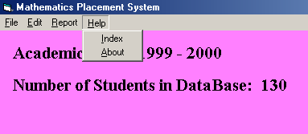
Figure 19 - The Help Menu
The choices on this menu are
Index | Gives access to an on-line version of the User Reference Manual below.
About | Program name, developer and copyright.

Unusual Events
Currently, the only problem that has come up is that the program occasionally crashes during report generation for a testing session. This is happening because it is encountering unknown CRNs. During the summer, new sections of mathematics courses are created as conditions warrant. When student data files are loaded into the machine, CRN values are updated for all students. The program does report unmatched CRNs to the Administrator but if they are not entered into the CRN table, the system cannot process the reports properly.

If the system crashes during processing session reports, open the output file being generated (the highest numbered IndividualXXX file). Find the last record. This is the last student who was successfully processed. Open the Student table in the Placement database and find that student (a find on the ID number is easiest). Find the next student from the same school in that testing session. The CRN for that student is the problem CRN. Either add it to the CRN table (preferred) or change all usages of it in the CRN field of the Students table to 00000 (easiest). Then rerun the program. It will restart as if it had not previously run.

User Reference Manual

Installation
The MPS will be installed on the Administrator’s computer by the developer before the start of the first testing cycle. It will consist of an executable code module and two databases. The Placement database will be preloaded with persistent data from the previous year. It will be ready for the system to perform the New operation. The Archive database will have its table structure set up but will be empty of data. When full with on testing cycle’s data, the Placement database will easily fit on a single 1.4 MB floppy. To run the program on another PC, put a copy of the executable code on that PC (permanently) and move the two databases to the PC using floppies or electronic transfer. Be sure to record which copy of the databases is the single current copy.
The database should be backed up periodically as well as all produced files.

Listing of Services

Service | Menu | Reference
Add New Student | Edit | 2.3.5.1
Add Test Grades | Edit | 2.3.5.2
Archive Current Year | Main | 2.3.4.5
Create Custom Report | Report | 2.3.6.3
Error Handling | None | 2.4
Exit | Main | 2.3.4.6
Initialize Program | Main | 2.3.3
Installation | None | 3.1
Load CRN File | Main | 2.3.4.4
Load Data File | Main | 2.3.4.2
Load Test File | Main | 2.3.4.3
Master Report | Report | 2.3.6.4
Modify Persistent Data | Directly on Database | 2.3.2
New (start of cycle) | Main | 2.3.4.1
Report Session | Report | 2.3.6.2
Student List | Report | 2.3.6.1
Upload File | Report | 2.3.6.5

Error Messages and Error Recovery

Currently, there are none. See Unusual Events above.

Appendix
In these examples, the names are either obviously false or are staff or faculty at the University. The ID numbers are based on student ID numbers but have been edited so that they are not correct ID numbers of anyone at the University. Testing of this system was done with real student data but we have created example files here to protect student privacy.

Example Student List
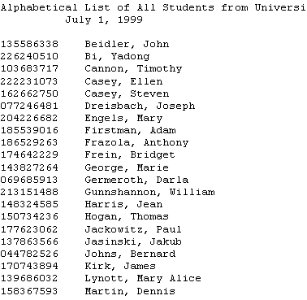

This is a portion of an example list. This list can be double columned in a word processor for easier handling.

Example Individual Student Report

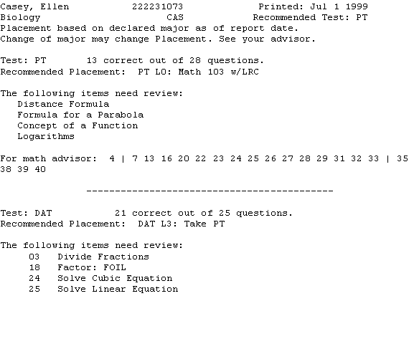
This student has taken two tests so both are reported. The first test reported is the recommended test for her major. The numbers on the bottom of the PT report are the questions answered wrong for a math advisor to better work with the student.

Example Multi-Line Report

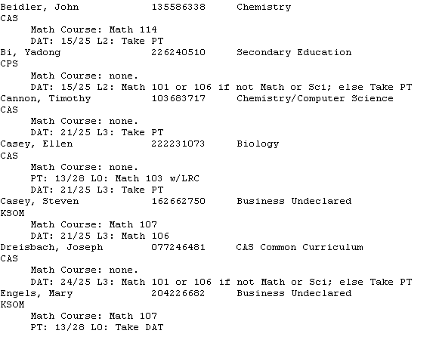
This is the alphabetical list of all students tested. The system also generates multi-line lists by school for the use of the various advising centers.

Example “Should Take” List

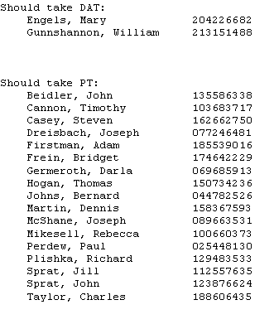

Example Upload List

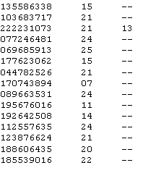
This is a part of the upload file. The columns are student ID, DAT score, and PT score respectively. A double dash is a test not taken.

Example Section (CRN) Information – DAT Distribution

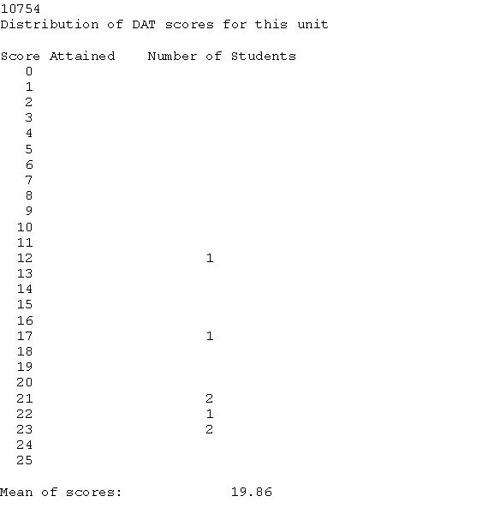
This is actual student data.

Example Section (CRN) Information – PT Distribution

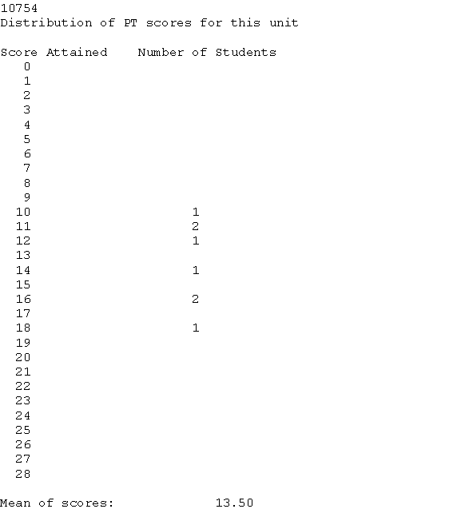

This is actual student data.

Example Section (CRN) Information – DAT Question Analysis

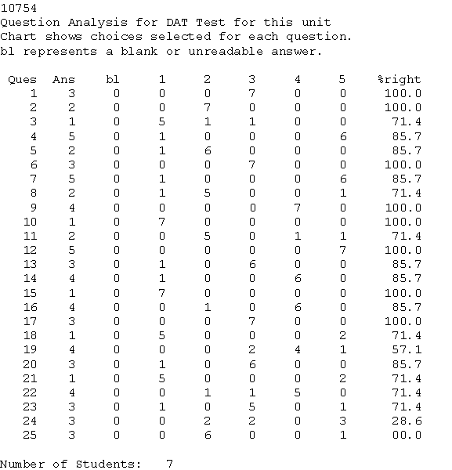
This is actual student data.

Example Section (CRN) Information – PT Question Analysis
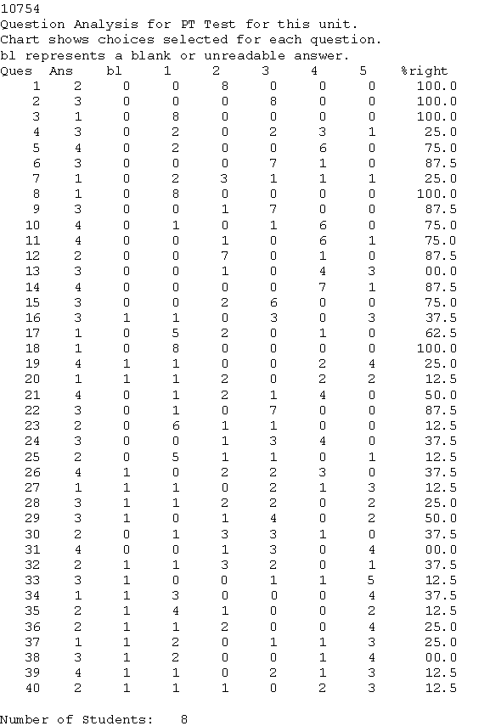

This is actual student data.

Index

Academic Major, 2, 11, 12, 19, 34
Administrator, 1, 2, 7, 8, 10, 14, 15, 16, 21, 28, 31, 32, 37, 38, 40, 41
Archive, 2, 16, 18, 30, 41
Course Registration Number (CRN), ii, 7, 9, 15, 16, 17, 18, 19, 29, 30, 33, 35, 40, 41, 48, 49, 50, 51
Local File System, 7, 8, 18, 20, 29, 35, 36, 39
Mathematics Placement System (MPS), 1, ii, 1, 2, 3, 6, 7, 8, 16, 19, 21, 22, 27, 28, 29, 32, 41
Persistent Data, ii, 3, 10, 41, 42
Placement (Current) Database, 2, 16, 18, 40, 41
Recommendation, 1, 3, 6, 8, 12, 13, 33, 34, 35
Remote File System (Tiger), 1, 7, 18, 20, 29
Session, 3, 17, 26, 28, 33, 35, 36, 40, 42
Student, i, ii, iii, 1, 2, 3, 4, 6, 7, 9, 13, 14, 15, 16, 17, 18, 19, 20, 21, 22, 23, 24, 25, 26, 27, 28, 29, 30, 31, 32, 33, 34, 35, 36, 37, 38, 39, 40, 41, 42, 43, 44, 45, 47, 48, 49, 50, 51
Student Data File, iii, 20
Student ID, 2, 3, 21, 23, 25, 26, 27, 28, 29, 32, 33, 34, 35, 40, 43, 47
Test, iii, 1, 2, 3, 4, 7, 9, 12, 13, 14, 17, 18, 19, 20, 21, 22, 23, 24, 25, 26, 27, 28, 29, 30, 31, 32, 33, 34, 35, 36, 37, 39, 41, 42, 44, 47
Test Data File, 3
Test Results, 3, 5, 33, 34
Transient Data, 3

