Problem: identifying diabetes-related events and disaggregating them from events for people with diabetes

Ppl with diabetes can go to the ED or hospitalized or go to ED for reasons other than diabetes, even if diabetes is listed as one of the diagnoses in their claims.

Disaggregating diabetes-related healthcare utilization will make the study more meaningful and impactful

Methods applied to estimate costs attributed to diabetes were described in detail here:

*Economic Costs of Diabetes in the US in 2017*

*American Diabetes Association. (2018). Economic costs of diabetes in the US in 2017. Diabetes care, 41(5), 917-928.*

Uses a prevalence-based approach that combines US population demographic, epidemiological data, health care cost and economic data into a model. Data from American Community Survey, BRFSS, Medicare Current Beneficiary Survey, and Long Term Care Minimum Data Set (MDS). Sources for national data include the Current Population Survey (CPS, OptumInsight de-identified Normative Health Information (dNHI) database, Medical Expenditure Panel Survey (MEPS), National Ambulatory Medical Care Survey (MACS), National Hospital Ambulatory Medical Care Survey, National Home and Hospice Care Survey, NIS, and Medicare 5% sample Standard Analytical Files.

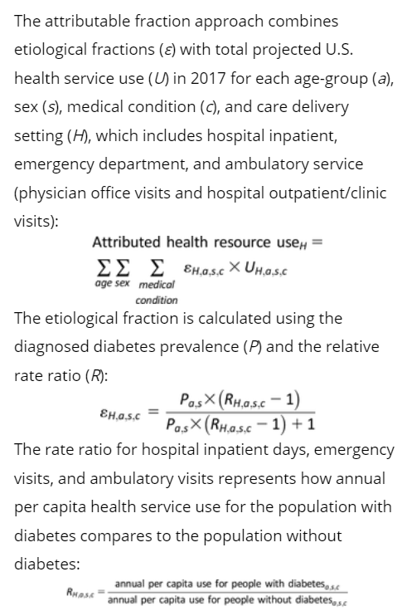Estimated prevalence of diagnosed diabetes for 480 population strata defined by age-group, sex, race/ethnicity, white, non-Hispanic black, non-Hispanic other, and insurance status, and whether residing in community, residential care facility, or nursing home. Population database starts with 2016. Diabetes status in MDS and MCBS is based on clinical diagnosis.

“Diabetes and its comorbidities are correlated with other patient characteristics such as demographics and body weight. To mitigate bias caused by correlation, we estimate age/sex/setting–specific etiological fractions for each medical condition.

Primarily used 2015 OptumInsight dNHI data and the 2014 5% sample SAF

* dNHI data contain a complete set of medical claims for 31 million+ beneficiaries and allows patient records to be linked during the year –

Authors used MEPS to determine the extent to which controlling only for age and sex might bias rate ratios – first by estimating a naïve model that produced diabetes-related rate ratios for hospital inpatient days and mergency visits controlling for age and sex only, then a full model with diabetes status as the main explanatory variable and a number of predictors as covariates