The intended program is an application that connects to a GitHub project, collects various kinds of data from the project and displays statistical measures about various metrics. Essentially, the program will make use of the GitHub connection API for Python, for which we have to obtain the API key and API documentation for Python to connect to our project. We are emphasizing on the following statistical measures about the project.

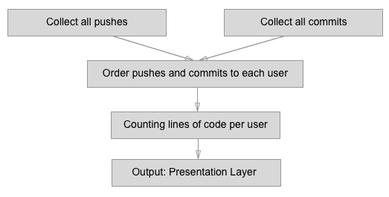

1. **API**: Github API v3 – to connect with Git and collect/request commit/log data from GitHub
2. **Statistics**: Matplotlib Library
   1. **Collect all pushes**: for this, a loop will be initiated that will travers over every pushes made to the project by every user. The count will be stored locally for the presentation afterwards.
   2. **Collect all commits**: for this, a loop will be initiated that will travers over every commits made to the project by every user. The count will be stored locally for the presentation afterwards.
   3. **Order pushes and commits to each user**: First of all, we get all the users contributing to the project. Then for each user we loop over the respective pushes and commits and store the informations locally.
   4. **Counting lines of code per user**: While analyzing every user for it’s commits and pushes we’ll get the difference of lines of code made by that user during that commit/push.
   5. **Output**: **Presentation Layer**: The program will have the console-based menu output that will ask the user which kind of statistic he wants to see (number of pushes/commits, number of pushes and commits). Upon selection from the above analysis types, the user will see the performance metric of every user in comparison, plotted using graph visualization using the python’s Matplotlib Library.