Assess tool bar:

Here is the place where we can add required short cuts.

To do add that the list of the assess tool bar, go to it on the top select more options then add the list of the items according to the requirement.

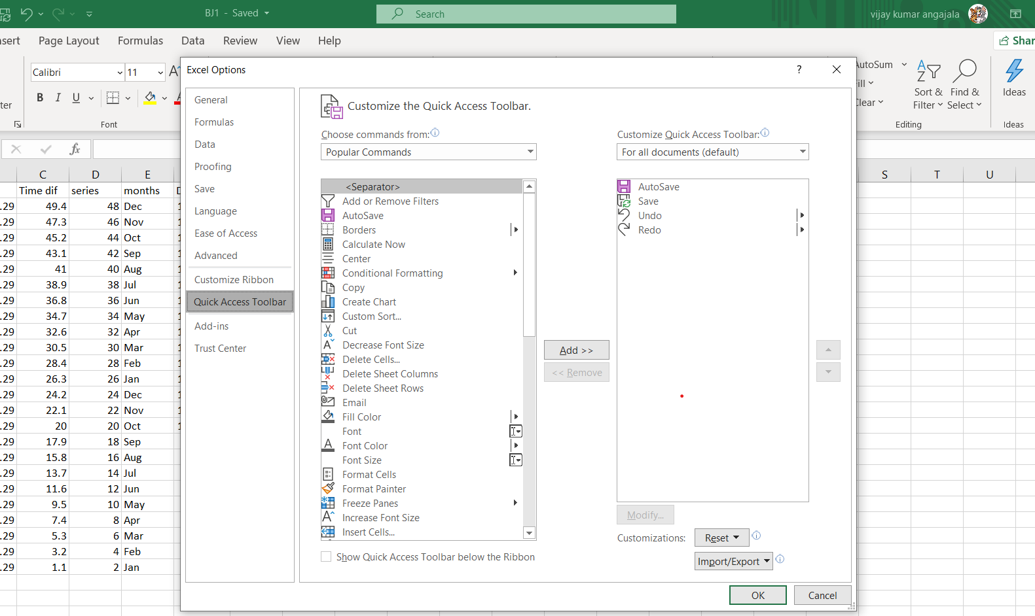

Here are the three images here, now you want to see the print sheet look then select the second image. Where in only the part of the table if you want to see then use the last option.

