Lab Manual

Double Pointers, 2D Dynamic Arrays and Jagged Arrays

Lab Objectives
After completing this lab, you should be able to:
1. Understand double pointers (pointer-to-pointer).
2. Pass double pointers to functions.
3. Create and manipulate 2D dynamic arrays.
4. Create and manipulate jagged dynamic arrays.
5. Perform memory management correctly using delete and delete[].
6. Design modular solutions using functions.

Double Pointers
A double pointer stores the address of another pointer.
Syntax:
int **ptr;
Useful when:
• A function needs to modify a pointer itself.
• Dynamic allocation of 2D arrays.
• Building complex data structures.
Sample Code:
int value = 10;
int *p = &value;
int **pp = &p;
cout << value;
cout << *p;
cout << **pp;

Double Pointers with Functions
Functions can receive double pointers to allocate memory or modify pointers.
Sample Code:
void allocateArray(int **arr, int size)
{
*arr = new int[size];
}
int main()
{
int *data = nullptr;
allocateArray(&data, 5);
delete[] data;
}

Dynamic 2D Arrays
A dynamic 2D array is implemented using an array of pointers.
Steps:
1. Allocate rows.
2. Allocate columns for each row.
3. Access using arr[i][j].
4. Deallocate row-wise.
Sample Code:
int rows = 3, cols = 4;
int **arr = new int*[rows];
for(int i=0;i<rows;i++)
arr[i] = new int[cols];
for(int i=0;i<rows;i++)
delete[] arr[i];
delete[] arr;

Topic 4: Jagged Arrays
A jagged array has rows of different lengths.
Useful for:
• Variable-sized records.
• Sparse datasets.
• Game maps and level structures.
Sample Code:
int rows = 3;
int sizes[3] = {2,4,6};
int **jagged = new int*[rows];
for(int i=0;i<rows;i++)
jagged[i] = new int[sizes[i]];

Functions with 2D Arrays
Recommended Functions:
• createArray()
• inputArray()
• displayArray()
• rowSum()
• columnSum()
• destroyArray()
Benefits:
• Reusability
• Maintainability
• Better modular design

Lab Exercise

Task 1
A university wants to create a dynamic system to store student marks. Since the number of students is not known at compile time, memory must be allocated dynamically.
Write a C++ program that uses double pointers (int**) and functions to perform the following tasks:
- Dynamically create a 1D array to store marks of N students.
- Input marks from the user.
- Display all marks.
- Calculate and display the average marks.
- Release the allocated memory before program termination.
Functional Requirements
Implement the following functions:
void createArray(int** arr, int size);
void inputMarks(int* arr, int size);
void displayMarks(int* arr, int size);
double calculateAverage(int* arr, int size);
void deleteArray(int** arr);

Task 2:
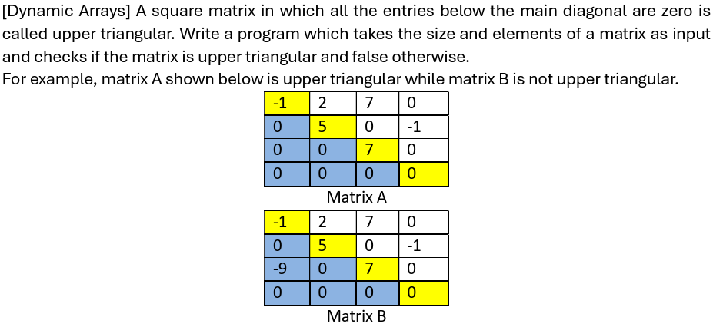

Task 3: Jagged Array
A university offers multiple courses. Each course has a different number of enrolled students. Store the marks of students in a jagged array, where:
- Each row represents a course.
- Each row can have a different number of students.
- Marks are stored dynamically.
Requirements
- Input the number of courses N.
- For each course:
  - Input the number of enrolled students.
  - Dynamically allocate memory for that row.
  - Input student marks.
- Display all course records.
- Calculate and display:
  - Average marks for each course.
  - Highest mark in each course.
  - Overall highest mark among all courses.
- Deallocate all memory.
Sample Input
Courses: 3
Students in Course 1: 4
Marks: 78 85 90 88
Students in Course 2: 2
Marks: 67 75
Students in Course 3: 5
Marks: 92 81 79 88 95
Sample Output
Course 1 Average = 85.25
Course 2 Average = 71.00
Course 3 Average = 87.00
Highest mark in Course 1 = 90
Highest mark in Course 2 = 75
Highest mark in Course 3 = 95
Overall Highest Mark = 95
Concepts:
- Dynamic jagged arrays (int**)
- Variable row sizes
- Nested loops
- Memory management
- Statistical calculations

Task 4: Jagged Array
A retail company wants to store daily sales data for several months. Since different months have different numbers of days, a jagged array should be used.
- Each row represents a month.
- Each row size equals the number of days in that month.
- Each element stores sales for one day.
Requirements
- Input the number of months.
- For each month:
  - Input the number of days.
  - Dynamically allocate memory.
  - Input daily sales.
- Display sales month-wise.
- Calculate:
  - Total sales for each month.
  - Average daily sales for each month.
  - Best sales day in each month.
  - Overall total company sales.
- Free all allocated memory.
Sample Input
Months: 3
Days in Month 1: 3
Sales: 1200 1500 1800
Days in Month 2: 5
Sales: 900 1100 1300 1400 1250
Days in Month 3: 4
Sales: 1700 1600 1550 1800
Sample Output
Month 1 Total Sales = 4500
Month 1 Average = 1500
Month 2 Total Sales = 5950
Month 2 Average = 1190
Month 3 Total Sales = 6650
Month 3 Average = 1662.5
Overall Company Sales = 17100
Best Day Sales:
Month 1 = 1800
Month 2 = 1400
Month 3 = 1800

