

**Wroclaw University of Science and Technology**

**SMB-ERP**

**Authors:**

**Tural Hajiyev – 270010**

**Supervised By:**

**Marek Woda BEng, PhD**

**June 2022**

1. **The subject of the project**

Enterprise resource planning (ERP) refers to a type of software that organizations use to manage day-to-day business activities such as accounting, procurement, project management, risk management and compliance, and supply chain operations. A complete ERP suite also includes enterprise performance management, and software that helps plan, budget, predict, and report on an organization’s financial results.

The main problem with current ERP applications is that they are mostly targeted at big corporations. It’s hard for Small and Medium Businesses to afford these prices to avoid paperwork and start to use electron management.

That’s why SMB gets its name from its main audience, “Small and Medium Businesses”. The main aims of SMB-ERP are:

* Handle your relations, stocks, products, and business operations from the online application.
* Access your business from everywhere without any application requirement.
* Store and process all data in one place, which makes generating reports and calculations easier.

Decreasing dependency on high-price technologies is one of the best features of SMB-ERP. As a web application, it doesn’t need any expensive or high-resource PC or laptop to access. The only thing you need is a budget computer and a stable internet connection.

1. **Justification**

Key Takeaways of ERP application:

* Make your business more agile.

An agile business process is a flexible project management technique in which changes can easily be made on the fly. They originated because of trying to find an alternative to manual, document-driven, software development processes. Save on unnecessary costs.

* Avoid data loss.

Because your data will be managed from one point, it decreases the possible data loss to a minimum. In addition, there are lots of tools that are designed to find gaps in the defense of database implementations. It functions as a unified security control center that automates the protection of customer data and allows you to anticipate data loss with an ERP system. It also provides practical recommendations to mitigate security risks.

* Improve security and accessibility.

ERP system helps to keep all sensitive information safe in different areas. It ranges from

* Infrastructure security
* Network Security
* Database security

1. **Project scope & risks**
   1. **Project scope­­**

* Access your data from anywhere.

At its core, SMB -ERP is an application that automates business processes, and provides insights and internal controls, drawing on a central database that collects inputs from different sources including relations, stocks, products, and trade operations.

Because SMB-ERP is a cloud application, it helps you to access your data, sales, and all new operations from anywhere with any device. The only point is to keep your username and password safe and doesn’t share with third-party applications.

* Store all your sensitive data in one place.

SMB-ERP uses an internal DB application (MongoDB) to store and make query operations. It helps you to avoid all paperwork and input all your data into the online application. After it, you will be able to access all your data from one point without any data loss risk.

* Use data of different modules to create relational processes.

Thanks to SMB-ERP, you have the option to create complex relations between your data. For example, you can add all your customers to SMB-ERP, and at the end of the month, you can get a report of monthly purchases and sales for every customer.

* 1. **Project risks**
* Lack of information

We should not forget that all people don’t have good computer and application knowledge. Even application looks easy for developers and project development staff, it can be challenging for end-users. SMB-ERP aims to avoid this risk by using simple UI components to show data.

* Competitive market

However new ERP applications are going to be implemented by others every day, ERP market is very competitive. Currently, 9.5% of the Web Applications market are ERP apps from different companies. Katana, Oracle NetSuite, Microsoft Dynamics 365, and SAP Business One are the main ERP applications that are used by many companies.

* Keep performance up to date

First days, all applications work smoothly and without any problem. Main issues start after users input many data into the application. That’s why keeping performance up to date is one of the challenging features for each ERP application. SMB-ERP planning to avoid this problem by showing only necessary information to end-users.

* Lack of business knowledge

One of the main points of ERP applications is that you need to think like a “businessman” Having a lot of features doesn’t mean that this application is useful for all companies. All features should aim to solve an aimed business problem.

1. **Goal / Aims**

**Aim**

The aim of SMB-ERP is to help small and medium companies to integrate their businesses into the electron world. Providing reliable web application that allows to access to their businesses with one click will make their life easier.

**Goals**

* **Help businesses to move to an electronic system for an affordable price.**
* **Help companies to access their businesses from one point and access their data from anywhere.**
* **By letting users make complex relations between their dates, make daily/monthly/yearly reports seeing margin, income, total turnovers, and other important calculations with one click.**

1. **Features to be implemented**

**Authentication and Authorization**

Each company can create their businesses in SMB-ERP by adding general information like full name, company name, email, and password. This registration is required only the first time, after the registration each user can log in to his account by using his email and password.

**Relations module**

This module helps users to create a list of contacts and partners of the company. Companies can store main information about their customers, like:

* Name
* Type of the customer (Individual or Company)
* Category of the customer (Seller, Buyer or Manufacturer)
* Company
* Position
* Bank Account
* Phone number
* Website
* Address
* Description

We will be able to see a list of users on the nice-looking table with all of this information.

**Stocks**

This module helps users to create different Stocks by adding information like the name of the stock, address, and short description. In purchase and sales operations, by selecting scope we can relate all of our products with warehouses. It will help us to generate sales operation reports based on stocks.

**Catalogs**

This module aims to help end-users to categorize their products based on type (product or service) and store a list of products under the same roof. For example, if we have products like laptops, mobile phones, and smartwatches, creating a catalog with the name “Electronics” will help us to create reports based on this catalog at the end of the month.

**Products**

This module is one of the main modules of the project. Adding new products help us to create purchase and sales operations for these products. Each product has

* Name (Unique)
* Catalog (we can create from the catalogs module)
* Manufacturer (we can create from the relations module)
* Price and currency (for now, we have only PLN)
* Measurement unit (Box, Unit, Kg)
* Barcode

We can buy these products from different sellers or can sell them to different buyers from the Relations module.

**Trade**

The trade module helps us to create purchase and sales operations. Each trade operation has

* Invoice Number (unique)
* Operation type (purchase or sales)
* Counterparty (we can create it from Relations module
* Currency (for now, we have only PLN)
* Description
* List of products with price and quantity.

**Reports**

As the sum of this application, the Reports module helps us to get reports based on different modules. For now, we can get reports of Relations with total operations count and total turnover. It can be possible to make more complex reports based on stocks, catalogs and products.

1. **Techniques & Technologies used**

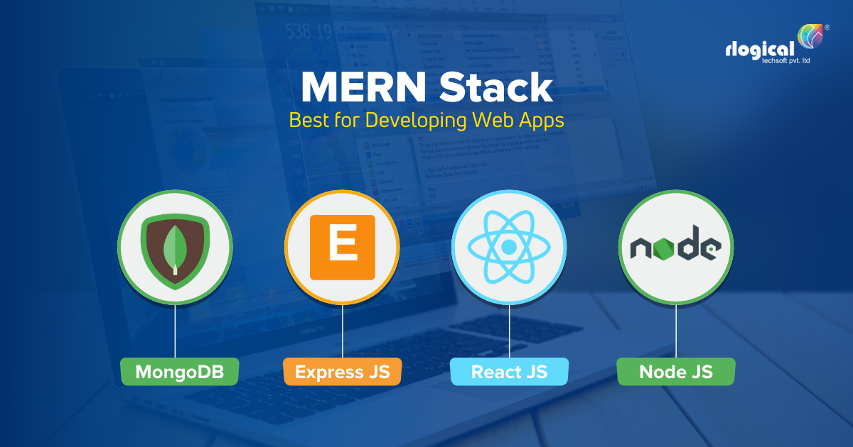

As each application, SMB-ERP contains 3 main parts

**Frontend**

On the front side as the main tool, we are using React JS. React is a JavaScript library for building user interfaces and single-page applications. The main point of React is that it allows us to create reusable UI components.

Main libraries we are using on the front side

* React – Main react library to use reactJS features
* Antd-design – UI library which contains different UI elements like Button, Input, Select Box, etc.
* sweetalert

**Backend**

On the backend side of the application, we’re using Node JS and Express JS to run our server. We are using various libraries to handle different user requirements:

* bcryptjs – Encrypt and decrypt user password
* express – Main express library to run backend application
* gravatar – Access avatars of users from one source
* jsonwebtoken – Generate and use web token for authorization

To store data, we are using MongoDB. With a document data model that maps to how developers think and code and a powerful, unified query API, MongoDB powers faster, more flexible application development. Mongoose is one of the main JS libraries to use MongoDB features.

**Deployment (in future)**

For the deployment purpose, the chosen stack is Docker and Heroku.

* Docker: is an open-source containerization platform. It enables developers to package applications into containers—standardized executable components combining application source code with the operating system (OS) libraries and dependencies required to run that code in any environment.
* Heroku: is a container-based cloud Platform as a Service (PaaS). Developers use Heroku to deploy, manage, and scale modern apps. Our platform is elegant, flexible, and easy to use, offering developers the simplest path to getting their apps to market.

1. **State of art**

* Microsoft Dynamics: It helps users run their businesses and improve their results using artificial intelligence-driven insights.
* SAP: SAP Business One is a comprehensive ERP application that helps users manage all aspects of their business affordably.
* Acumatica - This application is going to be a cloud app, which means that managers can access their businesses from anywhere if they have internet connection.
* Micro, ERPNext, odoo, Oracle NET Suite, etc.

1. **Implementation and Deployment of application**

**Implementation of application (UI pages)**

**Login Page**

**List of Relations**

**New Relation**

**List of Stocks**

**New Stock**

**List of Catalogs**

**New Catalog**

**List of Products**

**New Product**

**List of Trade Operations**

**New Trade Operation**

**Reports**

**Deployment of application**

It’s the folder structure of the application. To set up and run the application properly, we only need to run 2 commands from package.json



* Setup:app – This command installs all required packages
* Start:app – This command runs backend and frontend server

**Mermaid diagram of Frontend components**

**UML diagram of the database**

**Future scope of the project**

* Allow multiple users to log in to the profile of the same company.
* Allow users to delete products and trade operations.
* Add dependency between purchase and sales operations. If there are not any products in the warehouse, don’t let users make sales operations.
* Add reports based on catalogs, manufacturers, product types, and operation types.
* Let users update their profiles. (Full name, email, password, profile picture)
* Add Stock section to Operations.
* Add new Operation types – Retrieval, Sell back, Transfer.
* Add stages to operations (New, In progress, Done)