

**Web technologies**

**Final project documentation**

**AstanaIT University**

**Teacher:** Salkenov A.

**Made by:** Turarova Zhansaya

Kairula Madina

Kanapiya Daulet

Dzhumaniyazova Ademi

Gaziz Aida

# **Overview**

* **About our team**
  + Zhansaya Turarova, 201011, [201011@astanait.edu.kz](mailto:201011@astanait.edu.kz), Front-END developer
  + Daulet Kanapiya, 201817, [201817@astanait.edu.kz](mailto:201817@astanait.edu.kz), Front-END developer
  + Madina Kairula, 201450, [201450@astanait.edu.kz](mailto:201450@astanait.edu.kz), Back-END developer
  + Ademi Jumaniyazova, 201304, [201304@astanait.edu.kz](mailto:201304@astanait.edu.kz), Back-END developer
  + Aida Gaziz, 201425, [201435@astanait.edu.kz](mailto:201435@astanait.edu.kz), CSS and HTML maker
* **Communication strategy –** the very first step of our project creation was logically the discussion in the group. We made a discussion about out project, generally discussed what type of functions there should be, how we can achieve them, and divided the work amount. Then we started practical part, there we helped each other with some troubles that appeared due the project building**.** Shared some knowledge, cause everyone of us is stronger in different spheres.

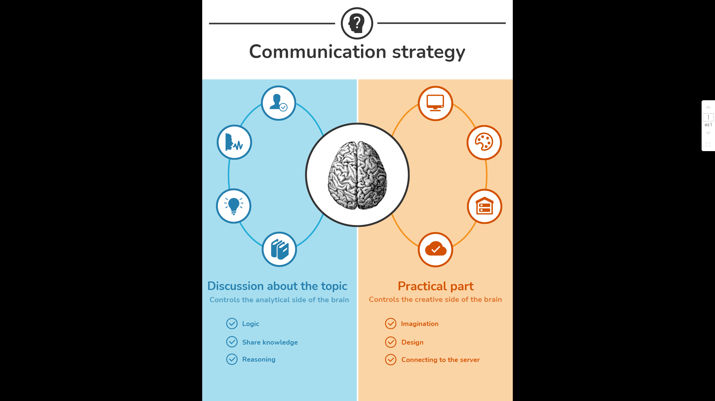

* **Motivation** – This project is unique, because with the help of this we developed our logic, invested all our knowledge that we studied during our studies. It was a great experience for us and we hope that it will definitely be useful for our future, as well as throughout the project, our team acted very clearly in order to eventually get a good result and achieve our goals.

* **High-level project scope** – This is a brand-new website, for which our participants wrote code JS for HTML, CSS and connected to the server using Node.js express.
* **Target audience/market** – The audience of this website is determined to be both teenagers and adults who are interested in football. And also, some people that are interested in programming, cause they can easily make this type of projects too, to practice more.

# **Project goals and team interests**

**Project goals**

* Quickly calculate the points during the game
* Make the website convenient and comfortable
* Use all our knowledge that we have learned throughout our studies and eventually create a good website.

**Team interests**

* Combine all the knowledge in the field of HTML, CSS when creating a website.
* Make the website convenient to use at the same time, work well on the design of the website.
* The formation of a cohesive team is the creation of a workplace atmosphere in which employees value teamwork and the ability to cooperate.

**Phases**

* Phase 1 – Website about the football team, all information about the players
* Phase 2 – Work on the design, make the website fun and expand the content.
* Phase 3 – Connect the website to the server for full use

# **Content structure**

**Website map**

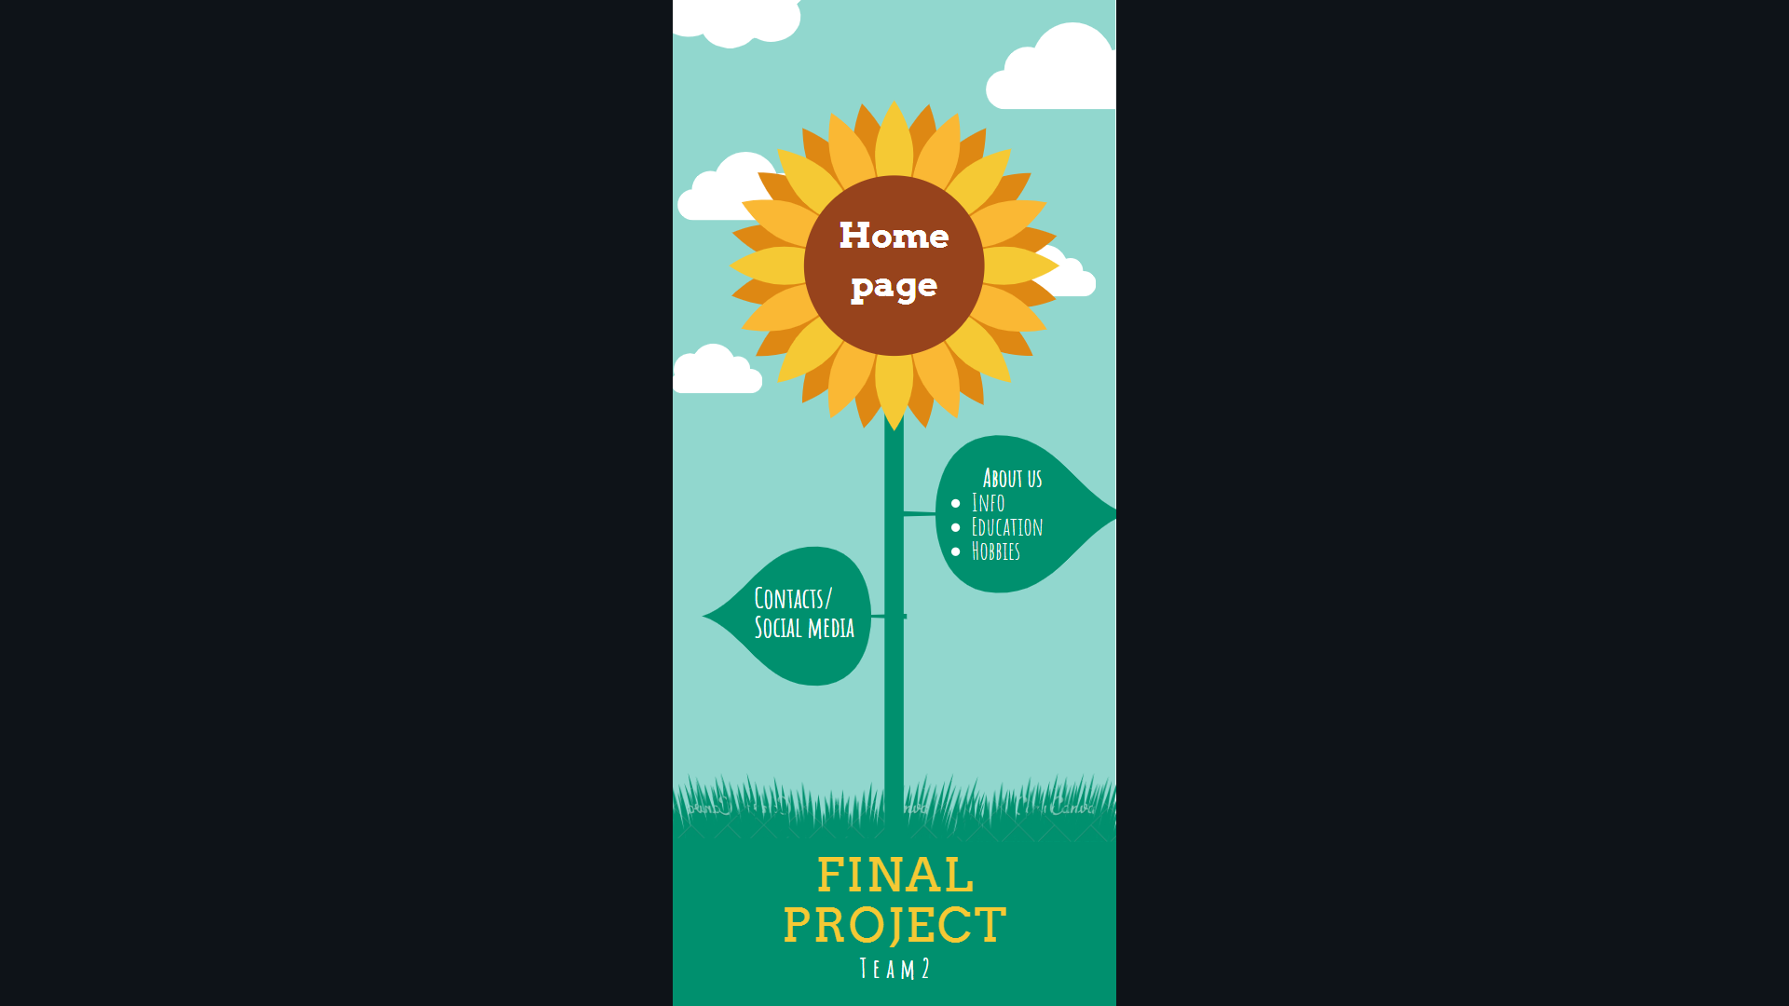

**Design**

It is important to provide design assets and related references

There are many ways to provide design assets, for example:

* Reference links
* Image files
* Sketch files

It is also important to provide a style guide and/or annotations for information such as:

* colours
* typography rules
* hover states
* animations
* grid systems
* spacing

**Functionality**

Generally, the functionality of our project is a pretty sure interesting. There is a lot of javascript functions that are making several operations, such as outputting the winner team, the names of the team members, also probability of the goals. There is a section on our website where we have specified ways to contact us. Anyone interested can write to the post office, for this they need to have an email address. Also, there is a website of the main page of the university and an Instagram account, where the latest news and important projects on IT are published. The website is so convenient that there are no big problems.

**Hosting**

1) Logging into the account in GitHub

2) Creating new repository with README file inside

3) Importing files, with index.html as default name of the main page of the website

4) After uploading all videos, now it’s time to make a link, in the settings by creating a root to the main. Then link to the website repository will activate (became green), its ready to be used by us.

5) Copying, the link to the webpage itself, and to the repository files

**Accessibility**

Our website is easy to use, it is divided into several pages, which you can switch to the navigation point.



With the help of which, the user can easily find the information he was looking for. On the first main page, you can see all the information about the game. Here you can count the number of goals scored, and at the end identify the winning team between two of them.

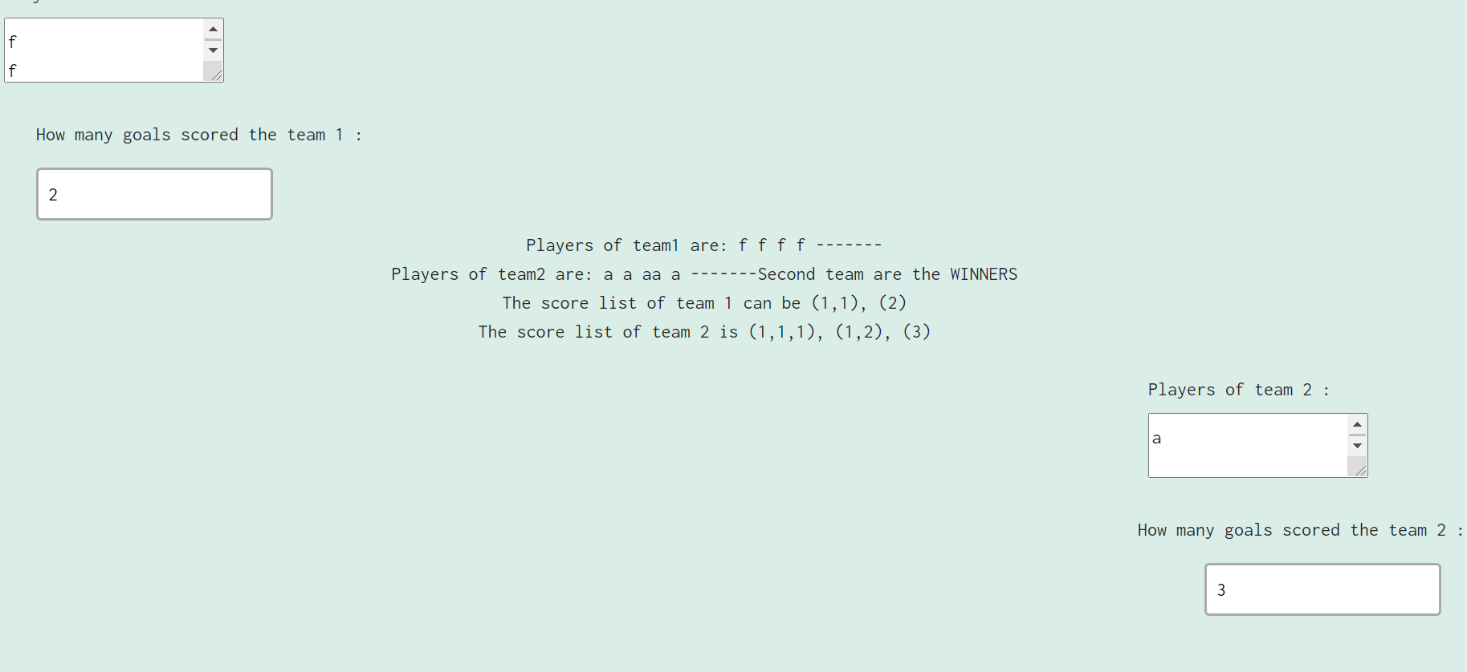

At the end of this page, we indicated the email address, the Instagram page, and the website of our university for recommendations.



The second section "About us" contains all the information about the developers of this website.

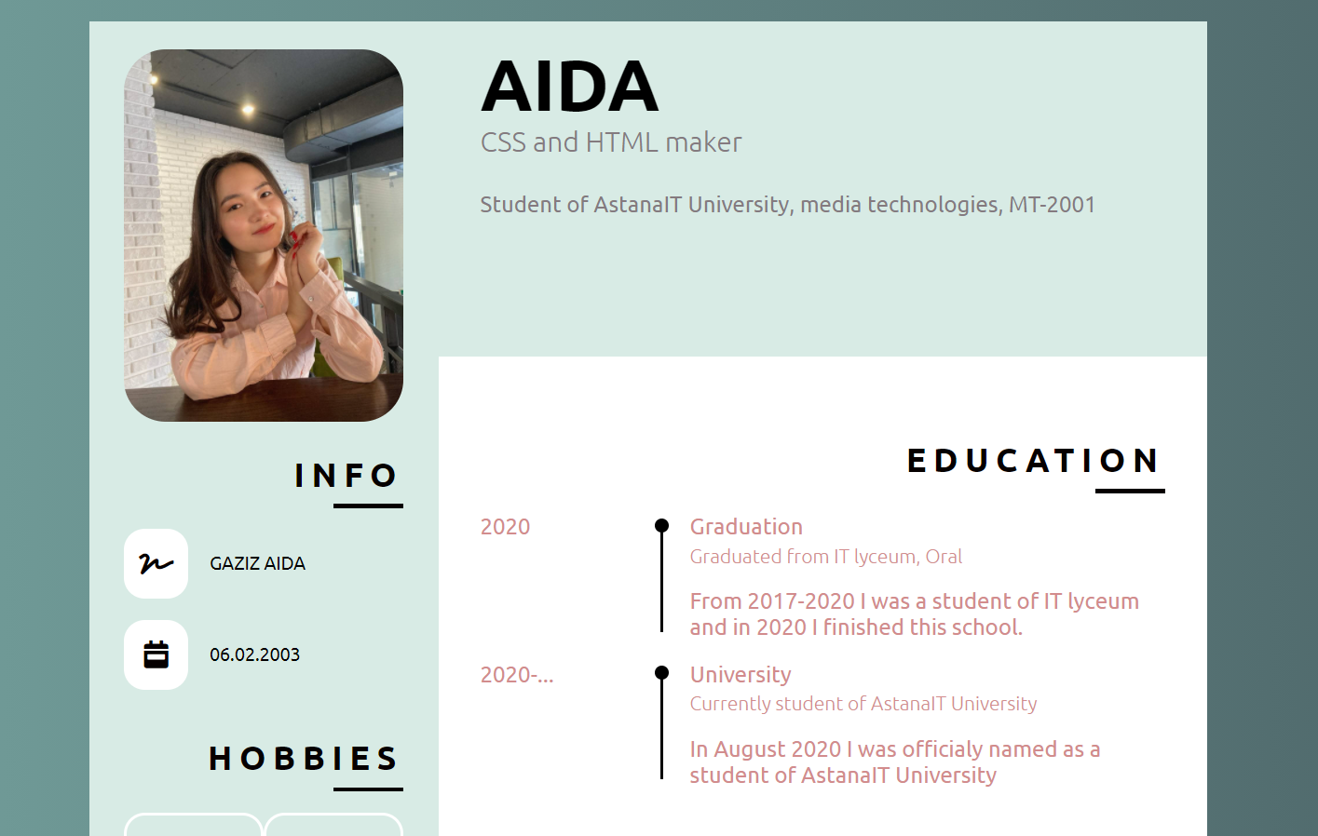

In this case, we can recommend using a table or other different methods to quickly find specific information. In general, we want to recommend the website developer to choose a beautiful color that does not catch the eye sharply, you need those colors that are well combined and more. Make the website comfortable for everyone, share all the information so that it can be easily and quickly found. Do not forget to add contacts for communication, if you have any questions, as well as for cooperation.

**Deadlines**

* Phase 1 – March 14, 19:00
* Phase 2 – March 15, 22:00
* Phase 3 – March 16, 23:00

# **Summary**

Project creation is a unique process consisting of a set of coordinated and managed actions with a start and end date, taken to achieve a goal that meets specific requirements, including time, cost, and resource constraints. Our project is that you need to create a website about a football game, with which you can count the points of the goals of the team that scored a goal and at the end identify the winning team. To do this, we created the website using our skills in HTML, CSS, and Node.js express. We had some problems coding in Node.js express, since this is our first practical task, but we were eventually able to solve this problem and eventually got a good result. With the help of this project, we learned everything, for example, we gained a lot of skills when practicing a new topic, increased educational and cognitive motivation, as well as the effectiveness of assimilation and updating of knowledge.