# System Design of Support Software in Autonomous Vehicles

## Abstract

This report examines three support technologies incorporated into autonomous vehicles from an object-oriented approach: Automatic Emergency Braking (AEB), Lane-keeping Assist (LKA), and Adaptive Cruise Control (ACC). Transitioning to a society that is completely driven by autonomous vehicles is a great uncertainty, but what is certain is that the safety and efficiency introduced by semi-autonomous vehicles and more importantly the software systems that support them is incredibly valuable and will have impact across a large number of industries and the economy, lessening the massive demand for oil (Kim, T.J. 2018).

## Summary

Autonomous vehicles, driverless cars, or self-driving cars, are vehicles that are designed to sense their environment and operate with little to no human input (Reddy, P. P., 2019). Today we can observe an increase vehicular safety and efficiency by systems implemented to aid the driver and those around them that come standard on many cars now, including automatic stability control and backup cameras among many others. Those previously unable to commute broadens with increases in vehicle autonomy to include people like the elderly and those with disabilities (Schoitsch, E. 2016). There is a long road to full autonomous safety, but a testing methodology called Metamorphic Testing (MT) has greatly assisted in further refining the safety of autonomous vehicle systems by proving errors in existing systems (Zhou, Z. Q. & Sun, L., 2019). Tesla’s Autopilot, Cadillac’s Super Cruise, or Mercedes’ Drive Pilot are examples of degrees of autonomous driving systems in vehicles. These systems can all technically operate without a driver but are not considered fully autonomous by definition or by industry standards, for example, those set forth by The Society of Engineers (SAE). There are several other factors to include in the development and manufacture of driverless vehicles including societal issues, environmental issues, autonomous-friendly infrastructure, and legal requirements. To better understand the systems that support autonomy in vehicles, this report will outline three support operations in driverless vehicles, including Automatic Emergency Braking (AEB), Lane-keeping Assist (LKA), and Adaptive Cruise Control (ACC). I will take a dive into the details of each system to see how they operate using an object-oriented approach utilizing the Unified Modelling Language (UML).

In my research for this report, some general and relevant search terms that I used were “driverless”, “autonomous”, and “autonomous vehicle functions”.

## Systems Design Models

### Class Diagram

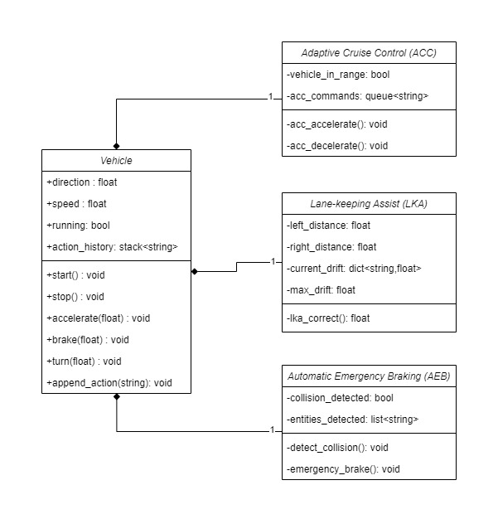

### Use Case Diagram

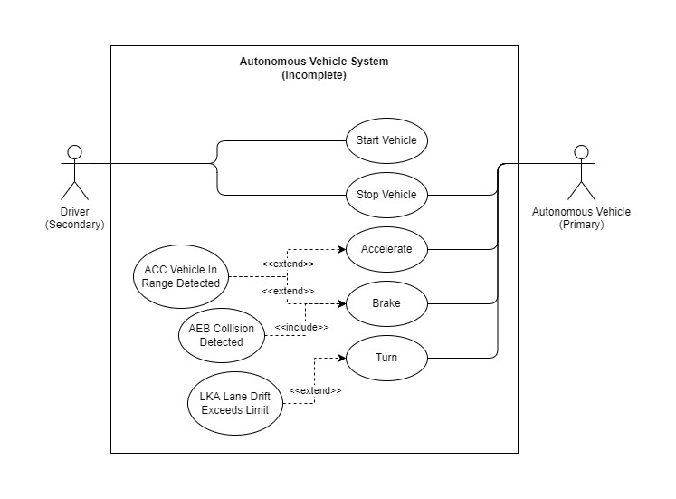

### State Machine Diagram

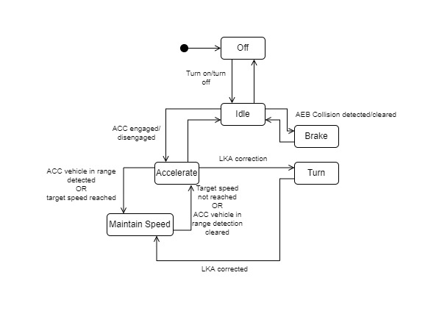

### Activity Diagram

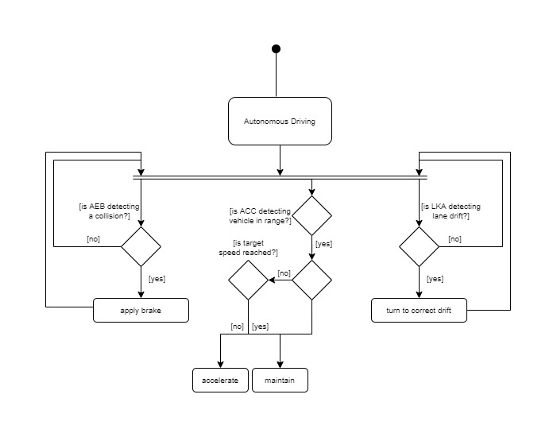

# References

* Reddy, P. P. (2019) Driverless Car: Software Modelling and Design Using Python and Tensorflow. Available at: <https://easychair.org/publications/preprint_open/k7wj> [Accessed 31 October 2022]
* Zhou, Z. Q. & Sun, L. (2019) Metamorphic testing of driverless cars. Commun. ACM 62(3): 61-67. DOI: <https://doi.org/10.1145/3241979>.
* Kim, T.J. (2018) Automated Autonomous Vehicles: Prospects and Impacts on Society. Journal of Transportation Technologies, 8, 137-150. DOI: <https://doi.org/10.4236/jtts.2018.83008>.
* Schoitchs, E. (2016) AUTONOMOUS VEHICLES AND AUTOMATED DRIVING STATUS, PERSPECTIVES AND SOCIETAL IMPACT. Available at: <https://www.researchgate.net/profile/Erwin-Schoitsch/publication/306373756_AUTONOMOUS_VEHICLES_AND_AUTOMATED_DRIVING_STATUS_PERSPECTIVES_AND_SOCIETAL_IMPACT> [Accessed 06 November 2022]
* Bissell, D., Birtchnell, T., Elliott, A., & Hsu, E. L. (2020). Autonomous automobilities: The social impacts of driverless vehicles. Current Sociology, 68(1), 116–134. DOI: <https://doi.org/10.1177/0011392118816743.>
* Fagnant, D.J., & Kockelman, K. (2015). Preparing a nation for autonomous vehicles: opportunities, barriers and policy recommendations. DOI: <https://doi.org/10.1016/j.tra.2015.04.003>.
* Hancock, P.A., Nourbakhsh, I., & Stewart, J. (2019). On the future of transportation in an era of automated and autonomous vehicles. DOI: <https://doi.org/10.1073/pnas.1805770115>