Lessons learned:
- Performance maps using pressure ratio are not useful when the fluid does not behave as an ideal gas. Performance in terms of isentropic specific work (enthalpy change) should be used when the fluid behaves as a real gas.
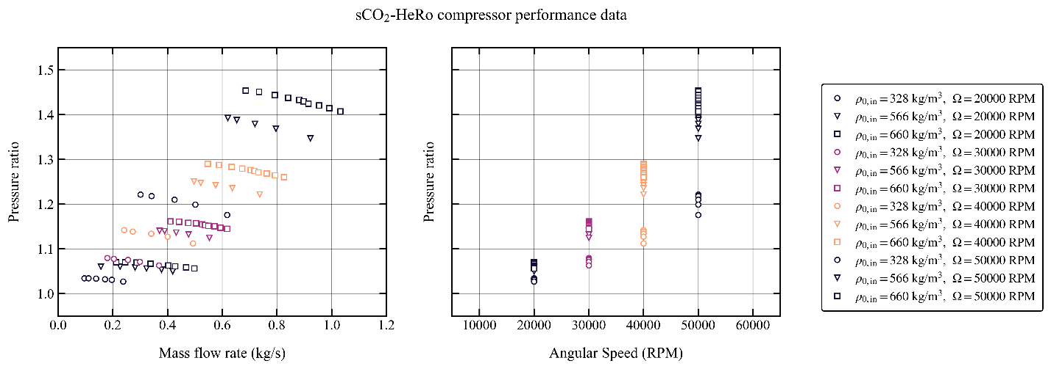
- Performance maps in terms of equivalent quantities seem to generalize well when the inlet conditions even when the fluid behaves as a real gas.
- I think that the Barber-Nichols/Sandia-Laboratories way to define the equivalent conditions might work to account for some small real gas effects when the inlet conditions are not very close to the critical point. However, their semi-perfect approach gives unphysical results when the fluid is very close to the critical point.
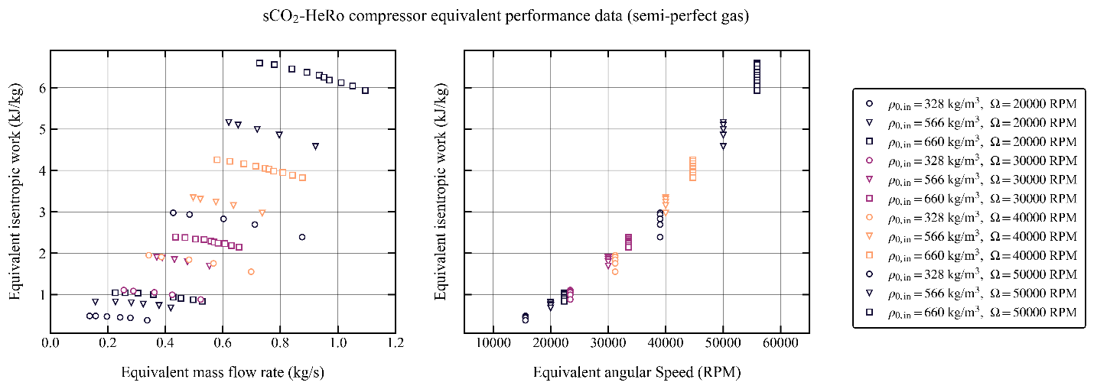
- The semi-perfect gas equivalent definitions predict that the θ correction factor (ratio of actual critical velocity to reference critical velocity) is more than one for the inlet condition at low density. This means that the semi-perfect relations predict that the critical velocity for the more gas-like state is higher than for the liquid-like state. This is clearly not the case as we can see that the speed of sound is in fact lower for the gas-like case with low density (as we could expect). This results in unrealistic equivalent isentropic work and angular speed.
p | T | d | a | γ | Z | δ | θ | ε | Δh | Δheq | Ω | Ωeq
77.3 | 34.5 | 328 | 189.19 | 10.27 | 0.41 | 0.99 | 1.64 | 1.09 | 798.61 | 486.31 | 20000 | 15607
78.3 | 33.0 | 566 | 197.82 | 17.29 | 0.24 | 1.00 | 1.00 | 1.00 | 824.67 | 824.67 | 20000 | 20000
79.3 | 31.5 | 660 | 256.40 | 6.70 | 0.21 | 1.01 | 0.80 | 1.20 | 838.96 | 1048.69 | 20000 | 22361

- As an alternative, using the inlet stagnation density and speed of sound seems to be more realistic because they critical velocity and density are more closely related to these two parameters (at least when the critical state is not in the two-phase region)
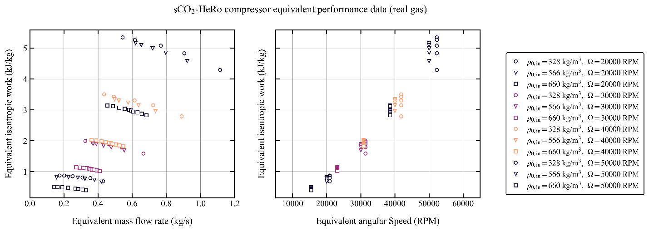
- Using the stagnation speed of sound and density to define the equivalent conditions seems more physically consistent and yields the anticipated behavior that the critical speed is lower in the more gas-like region.
- Perhaps, the best way to achieve similarity at the critical condition would be to compute the actual critical condition based on the conservation of stagnation enthalpy and entropy in a frictionless nozzle with a real fluid. However, I anticipate some challenges:
  - The calculation is not straightforward (requires iterative root finding)
  - The critical state might be less representative of the conditions within the compressor/turbine than the stagnation state? Discuss and clarify.
  - The critical state might fall within the two-phase region. In this case it is clear that the sonic state and the sonic speed of sound is clearly not representative of the actual fluid states within the compressor.
  - Calculations based on the sonic state assume that the flow is isentropic, when in fact it is never the case. Is this a limitation? Or it does not really matter as it is only used as a scaling variable and its value does not really matter?
  - If it does not matter, why bother at all? It probably matters to some extent, but if the efficiency of the machine is high enough the effect is probably marginal.

