acqApp — Operator Quick-Start
A practical walkthrough of running a session: launch, pick instruments, configure one, go live, record, and where the file ends up. For what the app is and how it's built, see README.md; for what's planned or in progress, see PLAN.md.
Screenshots below are from a mock session (no rig hardware attached), so frame previews show synthetic noise instead of a real image — the layout and controls are identical on the rig.

1. Launching
acqApp\.venv\Scripts\python acqApp\main.py
No setup needed the first time — main.py creates acqApp\.venv if it's missing and installs everything into it. Add --mock to run with no hardware attached (simulated signals in place of every device) — useful for practicing away from the rig.

2. Pick what to load
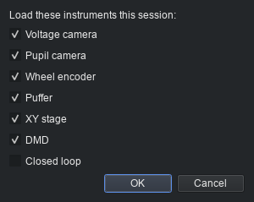
Module picker: a checkbox per instrument
Tick which instruments to load this session. It defaults to whatever you had loaded last time. Experiment routines has no checkbox — it owns no device, so there's nothing to unload.
You aren't locked in: the sidebar's 🧩 Modules button reopens this same picker at any time, and loading or unloading applies live — a module you add mid-session builds its own worker and joins the live view immediately. The only time it's refused is while recording, so a stream can't appear or vanish partway through a file.

3. The main window
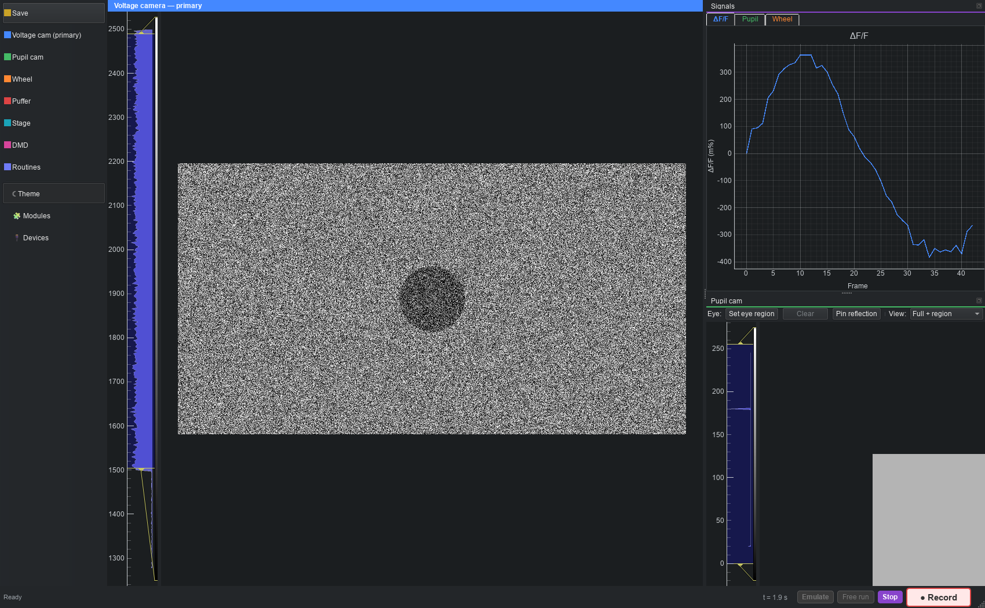
Main window during live view, several instruments loaded
- Left sidebar — one item per loaded instrument's settings page (plus Save), each in its own accent colour. Below the divider: Theme, Modules (the picker again), Devices (§6).
- Centre — the voltage camera's live preview, when loaded; otherwise whatever module claims the central view.
- Right — the Signals dock: rolling plots per instrument, tabbed. The pupil camera additionally gets its own dock (bottom right here) with the live frame, the fitted pupil outline, the eye region, and any pinned reflections.
- Bottom status bar — session clock, recording readout, then Emulate / Free run / Live view / ● Record.
Every dock and plot panel is draggable — pull one out to float it, tab it with another, or re-dock it elsewhere. The layout is remembered across runs.

Starting a session
- Live view starts the shared session clock and every loaded worker, with preview but nothing saved to disk. Good for framing, focusing, checking a signal.
- ● Record does the same and additionally streams every sample to one HDF5 file (starting Live first if it wasn't already running).
- Emulate swaps every device for its mock twin — flip it on to rehearse or test with no hardware attached, same as --mock at launch but toggleable per session.
- Free run ticks a single module with no session clock and no recording — for checking one instrument in isolation.

4. Configuring an instrument
Click any sidebar item to open the shared settings window on that page — a tab bar across the top mirrors the sidebar, and both stay in sync. Clicking the sidebar item you're already on tucks the window away again. It's a separate window, so it can sit on a second monitor while a session runs.
Example — the pupil camera's page:
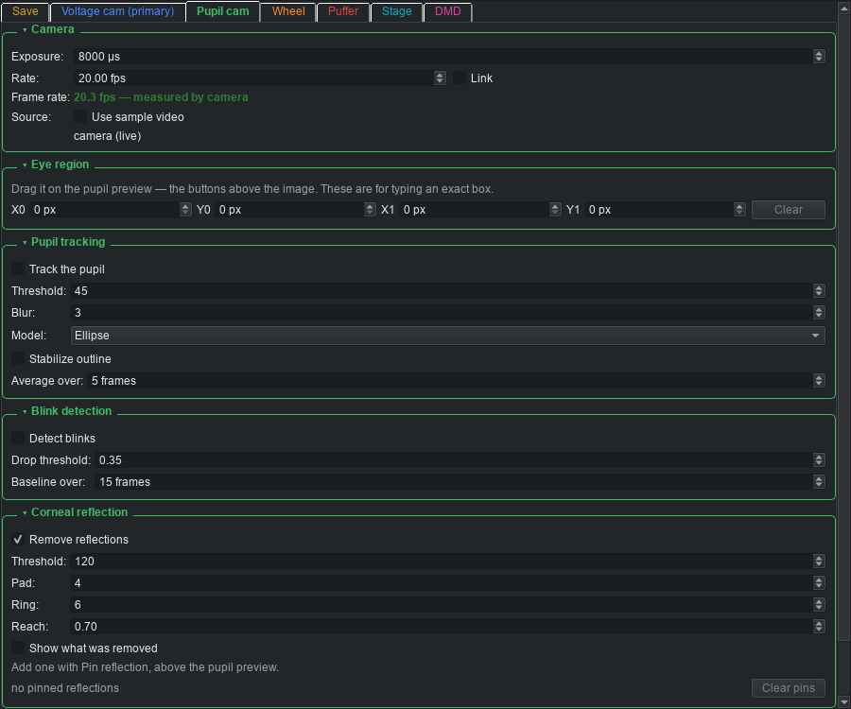
Pupil camera settings: exposure, eye region, tracking, blink detection, corneal reflection
A few things worth knowing about this one, since they aren't typed as numbers:
- Eye region — drag a box directly on the pupil preview dock (not here); these fields just show/type the box you already drew.
- Rate / Exposure Link — check it to keep the two locked together (exposure = 1/rate); unchecked, Rate is just a ceiling on Exposure.
- Stabilize outline and Detect blinks trade a little lag for a steadier trace and a flagged-blink overlay on the radius plot, respectively — both off by default so a session captures the raw fit unless you opt in.
- Pin reflection (button above the preview, not shown here) marks a fixed IR glint for removal — there's no separate button for it in this settings page on purpose; it's a position in the frame, so it's placed by clicking the frame.
Every panel's settings persist to acqapp_local.json and come back at the next launch — except runtime-only state like the eye-tracking LED, which always starts off so the app can never come up with an illuminator already on.

Where the data goes — the Save tab
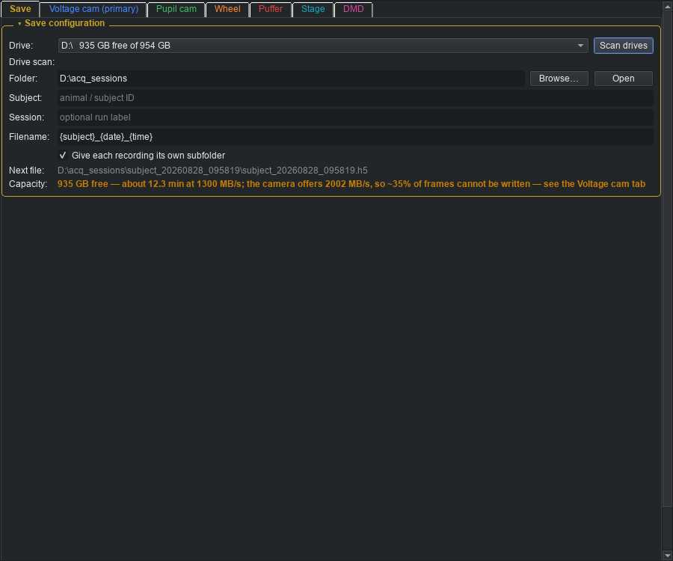
Save tab: drive, folder, subject, filename template, capacity warning
Pick the destination drive and folder, a subject ID, and a filename template ({subject}, {session}, {date}, {time}). The Next file line always shows the exact path the next recording will get — a name that already exists is auto-numbered, never overwritten.
The Capacity line is the one to actually read before a long session: it compares the free space and the configured data rate, and — as in the screenshot above — will tell you plainly if the current configuration can't actually be written to disk fast enough, with a pointer to the tab that can fix it. If a drive looks slower than it should, hit Scan drives: it benchmarks each one directly rather than trusting what the OS reports.

5. Checking device connections
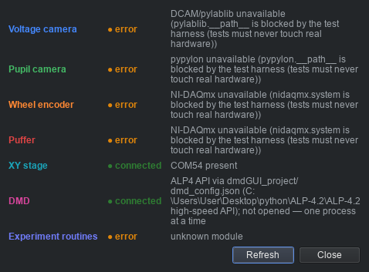
Device connections monitor, one row per loaded instrument
The sidebar's Devices item opens a live probe of every loaded instrument — safe to open any time, including mid-session, since it only enumerates (checks presence), never opens a device for real. On the rig, instruments that are plugged in and powered read connected; the example above is from a dev machine with none of the rig hardware attached, so almost everything reads error — that's expected there, not a fault.
A connected probe is not the same as working: it means the OS can see the device, not that acqApp has successfully opened and driven it.

6. Running an experiment routine
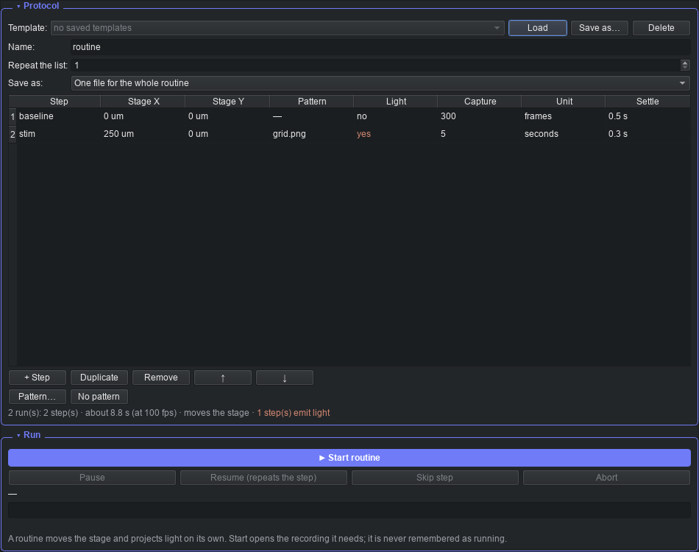
Routines window: a two-step protocol, ready to run
Experiment routines is always loaded and opens in a window of its own (not a settings-page tab), reachable from the sidebar. A routine is a list of steps — move the stage here, put this pattern up, capture this long — run in order, for as many cycles as you set.
Add steps with + Step, edit a cell directly (each field is a proper widget — a dropdown, a spin box — not free text), and reorder by dragging a row, Ctrl+Up/Down, or the arrow buttons. The summary line under the table (visible above: "2 run(s): 2 step(s) · about 8.8 s ... · 1 step(s) emit light") tells you what's about to happen before you commit to it.
▶ Start routine validates the whole protocol up front — an out-of-range stage target, a frames-based step with no camera loaded, a missing pattern file — and refuses with every problem listed, rather than faulting partway through with an animal on the rig. It opens its own recording if one isn't already running, and closes only the recording it opened when the routine ends.
If something goes wrong mid-run, the routine pauses, not aborts: the stage stops, the light goes out, and the interrupted step's partial data is kept (marked, not discarded) so you can Resume (repeats that step cleanly) or Skip.

7. Stopping and closing
● Record (or Live view) toggles off to stop; the window's dock layout, your last module selection, and every panel's settings are saved automatically on close and restored at the next launch.

Quick troubleshooting
- A device won't connect — open Devices first; it tells you whether the OS even sees it before you go looking further.
- Nothing to test with, no rig nearby — toggle Emulate, or launch with --mock.
- "Cannot record" or any other message vanished before you could read it — the status bar (bottom-left) holds the last message; give it a second look, it no longer gets overwritten by the running clock.
- A setting won't stick — check whether the app closed cleanly last time; persistence writes on close, not on every keystroke.

