**Foto galerija**

--------------------------------------------------------------------------------------------

Dodati span sa id naziv i glavni div id glavna slika

*Skripta:*

function zameni(ele)

{

document.getElementById('glavna_slika').src=ele.src;

document.getElementById('naziv').innerHTML=ele.id;

}

U htmlu:

onclick=”zameni(this)”

--------------------------------------------------------------------------------------------

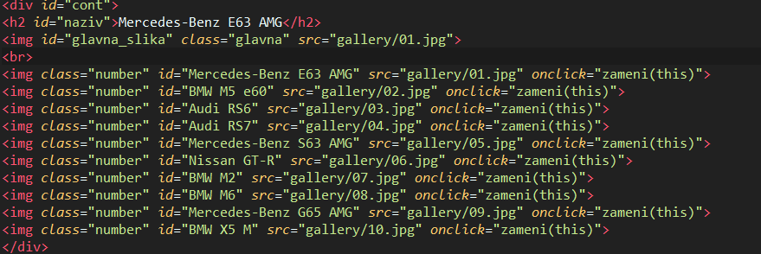

**Zvuci instrumenata**

--------------------------------------------------------------------------------------------

*Skripta:*

function zvuk1() {

document.getElementById('ovde ide id od audia').play();

}

function zvuk11() {

document.getElementById('zvukic').pause();

}

*Html:*

<td >

<img src="Slike/zvucnik.jpg" id="zvucnik" onmouseenter="zvuk1()" onmouseleave="zvuk11()">

<audio class="media" id="zvukic" src="Zvuk/zvuk1.mp3"></audio>

</td>

*Css:*

Sakriti audio audio{display:none}

----------------------------------------------------------------------------------------------

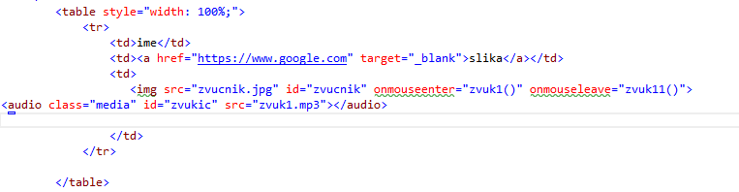

**Domaće zivotinje**

------------------------------------------------------------------------------------------------

*Skripta:*

function zvuk1() {

document.getElementById('ovde ide id od audia').play();

}

function zvuk11() {

document.getElementById('zvukic').pause();

}

*Html:*

<td >

<img src="Slike/zvucnik.jpg" id="zvucnik" onmouseenter="zvuk1()" onmouseleave="zvuk11()”>

<audio class="media" id="zvukic" src="Zvuk/zvuk1.mp3"></audio>

</td>

*Css:*

Sakriti audio audio{display:none}

Postavljanje pozadinske slike:

background-image: url("../Slike/farma.jpg");

background-size:cover;

-----------------------------------------------------------------------------------------------

**Vremenska prognoza**

------------------------------------------------------------------------------------------------

Aspx.cs

protected void DropDownList1_SelectedIndexChanged(object sender, EventArgs e)

{

if (DropDownList1.SelectedItem.Value == "Beograd")

{

urIframe.Attributes.Add("src", "https://naslovi.net/vremenska-prognoza/beograd");

}

if (DropDownList1.SelectedItem.Value == "Novi Sad")

{

urIframe.Attributes.Add("src", "https://naslovi.net/vremenska-prognoza/novi-sad");

}

}

Html

<asp:DropDownList ID="DropDownList1" runat="server" OnSelectedIndexChanged="DropDownList1_SelectedIndexChanged" AutoPostBack="true" style="height: 22px">

<asp:ListItem>Beograd</asp:ListItem>

<asp:ListItem>Novi Sad</asp:ListItem>

</asp:DropDownList>

<iframe id="urIframe" runat="server" src="https://naslovi.net/vremenska-prognoza/beograd"></iframe>

-------------------------------------------------------------------------------------------------

**Sortiranje tabele**

-------------------------------------------------------------------------------------------------

*Html:*

Dodati na tabelu koju zelimo da napravimo sortable:

<table class="sortable">

</table>

<head>

<script src="Skript/JavaScript1.js"></script>

</head>

*Skript:*

<https://www.kryogenix.org/code/browser/sorttable/>

**II NACIN**

1. Napravi bazu i popuni sa podacima

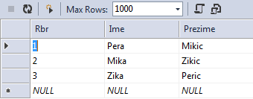

1. Napravi sqldatasource(izaberi bazu i sve normalno bez ikakvih uslova)
2. Postavi GridView i povezi ga sa datasourcom
3. Izaberi sorting kod gridViewa

-------------------------------------------------------------------------------------------------

**Biblioteka**

------------------------------------------------------------------------------------------------

1. Napraviti xml fajl
2. Na pocetnoj strani dodati textboxove, button i sqldatasource
3. Dodati tabelu i popuniti je
4. Dodati ove klase u aspx.cs

using System.Data;

using System.Configuration;

using System.Data.SqlClient;

1. Na aspx.cs dodati ovaj kod:

// ovo Ime je naziv kolone u tabeli kao i Sifra, a ime i sifra su stringovi koji dobijaju podakte iz textboxova

SqlConnection konekcija = new SqlConnection(ConfigurationManager.ConnectionStrings["ConnectionString"].ToString());

protected void Button1_Click(object sender, EventArgs e)

{

try

{

string ime = TextBox1.Text;

string sifra = TextBox2.Text;

konekcija.Open();

string query= "select * from Tabela where Ime='"+ ime+"' and Sifra='"+sifra+"'";

SqlCommand komanda = new SqlCommand(query,konekcija);

SqlDataReader sdr = komanda.ExecuteReader();

if(sdr.Read())

{

Label3.Text = "Uspesno logovanje";

// ako je potrebna redirekcija na drugu stranu Response.Redirect('WebForm.aspx');

}

else

{

Label3.Text = "Neuspesno logovanje";

}

konekcija.Close();

}

catch (Exception ex)

{

Response.Write(ex.Message);

}

}

5.Na strani Pregled dodati gridview samo bez ikakvog dodavanja u njega

6. U aspx.cs dodati

// ovo XMLFile1.xml je ime xml fajla koje dobijes, citano DESC sortira opadajuce po koloni citano

using System.Data;

protected void Page_Load(object sender, EventArgs e)

{

string Path = Server.MapPath("~/XMLFile1.xml");

DataSet ds = new DataSet();

ds.ReadXml(Path);

ds.Tables[0].DefaultView.Sort = "citano DESC";

GridView1.DataSource = ds.Tables[0].DefaultView.ToTable();

GridView1.DataBind();

}

----------------------------------------------------------------------------------------

**Uspeh ucenika**

-----------------------------------------------------------------------------------------

1. Napraviti bazu i popuniti je BEZ PROSEKA
2. Na glavnoj formi dodati grid view i sql data source
3. U sql data source upisati query

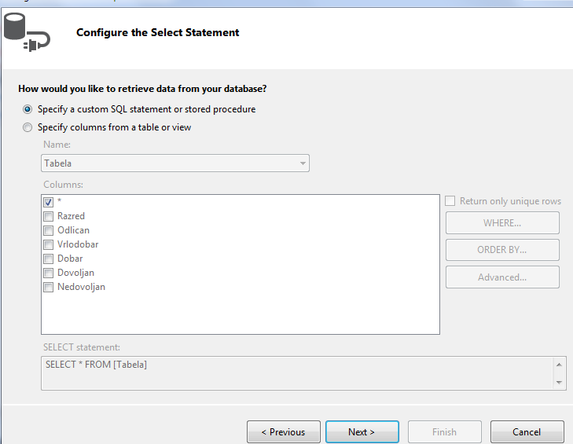

SELECT Razred, Odlican, Vrlodobar, Dobar, Dovoljan, Nedovoljan, CAST ((Odlican*5+Vrlodobar*4+Dobar*3+Dovoljan*2+Nedovoljan*1)*1.0/(Odlican+Vrlodobar+Dobar+Dovoljan+Nedovoljan) AS decimal(16,2)) AS Prosek FROM Uspeh;

// Obrati paznju na ime kolona i ime tabele

//Cast prebacuje u odredjeni tip podataka

4. Na drugoj formi dodati SqlDataSource opet sa istim queriem

5. Dodati chart (mozda izbaci neku poruku za id nije bitno)

6. U chartu ubaciti datasource i podesiti x,y osu i tip charta

-----------------------------------------------------------------------------------------

**Knjiga utisaka**

-----------------------------------------------------------------------------------------

1. Postaviti textboxove   
   - za email text box postaviti unutar textboxa type="email"

-za komentar unutar textboxa dodati textmode="multiline"

-za obavezan unos unutar textboxa uneti required="true"

1. Napraviti bazu podataka (ID postaviti kao IS IDENTITY)
2. Dodati sqldatasource Koa SELECT * FROM UTISAK
3. U apsx.cs dodati sledeci kod
4. Dodati

using System.Data;

using System.Data.OleDb;

using System.Data.Sql;

using System.Data.SqlClient;

public string GetConnectionString()

{

return System.Configuration.ConfigurationManager.ConnectionStrings["ConnectionString"].ConnectionString;

}

private void InsertInfo()

{

SqlConnection conn = new SqlConnection(GetConnectionString());

string sql = "INSERT INTO Utisak (Ime,Email,Komentar,Datum) VALUES (@Ime,@Email,@Komentar,@Datum)";

try

{

conn.Open();

SqlCommand cmd = new SqlCommand(sql, conn);

cmd.Parameters.AddWithValue("@Ime", TextBox1.Text);

cmd.Parameters.AddWithValue("@Email", TextBox2.Text);

cmd.Parameters.AddWithValue("@Komentar", TextBox3.Text);

cmd.Parameters.AddWithValue("@Datum", DateTime.Now);

cmd.CommandType = CommandType.Text;

cmd.ExecuteNonQuery();

}

catch (System.Data.SqlClient.SqlException ex)

{

string msg = "Insert Error:";

msg += ex.Message;

throw new Exception(msg);

}

finally

{

conn.Close();

}

}

protected void Button1_Click(object sender, EventArgs e)

{

InsertInfo();

}

-------------------------------------------------------------------------------------------------

**Elektronski recnik**

-------------------------------------------------------------------------------------------------

1. Napravi bazu podataka

Podesiti identity za id

2. Dodati sqldatasource SELECT * FROM tabela1 na obe stranice

Za DODAVANJE reci:

Napraviti stranicu i dodati 3 labela 3 textboxa i jedan label na kraju za poruku

Zatim u aspx.cs

Dodati

using System.Data.SqlClient;

using System.Data;

protected void Button1_Click(object sender, EventArgs e)

{

SqlConnection con = new SqlConnection(SqlDataSource1.ConnectionString);

con.Open();

int k = 0;

SqlDataAdapter adapter = new SqlDataAdapter();

SqlCommand komanda1 = new SqlCommand("Select * from tabela1", con);

DataTable tabela = new DataTable();

adapter.SelectCommand = komanda1;

adapter.Fill(tabela);

k = tabela.Rows.Count + 1;

string s1, s2, s3;

s1 = TextBox1.Text;

s2 = TextBox2.Text;

s3 = TextBox3.Text;

if (s1 != "" && s2 != "")

{

try

{

string upit = "INSERT INTO [tabela1] ([Engleski],[Srpski],[Opis]) VALUES(@Engleski,@Srpski,@Opis)";

SqlCommand komanda = new SqlCommand(upit, con);

//komanda.Parameters.AddWithValue("@Id", k);

komanda.Parameters.AddWithValue("@Engleski", s1);

komanda.Parameters.AddWithValue("@Srpski", s2);

if (s3 != "")

komanda.Parameters.AddWithValue("@Opis", s3);

else komanda.Parameters.AddWithValue("@Opis", DBNull.Value);

komanda.ExecuteNonQuery();

TextBox1.Text = TextBox2.Text = TextBox3.Text = "";

Label4.Font.Size = 40;

Label4.Text = "Uspesno ste upisali rec u recnik!";

}

catch

{

Label4.Text = "Ne mozete upisati ovaj podatak";

}

}

}

Za RECNIK

Dodati prvo

using System.Configuration;

using System.Data;

using System.Data.SqlClient;

protected void Button1_Click(object sender, EventArgs e)

{

string rec = TextBox1.Text;

string tekst = Label2.Text;

int a = 0;

if (DropDownList1.SelectedValue == "srpsko-engleski")

{

SqlConnection con = new SqlConnection(SqlDataSource1.ConnectionString);

con.Open();

string query = "select * from tabela1 where Srpski='" + TextBox1.Text + "'";

SqlCommand cmd = new SqlCommand(query, con);

// string output = cmd.ExecuteScalar().ToString();

SqlDataReader rider1;

rider1 = cmd.ExecuteReader();

while (rider1.Read())

{

Label1.Text = rider1[1].ToString();

Label2.Text = rider1[3].ToString();

a++;

}

if (a == 0)

{

Label2.Text = "Nema reci";

Label1.Text = "";

}

con.Close();

}

else

{

SqlConnection con = new SqlConnection(ConfigurationManager.ConnectionStrings["ConnectionString"].ToString());

con.Open();

string query = "select * from tabela1 where Engleski='" + TextBox1.Text + "'";

SqlCommand cmd = new SqlCommand(query, con);

// string output = cmd.ExecuteScalar().ToString();

SqlDataReader rider1;

rider1 = cmd.ExecuteReader();

while (rider1.Read())

{

Label1.Text = rider1[2].ToString();

Label2.Text = rider1[3].ToString();

a++;

}

if (a == 0)

{

Label2.Text = "Nema reci";

Label1.Text = "";

}

con.Close();

}

}

// vrednost u aspx.cs za drop down zavisi od onoga sta pise u dropdownu

LABELE PREPRAVITI PO POTREBI

//Ako ne radi lepo proveri redosled u bazi podataka SRPSKI i ENGLESKI.

-------------------------------------------------------------------------------------------------

**Red voznje**

-------------------------------------------------------------------------------------------------

1. U apsx dodati drop down listu za liniju (OBAVEZNO AutoPostBack)

<asp:DropDownList ID="DropDownList1" AutoPostBack="True" runat="server">

<asp:ListItem Selected="True">Izaberite liniju</asp:ListItem>

<asp:ListItem Value="linija1">Linija 1</asp:ListItem>

<asp:ListItem Value="linija2">Linija 2</asp:ListItem>

<asp:ListItem Value="linija3">Linija 3</asp:ListItem>

<asp:ListItem Value="linija4">Linija 4</asp:ListItem>

<asp:ListItem Value="linija5">Linija 5</asp:ListItem>

<asp:ListItem Value="linija6">Linija 6</asp:ListItem>

<asp:ListItem Value="linija7">Linija 7</asp:ListItem>

</asp:DropDownList>

2.Dropdown listu za smer

<asp:DropDownList ID="DropDownList2" runat="server">

</asp:DropDownList>

3.Dodati button i tabelu

<asp:Table ID="Table1" runat="server">

<asp:TableHeaderRow>

<asp:TableCell>Redni broj polazaka</asp:TableCell>

<asp:TableCell>Vreme polazaka</asp:TableCell>

</asp:TableHeaderRow>

</asp:Table>

4. U apsx dodati

using System.IO;

using System.Data;

5. U apsx dodati

protected void DropDownList1_SelectedIndexChanged(object sender, EventArgs e)

{

if (DropDownList1.SelectedValue == "Izaberite liniju")

return;

HashSet<string> pravac = new HashSet<string>();

StreamReader citac = new StreamReader(HttpRuntime.AppDomainAppPath + DropDownList1.SelectedValue + ".txt");

while (citac.Peek() > 0)

{

string pom = citac.ReadLine();

pom = pom.Substring(5);

pom = pom.Substring(0, pom.IndexOf(' '));

pravac.Add(pom);

}

DropDownList2.Items.Clear();

foreach (string lel in pravac)

{

DropDownList2.Items.Add(lel);

}

}

protected void DropDownList2_SelectedIndexChanged(object sender, EventArgs e)

{

for (int i = 1; i < Table1.Rows.Count; i++)

{

Table1.Rows.RemoveAt(i);

}

}

protected void Button1_Click(object sender, EventArgs e)

{

if (DropDownList1.SelectedValue == "Izaberite liniju")

return;

StreamReader citac = new StreamReader(HttpRuntime.AppDomainAppPath + DropDownList1.SelectedValue + ".txt");

for (int i = 1; i < Table1.Rows.Count; i++)

{

Table1.Rows.RemoveAt(i);

}

while (citac.Peek() > 0)

{

string pom = citac.ReadLine();

if (pom.Contains(DropDownList2.SelectedValue))

{

string[] polasci = pom.Split(' ');

bool prvi = true;

int br = 1;

foreach (string b in polasci)

{

if (prvi)

{

prvi = false;

continue;

}

TableRow redic = new TableRow();

TableCell celija1 = new TableCell();

TableCell celija2 = new TableCell();

celija1.Text = br.ToString();

redic.Cells.Add(celija1);

celija2.Text = b;

redic.Cells.Add(celija2);

Table1.Rows.Add(redic);

br++;

}

}

}

}

Dodati sve eventove u same elemente!!