Demo video: <https://www.loom.com/share/33a89b2bd01c4499beedaae4d3feb9aa>

{

    "data": [

        {

            "video": "video/demo.mp4",

            "bitrate": "4000",

            "allow_crop": "no",

            "crop": {

                "top_bottom": "150",

                "left_right": "0"

            },

            "allow_cut": "no",

            "cut": {

                "from": "00:00:02",

                "to": "00:00:07"

            },

            "filter": "greyscale",

            "iw": [

                {

                    "path": "watermark/start.png",

                    "position": "top_left",

                    "offset": {

                        "x": "1",

                        "y": "-17"

                    },

                    "height": "63",

                    "width": "35",

                    "between": "yes",

                    "between_from": "0",

                    "between_to": "4"

                },

                {

                    "path": "watermark/right.png",

                    "position": "bottom_right",

                    "offset": {

                        "x": "-100",

                        "y": "-100"

                    },

                    "height": "40",

                    "width": "25",

                    "between": "no"

                },

                {

                    "path": "watermark/start.png",

                    "position": "center",

                    "offset": {

                        "x": "10",

                        "y": "450"

                    },

                    "height": "50",

                    "width": "30",

                    "between": "yes",

                    "between_from": "70",

                    "between_to": "84"

                }

            ],

            "text_overlay": "yes",

            "to": [

                {

                    "font_file": "font/font.ttf",

                    "font_size": "20",

                    "font_color": "#000000",

                    "draw_text": "hexa format text",

                    "position": "bottom_right",

                    "offset": {

                        "x": "20",

                        "y": "20"

                    },

                    "between": "yes",

                    "between_from": "3",

                    "between_to": "8"

                },

                {

                    "font_file": "font/font.ttf",

                    "font_size": "30",

                    "font_color": "blue",

                    "draw_text": "blue text",

                    "position": "top_left",

                    "offset": {

                        "x": "30",

                        "y": "30"

                    },

                    "between": "no"

                }

            ],

            "output": {

                "format": "mp4",

                "aspectRatio": "19:6",

                "size": {

                    "width": "1080",

                    "height": "720"

                },

                "fps": "25"

            }

        }

    ]

}

**Parameters**

**Video source**: Required (string)

**BitRate**: required (default value 128 means that 128k) (integer)

**Allow crop**: yes or no (for yes need to pass values which will be in pixel) (integer)

**Allow cut**: want to cut then specify from and to in HH:MM:SS (string)

**Filter**: optional (string)

**iw** (image watermark) : required (array)

**Watermark parameters** {

**Path**: required (string)

**Position**: required (string) must be => **top_left, top_right, bottom_left, bottom_right, center or custom**

Some Position Examples are here

**Top left position**

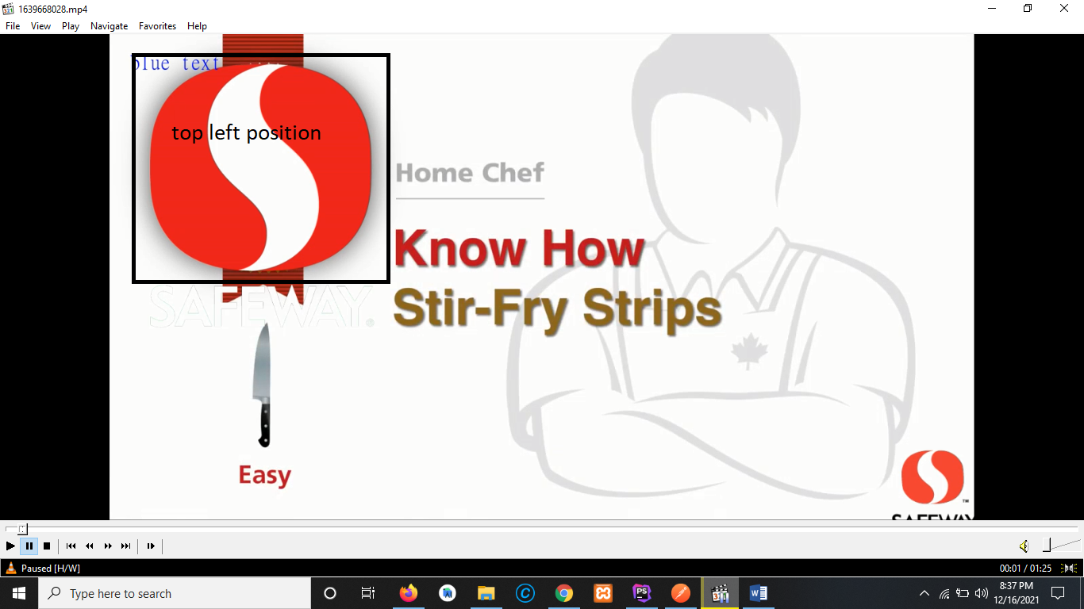

**Bottom right position**

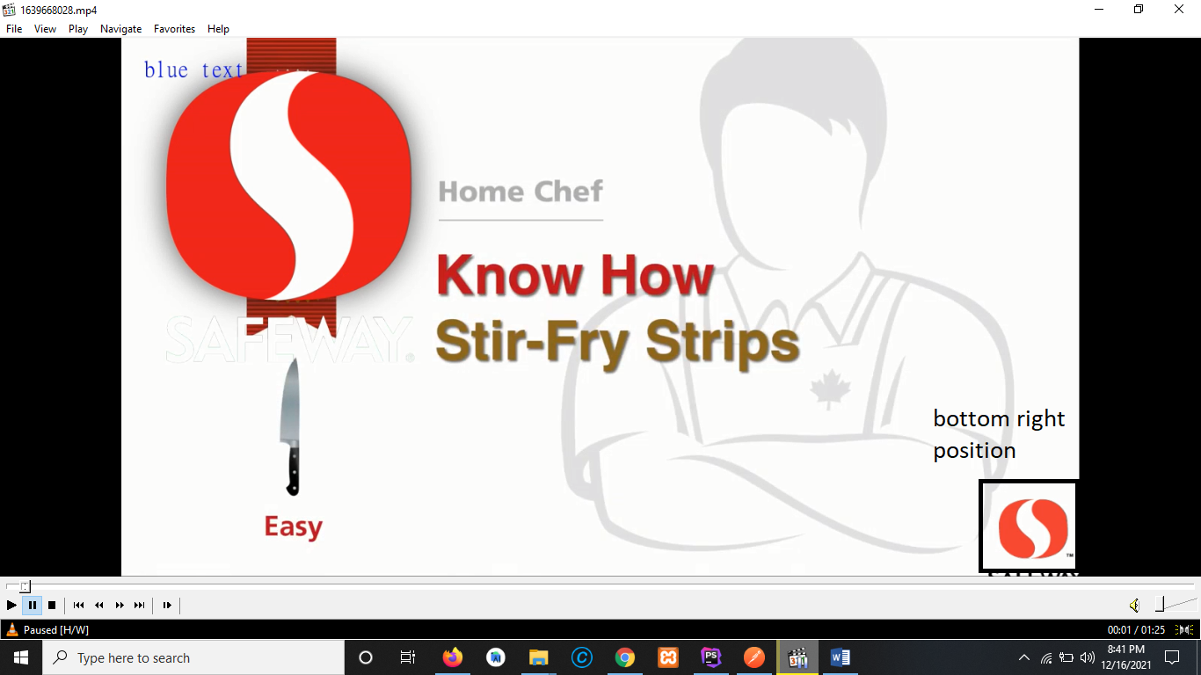

**Center Position on top**

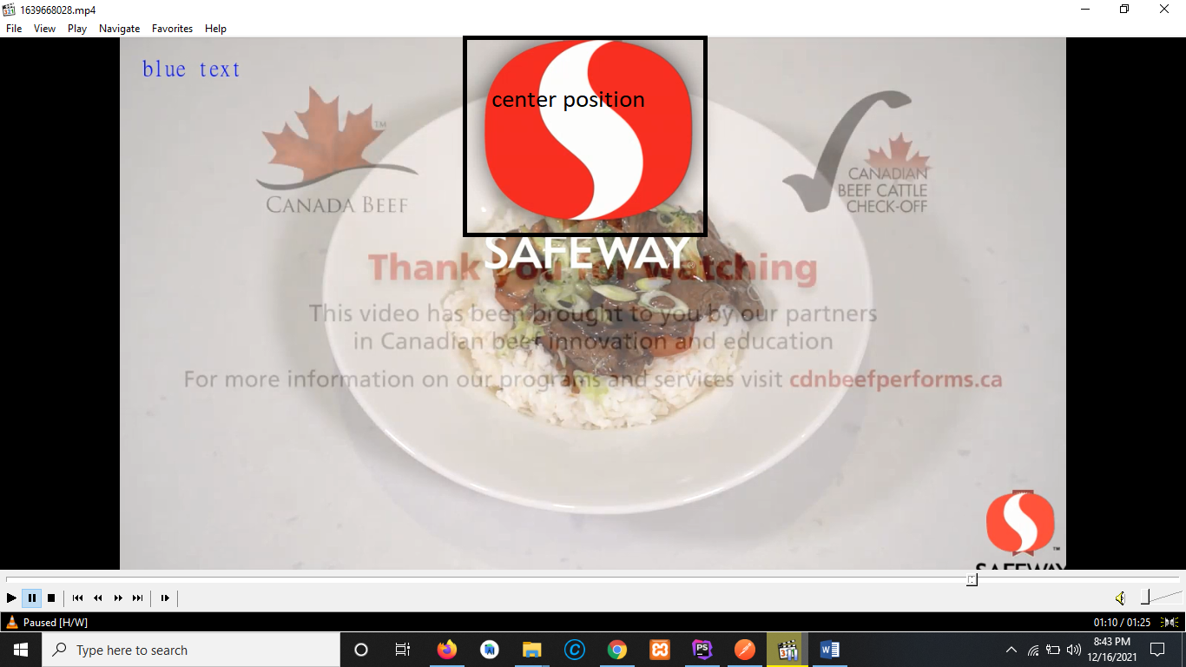

**Offset**: required (array) {

**X**: required (integer in pixel)

**Y**: required (integer in pixel)

}

**Height**: required (integer in percentage)

**Width**: required (integer in percentage)

**Between**: required (string yes or no, for yes pass time in integer from and to)

}

**Text Overlay**: required (string, yes or no){

**Font File**: required (string)

**Font Size**: required (integer)

**Draw Text**: Any text that we need to place

**Font color**: required (string, hex format or human readable)

**Position**: required (string) must be => **top_left, top_right, bottom_left, bottom_right, center or custom**

**Top left position of overlay**

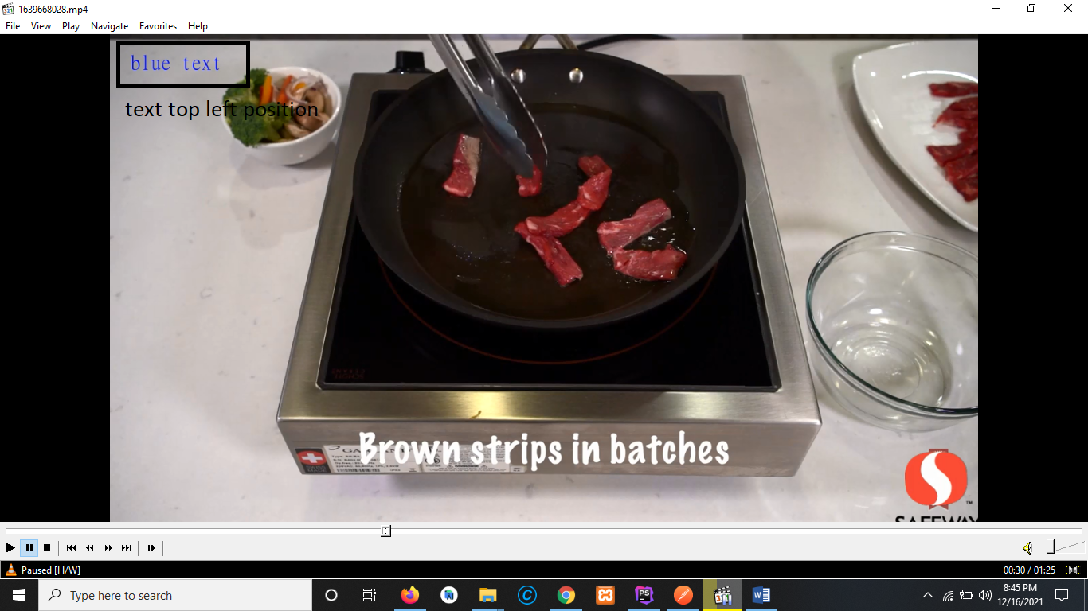

**Bottom right position of text overlay**

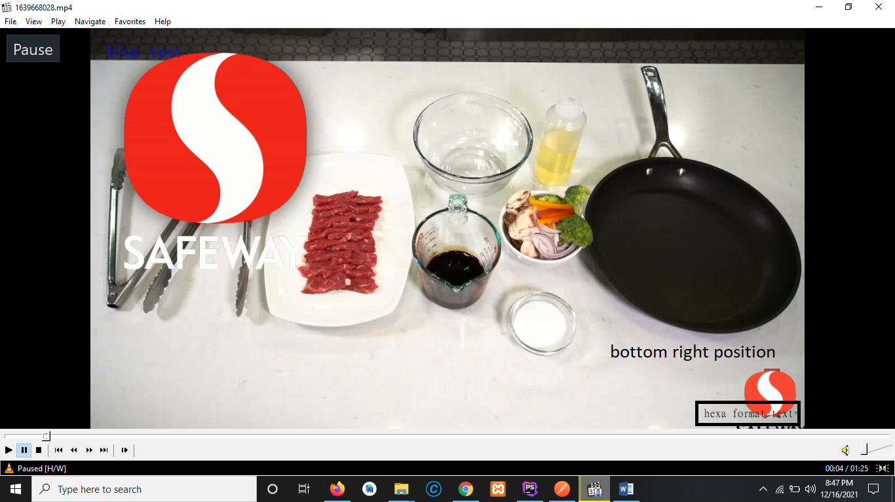

**Offset**: required (array) {

**X**: required (integer in pixel)

**Y**: required (integer in pixel)

}

**Output**: required (array) {

**Format**: required (string) must be (MP4, MOV, FLV, AVI, WebM, MKV)

**aspectRatio**: required (string) must be (19:6, 4:3)

**Size** (resolution): required (array) {

**Width**: required (integer)

**Height**: required (integer)

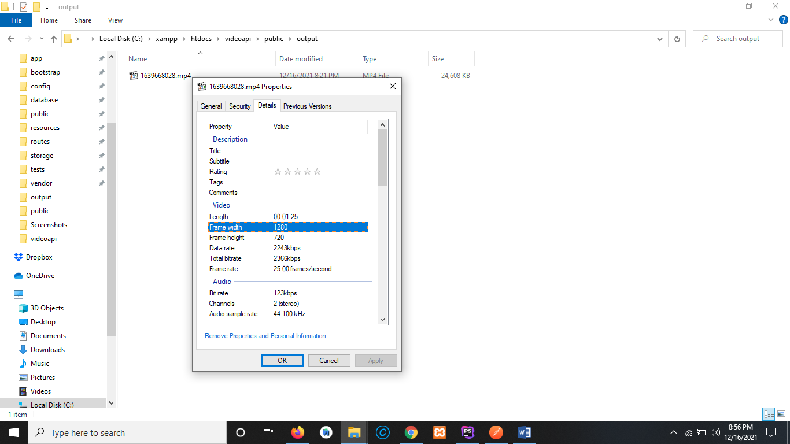

}

**Fps** (framerate): required (integer)

To setup frame rate per second



