

**Politecnico di Milano**  
Dipartimento di Scienze e Tecnologie Aerospaziali  
Prova finale: Introduzione all’Analisi di Missioni Spaziali  
Docente: Massari Mauro

Elaborato n. C13

Autori:

|  |  |
| --- | --- |
| 10694997 | Pala Silvia |
| 10711624 | Turcu Alex Cristian |
| 10730510 | Vanelli Paolo |

Anno Accademico 2022-2023

Data di consegna: 00/00/00

# Table of contents

Table of contents 2

1. Introduction 3

2. Initial orbit characterization 3

2.1. Initial orbital parameters 3

2.2. Data interpretation 3

2.3. Graphical representation 4

3. Final orbit characterization 5

3.1. Final position and velocity 5

3.2. Data interpretation 5

3.3. Graphical representation 6

4. Transfer trajectory definition and analysis 7

4.1. Standard maneuver 7

4.2. Alternative maneuvers 7

4.3. Graphical representation 7

5. Conclusions 7

6. Appendix 7

# Introduction

The present project aim is to study, optimize and choose various orbital transfer strategies, having as initial data a point on the initial orbit, which position and velocity vectors are given, and a point on the final orbit, which is defined by its orbital parameters.

First it will be analysed a strategy based on a set of standard maneuvers.

Several other alternative strategies have been examined to try to optimize the two most significant parameters in their distinction: the maneuvering cost (the total speed gap required to complete all the orbital changes) and the operating time (from the start point to the final point).

# Initial orbit characterization

## Initial orbital parameters

The assigned starting position and velocity vectors are the following:

Using MATLAB software, it is possible to calculate the orbital parameters assigned to this specific couple of vectors:

|  |  |  |  |  |  |
| --- | --- | --- | --- | --- | --- |
|  |  |  |  |  |  |
| 36087 | 0.4939 | 77.1293 | 101.5435 | 57.0948 | 283.3233 |

## Data interpretation

The starting geocentric orbit is elliptical, with an eccentricity value between 0 and 1 and a specific energy of:

It belongs to Medium Earth Orbit (MEO) category, as its apogee and its perigee are inside the range of 8000 – 42000 km:

According to the given value, it is nor a polar nor a geo-synchronous orbit and has a period of:

## Graphical representation

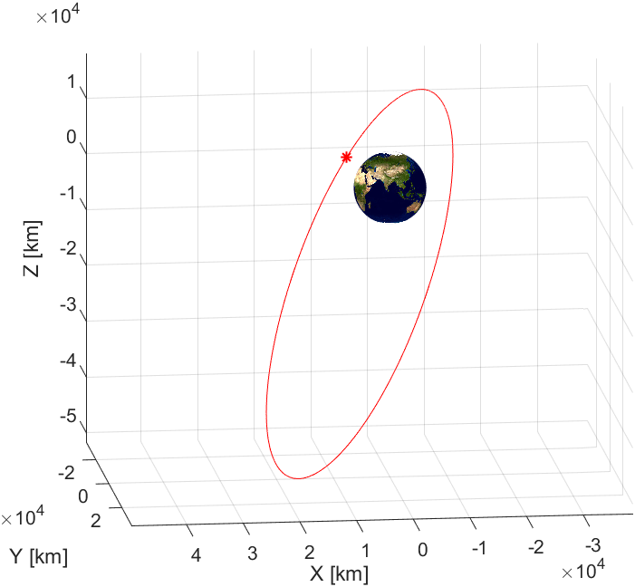A graphical representation of the orbit is possible with the aid of MATLAB software:

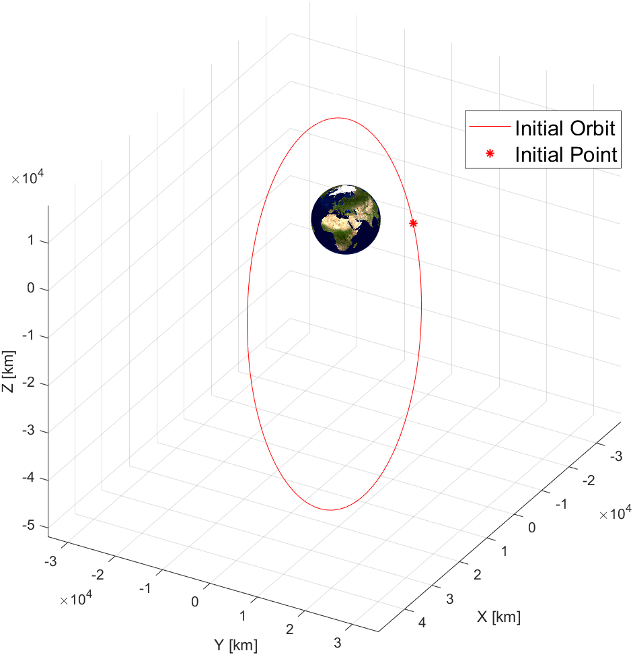

# Final orbit characterization

## Final position and velocity

The goal orbit, that is geocentric just like the starting one, is defined by its orbital parameters:

|  |  |  |  |  |  |
| --- | --- | --- | --- | --- | --- |
|  |  |  |  |  |  |
| 10860 | 0.2332 | 30.2751 | 24.6315 | 173.2051 | 18.9993 |

The final position and velocity are calculated from these parameters using again the MATLAB software:

## Data interpretation

The final geocentric orbit is elliptical, with an eccentricity value between 0 and 1 and a specific energy of:

It belongs to Medium Earth Orbit (MEO) category, as its apogee and its perigee are inside the range of 8000 – 42000 km:

According to the given value, it is nor a polar nor a geo-synchronous orbit and has a period of:

## Graphical representation

A graphical representation of the orbit is possible with the aid of MATLAB software:

# Transfer trajectory definition and analysis

## Standard maneuver

## Alternative maneuvers

## Graphical representation

# Conclusions

# Appendix