Nicholas Turdo
Senior Capstone Project
CIS 480
Dr. Brian Ladd
Spring 2013

0.1 Introduction 3
0.1.1 EMS
0.1.2 RFID
0.1.3 Pyramid
0.1.4 Python
0.1.5 SQLAlchemy
0.1.6 Chameleon
0.2 Objectives 4
0.2.1 Original Plan
0.2.2 Evolved Plan
0.3 Design 5
0.3.1 Pyramid
0.3.2 Database
0.3.2.a Database Design
0.3.3 Security
0.4 Shortcomings 7
0.4.1 RFID Communication
0.5 Future Considerations 7
0.4.1 RFID Communication
0.4.1 Security
0.4.1 Verification with NYS-DOH
0.6 Reflection 8
What could have been done better.
0.7 Closing Statements 9
0.8 10
0.9 Glossary 11
0.20 Bibliography 12

0.1 Introduction
0.1.1 Emergency Medical Services (EMS)
Emergency Medical Services is any and all services provided in the community when they are in need of medical attention outside of the Hospital. They provide the medical care they can while transporting the patient to the Hospital to obtain the level of medical attention needed.
0.1.2 Radio Frequency Identification Devices (RFID)
Radio Frequency Identification Devices is any device that uses electro-magnetism to transfer data via radio frequencies. The intention of development of RFID's was to replace the modern bar-code. RFID's can store more data then the typical bar-code, can be tracked and scanned automatically, and can identify a specific product whereas bar-codes are limited to only type of product. (RFID book)
0.1.3 Pyramid
“Pyramid is a small, fast, down-to-earth Python web application development framework. It is developed as part of the Pylons Project. It is licensed under a BSD-like license.” (Pyramid)
0.1.4 Python
“Python is a programming language that lets you work more quickly and integrate your systems more effectively. You can learn to use Python and see almost immediate gains in productivity and lower maintenance costs.” (Python)
0.1.5 SQLAlchemy
SQLAlchemy is the Python SQL toolkit and Object Relational Mapper that gives application developers the full power and flexibility of SQL.
0.1.6 Chameleon
Chameleon is an HTML/XML template engine for Python.

0.2 Objectives
For my senior project, I decided that I wanted to work with many components of computer science that I have not had much experience in. I planned to use RFID chips to store medical data such as medical history, allergies or forms about a specific person. People occasionally carry medical alert tags on them which will have some of this information, but RFID's would be able to store much more about the person, and a medic would be able to retrieve the information at a much faster rate.
0.2.1 Original Plan
Originally, I also planned on using Java swing to construct the user interface so anyone could enter their own medical data and store it onto a card. Authorized personnel would then be able to retrieve the medical data from the card. In this scenario there would have to be a database that would store the people who are authorized to see the patients information.
0.2.2 Evolved Plan
About half way through the semester, the project was completely reworked. One of the major changes was that I switched the programming language to python. I wanted to build a web framework in which people could sign onto a website and enter all their information there as well as link their account to their RFID card. Medical professionals could also use the website to retrieve information about patients during medical calls. This would be a safer and easier way to protect the patient information.
0.3 Design
0.3.1 Pyramid
The Pyramid framework was used to build the user interface for the website. The website is developed such that any user must make a user account that contains that basic information about them. This would include things such as login, password, name, address, gender, primary languages, etc. Users would then have the option to register as a Patient, Medic, and/or Medical Director.
A User that is registered as a Patient will have the ability to upload Allergies and Past Medical History and change their personal information. They also can post who their Primary Physician is. Then the Patient would have the ability to link their account with an RFID Card.
A User that is Registered as a Medic can store their level of training as well as their certification number. A Medic has the ability to view a patient. Currently the Medic is offered a scroll down of all usernames that link to a Patient, but in later development, the Medic would have to scan a RFID to bring up Patient Information. Every time a Medic reads a Patients RFID, it will store when they accessed it, this is to insure that no Medic abuses the power to view this information.
A User that is a Medical Director will store information such as the district they work in. Medical Directors exist as administration; they can keep track which EMT's are viewing which Patients, so that activity is monitored and medics are held accountable.
Once when some is signed in, a python dictionary is formed that contains their User account and if they are a Patient, Medic, and/or Medical Director. This is used to check privileges to certain areas of the website. There is also an Admin section of functions. Currently they only contain links that will list off all people in each specific field, and everyone has access to it.
0.3.2 Database
By default, pyramid uses SQLite to set up the database. The project uses SQLAlchemy to to communicate with the database. The database was originally a secondary objective, but as the project progressed, I realized the importance of keeping track of all this information. That is also part of the reason I made the transition to Python and Pyramid; Pyramid is a framework that I am familiar with and with the limited time, I couldn't risk trying it with something new. The database contains tables for each of the categories of users; User, Patient, Medic, Medical Director. There are additional tables for additional purposes.
The Views table is used to keep track of when Medics view any of the Patient records. This is to make sure that they don't abuse the power to do so. This table has two foreign keys to the Users tables, as well as, a Python datetime object to store the exact time in which the record is viewed.
There is also a Page table in which is used just to store the information for each of the pages that appear in the website. This makes editing the website much easier for the user to do on their own, instead of relaying on the developers. This table users a surrogate key to keep the records unique.
0.3.3 Security
I used Pyramid security features to limit access for users without privileges. As a User adds themselves to another group, such as Patient, Medic, or Director, they would also be added to the security group for that table. The links to areas that you don't have permission to not only won't appear in the drop downs, but if you try to enter the url directly, it will send you to a different page.

0.4 Shortcomings
0.4.1 RFID Communication
A major objective for this project that didn't get done was the ability to communicate with RFID cards. This is a disappointment because that was the one thing that I wanted to take away from the this project. RFID communication got to the point there the system would notice the RFID card was present, but wouldn't let the user send or receive information from the user. I continuously received an 6700 error from the reader.

0.5 Future Considerations
0.5.1 RFID Communication
Getting the RFID communication to work is one of the major priorities I have while I continue working through this project. Without the RFID's, the system is not at all convenient or worth using.
0.5.2 Security
The database has only the built-in security features, but since the information that is stored on this system is especially private, it is definitely worth looking into increasing the security. Once when the RFID's are implemented, improving the security on those as well would be worth trying.

0.5.3 Verification from the DOH
It would be interesting to see if it was possible to connect to the Department of Health's database to get verification of certification for all the users who attempt to access the website as a medical professional. This would be useful to ensure that the people actually have the qualifications that they claim to.
0.5.4 Implementation at a Squad Level
To test the efficiency of this application, would have to be implemented on a small scale. A small community such as a senior home or a college campus would be ideal for this. This will not only test how efficient the system is, but point out any considerations that I haven't thought of yet. This will also be a good bug catcher if we implement it in a small enough environment that it wouldn't cause any problems.

0.6 Reflection
This project all together was a great success. I learned a great deal about web design, database design, and security considerations. The major disappointment is that the RFID's never successfully communicated with the system. I also got the opportunity that I wanted to work with new languages and new systems. Before this semester, I have never worked in Python or done web development, I now I feel very comfortable with it.

0.7 Closing Statements
I would like to thank the SUNY Potsdam's Department of Computer Science for giving me the opportunity to do independent research and development, also for suppling the hardware that I needed to do my work.
I would also like to thank Dr.Ladd for the contributions that he made through this process and for teaching me some of the necessary skills needed to develop such a program on my own.

0.8 Diagrams
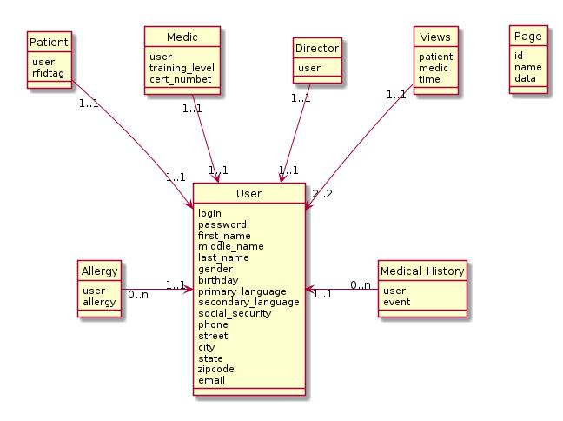Diagram 1: The design for the database used in this project.

0.9 Glossary
EMS – Emergency Medical Services
EMT – Emergency Medical Technician
RFID – Radio Frequency Identification
Patient – Someone receiving medical care
Medical alert tag – A physical tag that someone carries on them that has medical information such as allergies printed on it.
NYS-DOH – New York State Department of Health

0.10 Bibliography
http://www.pylonsproject.org/
http://www.python.org/
http://www.sqlalchemy.org/
RFID Book
web dictionary
http://chameleon.readthedocs.org/en/latest/

