**1.What are the two values of the Boolean data type? How do you write them?**

ANS: The two values of Boolean data type are True and False.It can also be represented as integers as 1=True and 0=False.

**2. What are the three different types of Boolean operators?**

ANS:The three Boolean operators are and ,or ,not.

and returns true if both expressions are true

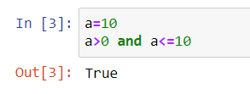

Or returns true if any one expression is true

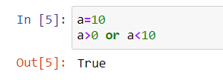

Not checks the expression , if the expression returns true it will display false and vice versa

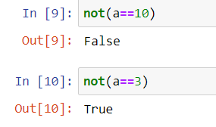

**3. Make a list of each Boolean operator truth tables (i.e. every possible combination of Boolean**

**values for the operator and what it evaluate ).**

ANS: AND TABLE

|  |  |  |
| --- | --- | --- |
| **A** | **B** | **A and B** |
| True | True | True |
| True | False | False |
| False | True | False |
| False | False | False |

**Or table**

|  |  |  |
| --- | --- | --- |
| **A** | **B** | **A or B** |
| True | True | True |
| True | False | True |
| False | True | True |
| False | False | False |

**Not Table**

|  |  |
| --- | --- |
| **A** | **Not A** |
| True | False |
| False | True |

**4. What are the values of the following expressions?**

(5> 4) and (3 == 5) - False

not (5> 4) -False

(5 >4) or (3 == 5) -True

not ((5 > 4) or (3 == 5)) -False

(True and True) and (True == False) -False

(not False) or (not True) -True

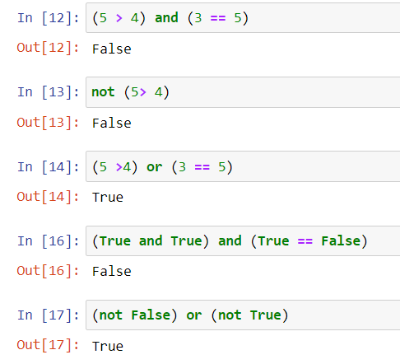

**5. What are the six comparison operators?**

ANS: < :less than

>:greater than

<=:lesser than equal to

>=:greater than equal to

==: equal to

!=:not equal to

**6. How do you tell the difference between the equal to and assignment operators?Describe a**

**condition and when you would use one.**

ANS: the = is assignment operator and is used for assigning values to variables, whereas the == is the equal to operator is used to check if the values on both sides of operators are equal.

A=10 is assignment but,

A==10 is checking if the value of A is 10 or not

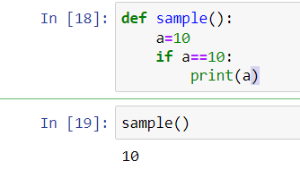

7. Identify the three blocks in this code:

spam = 0

if spam == 10:

print('eggs')

if spam > 5:

print('bacon')

else:

print('ham')

print('spam')

print('spam')

ANS: There are two blocks within a starting block which starts at if spam==10.Second block starts at if spam>5 and ends before else.Third block starts from else and ends at print(‘ham’).Th e first block ends at print(‘spam’)

8. Write code that prints Hello if 1 is stored in spam, prints Howdy if 2 is stored in spam, and prints

Greetings! if anything else is stored in spam.

ANS:

spam=int(input("Enter value"))

if spam==1:

print("Hello")

elif spam==2:

print("Howdy")

else:

print("Greetings")

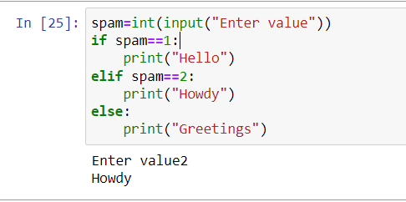

9.If your programme is stuck in an endless loop, what keys you’ll press?

ANS: CTRL+C

10. How can you tell the difference between break and continue?

ANS:The break statement terminates the execution of the current loop and passes the control over the next loop or main body, whereas when continue keyword is encountered, it skips the current iteration and executes the very next iteration in the loop.

11. In a for loop, what is the difference between range(10), range(0, 10), and range(0, 10, 1)?

ANS:There is no difference among the three statements all return the same set of values.

12. Write a short program that prints the numbers 1 to 10 using a for loop. Then write an equivalent

program that prints the numbers 1 to 10 using a while loop.

ANS: for i in range(1,11):

print(i)

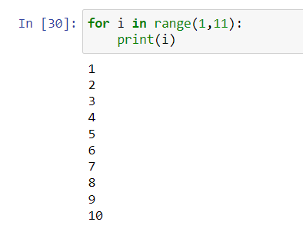

i=1

while i <=10:

print(i)

i=i+1

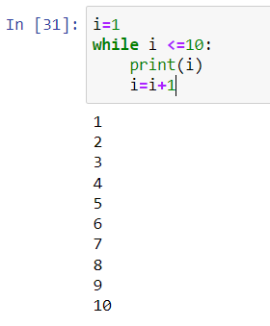

13. If you had a function named bacon() inside a module named spam, how would you call it after

importing spam?

 This function can be called with **spam.** **bacon()**.