1. Why are functions advantageous to have in your programs?

ANS: Functions are useful because they can be used in scenarios where you need recursive functionality.It reduces redundant code thereby making the code clean and error free.

2. When does the code in a function run: when it&#39;s specified or when it&#39;s called?

ANS:A function runs when it is called not when it is defined

3. What statement creates a function?

ANS:A function is created by def keyword.eg:

def sample():

…func defn….

4. What is the difference between a function and a function call?

ANS: A function is a block of code that does a particular operation and returns a result. It usually accepts inputs as parameters and returns a result. The parameters are not mandatory. A function call is the code used to pass control to a function.

5. How many global scopes are there in a Python program? How many local scopes?

ANS:

6. What happens to variables in a local scope when the function call returns?

ANS:The local variables are destroyed once the function is exhausted and returns output.This identifier of the local variable can be further used in the program outside the function to store some other value.

7. What is the concept of a return value? Is it possible to have a return value in an expression?

ANS: The return keyword returns a value or expression which is given in the function and terminates the current execution of the function.If the function has explicit return in the function ,it can be used in any expression.

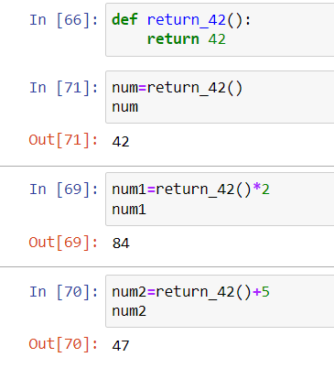

8. If a function does not have a return statement, what is the return value of a call to that function?

ANS:If the function does not have a return statement,the return value of a call to that function is None.

9. How do you make a function variable refer to the global variable?

ANS: We use global keyword to read and write a global variable inside a function.

10. What is the data type of None?

ANS: The None keyword is used to define a null value, or no value at all. None is not the same as 0, False, or an empty string. None is a data type of its own (NoneType) and only None can be None.

11. What does the sentence import areallyourpetsnamederic do?

ANS: That import statement imports a module named areallyourpetsnamederic.

12. If you had a bacon() feature in a spam module, what would you call it after importing spam?

ANS: This function can be called with spam.bacon().

13. What can you do to save a programme from crashing if it encounters an error?

ANS: When it encounters an error, the control is passed to the except block, skipping the code in between .It should throw an error message instead of crashing the program.

14. What is the purpose of the try clause? What is the purpose of the except clause?

ANS: The try block is used to check some code for errors i.e the code inside the try block will execute when there is no error in the program. Whereas the code inside the except block will execute whenever the program encounters some error in the preceding try block