**1. What exactly is []?**

ANS: The empty list value, which is a list value that contains nc items.

**2. In a list of values stored in a variable called spam, how would you assign the value &#39;hello&#39; as the**

**third value? (Assume [2, 4, 6, 8, 10] are in spam.)**

ANS: spam[3]=”hello”

spam[3]="hello"

**Let&#39;s pretend the spam includes the list [&#39;a&#39;, &#39;b&#39;, &#39;c&#39;, &#39;d&#39;] for the next three queries.**

**3. What is the value of spam[int(int(&#39;3&#39; * 2) / 11)]?**

**4. What is the value of spam[-1]?**

**5. What is the value of spam[:2]?**

**ANS:**d



**Let&#39;s pretend bacon has the list [3.14, &#39;cat,&#39; 11, &#39;cat,&#39; True] for the next three questions.**

**6. What is the value of bacon.index(&#39;cat&#39;)?**

ANS:1



**7. How does bacon.append(99) change the look of the list value in bacon?**

ANS: 

**8. How does bacon.remove(&#39;cat&#39;) change the look of the list in bacon?**

ANS:Remcves the first cccurence cf cat



9. What are the list concatenation and list replication operators?

ANS: The operator for list concatenation is +, while the operator for replication is *

10. What is difference between the list methods append() and insert()?

ANS: The only difference between append() and insert() is that insert function allows us to add a specific element at a specified index of the list unlike append() where we can add the element only at end of the list.

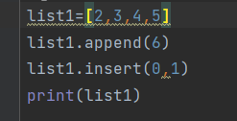 

11. What are the two methods for removing items from a list?

ANS: The methods are remove(), pop() and clear(). It helps to remove the very first given element matching from the list. The pop() method removes an element from the list based on the index given

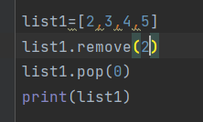 

12. Describe how list values and string values are identical.

ANS: Both lists and strings can be passed to len()

Have indexes and slices

Can be used in for loops

Can be concatenated or replicated

Can be used with the in and not in operators

13. What&#39;s the difference between tuples and lists?

ANS:Tuples are immutable whereas lists are mutable.

14. How do you type a tuple value that only contains the integer 42?

ANS: t=(42,)

t=(42,None)

15. How do you get a list value&#39;s tuple form? How do you get a tuple value&#39;s list form?

ANS:

l=[1,"def","der"]  
l=tuple(l)  
str=("abc","set")  
str=list(str)  
print(l)  
print(type(l))  
print(str)  
print(type(str))

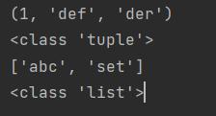

16. Variables that &quot;contain&quot; list values are not necessarily lists themselves. Instead, what do they

contain?

ANS: They contain references to list values.

17. How do you distinguish between copy.copy() and copy.deepcopy()?

ANS: The copy.copy() function will do a shallow copy of a list,

The copy.deepcopy() function will do a deep copy of a list. only copy.deepcopy() will duplicate any lists inside the list