|  |
| --- |
| BIL105E HOMEWORK 3 |
| THE BMI CALCULATOR |
| Turgut Can Aydınalev 150120021 09.05.2016 |

# INTRODUCTION

The program hassome string operations to manipulate or examine the current string. It also uses dynamic memory allocation for memory management.

# DEVELOPMENT ENVIRONMENT

The code is written in C language. I worked both Windows and Mac OS X when I was developing the project. I used Xcode and GCC for text editor and their compiler for testing. I used stdio.h, stdlib.h and math.h which are basic headers.

I used gcc –o hw4 hw4.c for compiling and ./hw4 *N* *M threshhold* command for running the program in the linux compiler.

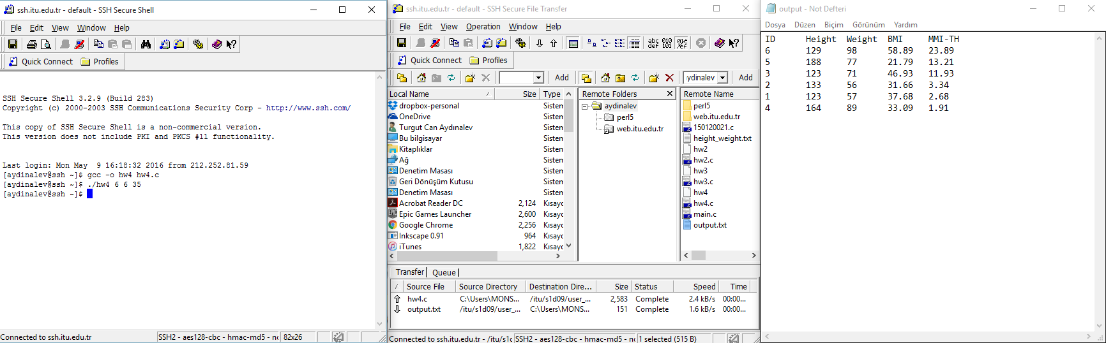

# DATA STRUCTURES AND VARIABLES

## Variables:

# PROGRAM FLOW

# CONCLUSIONS

.