**EEE316 Microprocessors**

**Pre-laboratory Report**

**Name : Turhan Can Kargın**

**ID Number : 150403005**

**Lab. Number : 5**

**Objectıves of the Laboratory Assignment:**

*Objectives of this lab are embedded programming with C language,* *getting familiar with parallel ports, and to understand how to use four 7 segment display.*

**Code and Comments:**



#include <xc.h>

//***Define the signal pins of all four displays***//

#define s1 PORTAbits.RA0

#define s2 PORTAbits.RA1

#define s3 PORTAbits.RA2

#define s4 PORTAbits.RA3

//***End of definition**////

void main**()**

**{**

unsigned int a**,**b**,**c**,**d**,**e**,**f**;** //just variables

unsigned int g **=** 0**;** //1st digit is saved here

int i **=** 0**;** //the 4-digit value that is to be displayed

int flag **=** 0**;** //for creating small delay

unsigned int seg**[]={**0X3F**,** //Hex value to display the number 0

0X06**,** //Hex value to display the number 1

0X5B**,** //Hex value to display the number 2

0X4F**,** //Hex value to display the number 3

0X66**,** //Hex value to display the number 4

0X6D**,** //Hex value to display the number 5

0X7C**,** //Hex value to display the number 6

0X07**,** //Hex value to display the number 7

0X7F**,** //Hex value to display the number 8

0X6F //Hex value to display the number 9

**};** //End of Array for displaying numbers from 0 to 9

//*****I/O Configuration****//

TRISB**=**0X00**;**

PORTB**=**0X00**;**

TRISA**=**0x00**;**

PORTA**=**0X00**;**

//***End of I/O configuration**///

#define _XTAL_FREQ 20000000

**while(**1**)**

**{**

//***Splitting "i" into four digits***//

a**=**i**%**10**;**//4th digit is saved here

b**=**i**/**10**;**

c**=**b**%**10**;**//3rd digit is saved here

d**=**b**/**10**;**

e**=**d**%**10**;** //2nd digit is saved here

f**=**d**/**10**;**

//***End of splitting***//

**if** **(**seg**[**e**]** **==** 0X7C **)** // If command for increment 1st digit when second is 60.

**{**

i**=**0**;** // reset all

g**=**g**+**1**;** // increment

**}**

PORTB**=**seg**[**g**];**s1**=**1**;** //Turn ON display 1 and print 4th digit

__delay_ms**(**1**);**s1**=**0**;** //Turn OFF display 1 after 2ms delay

PORTB**=**seg**[**e**];**s2**=**1**;** //Turn ON display 2 and print 3rd digit

__delay_ms**(**2**);**s2**=**0**;** //Turn OFF display 2 after 2ms delay

PORTB**=**seg**[**c**];**s3**=**1**;** //Turn ON display 3 and print 2nd digit

__delay_ms**(**2**);**s3**=**0**;** //Turn OFF display 3 after 2ms delay

PORTB**=**seg**[**a**];**s4**=**1**;** //Turn ON display 4 and print 1st digit

__delay_ms**(**2**);**s4**=**0**;** //Turn OFF display 4 after 2ms delay

**if(**flag**>=**1**)** //wait till flag reaches 1

**{**

i**++;**flag**=**0**;** //only if flag is one "i" will be incremented

**}**

flag**++;** //increment flag for each flash

**}**

**}**

**while(**1**)**

**{**

//***Splitting "i" into four digits***//

a**=**i**%**10**;**//4th digit is saved here

b**=**i**/**10**;**

c**=**b**%**10**;**//3rd digit is saved here

d**=**b**/**10**;**

e**=**d**%**10**;** //2nd digit is saved here

f**=**d**/**10**;**

//***End of splitting***//

**if** **(**seg**[**e**]** **==** 0X7C **)** // If command for increment 1st digit when second is 60.

**{**

i**=**0**;** // reset all

g**=**g**+**1**;** // increment

**}**

PORTB**=**seg**[**g**];**s1**=**1**;** //Turn ON display 1 and print 4th digit

__delay_ms**(**1**);**s1**=**0**;** //Turn OFF display 1 after 2ms delay

PORTB**=**seg**[**e**];**s2**=**1**;** //Turn ON display 2 and print 3rd digit

__delay_ms**(**2**);**s2**=**0**;** //Turn OFF display 2 after 2ms delay

PORTB**=**seg**[**c**];**s3**=**1**;** //Turn ON display 3 and print 2nd digit

__delay_ms**(**2**);**s3**=**0**;** //Turn OFF display 3 after 2ms delay

PORTB**=**seg**[**a**];**s4**=**1**;** //Turn ON display 4 and print 1st digit

__delay_ms**(**2**);**s4**=**0**;** //Turn OFF display 4 after 2ms delay

**if(**flag**>=**1**)** //wait till flag reaches 1

**{**

i**++;**flag**=**0**;** //only if flag is one "i" will be incremented

**}**

flag**++;** //increment flag for each flash

**}**

**}**

#include <xc.h>

//***Define the signal pins of all four displays***//

#define s1 PORTAbits.RA0

#define s2 PORTAbits.RA1

#define s3 PORTAbits.RA2

#define s4 PORTAbits.RA3

//***End of definition**////

void main**()**

**{**

int a**=**0**;**

static char flow**;**

unsigned int seg**[]={**0X78**,**0X3E**,**0X7B**,**0X76**,**0X77**,**0X54**,**0x00**,**0X39**,**0X77**,**0X54**,**0x00**,**0X7A**,**0X77**,**0X7B**,**0X3D**,**

0X30**,**0X54**,**0x00**,**0x06**,**0x6D**,**0x3F**,**0X66**,**0X3F**,**0X4F**,**0X3F**,**0X3F**,**0X6D**,**0X00**,**

**};** //End of Array for displaying Name,Surname,Number

//*****I/O Configuration****//

TRISB**=**0X00**;**

PORTB**=**0X00**;**

TRISA**=**0x00**;**

PORTA**=**0X00**;**

//***End of I/O configuration**///

#define _XTAL_FREQ 20000000

**while(**1**)** // infine loop

**{**

turhan**:** // when the process is done, it will come here and start again

flow**=**0**;** // f=0

**if** **(**flow **==** 0**)** // Start

**{**

**for** **(**int i **=** 0**;** i**<**25**;** **++**i**)** // for loop to wait a little while

**{**

s1**=** 1**;** // RA0=1

PORTB**=**seg**[**0**];** // Write "T" to the 1st digit

__delay_ms**(**2**);** // very small delay

s1**=**0**;** // RA0=0

s2**=**1**;** // RA1=1

PORTB**=**seg**[**1**];** // Write "U" to the 2nd digit

__delay_ms**(**2**);** // very small delay

s2**=**0**;** // RA1=0

s3**=**1**;** // RA2=1

PORTB**=**seg**[**2**];** // Write "R" to the 3th digit

__delay_ms**(**2**);** // very small delay

s3**=**0**;** // RA2=0

s4**=**1**;** // RA3=1

PORTB**=**seg**[**3**];** // Write "H" to the 3th digit

__delay_ms**(**2**);** // very small delay

s4**=**0**;** // RA3=0

**}**

flow **=** 1**;**

**}**

**if** **(**flow **==** 1**)**

**{**

**for** **(**int i **=** 0**;** i**<**25**;** **++**i**)**

**{**

s1**=** 1**;**

PORTB**=**seg**[**1**];** // Write "U" to the 1st digit

__delay_ms**(**2**);** // very small delay

s1**=**0**;**

s2**=**1**;**

PORTB**=**seg**[**2**];** // Write "R" to the 1st digit

__delay_ms**(**2**);** // very small delay

s2**=**0**;**

s3**=**1**;**

PORTB**=**seg**[**3**];** // Write "H" to the 1st digit

__delay_ms**(**2**);** // very small delay

s3**=**0**;**

s4**=**1**;**

PORTB**=**seg**[**4**];** // Write "A" to the 1st digit

__delay_ms**(**2**);** // very small delay

s4**=**0**;**

**}**

flow**=**2**;**

**}**

**if** **(**flow **==** 2**)**

**{**

**for** **(**int i **=** 0**;** i**<**25**;** **++**i**)**

**{**

s1**=** 1**;**

PORTB**=**seg**[**2**];** // Write "R" to the 1st digit

__delay_ms**(**2**);**

s1**=**0**;**

s2**=**1**;**

PORTB**=**seg**[**3**];** // Write "H" to the 1st digit

__delay_ms**(**2**);**

s2**=**0**;**

s3**=**1**;**

PORTB**=**seg**[**4**];** // Write "A" to the 1st digit

__delay_ms**(**2**);**

s3**=**0**;**

s4**=**1**;**

PORTB**=**seg**[**5**];** // Write "N" to the 1st digit

__delay_ms**(**2**);**

s4**=**0**;**

**}**

flow**=**3**;**

**}**

**if** **(**flow **==** 3**)**

**{**

**for** **(**int i **=** 0**;** i**<**25**;** **++**i**)**

**{**

s1**=** 1**;**

PORTB**=**seg**[**3**];** // Write "H" to the 1st digit

__delay_ms**(**2**);**

s1**=**0**;**

s2**=**1**;**

PORTB**=**seg**[**4**];** // Write "A" to the 1st digit

__delay_ms**(**2**);**

s2**=**0**;**

s3**=**1**;**

PORTB**=**seg**[**5**];** // Write "N" to the 1st digit

__delay_ms**(**2**);**

s3**=**0**;**

s4**=**1**;**

PORTB**=**seg**[**6**];** // Write " " to the 1st digit

__delay_ms**(**2**);**

s4**=**0**;**

**}**

flow**=**4**;**

**}**

s3**=**0**;**

s4**=**1**;**

PORTB**=**seg**[**6**];** // Write " " to the 1st digit

__delay_ms**(**2**);**

s4**=**0**;**

**}**

flow**=**4**;**

**}**

**if** **(**flow **==** 4**)**

**{**

**for** **(**int i **=** 0**;** i**<**25**;** **++**i**)**

**{**

s1**=** 1**;**

PORTB**=**seg**[**4**];** // Write "A" to the 1st digit

__delay_ms**(**2**);**

s1**=**0**;**

s2**=**1**;**

PORTB**=**seg**[**5**];** // Write "N" to the 1st digit

__delay_ms**(**2**);**

s2**=**0**;**

s3**=**1**;**

PORTB**=**seg**[**6**];** // Write " " to the 1st digit

__delay_ms**(**2**);**

s3**=**0**;**

s4**=**1**;**

PORTB**=**seg**[**7**];** // Write "C" to the 1st digit

__delay_ms**(**2**);**

s4**=**0**;**

**}**

flow**=**5**;**

**}**

**if** **(**flow **==** 5**)**

**{**

**for** **(**int i **=** 0**;** i**<**25**;** **++**i**)**

**{**

s1**=** 1**;**

PORTB**=**seg**[**5**];** // Write "N" to the 1st digit

__delay_ms**(**2**);**

s1**=**0**;**

s2**=**1**;**

PORTB**=**seg**[**6**];** // Write " " to the 1st digit

__delay_ms**(**2**);**

s2**=**0**;**

s3**=**1**;**

PORTB**=**seg**[**7**];** // Write "C" to the 1st digit

__delay_ms**(**2**);**

s3**=**0**;**

s4**=**1**;**

PORTB**=**seg**[**8**];** // Write "A" to the 1st digit

__delay_ms**(**2**);**

s4**=**0**;**

**}**

flow**=**6**;**

**}**

**if** **(**flow **==** 6**)**

**{**

**for** **(**int i **=** 0**;** i**<**25**;** **++**i**)**

**{**

s1**=** 1**;**

PORTB**=**seg**[**6**];** // Write " " to the 1st digit

__delay_ms**(**2**);**

s1**=**0**;**

s2**=**1**;**

PORTB**=**seg**[**7**];** // Write "C" to the 1st digit

__delay_ms**(**2**);**

s2**=**0**;**

s3**=**1**;**

PORTB**=**seg**[**8**];** // Write "A" to the 1st digit

__delay_ms**(**2**);**

s3**=**0**;**

s4**=**1**;**

PORTB**=**seg**[**9**];** // Write "N" to the 1st digit

__delay_ms**(**2**);**

s4**=**0**;**

**}**

flow**=**7**;**

**}**

**if** **(**flow **==** 6**)**

**{**

**for** **(**int i **=** 0**;** i**<**25**;** **++**i**)**

**{**

s1**=** 1**;**

PORTB**=**seg**[**6**];** // Write " " to the 1st digit

__delay_ms**(**2**);**

s1**=**0**;**

s2**=**1**;**

PORTB**=**seg**[**7**];** // Write "C" to the 1st digit

__delay_ms**(**2**);**

s2**=**0**;**

s3**=**1**;**

PORTB**=**seg**[**8**];** // Write "A" to the 1st digit

__delay_ms**(**2**);**

s3**=**0**;**

s4**=**1**;**

PORTB**=**seg**[**9**];** // Write "N" to the 1st digit

__delay_ms**(**2**);**

s4**=**0**;**

**}**

flow**=**7**;**

**}**

**if** **(**flow **==** 7**)**

**{**

**for** **(**int i **=** 0**;** i**<**25**;** **++**i**)**

**{**

s1**=** 1**;**

PORTB**=**seg**[**7**];**

__delay_ms**(**2**);**

s1**=**0**;**

s2**=**1**;**

PORTB**=**seg**[**8**];**

__delay_ms**(**2**);**

s2**=**0**;**

s3**=**1**;**

PORTB**=**seg**[**9**];**

__delay_ms**(**2**);**

s3**=**0**;**

s4**=**1**;**

PORTB**=**seg**[**10**];**

__delay_ms**(**2**);**

s4**=**0**;**

**}**

flow**=**8**;**

**}**

**if** **(**flow **==** 8**)**

**{**

**for** **(**int i **=** 0**;** i**<**25**;** **++**i**)**

**{**

s1**=** 1**;**

PORTB**=**seg**[**8**];**

__delay_ms**(**2**);**

s1**=**0**;**

s2**=**1**;**

PORTB**=**seg**[**9**];**

__delay_ms**(**2**);**

s2**=**0**;**

s3**=**1**;**

PORTB**=**seg**[**10**];**

__delay_ms**(**2**);**

s3**=**0**;**

s4**=**1**;**

PORTB**=**seg**[**11**];**

__delay_ms**(**2**);**

s4**=**0**;**

**}**

flow**=**9**;**

**}**

s3**=**0**;**

s4**=**1**;**

PORTB**=**seg**[**11**];**

__delay_ms**(**2**);**

s4**=**0**;**

**}**

flow**=**9**;**

**}**

**if** **(**flow **==** 9**)**

**{**

**for** **(**int i **=** 0**;** i**<**25**;** **++**i**)**

**{**

s1**=** 1**;**

PORTB**=**seg**[**9**];**

__delay_ms**(**2**);**

s1**=**0**;**

s2**=**1**;**

PORTB**=**seg**[**10**];**

__delay_ms**(**2**);**

s2**=**0**;**

s3**=**1**;**

PORTB**=**seg**[**11**];**

__delay_ms**(**2**);**

s3**=**0**;**

s4**=**1**;**

PORTB**=**seg**[**12**];**

__delay_ms**(**2**);**

s4**=**0**;**

**}**

flow**=**10**;**

**}**

**if** **(**flow **==** 10**)**

**{**

**for** **(**int i **=** 0**;** i**<**25**;** **++**i**)**

**{**

s1**=** 1**;**

PORTB**=**seg**[**10**];**

__delay_ms**(**2**);**

s1**=**0**;**

s2**=**1**;**

PORTB**=**seg**[**11**];**

__delay_ms**(**2**);**

s2**=**0**;**

s3**=**1**;**

PORTB**=**seg**[**12**];**

__delay_ms**(**2**);**

s3**=**0**;**

s4**=**1**;**

PORTB**=**seg**[**13**];**

__delay_ms**(**2**);**

s4**=**0**;**

**}**

flow**=**11**;**

**}**

**if** **(**flow **==** 11**)**

**{**

**for** **(**int i **=** 0**;** i**<**25**;** **++**i**)**

**{**

s1**=** 1**;**

PORTB**=**seg**[**11**];**

__delay_ms**(**2**);**

s1**=**0**;**

s2**=**1**;**

PORTB**=**seg**[**12**];**

__delay_ms**(**2**);**

s2**=**0**;**

s3**=**1**;**

PORTB**=**seg**[**13**];**

__delay_ms**(**2**);**

s3**=**0**;**

s4**=**1**;**

PORTB**=**seg**[**14**];**

__delay_ms**(**2**);**

s4**=**0**;**

**}**

flow**=**12**;**

**}**

**if** **(**flow **==** 11**)**

**{**

**for** **(**int i **=** 0**;** i**<**25**;** **++**i**)**

**{**

s1**=** 1**;**

PORTB**=**seg**[**11**];**

__delay_ms**(**2**);**

s1**=**0**;**

s2**=**1**;**

PORTB**=**seg**[**12**];**

__delay_ms**(**2**);**

s2**=**0**;**

s3**=**1**;**

PORTB**=**seg**[**13**];**

__delay_ms**(**2**);**

s3**=**0**;**

s4**=**1**;**

PORTB**=**seg**[**14**];**

__delay_ms**(**2**);**

s4**=**0**;**

**}**

flow**=**12**;**

**}**

**if** **(**flow **==** 12**)**

**{**

**for** **(**int i **=** 0**;** i**<**25**;** **++**i**)**

**{**

s1**=** 1**;**

PORTB**=**seg**[**12**];**

__delay_ms**(**2**);**

s1**=**0**;**

s2**=**1**;**

PORTB**=**seg**[**13**];**

__delay_ms**(**2**);**

s2**=**0**;**

s3**=**1**;**

PORTB**=**seg**[**14**];**

__delay_ms**(**2**);**

s3**=**0**;**

s4**=**1**;**

PORTB**=**seg**[**15**];**

__delay_ms**(**2**);**

s4**=**0**;**

**}**

flow**=**13**;**

**}**

**if** **(**flow **==** 13**)**

**{**

**for** **(**int i **=** 0**;** i**<**25**;** **++**i**)**

**{**

s1**=** 1**;**

PORTB**=**seg**[**13**];**

__delay_ms**(**2**);**

s1**=**0**;**

s2**=**1**;**

PORTB**=**seg**[**14**];**

__delay_ms**(**2**);**

s2**=**0**;**

s3**=**1**;**

PORTB**=**seg**[**15**];**

__delay_ms**(**2**);**

s3**=**0**;**

s4**=**1**;**

PORTB**=**seg**[**16**];**

__delay_ms**(**2**);**

s4**=**0**;**

**}**

flow**=**14**;**

**}**

**if** **(**flow **==** 14**)**

**{**

**for** **(**int i **=** 0**;** i**<**25**;** **++**i**)**

**{**

s1**=** 1**;**

PORTB**=**seg**[**14**];**

__delay_ms**(**2**);**

s1**=**0**;**

s2**=**1**;**

PORTB**=**seg**[**15**];**

__delay_ms**(**2**);**

s2**=**0**;**

s3**=**1**;**

PORTB**=**seg**[**16**];**

__delay_ms**(**2**);**

s3**=**0**;**

s4**=**1**;**

PORTB**=**seg**[**17**];**

__delay_ms**(**2**);**

s4**=**0**;**

**}**

flow**=**15**;**

**}**

**if** **(**flow **==** 15**)**

**{**

**for** **(**int i **=** 0**;** i**<**25**;** **++**i**)**

**{**

s1**=** 1**;**

PORTB**=**seg**[**15**];**

__delay_ms**(**2**);**

s1**=**0**;**

s2**=**1**;**

PORTB**=**seg**[**16**];**

__delay_ms**(**2**);**

s2**=**0**;**

s3**=**1**;**

PORTB**=**seg**[**17**];**

__delay_ms**(**2**);**

s3**=**0**;**

s4**=**1**;**

PORTB**=**seg**[**18**];**

__delay_ms**(**2**);**

s4**=**0**;**

**}**

flow**=**16**;**

**}**

**if** **(**flow **==** 16**)**

**{**

**for** **(**int i **=** 0**;** i**<**25**;** **++**i**)**

**{**

s1**=** 1**;**

PORTB**=**seg**[**16**];**

__delay_ms**(**2**);**

s1**=**0**;**

s2**=**1**;**

PORTB**=**seg**[**17**];**

__delay_ms**(**2**);**

s2**=**0**;**

s3**=**1**;**

PORTB**=**seg**[**18**];**

__delay_ms**(**2**);**

s3**=**0**;**

s4**=**1**;**

PORTB**=**seg**[**19**];**

__delay_ms**(**2**);**

s4**=**0**;**

**}**

flow**=**17**;**

**}**

**if** **(**flow **==** 17**)**

**{**

**for** **(**int i **=** 0**;** i**<**25**;** **++**i**)**

**{**

s1**=** 1**;**

PORTB**=**seg**[**17**];**

__delay_ms**(**2**);**

s1**=**0**;**

s2**=**1**;**

PORTB**=**seg**[**18**];**

__delay_ms**(**2**);**

s2**=**0**;**

s3**=**1**;**

PORTB**=**seg**[**19**];**

__delay_ms**(**2**);**

s3**=**0**;**

s4**=**1**;**

PORTB**=**seg**[**20**];**

__delay_ms**(**2**);**

s4**=**0**;**

**}**

flow**=**18**;**

**}**

**if** **(**flow **==** 18**)**

**{**

**for** **(**int i **=** 0**;** i**<**25**;** **++**i**)**

**{**

s1**=** 1**;**

PORTB**=**seg**[**18**];**

__delay_ms**(**2**);**

s1**=**0**;**

s2**=**1**;**

PORTB**=**seg**[**19**];**

__delay_ms**(**2**);**

s2**=**0**;**

s3**=**1**;**

PORTB**=**seg**[**20**];**

__delay_ms**(**2**);**

s3**=**0**;**

s4**=**1**;**

PORTB**=**seg**[**21**];**

__delay_ms**(**2**);**

s4**=**0**;**

**}**

flow**=**19**;**

**}**

**if** **(**flow **==** 19**)**

**{**

**for** **(**int i **=** 0**;** i**<**25**;** **++**i**)**

**{**

s1**=** 1**;**

PORTB**=**seg**[**19**];**

__delay_ms**(**2**);**

s1**=**0**;**

s2**=**1**;**

PORTB**=**seg**[**20**];**

__delay_ms**(**2**);**

s2**=**0**;**

s3**=**1**;**

PORTB**=**seg**[**21**];**

__delay_ms**(**2**);**

s3**=**0**;**

s4**=**1**;**

PORTB**=**seg**[**22**];**

__delay_ms**(**2**);**

s4**=**0**;**

**}**

flow**=**20**;**

**}**

**if** **(**flow **==** 20**)**

**{**

**for** **(**int i **=** 0**;** i**<**25**;** **++**i**)**

**{**

s1**=** 1**;**

PORTB**=**seg**[**20**];**

__delay_ms**(**2**);**

s1**=**0**;**

s2**=**1**;**

PORTB**=**seg**[**21**];**

__delay_ms**(**2**);**

s2**=**0**;**

s3**=**1**;**

PORTB**=**seg**[**22**];**

__delay_ms**(**2**);**

s3**=**0**;**

s4**=**1**;**

PORTB**=**seg**[**23**];**

__delay_ms**(**2**);**

s4**=**0**;**

**}**

flow**=**21**;**

**}**

**if** **(**flow **==** 21**)**

**{**

**for** **(**int i **=** 0**;** i**<**25**;** **++**i**)**

**{**

s1**=** 1**;**

PORTB**=**seg**[**21**];**

__delay_ms**(**2**);**

s1**=**0**;**

s2**=**1**;**

PORTB**=**seg**[**22**];**

__delay_ms**(**2**);**

s2**=**0**;**

s3**=**1**;**

PORTB**=**seg**[**23**];**

__delay_ms**(**2**);**

s3**=**0**;**

s4**=**1**;**

PORTB**=**seg**[**24**];**

__delay_ms**(**2**);**

s4**=**0**;**

**}**

flow**=**22**;**

**}**

**if** **(**flow **==** 22**)**

**{**

**for** **(**int i **=** 0**;** i**<**25**;** **++**i**)**

**{**

s1**=** 1**;**

PORTB**=**seg**[**22**];**

__delay_ms**(**2**);**

s1**=**0**;**

s2**=**1**;**

PORTB**=**seg**[**23**];**

__delay_ms**(**2**);**

s2**=**0**;**

s3**=**1**;**

PORTB**=**seg**[**24**];**

__delay_ms**(**2**);**

s3**=**0**;**

s4**=**1**;**

PORTB**=**seg**[**25**];**

__delay_ms**(**2**);**

s4**=**0**;**

**}**

flow**=**23**;**

**}**

**if** **(**flow **==** 23**)**

**{**

**for** **(**int i **=** 0**;** i**<**25**;** **++**i**)**

**{**

s1**=** 1**;**

PORTB**=**seg**[**23**];**

__delay_ms**(**2**);**

s1**=**0**;**

s2**=**1**;**

PORTB**=**seg**[**24**];**

__delay_ms**(**2**);**

s2**=**0**;**

s3**=**1**;**

PORTB**=**seg**[**25**];**

__delay_ms**(**2**);**

s3**=**0**;**

s4**=**1**;**

PORTB**=**seg**[**26**];**

__delay_ms**(**2**);**

s4**=**0**;**

**}**

flow**=**24**;**

**}**

**if** **(**flow **==** 24**)**

**{**

**for** **(**int i **=** 0**;** i**<**25**;** **++**i**)**

**{**

s1**=** 1**;**

PORTB**=**seg**[**24**];**

__delay_ms**(**2**);**

s1**=**0**;**

s2**=**1**;**

PORTB**=**seg**[**25**];**

__delay_ms**(**2**);**

s2**=**0**;**

s3**=**1**;**

PORTB**=**seg**[**26**];**

__delay_ms**(**2**);**

s3**=**0**;**

s4**=**1**;**

PORTB**=**seg**[**27**];**

__delay_ms**(**2**);**

s4**=**0**;**

**}**

flow **=** 25**;**

**}**

**if** **(**flow **==** 25**)**

**{**

**for** **(**int i **=** 0**;** i**<**25**;** **++**i**)**

**{**

s1**=** 1**;**

PORTB**=**seg**[**25**];**

__delay_ms**(**2**);**

s1**=**0**;**

s2**=**1**;**

PORTB**=**seg**[**26**];**

__delay_ms**(**2**);**

s2**=**0**;**

s3**=**1**;**

PORTB**=**seg**[**27**];**

__delay_ms**(**2**);**

s3**=**0**;**

s4**=**1**;**

PORTB**=**seg**[**27**];**

__delay_ms**(**2**);**

s4**=**0**;**

**}**

flow **=** 26**;**

**}**

**if** **(**flow **==** 26**)**

**{**

**for** **(**int i **=** 0**;** i**<**25**;** **++**i**)**

**{**

s1**=** 1**;**

PORTB**=**seg**[**26**];**

__delay_ms**(**2**);**

s1**=**0**;**

s2**=**1**;**

PORTB**=**seg**[**27**];**

__delay_ms**(**2**);**

s2**=**0**;**

s3**=**1**;**

PORTB**=**seg**[**27**];**

__delay_ms**(**2**);**

s3**=**0**;**

s4**=**1**;**

PORTB**=**seg**[**27**];**

__delay_ms**(**2**);**

s4**=**0**;**

**}**

flow **=** 27**;**

**}**

**if** **(**flow **==** 27**)**

**{**

**for** **(**int i **=** 0**;** i**<**25**;** **++**i**)**

**{**

s1**=** 1**;**

PORTB**=**seg**[**27**];**

__delay_ms**(**2**);**

s1**=**0**;**

s2**=**1**;**

PORTB**=**seg**[**27**];**

__delay_ms**(**2**);**

s2**=**0**;**

s3**=**1**;**

PORTB**=**seg**[**27**];**

__delay_ms**(**2**);**

s3**=**0**;**

s4**=**1**;**

PORTB**=**seg**[**27**];**

__delay_ms**(**2**);**

s4**=**0**;**

**}**

flow **=** 27**;**

**}**

**if** **(**flow**==**27**)** // if command to start from the beginning

**{**

**goto** turhan**;** // go to starting point of the while(1) loop

**}**

**}**

**}**

**Explanations:**

**Question-1 :**

The aim of the question is design a chronometer in C programming language by using Mplab consisting of three fields to show minute, second and tenth of a second like in figure below.

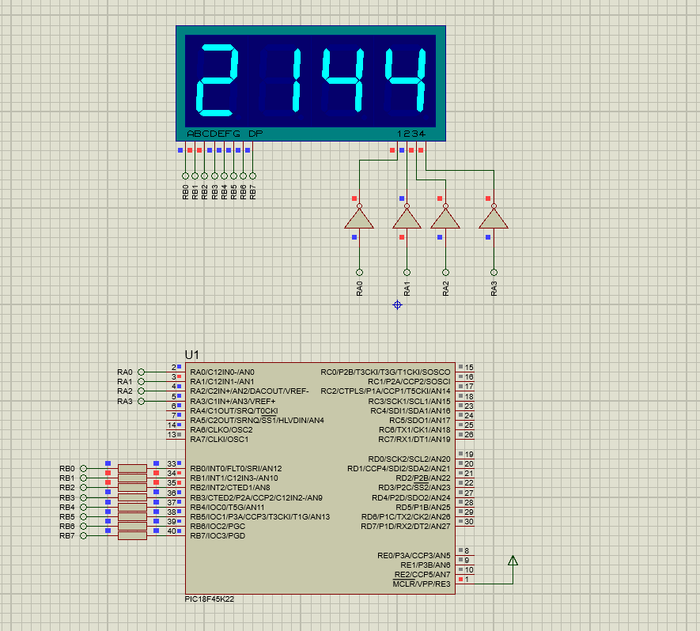

**Question-2 :**

The aim of the question is to write a scrolling text application in C programming language by using Mplab which shows your name, surname, student number by moving the letters or numbers four 7-segment like in figure below.

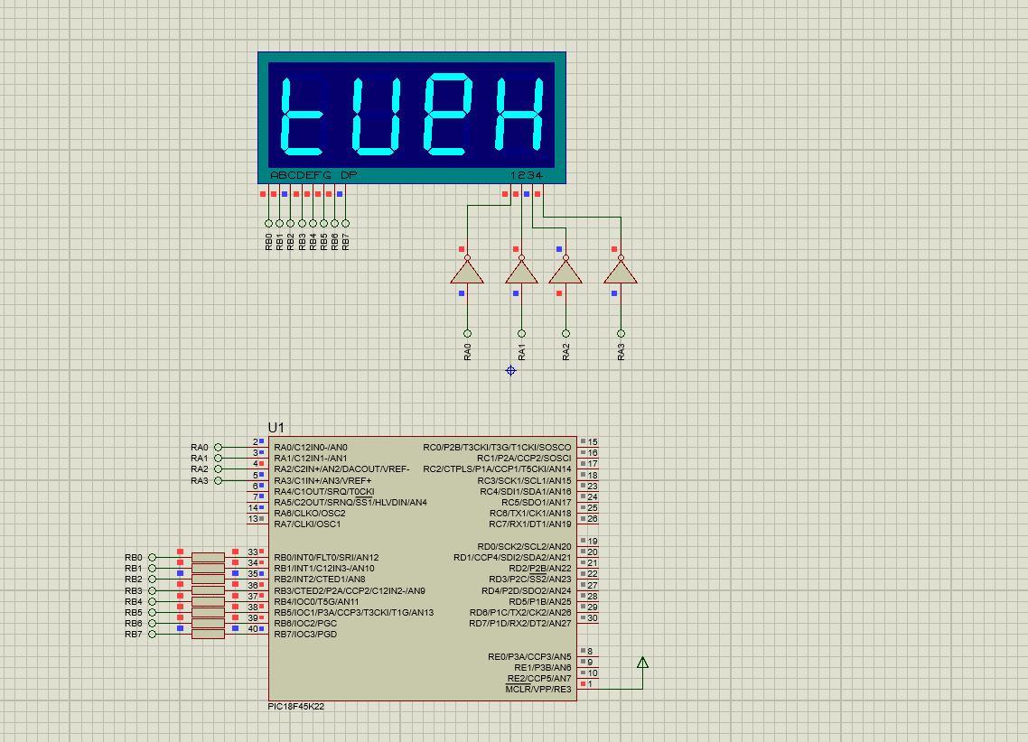

*Note:*

This document will be prepared before the lab session. Unless you bring this document in the desired format or prepared, you will not be let to the session.