EEE316 Microprocessors
Pre-laboratory Report

Name : Turhan Can Kargın
ID Number : 150403005
Lab. Number : 8

Objectıves of the Laboratory Assignment:

Objectives of this lab are learning embedded programming with C language
and understanding of Graphical LCD.

Code and Comments:
// Uploading Images
const code char fenerbahce[1024];
const code char besiktas[1024];
const code char galatasaray[1024];
const code char basaksehir[1024];
const code char bursaspor[1024];
const code char trabzonspor[1024];
const code char alanyaspor[1024];
const code char denizlispor[1024];
const code char goztepe[1024];
//const code char sivasspor[1024];
//--------------------------//
// Keypad
char keypadPort at PORTC;
// GLDC
char GLCD_DataPort at PORTD;
sbit GLCD_CS1 at LATA0_bit;
sbit GLCD_CS2 at LATA1_bit;
sbit GLCD_RS at LATA2_bit;
sbit GLCD_RW at LATA3_bit;
sbit GLCD_EN at LATA4_bit;
sbit GLCD_RST at LATA5_bit;
sbit GLCD_CS1_Direction at TRISA0_bit;
sbit GLCD_CS2_Direction at TRISA1_bit;
sbit GLCD_RS_Direction at TRISA2_bit;
sbit GLCD_RW_Direction at TRISA3_bit;
sbit GLCD_EN_Direction at TRISA4_bit;
sbit GLCD_RST_Direction at TRISA5_bit;
//----------------------------------//
// Assignment
unsigned short kp; // Keypad key
unsigned char flag; // for interrupt
unsigned char team; // To change image

bit breakFlag; // for pause,forward or backward
unsigned char x;
unsigned char y;

// Keypad function for checking if pressed
void check_Keypad()
{
kp = keypad_key_Press();
if (kp == 1)
{
team=1; // for fenerbahce
}
if (kp == 2)
{
team=2; // for besiktas
}
if (kp == 12)
{
team=3; // for galatasaray
}
if (kp == 5)
{
team=4; // for basaksehir
}
if (kp == 6)
{
team=5; // for bursaspor
}
if (kp == 13)
{
team=6; // for trabzonspor
}
if (kp == 9)
{
team=7; // for alanyaspor
}
if (kp == 10)
{
team=8; // for denizlispor
}
if (kp == 14)
{
team=9; // for göztepe
}
}
// Fenerbahce Forward Function
fenerbahce_Animation_forward(){
Glcd_Image(fenerbahce); // display fenerbahce
Delay_ms(300);
check_Keypad(); // chech if we pressed to keypad
Glcd_Fill(0x00); // clear
Glcd_Write_Text_Adv("EN",50,5); // Write text
Delay_ms(300);
check_Keypad();
Glcd_Write_Text_Adv("BUYUK",70,5); // Write text
Delay_ms(300);
check_Keypad();
Glcd_Write_Text_Adv("FENER",30,20); // Write text
Delay_ms(300);
check_Keypad();
Glcd_Write_Text_Adv("SAMPIYON",70,20); // Write text
Delay_ms(300);
check_Keypad();
Glcd_Write_Text_Adv("FENER",50,35); // Write text
Delay_ms(300);
check_Keypad();
Glcd_Image(fenerbahce); // display fenerbahce
Delay_ms(300);
check_Keypad();
}

// Fenerbahce animation reverse mode
fenerbahce_Animation_Reverse()
{
Glcd_Image(fenerbahce); // display fenrbahce
Delay_ms(1000);
check_Keypad(); // chech if we pressed to keypad
Glcd_Fill(0x00); // clear
Glcd_Write_Text_Adv("EN",50,5); // Write text
Glcd_Write_Text_Adv("BUYUK",70,5); // Write text
Glcd_Write_Text_Adv("FENER",30,20); // Write text
Glcd_Write_Text_Adv("SAMPIYON",70,20); // Write text
Glcd_Write_Text_Adv("FENER",50,35); // Write text
Delay_ms(300);
check_Keypad();
Glcd_Fill(0x00); // clear
Glcd_Write_Text_Adv("EN",50,5); // Write text
Glcd_Write_Text_Adv("BUYUK",70,5); // Write text
Glcd_Write_Text_Adv("FENER",30,20); // Write text
Glcd_Write_Text_Adv("SAMPIYON",70,20); // Write text
Delay_ms(300);
check_Keypad();
Glcd_Fill(0x00); // clear
Glcd_Write_Text_Adv("EN",50,5); // Write text
Glcd_Write_Text_Adv("BUYUK",70,5); // Write text
Glcd_Write_Text_Adv("FENER",30,20); // Write text
Delay_ms(300);
check_Keypad();
Glcd_Fill(0x00); // clear
Glcd_Write_Text_Adv("EN",50,5); // Write text
Glcd_Write_Text_Adv("BUYUK",70,5); // Write text
Delay_ms(300);
check_Keypad();
Glcd_Fill(0x00); // clear
Glcd_Write_Text_Adv("EN",50,5); // Write text
Delay_ms(300);
check_Keypad();
Glcd_Fill(0x00); // clear
Glcd_Image(fenerbahce); // display fenerbahce
}
// animation forward
animation_forward()
{
for(x=x;x<=120; x=x+2) //loop for move image
{
if(team==2) // check which image
{
Glcd_Fill(0x00); // clear
Glcd_PartialImage(x,0,128,64,128,64,besiktas); // besiktas
}
if(team==3) // check which image
{
Glcd_Fill(0x00); // clear
Glcd_PartialImage(x,0,128,64,128,64,galatasaray); // galatasaray
}
if(team==4) // check which image
{
Glcd_Fill(0x00); // clear
Glcd_PartialImage(x,0,128,64,128,64,basaksehir); // basaksehir
}
if(team==5) // check which image
{
Glcd_Fill(0x00); // clear
Glcd_PartialImage(x,0,128,64,128,64,bursaspor); // bursaspor
}
if(team==6) // check which image
{
Glcd_Fill(0x00); // clear
Glcd_PartialImage(x,0,128,64,128,64,trabzonspor); // trabzonspor
}
if(team==7) // check which image
{
Glcd_Fill(0x00); // clear
Glcd_PartialImage(x,0,128,64,128,64,alanyaspor); // alanyaspor
}
if(team==8) // check which image
{
Glcd_Fill(0x00); // clear
Glcd_PartialImage(x,0,128,64,128,64,denizlispor); // denizlispor
}
if(team==9) // check which image
{
Glcd_Fill(0x00); // clear
Glcd_PartialImage(x,0,128,64,128,64,goztepe); // goztepe
}

if(team==6) // check which image
{
Glcd_Fill(0x00); // clear
Glcd_PartialImage(x,0,128,64,128,64,trabzonspor); // trabzonspor
}
if(team==7) // check which image
{
Glcd_Fill(0x00); // clear
Glcd_PartialImage(x,0,128,64,128,64,alanyaspor); // alanyaspor
}
if(team==8) // check which image
{
Glcd_Fill(0x00); // clear
Glcd_PartialImage(x,0,128,64,128,64,denizlispor); // denizlispor
}
if(team==9) // check which image
{
Glcd_Fill(0x00); // clear
Glcd_PartialImage(x,0,128,64,128,64,goztepe); // goztepe
}
if(team==1) // check which image
{
Glcd_Fill(0x00); // clear
fenerbahce_Animation_forward(); // fenerbahce
}
Delay_ms(100);
check_Keypad();
y=x; // x for forward and y for reverse
if(x==120) // to check is image is out of the screen
{
x=0;
}
if(breakFlag == 1) break; // Check if there is interrupt
}
}
animation_backward()
{
for(y=y;y>=2; y=y-2) //loop for move image
{
if(team==2) // check which image
{
Glcd_Fill(0x00); // clear
Glcd_PartialImage(y,0,128,64,128,64,besiktas); // besiktas
}
if(team==3) // check which image
{
Glcd_Fill(0x00); // clear
Glcd_PartialImage(y,0,128,64,128,64,galatasaray); // galatasaray
}
if(team==4) // check which image
{
Glcd_Fill(0x00); // clear
Glcd_PartialImage(y,0,128,64,128,64,basaksehir); // basaksehir
}
if(team==5) // check which image
{
Glcd_Fill(0x00); // clear
Glcd_PartialImage(y,0,128,64,128,64,bursaspor); // bursaspor
}
if(team==6) // check which image
{
Glcd_Fill(0x00); // clear
Glcd_PartialImage(y,0,128,64,128,64,trabzonspor); // trabzonspor
}
if(team==7) // check which image
{
Glcd_Fill(0x00); // clear
Glcd_PartialImage(y,0,128,64,128,64,alanyaspor); // alanyaspor
}
if(team==8) // check which image
{
Glcd_Fill(0x00); // clear
Glcd_PartialImage(y,0,128,64,128,64,denizlispor); // denizlispor
}
if(team==9) // check which image
{
Glcd_Fill(0x00); // clear
Glcd_PartialImage(y,0,128,64,128,64,goztepe); // goztepe
}
if(team==1) // check which image
{
Glcd_Fill(0x00); // clear
fenerbahce_Animation_Reverse(); // fenerbahce
}
Delay_ms(100);
check_Keypad();
x=y; // x for forward and y for reverse
if(y<=2) // to check is image is out of the screen
{
y=120;
}
if(breakFlag == 1) break; // Check if there is interrupt
}
}

if(team==7) // check which image
{
Glcd_Fill(0x00); // clear
Glcd_PartialImage(y,0,128,64,128,64,alanyaspor); // alanyaspor
}
if(team==8) // check which image
{
Glcd_Fill(0x00); // clear
Glcd_PartialImage(y,0,128,64,128,64,denizlispor); // denizlispor
}
if(team==9) // check which image
{
Glcd_Fill(0x00); // clear
Glcd_PartialImage(y,0,128,64,128,64,goztepe); // goztepe
}
if(team==1) // check which image
{
Glcd_Fill(0x00); // clear
fenerbahce_Animation_Reverse(); // fenerbahce
}
Delay_ms(100);
check_Keypad();
x=y; // x for forward and y for reverse
if(y<=2) // to check is image is out of the screen
{
y=120;
}
if(breakFlag == 1) break; // Check if there is interrupt
}
}
// Pause the animation
animation_pause()
{
if(team==2) // check which image
{
Glcd_PartialImage(x,0,128,64,128,64,besiktas); // besiktas
}
if(team==3) // check which image
{
Glcd_PartialImage(x,0,128,64,128,64,galatasaray); // galatasaray
}
if(team==4) // check which image
{
Glcd_PartialImage(x,0,128,64,128,64,basaksehir); // basaksehir
}
if(team==5) // check which image
{
Glcd_PartialImage(x,0,128,64,128,64,bursaspor); // bursaspor
}
if(team==6) // check which image
{
Glcd_PartialImage(x,0,128,64,128,64,trabzonspor); // trabzonspor
}
if(team==7) // check which image
{
Glcd_PartialImage(x,0,128,64,128,64,alanyaspor); // alanyaspor
}
if(team==8) // check which image
{
Glcd_PartialImage(x,0,128,64,128,64,denizlispor); // denizlispor
}
if(team==9) // check which image
{
Glcd_PartialImage(x,0,128,64,128,64,goztepe); // goztepe
}
if(team==1) // check which image
{
Glcd_Image(fenerbahce); // display fenerbahce
}
check_Keypad();
}

if(team==9) // check which image
{
Glcd_PartialImage(x,0,128,64,128,64,goztepe); // goztepe
}
if(team==1) // check which image
{
Glcd_Image(fenerbahce); // display fenerbahce
}
check_Keypad();
}
// Interrupt when interrupt flag is set
void interrupt()
{
// Check Interrupt INT0 is set. INT0F_bit will be 1
if(INT0F_bit==1) // check for int0 Flag bit
{
flag = 1;
breakFlag =~ breakFlag;
}
// Check Interrupt INT0 is set. INT0F_bit will be 1
else if(INT1F_bit==1) // check for int1 Flag bit
{
flag = 2;
breakFlag =~ breakFlag;
}
// Check Interrupt INT0 is set. INT2F_bit will be 1
else if(INT2F_bit==1) // check for int2 Flag bit
{
flag = 3;
breakFlag =~ breakFlag;
}
INT0F_bit=0;
INT1F_bit=0;
INT2F_bit=0;
}
void main() {
// Configure ports
ANSELB=0;
ANSELD=0;
ANSELB=0;
ANSELD=0;
// External Hardware Interrupts (INT0(RB0),INT1(RB1),INT2(RB2))
flag=1;
breakFlag=0;
//INT0
INTEDG0_bit = 1; // Set Interrupt on rising edge
INT0IF_bit = 0; // Clear INT0 flag
INT0IE_bit = 1; // Enable INT0 interrupt
//INT1
INTEDG1_bit = 1; // Set Interrupt on rising edge
INT1IF_bit = 0; // Clear INT0 flag
INT1IE_bit = 1; // Enable INT0 interrupt
//INT2
INTEDG2_bit = 1; // Set Interrupt on rising edge
INT2IF_bit = 0; // Clear INT0 flag
INT2IE_bit = 1; // Enable INT0 interrupt
GIE_bit = 1; // enable Global interrupt
Keypad_Init(); // Start Keypad
Glcd_Init(); // Start glcd
Glcd_Fill(0x00); // clear glcd

team=0;
Glcd_Write_Text_Adv("Assignment Name:",0,0); // Write text
Glcd_Write_Text_Adv("Turkish Super League",0,10); // Write text
Glcd_Write_Text_Adv("Name: Turhan Can Kargin",0,30); // Write text
Glcd_Write_Text_Adv("Student Number: 150403005",0,40); // Write text
Delay_ms(1000);
Glcd_Fill(0x00); // clear glcd
Glcd_Write_Text_Adv("Please Press any",0,0); // Write text
Glcd_Write_Text_Adv("Button on Keypad",0,10); // Write text
Glcd_Write_Text_Adv("to see Your Super",0,20); // Write text
Glcd_Write_Text_Adv("League Team",0,30); // Write text
// Looping forever
while(1){
if(flag==1) // check if INT0
{
animation_forward(); // forward
}
if(flag==2) // check if INT1
{
animation_backward(); // backward
}
if(flag==3) // check if INT2
{
animation_pause(); // pause
}
}
}

Explanations:

Question:

The aim of the question is to design a short animation on Proteus using a GLCD. We are free to design our own animation. We need to design a light and simple animation. My animation is showing Turkish Super League Football Teams on GLCD by pressing keys on keypad. Every key has different football team. For example, when you press 1, then Fenerbahce will be displayed on GLCD or when you press 2, then Besiktas will be displayed. There are 3 buttons for forward, backward and pause image. Interrupts have been used for forward, backward, and pause buttons. Before animation starts, my name/surname, student ID and my animation’s name is being showed at the beginning.

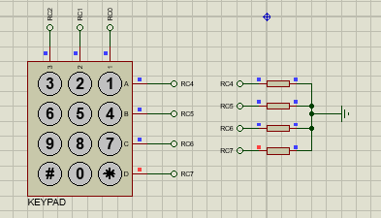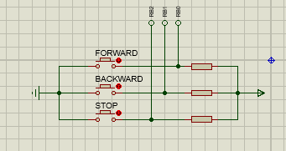

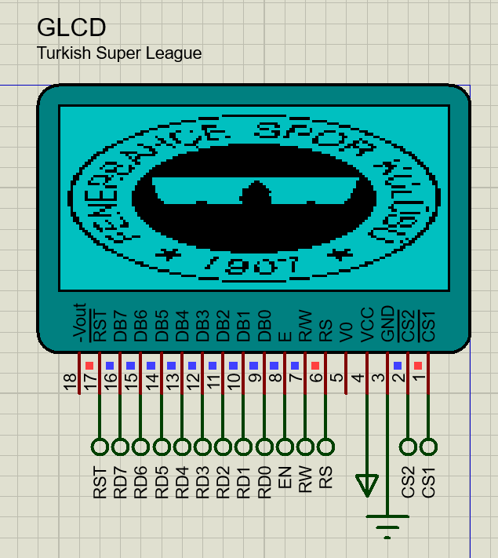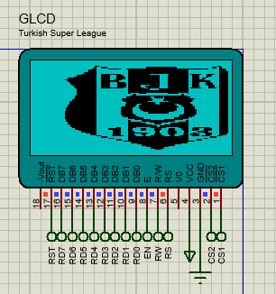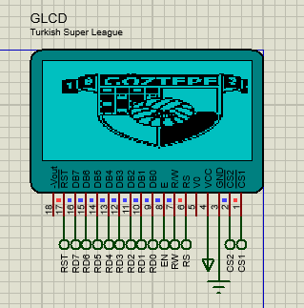

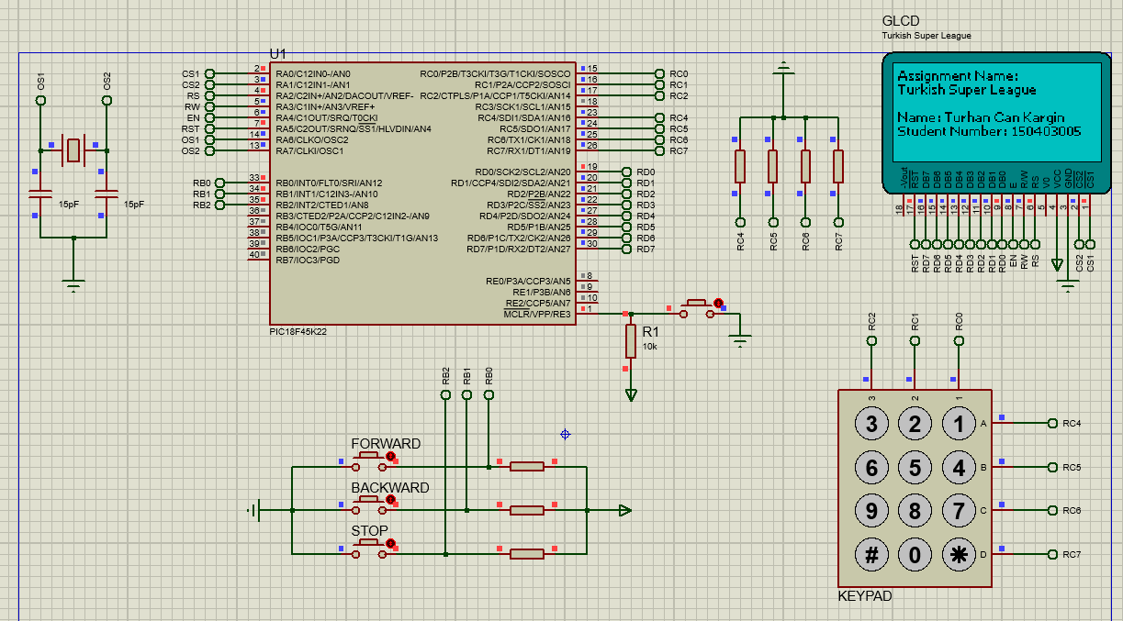

Note:
This document will be prepared before the lab session. Unless you bring this document in the desired format or prepared, you will not be let to the session.

