EEE316 Microprocessors
Pre-laboratory Report

Name : Turhan Can Kargın
ID Number : 150403005
Lab. Number : 1

Objectıves of the Laboratory Assignment:

Objectives of this lab are learning MPLAB IDE environment, examining and using the simple instructions and part of PIC microcontroller for programming in assembly such as WREG, FileReg, ADD, MOVE and examining status of the C, DC, Z, OV and N flags.

Code and Comments:

org 0h ; Used to indicate the beginning of the adress which is '00000000'
movlw 0x25 ;loading 25H to wreg
movwf 0x20 ;writes from wreg to FileReg location 20H
movlw 0xFF ;moves FF which is largest hex value for 8-bit register to wreg
movwf 0x21 ;writes from wreg to 21H location
movf 0x20, 0 ;from 20H to wreg to load 20H in wreg
subwf 0x21, 0 ;21H - wreg and '0' is for storing to wreg
movwf 0x22 ; moving data from wreg to any FileRegister to store
end

org 0h ; Used to indicate the beginning of the adress which is '00000000'
movlw 0x00 ;to make wreg 0
movwf 0x35 ; we came to 35H adress
movlw 0x15 ; wreg is 15H
addwf 0x35, F ; we add 15H to address of 35H
movlw b'11011001' ; wreg is b'11011001'
addwf 0x35, F ; we add b'11011001' to address of 35H
movlw .16 ; wreg is 16 Decimal
addwf 0x35, F ; we add D'16' to address of 35H and all summation is done in 35H
movf 0x35, 0 ; we moved summantion to wreg
movwf 0x36 ; we moved to 36H adress
INCF 0x36, F ; increment
movf 0x36, 0 ; we moved summantion to wreg
movwf 0x37 ; we moved to 37H adress and saved it
decf 0x37, F ; decrement
end

;My birthday is 11/11/1997(11,11,19,97)
org 0h ; Used to indicate the beginning of the adress which is '00000000'
movlw 0x11 ;loading wreg 11
movwf 0x10 ; we moved 11H value to 10H adress
movlw 0x11 ;loading wreg 11
movwf 0x11 ; we moved 11H value to 11H adress
movlw 0x19 ;loading wreg 19
movwf 0x12 ; we moved 19H value to 12H adress
movlw 0x97 ;loading wreg 97
movwf 0x13 ; we moved 97H value to 13H adress
movlw 0x00 ;make wreg 0
addlw 0x11 ; 11 +
addlw 0x11 ; 11 +
addlw 0x19 ; 19 +
addlw 0x97 ; 97 (summantion of all numbers) and they are in the wreg
end

org 0h ; Used to indicate the beginning of the adress which is '00000000'
movlw 0x0B ; loading wreg BH
movwf 0x15 ; we moved BH value to 15H adress
movlw 0x61 ; loading wreg 61H
movwf 0x16 ; we moved 61H value to 16H adress
comf 0x15, F ; takes complement of file registers 15H adress
comf 0x16, F ; takes complement of file registers 16H adress
INCF 0x15, F ;increases values of file registers by 1H
INCF 0x16, F ;increases values of file registers by 1H
end

Explanations:

Question-1 :

Our aim is to subtract two hex value which is 25H and 8-bit largest hex value (FF) in this question and load the result to any FileReg.

FF – 25 = DA

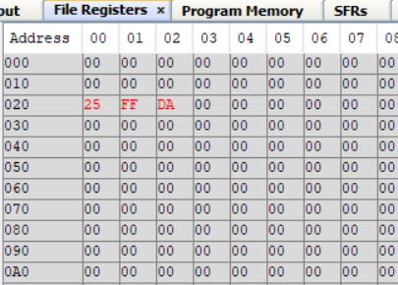
Question-2 :

We sum three number which are 15H, b’11011001’ (D9H), D’16’ (10H). Next, we increased the result. Finally, we decreased the result and load FileREg.
15H + D9 + 10H = FE
FE + 1H = FF
FF – 1H = FE

FileReg
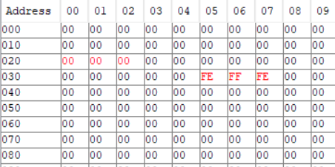

Question-3 :

My birthday is 11/11/1997. So, we saved 11, 11, 19, 97 hex numbers to FileRegs. Later, we sum these numbers and kept the result in WREG. After that, examined the status of the C, DC, Z, OV and N flags.
11H + 11H + 19H + 97H = D2(1101 0010)

WREG

FileReg
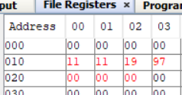

Status of the Flags
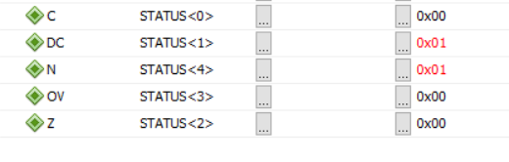

Question-4 :

Smallest two-digit prime number is 11 and largest two-digit prime number is 97.
D’11’ = Bh → complement of Bh is F4 → F4 + 01h = F5
D’97’ = 61h → complement of 61h is 9E → 9E + 01h = 9F

FileReg

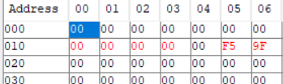

- When we invert (complement) all the bits and then add 1 to the result, we get the 2’s complement of a binary number. This is what we did in this question.

Note:
This document will be prepared before the lab session. Unless you bring this document in the desired format or prepared, you will not be let to the session.

