EEE316 Microprocessors
Pre-laboratory Report

Name : Turhan Can Kargın
ID Number : 150403005
Lab. Number : 2

Objectıves of the Laboratory Assignment:

Objectives of this lab are examining the I/O port operation using a MPLAB simulator and understanding how to turn the LEDs on with given delay intervals. Also, calculating the delay time and how to call delay.

Code and Comments:

org 0h
;initialization steps
BANKSEL ANSELC ; going anselc bank
CLRF ANSELC ; reset anselc
CLRF TRISC ; portc is output
MOVLW 0X00 ; clear wreg
MOVWF PORTC ; moving portc
; loop
COUNT EQU 0X25 ; COUNT = 25H
MOVLW .40 ; loading d'40' to wreg for 40 times loop
MOVWF COUNT ; moving value to 25h loc
AGAIN INCF PORTC,F ; every step portc will increase 1H
CALL DELAY ; calling delay
DECF COUNT,F ; checking if 25h loc is zero
BNZ AGAIN ; if it is not zero, go to AGAIN
;-----------delay subroutine
DELAY MOVLW .255 ; outer loop is starting
MOVWF 0X0C ; 0x0C is 255
LOOP_1 MOVLW .255 ; intermediate loop starts
MOVWF 0X0D ; 0x0D is 255
LOOP_0 NOP ; inner loop starts
NOP ; wasting 1 us 9 times
NOP
NOP
NOP
NOP
NOP
NOP
NOP
DECFSZ 0X0D,F
GOTO LOOP_0 ; repeat until 0x0D is zero
DECFSZ 0X0C,F
GOTO LOOP_1 ; repeat until 0x0C is zero
RETURN ; return to caller
END ; end of asm file

org 0h
;initialization steps
BANKSEL ANSELD
CLRF ANSELD
CLRF TRISD ; portd is output
BANKSEL ANSELB
CLRF ANSELB
CLRF TRISB ; portd is output
BANKSEL ANSELC
CLRF ANSELC
CLRF TRISC ; portdc is output
LOOP MOVLW 0X55 ; wreg = 55h
MOVWF PORTB ; put 55h on port b pins
MOVWF PORTC ; put 55h on port c pins
MOVWF PORTD ; put 55h on port d pins
CALL DELAY ; putting delay
MOVLW 0XAA ; wreg = AAh
MOVWF PORTB ; put AAh on port b pins
MOVWF PORTC ; put AAh on port c pins
MOVWF PORTD ; put AAh on port d pins
CALL DELAY ; putting delay
GOTO LOOP ; for infinite loop
;-----------delay subroutine
DELAY MOVLW .15 ; first loop is starting
MOVWF 0x01 ; 0x01 is 15
LOOP_3 MOVLW .255 ; second loop starts
MOVWF 0x02 ; 0x02 is 255
LOOP_2 MOVLW .255 ; third loop starts
MOVWF 0x03 ; 0x02 is 255
LOOP_1 NOP ; wasting 1 us 2 times
NOP
DECF 0x03,F ; repeat until 0x03 is zero
BNZ LOOP_1
DECF 0x02,F ; repeat until 0x02 is zero
BNZ LOOP_2
DECF 0x01,F ; repeat until 0x01 is zero
BNZ LOOP_3
RETURN ; return to caller
END ; end of asm file

org 0h
BANKSEL ANSELC ;Prepare port a and b
CLRF ANSELC
BANKSEL ANSELB
CLRF ANSELB
SETF TRISC ;set portc as input
CLRF TRISB ; b as output.
AGAIN BTFSS PORTC,0 ; checking portc rc0 pin
BRA AGAIN ; if it is zero go to AGAIN, otherwise continue
CALL DELAY ; putting 0.5 s delay
LOOP BSF PORTB,0 ; set portb rb0
CALL DELAY ; putting 0.5 s delay
BCF PORTB,0 ; clear portb rb0
BSF PORTB,1 ; set portb pb1
CALL DELAY ; putting 0.5 delay
BCF PORTB,1 ; clear portb rb1
GOTO LOOP ; loop to make red-yellow-red-yellow
;-----------delay subroutine
DELAY MOVLW .255 ; outer loop is starting
MOVWF 0X0C ; 0x0C is 255
LOOP_1 MOVLW .255 ; intermediate loop starts
MOVWF 0X0D ; 0x0D is 255
LOOP_0 NOP ; inner loop starts
NOP ; wasting 1 us 5 times
NOP
NOP
NOP
DECFSZ 0X0D,F
GOTO LOOP_0 ; repeat until 0x0D is zero
DECFSZ 0X0C,F
GOTO LOOP_1 ; repeat until 0x0C is zero
RETURN ; return to caller
END ; end of asm file

Explanations:

Question-1 :

Our aim is to increase Port C bits from 0 to 40 in decimal. We put 0.8 s delay for every increment. To understand that bits are increasing we build 8 led connected to Port C. You can see the circuit and delay calculation below;

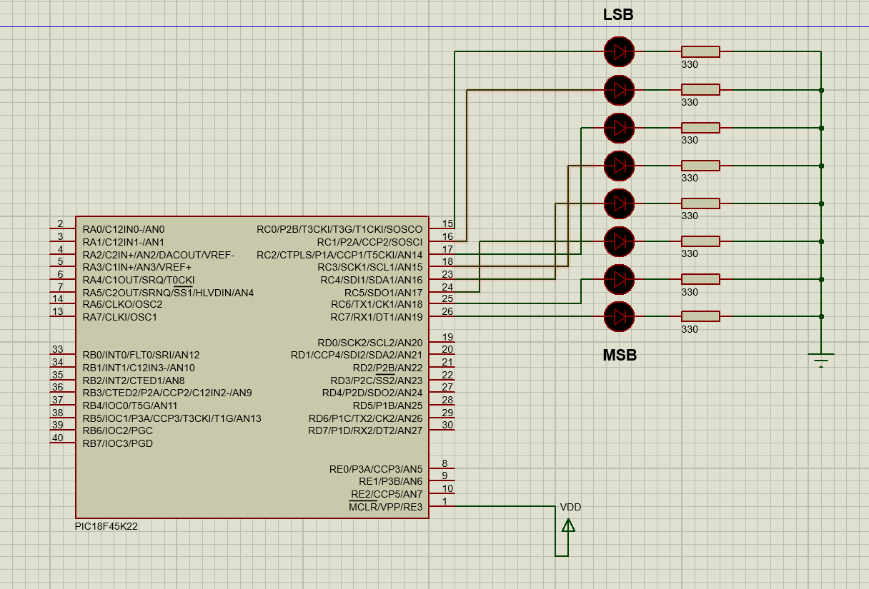

DELAY MOVLW .255 ; outer loop is starting
MOVWF 0X0C ; 0x0C is 255
LOOP_1 MOVLW .255 ; intermediate loop starts
MOVWF 0X0D ; 0x0D is 255
LOOP_0 NOP ; inner loop starts
NOP ; wasting 1 us 9 times
NOP
NOP
NOP
NOP
NOP
NOP
NOP
DECFSZ 0X0D,F
GOTO LOOP_0 ; repeat until 0x0D is zero
DECFSZ 0X0C,F
GOTO LOOP_1 ; repeat until 0x0C is zero
RETURN ; return to caller
END ; end of asm file

[(

Question-2 :

Our aim is to toggle all the bits of PORTB, PORTC and PORTD continuously by sending 55H and AAH to these ports and putting 1.2 s delay for each toggle. You can see the circuit and delay calculation below;

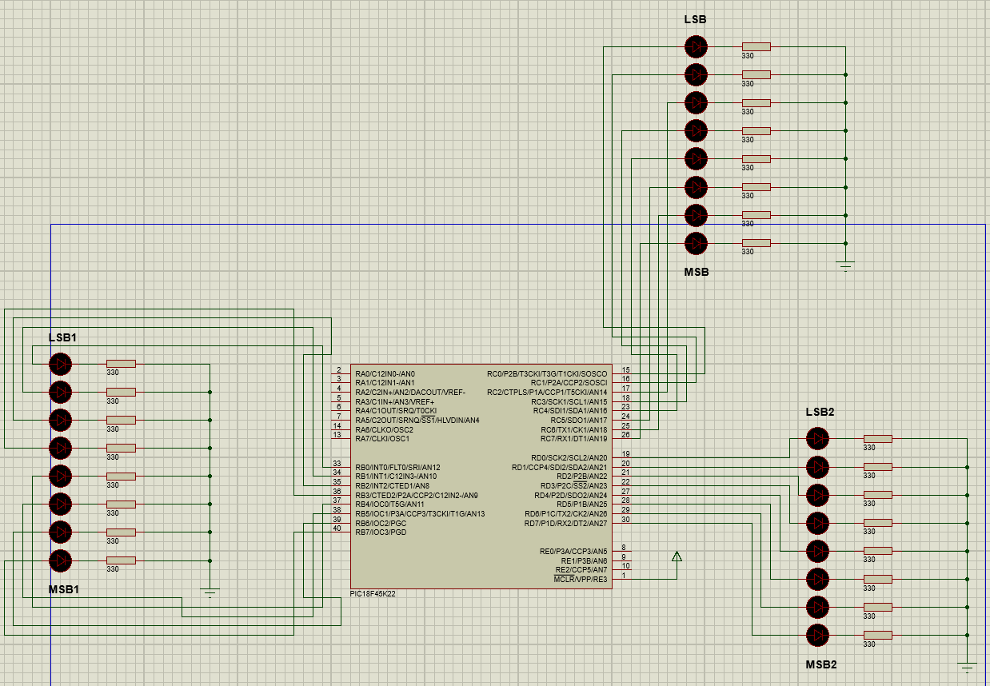

DELAY MOVLW .15 ; first loop is starting
MOVWF 0x01 ; 0x01 is 15
LOOP_3 MOVLW .255 ; second loop starts
MOVWF 0x02 ; 0x02 is 255
LOOP_2 MOVLW .255 ; third loop starts
MOVWF 0x03 ; 0x02 is 255
LOOP_1 NOP ; wasting 1 us 2 times
NOP
DECF 0x03,F ; repeat until 0x03 is zero
BNZ LOOP_1
DECF 0x02,F ; repeat until 0x02 is zero
BNZ LOOP_2
DECF 0x01,F ; repeat until 0x01 is zero
BNZ LOOP_3
RETURN ; return to caller
END ; end of asm file

Question-3 :

Our aim is to see when we press the button connected to RC0, red LED turns on, and turns off after 0.5s. When red LED turns off, yellow LED turns on and turns off after 0.5s. You can see circuit and delay calculation below;

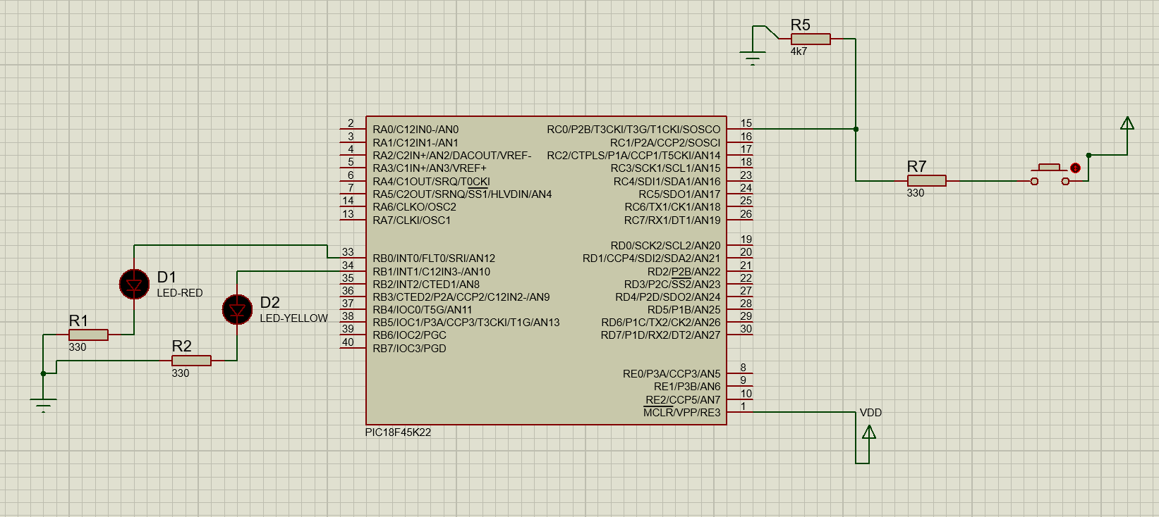

DELAY MOVLW .255 ; outer loop is starting
MOVWF 0X0C ; 0x0C is 255
LOOP_1 MOVLW .255 ; intermediate loop starts
MOVWF 0X0D ; 0x0D is 255
LOOP_0 NOP ; inner loop starts
NOP ; wasting 1 us 5 times
NOP
NOP
NOP
DECFSZ 0X0D,F
GOTO LOOP_0 ; repeat until 0x0D is zero
DECFSZ 0X0C,F
GOTO LOOP_1 ; repeat until 0x0C is zero
RETURN ; return to caller
END ; end of asm file

Note:
This document will be prepared before the lab session. Unless you bring this document in the desired format or prepared, you will not be let to the session.

