EEE316 Microprocessors
Pre-laboratory Report

Name : Turhan Can Kargın
ID Number : 150403005
Lab. Number : 3

Objectıves of the Laboratory Assignment:

Objectives of this lab are examining I/O port operations, improving math operations skills and learning Rotate commands.

Code and Comments:

org 0h
BANKSEL ANSELC ;initialization steps
CLRF ANSELC
BANKSEL ANSELB
CLRF ANSELB
BANKSEL ANSELA
CLRF ANSELA
CLRF TRISC ;make PORTC output
CLRF TRISB ;make PORTB output
SETF TRISA ;set PORTA as input
COUNT1 EQU 0X25 ; COUNT1 = 25H
; FIRST PART
Start movlw B'00000000' ; WREG = 00000000
movwf PORTB ; SET PORTB '00000000'
movwf PORTC ; SET PORTB '00000000'
CALL DELAY ; DELAY
BTFSC PORTA,0 ; checking portc RA0 pin
BRA AGAIN ; if it is SET go to AGAIN, otherwise continue
BTFSC PORTA,1 ; checking portc RA1 pin
BRA AGAIN2 ; if it is SET go to AGAIN2, otherwise continue
BTFSC PORTA,2 ; checking portc RA2 pin
BRA AGAIN3 ; if it is SET go to AGAIN3, otherwise continue
MOVLW .8 ; we have 8 leds and bits for port
MOVWF COUNT1
LOP1 RRCF PORTB ; For rotating 8 times from left to right
BSF STATUS, C ; C=1
RLCF PORTC ; For rotating 8 times from right to left
BSF STATUS, C ; C=1
CALL DELAY
DECF COUNT1 ; setting 8 times
BNZ LOP1
MOVLW .8
MOVWF COUNT1
LOP2 BCF STATUS, C ;C=0
RRCF PORTB ;rotate PORTB 8 times to right
BCF STATUS, C ;C=0
RLCF PORTC ;rotate PORTC 8 times to LEFT
BCF STATUS, C ;C=0
CALL DELAY
DECF COUNT1
BNZ LOP2
MOVLW .8
MOVWF COUNT1
LOP3 BSF STATUS, C ;C=1
RLCF PORTB ;rotate portB 8 times to LEFT
BSF STATUS, C ;C=1
RRCF PORTC ;rotate portC 8 times to RIGHT
BSF STATUS, C ;C=1
CALL DELAY
DECF COUNT1
BNZ LOP3
MOVLW .8
MOVWF COUNT1
LOP4 BCF STATUS, C ;C=1
RLCF PORTB ;rotate portB 8 times to LEFT
BCF STATUS, C ;C=1
RRCF PORTC ;rotate portC 8 times to RIGHT
BCF STATUS, C ;C=1
CALL DELAY
DECF COUNT1
BNZ LOP4
GOTO Start ; go to begining of this part
; SECOND PART
AGAIN BTFSS PORTA,0 ; checking portc RA0 pin
BRA Start ; if it is RESET go to START, otherwise continue
movlw B'00000001' ;set PORTC 00000001
movwf PORTC ;light it with delay
CALL DELAY
MOVLW .7
MOVWF COUNT1
LOP5 RLNCF PORTC ; rotate portb 7 times to left
CALL DELAY ; with delay
DECF COUNT1
BNZ LOP5
CLRF PORTC ; PORTC is 00000000
CALL DELAY
MOVLW B'00000001' ; start lighting portb with delay
MOVWF PORTB
CALL DELAY
MOVLW .7
MOVWF COUNT1
LOP6 RLNCF PORTB ; rotate portb 7 times to left
CALL DELAY ; with delay
DECF COUNT1
BNZ LOP6
MOVLW B'10000000'
MOVWF PORTB
MOVLW .7
MOVWF COUNT1
LOP7 RRNCF PORTB ; rotate portb 7 times to right
CALL DELAY ; with delay
DECF COUNT1
BNZ LOP7
CALL DELAY
CLRF PORTB
MOVLW B'10000000'
MOVWF PORTC
CALL DELAY
MOVLW .7
MOVWF COUNT1
LOP8 RRNCF PORTC ; rotate portb 7 times to right
CALL DELAY ; with delay
DECF COUNT1
BNZ LOP8
GOTO AGAIN ; go to begining of this part
;THIRD PART
AGAIN2 BTFSS PORTA,1 ;checking portc RA1 pin
BRA Start ; if it is RESET go to START, otherwise continue
MOVLW .8
MOVWF COUNT1
LOP9 RLCF PORTC ; rotate portB 7 times to LEFT
BSF STATUS, C ; C=1
CALL DELAY ; with delay
DECF COUNT1
BNZ LOP9
MOVLW .8
MOVWF COUNT1
LOP10 RLCF PORTB ; rotate portB 7 times to LEFT
BSF STATUS, C ; C=1
CALL DELAY ; with delay
DECF COUNT1
BNZ LOP10
MOVLW .8
MOVWF COUNT1
LOP11 BCF STATUS, C ; C=0
RRCF PORTB ; rotate portB 7 times to RIGHT
CALL DELAY ; with delay
DECF COUNT1
BNZ LOP11
MOVLW .8
MOVWF COUNT1
LOP12 BCF STATUS, C ; C=0
RRCF PORTC ; rotate portB 7 times to right
CALL DELAY ; with delay
DECF COUNT1
BNZ LOP12
GOTO AGAIN2 ; go to beginig of this part
;FORTH PART
AGAIN3 BTFSS PORTA,2 ; checking portc RA2 pin
BRA Start ; if it is RESET go to START, otherwise continue
MOVLW .8
MOVWF COUNT1
LOP13 BSF STATUS, C ; C=1
RLCF PORTB ; rotate portB 8 times to LEFT
BSF STATUS, C ; C=1
RRCF PORTC ; rotate portC 8 times to RIGHT
BSF STATUS, C ; C=1
CALL DELAY
DECF COUNT1
BNZ LOP13
MOVLW .7
MOVWF COUNT1
LOP14 BCF STATUS, C ; C=0
RRCF PORTB ; rotate portB 7 times to RIGHT
BCF STATUS, C ; C=0
RLCF PORTC ; rotate portC 7 times to LEFT
BCF STATUS, C ; C=0
CALL DELAY
DECF COUNT1
BNZ LOP14
GOTO AGAIN3 ; GO TO BEGINNINGOF THIS PART
;_____________Delay
DELAY movlw .40 ;I calculated these loop values to look better on proteus
movwf 0x21
For5 movlw .50
movwf 0x22
For4 movlw .1
movwf 0x23
For3 nop
nop
DECF 0x23,f
BNZ For3
decf 0x22,f
BNZ For4
decf 0x21,f
BNZ For5
RETURN
end

LOP2 BCF STATUS, C ;C=0
RRCF PORTB ;rotate PORTB 8 times to right
BCF STATUS, C ;C=0
RLCF PORTC ;rotate PORTC 8 times to LEFT
BCF STATUS, C ;C=0
CALL DELAY
DECF COUNT1
BNZ LOP2
MOVLW .8
MOVWF COUNT1
LOP3 BSF STATUS, C ;C=1
RLCF PORTB ;rotate portB 8 times to LEFT
BSF STATUS, C ;C=1
RRCF PORTC ;rotate portC 8 times to RIGHT
BSF STATUS, C ;C=1
CALL DELAY
DECF COUNT1
BNZ LOP3
MOVLW .8
MOVWF COUNT1
LOP4 BCF STATUS, C ;C=1
RLCF PORTB ;rotate portB 8 times to LEFT
BCF STATUS, C ;C=1
RRCF PORTC ;rotate portC 8 times to RIGHT
BCF STATUS, C ;C=1
CALL DELAY
DECF COUNT1
BNZ LOP4
GOTO Start ; go to begining of this part
; SECOND PART
AGAIN BTFSS PORTA,0 ; checking portc RA0 pin
BRA Start ; if it is RESET go to START, otherwise continue
movlw B'00000001' ;set PORTC 00000001
movwf PORTC ;light it with delay
CALL DELAY
MOVLW .7
MOVWF COUNT1
LOP5 RLNCF PORTC ; rotate portb 7 times to left
CALL DELAY ; with delay
DECF COUNT1
BNZ LOP5
CLRF PORTC ; PORTC is 00000000
CALL DELAY
MOVLW B'00000001' ; start lighting portb with delay
MOVWF PORTB
CALL DELAY
MOVLW .7
MOVWF COUNT1
LOP6 RLNCF PORTB ; rotate portb 7 times to left
CALL DELAY ; with delay
DECF COUNT1
BNZ LOP6
MOVLW B'10000000'
MOVWF PORTB
MOVLW .7
MOVWF COUNT1
LOP7 RRNCF PORTB ; rotate portb 7 times to right
CALL DELAY ; with delay
DECF COUNT1
BNZ LOP7
CALL DELAY
CLRF PORTB
MOVLW B'10000000'
MOVWF PORTC
CALL DELAY
MOVLW .7
MOVWF COUNT1
LOP8 RRNCF PORTC ; rotate portb 7 times to right
CALL DELAY ; with delay
DECF COUNT1
BNZ LOP8
GOTO AGAIN ; go to begining of this part
;THIRD PART
AGAIN2 BTFSS PORTA,1 ;checking portc RA1 pin
BRA Start ; if it is RESET go to START, otherwise continue
MOVLW .8
MOVWF COUNT1
LOP9 RLCF PORTC ; rotate portB 7 times to LEFT
BSF STATUS, C ; C=1
CALL DELAY ; with delay
DECF COUNT1
BNZ LOP9
MOVLW .8
MOVWF COUNT1
LOP10 RLCF PORTB ; rotate portB 7 times to LEFT
BSF STATUS, C ; C=1
CALL DELAY ; with delay
DECF COUNT1
BNZ LOP10
MOVLW .8
MOVWF COUNT1
LOP11 BCF STATUS, C ; C=0
RRCF PORTB ; rotate portB 7 times to RIGHT
CALL DELAY ; with delay
DECF COUNT1
BNZ LOP11
MOVLW .8
MOVWF COUNT1
LOP12 BCF STATUS, C ; C=0
RRCF PORTC ; rotate portB 7 times to right
CALL DELAY ; with delay
DECF COUNT1
BNZ LOP12
GOTO AGAIN2 ; go to beginig of this part
;FORTH PART
AGAIN3 BTFSS PORTA,2 ; checking portc RA2 pin
BRA Start ; if it is RESET go to START, otherwise continue
MOVLW .8
MOVWF COUNT1
LOP13 BSF STATUS, C ; C=1
RLCF PORTB ; rotate portB 8 times to LEFT
BSF STATUS, C ; C=1
RRCF PORTC ; rotate portC 8 times to RIGHT
BSF STATUS, C ; C=1
CALL DELAY
DECF COUNT1
BNZ LOP13
MOVLW .7
MOVWF COUNT1
LOP14 BCF STATUS, C ; C=0
RRCF PORTB ; rotate portB 7 times to RIGHT
BCF STATUS, C ; C=0
RLCF PORTC ; rotate portC 7 times to LEFT
BCF STATUS, C ; C=0
CALL DELAY
DECF COUNT1
BNZ LOP14
GOTO AGAIN3 ; GO TO BEGINNINGOF THIS PART
;_____________Delay
DELAY movlw .40 ;I calculated these loop values to look better on proteus
movwf 0x21
For5 movlw .50
movwf 0x22
For4 movlw .1
movwf 0x23
For3 nop
nop
DECF 0x23,f
BNZ For3
decf 0x22,f
BNZ For4
decf 0x21,f
BNZ For5
RETURN
end

CALL DELAY
MOVLW .7
MOVWF COUNT1
LOP8 RRNCF PORTC ; rotate portb 7 times to right
CALL DELAY ; with delay
DECF COUNT1
BNZ LOP8
GOTO AGAIN ; go to begining of this part
;THIRD PART
AGAIN2 BTFSS PORTA,1 ;checking portc RA1 pin
BRA Start ; if it is RESET go to START, otherwise continue
MOVLW .8
MOVWF COUNT1
LOP9 RLCF PORTC ; rotate portB 7 times to LEFT
BSF STATUS, C ; C=1
CALL DELAY ; with delay
DECF COUNT1
BNZ LOP9
MOVLW .8
MOVWF COUNT1
LOP10 RLCF PORTB ; rotate portB 7 times to LEFT
BSF STATUS, C ; C=1
CALL DELAY ; with delay
DECF COUNT1
BNZ LOP10
MOVLW .8
MOVWF COUNT1
LOP11 BCF STATUS, C ; C=0
RRCF PORTB ; rotate portB 7 times to RIGHT
CALL DELAY ; with delay
DECF COUNT1
BNZ LOP11
MOVLW .8
MOVWF COUNT1
LOP12 BCF STATUS, C ; C=0
RRCF PORTC ; rotate portB 7 times to right
CALL DELAY ; with delay
DECF COUNT1
BNZ LOP12
GOTO AGAIN2 ; go to beginig of this part
;FORTH PART
AGAIN3 BTFSS PORTA,2 ; checking portc RA2 pin
BRA Start ; if it is RESET go to START, otherwise continue
MOVLW .8
MOVWF COUNT1
LOP13 BSF STATUS, C ; C=1
RLCF PORTB ; rotate portB 8 times to LEFT
BSF STATUS, C ; C=1
RRCF PORTC ; rotate portC 8 times to RIGHT
BSF STATUS, C ; C=1
CALL DELAY
DECF COUNT1
BNZ LOP13
MOVLW .7
MOVWF COUNT1
LOP14 BCF STATUS, C ; C=0
RRCF PORTB ; rotate portB 7 times to RIGHT
BCF STATUS, C ; C=0
RLCF PORTC ; rotate portC 7 times to LEFT
BCF STATUS, C ; C=0
CALL DELAY
DECF COUNT1
BNZ LOP14
GOTO AGAIN3 ; GO TO BEGINNINGOF THIS PART
;_____________Delay
DELAY movlw .40 ;I calculated these loop values to look better on proteus
movwf 0x21
For5 movlw .50
movwf 0x22
For4 movlw .1
movwf 0x23
For3 nop
nop
DECF 0x23,f
BNZ For3
decf 0x22,f
BNZ For4
decf 0x21,f
BNZ For5
RETURN
end

;_____________Delay
DELAY movlw .40 ; these loop values calculated to look better on proteus
movwf 0x21
For5 movlw .50
movwf 0x22
For4 movlw .1
movwf 0x23
For3 nop
nop
DECF 0x23,f
BNZ For3
decf 0x22,f
BNZ For4
decf 0x21,f
BNZ For5
RETURN
end

INPUT equ 0x00 ; DEFINE LOCATIONS
H_BYTE equ 0x10
L_BYTE equ 0x11
C_Cont1 equ 0x30
C_Cont2 equ 0x31

org 0h
CLRF H_BYTE
CLRF C_Cont1
CLRF C_Cont2
CLRF L_BYTE
CLRF 0X01
MOVLW .22 ; INPUT VALUE
MOVWF INPUT
MOVLW .1 ; move wreg 1
MOVWF 0X01 ; First number is 1
MOVWF L_BYTE ; Second number is 1
LOOP BCF STATUS,0 ; clear carry
ADDWF 0X01,W ; sum first and second number
MOVWF 0X03 ; send summatıon to 0x03 location
MOVFF L_BYTE,0X01 ; second number = first number
MOVFF 0X03,L_BYTE ; summation = second number
movf C_Cont1,W ; For carries
addwfc C_Cont2,W
movff C_Cont1,C_Cont2
movwf C_Cont1
movff C_Cont1,H_BYTE ; we moved carries to H_BYTE
MOVF L_BYTE,W ; move second number to wreg
DECF INPUT ; loop input times
BNZ LOOP
END

org 0h
NUMBER1.1 EQU 0X30 ; first lower
NUMBER1.2 EQU 0X62 ; first higher
NUMBER2.1 EQU 0X2E ; second lower
NUMBER2.2 EQU 0X43 ; second higher

RESULT_4 EQU 0X10 ; MSB
RESULT_3 EQU 0X11 ; 2.bit
RESULT_2 EQU 0X12 ; 3.bit
RESULT_1 EQU 0X13 ; LSB

MOVLW NUMBER1.1 ; 1st low byte moved to wreg
MULLW NUMBER2.1 ; 2nd x 1st low byte

MOVFF PRODL,RESULT_1 ; result of low byte is directly to lowest byte
MOVFF PRODH,0X20 ; result of higher byte is at 0x20 loc.

MOVLW NUMBER1.2 ; 1st higher byte moved to wreg
MULLW NUMBER2.1 ; 2nd low byte x 1st high byte

MOVFF PRODL,0X22 ; result of low byte is at 0x22
MOVFF PRODH,0X21 ; result of high byte is 0x21

MOVLW NUMBER1.1 ; 1st lower byte moved to wreg
MULLW NUMBER2.2 ; 1st low byte x 2nd high byte

MOVFF PRODL,0X24 ; result of low byte is at 0x24
MOVFF PRODH,0X23 ; result of high byte is 0x23

MOVLW NUMBER1.2 ; 1st higher byte moved to wreg
MULLW NUMBER2.2 ; 1st high byte x 2nd high byte

MOVFF PRODL,0X25 ; result of low byte is at 0x25
MOVFF PRODH,RESULT_4 ; result of high byte is directly to highest byte

; Summing numbers and carry controls
MOVF 0X22,0
ADDWF 0X24,F ; adding location 22h and location 24h
BNC NO_CARRY0
INCF 0x21,F ; ıf carry exist, +1
NO_CARRY0 MOVF 0X21,0
ADDWF 0X23,F ; adding location 21h and location 23h
BNC NO_CARRY1
INCF RESULT_4,F ; ıf carry exist, +1

NO_CARRY1 MOVF 0X20,0
ADDWFC 0X24,F ; adding location 20h and location 24h
BNC NO_CARRY2
INCF 0x25,F ; ıf carry exist, +1
NO_CARRY2 MOVF 0X25,0
ADDWF 0X23,F ; adding location 25h and location 23h
BNC NO_CARRY3
INCF RESULT_4,F ; ıf carry exist, +1

NO_CARRY3 MOVFF 0X23,RESULT_3 ; moving result location
MOVFF 0X24,RESULT_2 ; moving result location
END

Explanations:

Question-1 :

Our aim is to simulate Knight Rider LED scanner on each LED from pin 0 to 7 of PORTB and PORTC and to do these visual effects, we should use the commands for rotating the bits such as RRNCF, RRCF or RLCF.

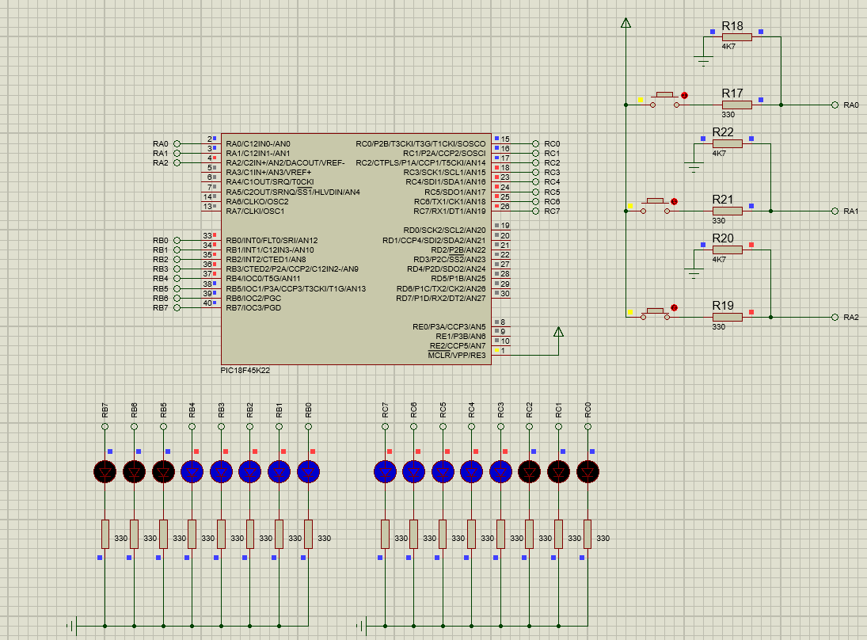

Question-2 :

Our aim is to implement the Fibonacci sequence in this question. You can see my 14th, 15th and 16th result of Fibonacci sequence below. Location 0x10 is higher byte and location 0x11 is lower byte.

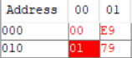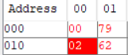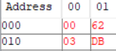

Question-3 :

Our aim is to write code for multiplying two 16 bit signed number. You can see my result on the location 0x10, 0x11, 0x12, and 0x13.

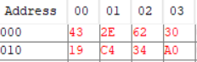
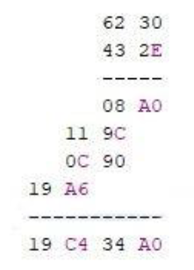

Note:
This document will be prepared before the lab session. Unless you bring this document in the desired format or prepared, you will not be let to the session.

