EEE316 Microprocessors
Pre-laboratory Report

Name : Turhan Can Kargın
ID Number : 150403005
Lab. Number : 6

Objectıves of the Laboratory Assignment:

Objectives of this lab are learning embedded programming with C language, understanding of Interrupts and understanding of timers and counters

Code and Comments:

unsigned cntr=0;
void interrupt() // Interrupt
{
if(INT0IF_bit==1)
{
cntr++;
if(cntr>=10) // Turning on LED after 10 packages
{
PORTb.RB1=1; // LED = 1
Delay_ms(5000); // Wait 5sec
PORTB.RB1=0; // LED = 0
Delay_ms(1000); // wait 1sec
cntr=0; // cntr = 0
}
}
INT0IF_bit=0;
}
void main() {
ANSELB=0; // Input - Output Configuration
ANSELD=0;
TRISB=0b00000001;
TRISD=0;

INTEDG0_bit=0; // Interrupt Setup
INT0IF_bit=0; // clear
INT0IE_bit=1; // enable
GIE_bit=1;

while(1)
{
PORTD=cntr; // To show how many packages we counted
}
}

unsigned cnt; // Assignings
int freq=0;
char txt[7];
char hex[7];
int high;
int low;
void main() {

ANSELA=0; // Configure pins as digital I/O
ANSELB=0;
ANSELC=0;
ANSELD=0;
ANSELE=0;
TRISA=0xFF;
TRISB=0b00000001;
TRISC=0;
TRISD=0;
TRISE=0;
PORTA=0x00;
PORTE=0x00;
PORTC=0x99;
PORTD=0x99;
Delay_ms(80);
PORTC=0x88;
PORTD=0x88;
Delay_ms(80);
PORTC=0x77;
PORTD=0x77;
Delay_ms(80);
PORTC=0x66;
PORTD=0x66;
Delay_ms(80);
PORTC=0x55;
PORTD=0x55;
Delay_ms(80);
PORTC=0x44;
PORTD=0x44;
Delay_ms(80);
PORTC=0x33;
PORTD=0x33;
Delay_ms(80);
PORTC=0x22;
PORTD=0x22;
Delay_ms(80);
PORTC=0x11;
PORTD=0x11;
Delay_ms(80);
PORTC=0x00;
PORTD=0x00;

// Setup Interrupt
T0CON=0b10101000;
TMR0H=0x77;
TMR0L=0x77;
TMR1H=0x3C;
TMR1L=0xB0;
T1CON = 0b00000111;
INTCON=0xC0;
TMR1IE_bit = 1;
PORTC=0x77;
PORTD=0x77;
while(1)
{
low=TMR0L;
high=TMR0H;
if(cnt >=20) // 10 ms * 100 = 1000 ms 0 1 sn
{
PORTE.RE2 = ~ PORTE.RE2;
freq=low-0x77+(256*(high-0x77)); // Calculating Frequency
IntToStr(freq,hex);
while(cnt>=20)
{
IntToStr(freq,hex);
if(freq>100&&freq<200) // frequency value between 100-200Hz
{
PORTC=PORTC-0x01;
if(PORTC==0x00)
{
PORTD=PORTD-0x01;
}
}
if(freq>200&&freq<300) // frequency value between 200-300Hz
{
PORTC=PORTC+0x01;
if(PORTC==0xFF)
{
PORTD=PORTD+0x01;
}
}
}
cnt=0;
}
IntToStr(cnt,txt);
}
}
void interrupt() // Interrupt
{
if(TMR0IF_bit)
{
TMR0H= 0x77;
TMR0L= 0x77;
TMR0IF_bit=0;
}
if(TMR1IF_bit)
{
cnt++;
TMR1H=0X3C;
TMR1L=0xB0;
TMR1IF_bit=0;
}
}

// Setup Interrupt
T0CON=0b10101000;
TMR0H=0x77;
TMR0L=0x77;
TMR1H=0x3C;
TMR1L=0xB0;
T1CON = 0b00000111;
INTCON=0xC0;
TMR1IE_bit = 1;
PORTC=0x77;
PORTD=0x77;
while(1)
{
low=TMR0L;
high=TMR0H;
if(cnt >=20) // 10 ms * 100 = 1000 ms 0 1 sn
{
PORTE.RE2 = ~ PORTE.RE2;
freq=low-0x77+(256*(high-0x77)); // Calculating Frequency
IntToStr(freq,hex);
while(cnt>=20)
{
IntToStr(freq,hex);
if(freq>100&&freq<200) // frequency value between 100-200Hz
{
PORTC=PORTC-0x01;
if(PORTC==0x00)
{
PORTD=PORTD-0x01;
}
}
if(freq>200&&freq<300) // frequency value between 200-300Hz
{
PORTC=PORTC+0x01;
if(PORTC==0xFF)
{
PORTD=PORTD+0x01;
}
}
}
cnt=0;
}
IntToStr(cnt,txt);
}
}
void interrupt() // Interrupt
{
if(TMR0IF_bit)
{
TMR0H= 0x77;
TMR0L= 0x77;
TMR0IF_bit=0;
}
if(TMR1IF_bit)
{
cnt++;
TMR1H=0X3C;
TMR1L=0xB0;
TMR1IF_bit=0;
}
}

Explanations:

Question-1 :

In this question, our aim is to write a C code to count the packages on the production line. We used a button to simulate the laser checker on PROTEUS which is connected to bit 0 of PORTB (RB0). There is a LED connected to bit 1 of PORTB (RB1) which is set to “off” normally. However, the LED turns on for five seconds after 10 packages are counted and no packages are counted during the LED is on.

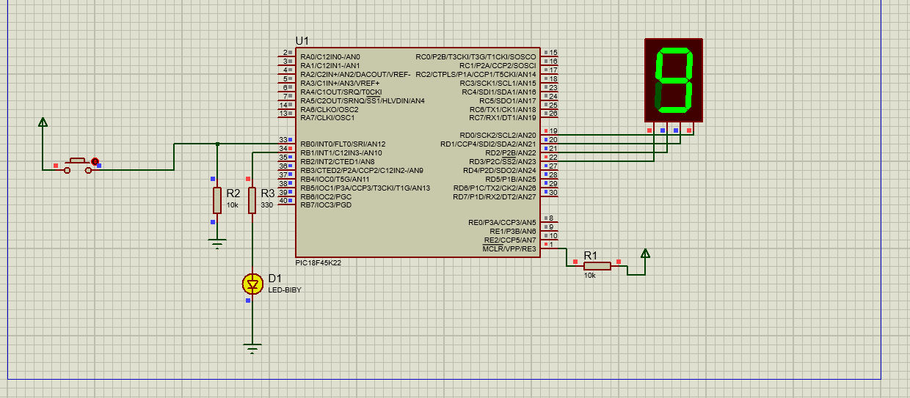

Question-2 :

In this question, our aim is to design an up- and down-counter. RB0 (PORTB.0) pin is fed with a square wave whose frequency change between 100 Hz and 300 Hz. We wrote a program the RB0 behavior so that each time a positive edge of the square wave occurs, an interrupt will be activated, and within the interrupt service routine a counter is incremented for the frequency values greater than 200 Hz and decremented for the frequency values lower than 200 Hz. I used the 1 sec sampling for frequency calculation. Therefore, TMR1 for 1 sec sampling and TMR0 for counting the cycles.
Example Interrupt Time Calculation:

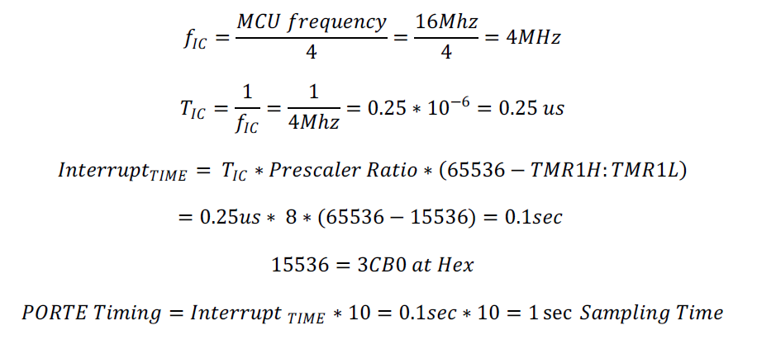
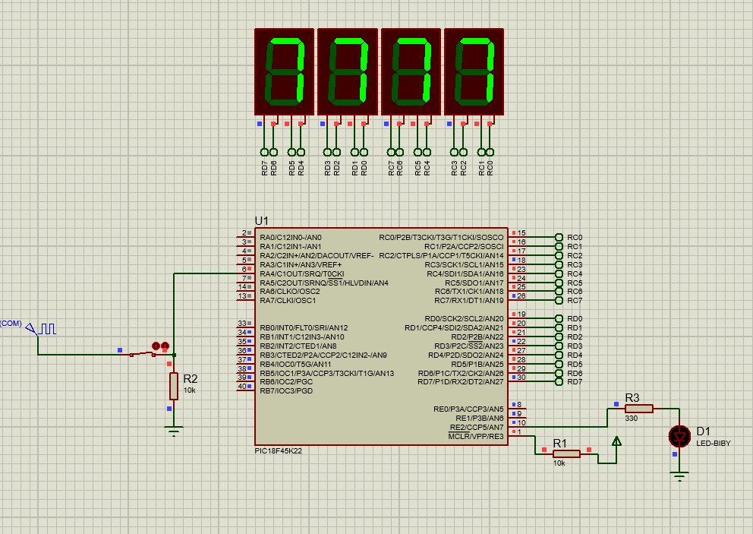

Note:
This document will be prepared before the lab session. Unless you bring this document in the desired format or prepared, you will not be let to the session.

