EEE316 Microprocessors
Pre-laboratory Report

Name : Turhan Can Kargın
ID Number : 150403005
Lab. Number : 7

Objectıves of the Laboratory Assignment:

Objectives of this lab are to understand how to use LCD screen and to understand how to use Keypad.

Code and Comments:

// LCD module connections
sbit LCD_RS at RE1_bit;
sbit LCD_EN at RE0_bit;
sbit LCD_D4 at RB4_bit;
sbit LCD_D5 at RB5_bit;
sbit LCD_D6 at RB6_bit;
sbit LCD_D7 at RB7_bit;
sbit LCD_RS_Direction at TRISE0_bit;
sbit LCD_EN_Direction at TRISE1_bit;
sbit LCD_D4_Direction at TRISB4_bit;
sbit LCD_D5_Direction at TRISB5_bit;
sbit LCD_D6_Direction at TRISB6_bit;
sbit LCD_D7_Direction at TRISB7_bit;
void main() {
// Configure AN pins as digital I/O
ANSELB=0;
ANSELE=0;
TRISB=0x00;
TRISE=0x00;
PORTB=0x00;
PORTE=0x00;
// For LCD
Lcd_Init(); // Initialize LCD
turhan: // After the code finish, it will come here
Lcd_Cmd(_LCD_CLEAR); // Clear display
Lcd_Cmd(_LCD_CURSOR_OFF); // Cursor off
Lcd_Out(1,1,"TurhanCan Kargin"); // Write text in first row
Lcd_Out(2,8,"150403005"); // Write text in second row
Delay_ms(1000);
// From here we scroll
Lcd_Cmd(_LCD_CLEAR);
Lcd_Out(1,2,"TurhanCan Kargin");
Lcd_Out(2,7,"150403005");
Delay_ms(250);
Lcd_Cmd(_LCD_CLEAR);

Lcd_Out(1,3,"TurhanCan Kargin");
Lcd_Out(2,6,"150403005");
Delay_ms(250);
Lcd_Cmd(_LCD_CLEAR);
Lcd_Out(1,4,"TurhanCan Kargin");
Lcd_Out(2,5,"150403005");
Delay_ms(250);
Lcd_Cmd(_LCD_CLEAR);
Lcd_Out(1,5,"TurhanCan Kargin");
Lcd_Out(2,4,"150403005");
Delay_ms(250);
Lcd_Cmd(_LCD_CLEAR);
Lcd_Out(1,6,"TurhanCan Kargin");
Lcd_Out(2,3,"150403005");
Delay_ms(250);
Lcd_Cmd(_LCD_CLEAR);
Lcd_Out(1,7,"TurhanCan Kargin");
Lcd_Out(2,2,"150403005");
Delay_ms(250);
Lcd_Cmd(_LCD_CLEAR);
Lcd_Out(1,8,"TurhanCan Kargin");
Lcd_Out(2,1,"150403005");
Delay_ms(250);
Lcd_Cmd(_LCD_CLEAR);
Lcd_Out(1,9,"TurhanCan Kargin");
Lcd_Out(2,0,"150403005");
Delay_ms(250);
Lcd_Cmd(_LCD_CLEAR);
Lcd_Out(1,10,"TurhanCan Kargin");
Lcd_Out(2,-1,"150403005");
Delay_ms(250);
Lcd_Cmd(_LCD_CLEAR);
Lcd_Out(1,11,"TurhanCan Kargin");
Lcd_Out(2,-2,"150403005");
Delay_ms(5000);
Lcd_Cmd(_LCD_CLEAR);
Lcd_Out(1,10,"TurhanCan Kargin");
Lcd_Out(2,-1,"150403005");
Delay_ms(500);
Lcd_Cmd(_LCD_CLEAR);
Lcd_Out(1,9,"TurhanCan Kargin");
Lcd_Out(2,0,"150403005");
Delay_ms(500);
Lcd_Cmd(_LCD_CLEAR);
Lcd_Out(1,8,"TurhanCan Kargin");
Lcd_Out(2,1,"150403005");
Delay_ms(500);
Lcd_Cmd(_LCD_CLEAR);
Lcd_Out(1,7,"TurhanCan Kargin");
Lcd_Out(2,2,"150403005");
Delay_ms(500);
Lcd_Cmd(_LCD_CLEAR);
Delay_ms(500);
goto turhan; // when it will scroll 4 times, the code will start from beginning
}

// LCD module connections
sbit LCD_RS at RE1_bit;
sbit LCD_EN at RE0_bit;
sbit LCD_D4 at RB4_bit;
sbit LCD_D5 at RB5_bit;
sbit LCD_D6 at RB6_bit;
sbit LCD_D7 at RB7_bit;
sbit LCD_RS_Direction at TRISE0_bit;
sbit LCD_EN_Direction at TRISE1_bit;
sbit LCD_D4_Direction at TRISB4_bit;
sbit LCD_D5_Direction at TRISB5_bit;
sbit LCD_D6_Direction at TRISB6_bit;
sbit LCD_D7_Direction at TRISB7_bit;
// Assignments
char display1[4];
char display2[4];
char i;
char j;
char k;
void main() {
// Configure AN pins as digital I/O
ANSELB=0;
ANSELE=0;
TRISB=0x00;
TRISE=0x00;
PORTB=0x00;
PORTE=0x00;
Lcd_Init(); // Initialize LCD
Lcd_Cmd(_LCD_CLEAR); // Clear display
Lcd_Cmd(_LCD_CURSOR_OFF); // Cursor off
Lcd_Out(1, 6, "02:00"); // It will start with 02:00
Delay_ms(750); // delay
Lcd_Cmd(_LCD_CLEAR); // Clear display
// For loop for counter
for (j=59;j>=0;j--) // count-down from 01.59
{
ByteToStr(j, display1); // We should convert char to string
Lcd_Out(1, 8, display1); // and show it in LCD
Lcd_Out(1, 7, "1");
Lcd_Out(1, 6, "0");
Lcd_Out(1, 8, ":");
Delay_ms(100);
if (j == 0) { // when it will be 01:00
for (i=59;i>=0;i--){ // count-down from 00.59
ByteToStr(i, display2); // We should convert char to string
Lcd_Out(1, 8, display2); // and show it in LCD
Lcd_Out(1, 7, "0");
Lcd_Out(1, 6, "0");
Lcd_Out(1, 8, ":");
Delay_ms(100);
if (i <= 0) { // when the count-down is over
goto turhan; // it will go to turhan go make 00:00 forever
}
}
}
}
while(1){
turhan:
Lcd_Out(1, 6, "00:00"); // make 00:00 forever
}
}

// Keypad module connections
char keypadPort at PORTD;
// Keypad module connections
// LCD module connections
sbit LCD_RS at RE1_bit;
sbit LCD_EN at RE0_bit;
sbit LCD_D4 at RB4_bit;
sbit LCD_D5 at RB5_bit;
sbit LCD_D6 at RB6_bit;
sbit LCD_D7 at RB7_bit;
sbit LCD_RS_Direction at TRISE0_bit;
sbit LCD_EN_Direction at TRISE1_bit;
sbit LCD_D4_Direction at TRISB4_bit;
sbit LCD_D5_Direction at TRISB5_bit;
sbit LCD_D6_Direction at TRISB6_bit;
sbit LCD_D7_Direction at TRISB7_bit;
// Assignments
char display1[4];
char display2[4];
char i;
char j;
char k;
unsigned short kp, count, oldstate = 0;
char txt[6];
void main() {
count = 5; // To write Counter in 5. columns
Keypad_Init(); // Initialize Keypad
ANSELB = 0; // Configure AN pins as digital I/O
ANSELD = 0;
ANSELE = 0;
Lcd_Init(); // Initialize LCD
Lcd_Cmd(_LCD_CLEAR); // Clear display
Lcd_Cmd(_LCD_CURSOR_OFF); // Cursor off

Lcd_Out(1, 1, "Enter Four Digits"); // Write message text on LCD
Lcd_Out(2, 1, "After 2 seconds");
delay_ms(2000);
Lcd_Cmd(_LCD_CLEAR); // Clear display
do {
kp = 0; // Reset key code variable

// Wait for key to be pressed and released
do
kp = Keypad_Key_Click(); // Store key code in kp variable
while (!kp);
// Prepare value for output, transform key to it's ASCII value

switch (kp) {
case 1: kp = 49; break; // 1
case 2: kp = 50; break; // 2
case 3: kp = 51; break; // 3
case 4: kp = 65; break; // A
case 5: kp = 52; break; // 4
case 6: kp = 53; break; // 5
case 7: kp = 54; break; // 6
case 8: kp = 66; break; // B
case 9: kp = 55; break; // 7
case 10: kp = 56; break; // 8
case 11: kp = 57; break; // 9
case 12: kp = 67; break; // C
case 13: kp = 42; break; // *
case 14: kp = 48; break; // 0
case 15: kp = 35; break; // #
case 16: kp = 68; break; // D

}

Lcd_Chr(1,++count, kp); // Print key ASCII value on LCD
Lcd_Out(1,8, ":"); // for count-down
delay_ms(100);

if (count == 10) { // when you enter four digit it will come here
// From here, code is like second question
Lcd_Cmd(_LCD_CLEAR);
for (j=59;j>=0;j--)
{
ByteToStr(j, display1);
Lcd_Out(1, 8, display1);
Lcd_Out(1, 7, "1");
Lcd_Out(1, 6, "0");
Lcd_Out(1, 8, ":");
Delay_ms(250);

if (j == 0)
{
Lcd_Cmd(_LCD_CLEAR);
for (i=59;i>=0;i--)
{
ByteToStr(i, display2);
Lcd_Out(1, 8, display2);
Lcd_Out(1, 7, "0");
Lcd_Out(1, 6, "0");
Lcd_Out(1, 8, ":");
Delay_ms(250);
if (i <= 0)
{
goto turhan;
}
}
}
}
while(1){
turhan:
Lcd_Out(1, 6, "00:00");
}
}
} while (1);
}

4.
// Keypad module connections
char keypadPort at PORTD;
// LCD Module connections
sbit LCD_RS at RE1_bit;
sbit LCD_EN at RE0_bit;
sbit LCD_D4 at RB4_bit;
sbit LCD_D5 at RB5_bit;
sbit LCD_D6 at RB6_bit;
sbit LCD_D7 at RB7_bit;
sbit LCD_RS_Direction at TRISE0_bit;
sbit LCD_EN_Direction at TRISE1_bit;
sbit LCD_D4_Direction at TRISB4_bit;
sbit LCD_D5_Direction at TRISB5_bit;
sbit LCD_D6_Direction at TRISB6_bit;
sbit LCD_D7_Direction at TRISB7_bit;
// Asignments
char kpi; kpi1; kpi2; total1; total; counter; remainder;
char lookup_table[] = " 741 8520963=/*-+" ;
int i ; b;
void main() {
ANSELB = 0; // Configure AN pins as digital I/O
ANSELD = 0;
ANSELE = 0;
Lcd_Init(); // Initialize LCD
Lcd_Cmd(_LCD_CLEAR); // Clear Display
Lcd_Cmd(_LCD_CURSOR_OFF); // Cursor Off
Lcd_Cmd(_LCD_CLEAR);
// When power is applied to the system,
// the LCD displays text “Decimal to Binary Converter” for 2 seconds by scrolling
Lcd_Out(2,1,"Decimal to Binary Converter”");
Delay_ms(125);
Lcd_Cmd(_LCD_CLEAR);
Lcd_Out(2,0,"Decimal to Binary Converter”");
Delay_ms(125);
Lcd_Cmd(_LCD_CLEAR);
Lcd_Out(2,-1,"Decimal to Binary Converter”");
Delay_ms(125);
Lcd_Cmd(_LCD_CLEAR);
Lcd_Out(2,-2,"Decimal to Binary Converter”");
Delay_ms(125);
Lcd_Cmd(_LCD_CLEAR);
Lcd_Out(2,-3,"Decimal to Binary Converter”");
Delay_ms(125);
Lcd_Out(2,-4,"Decimal to Binary Converter”");
Delay_ms(125);
Lcd_Cmd(_LCD_CLEAR);
Lcd_Out(2,-5,"Decimal to Binary Converter”");
Delay_ms(125);
Lcd_Cmd(_LCD_CLEAR);
Lcd_Out(2,-6,"Decimal to Binary Converter”");
Delay_ms(125);
Lcd_Cmd(_LCD_CLEAR);
Lcd_Out(2,-7,"Decimal to Binary Converter”");
Delay_ms(125);
Lcd_Cmd(_LCD_CLEAR);
Lcd_Out(2,-8,"Decimal to Binary Converter”");
Delay_ms(125);
Lcd_Cmd(_LCD_CLEAR);
Lcd_Out(2,-9,"Decimal to Binary Converter”");
Delay_ms(125);
Lcd_Cmd(_LCD_CLEAR);
Lcd_Out(2,-10,"Decimal to Binary Converter”");
Delay_ms(250);

Delay_ms(125);
Lcd_Cmd(_LCD_CLEAR);
Lcd_Out(2,-10,"Decimal to Binary Converter”");
Delay_ms(250);
Lcd_Cmd(_LCD_CLEAR); // Clear Display
delay_ms(500); // Delay of 0.5s
Keypad_Init(); // Initialize Keypad
Lcd_Out(1,1,"Write a Number"); // Write "Write a Number" in the first row
Lcd_Out(2,1,"to Convert"); // Write "to Convert" in the first row
delay_ms(1000); // Delay of 0.5s
Lcd_Cmd(_LCD_CLEAR); // Clear Display
do
{
kpi = 0; // Reset key code variable
// Wait for key to be pressed and released
do
kpi = Keypad_Key_Click(); // Store key code in kpi variable

while (!kpi);
if (kpi <= 16) {
kpi = lookup_table[kpi]; }
Lcd_Chr(1, 2, kpi); // Print key ASCII value on Lcd
kpi1= 0; // Reset key code variable
// Wait for key to be pressed and released
do
kpi1 = Keypad_Key_Click(); // Store key code in kpi variable
while (!kpi1);
if (kpi1<= 16) {
kpi1= lookup_table[kpi1];
}
Lcd_Chr(1, 3, kpi1); // Print key ASCII value on Lcd
kpi2 = 0;
do
kpi2 = Keypad_Key_Click();
while(!kpi2);
if(kpi2<= 16){
kpi2 = lookup_table[kpi2];
}
Lcd_Chr(1, 4, kpi2);
kpi &= 0x0F;
kpi1 &= 0x0F;
kpi2 &= 0x0F;
total = 0;
total = (kpi*100) + (kpi1*10) + kpi2 ;
for (b = 8; b != 0; b--) //loop 8 times
{ {
remainder = total%2;
total = total/2;
if (remainder==1)
{
Lcd_Chr(2,b,'1');
}
else
Lcd_Chr( 2,b,'0');
}
}
delay_ms(3000);
Lcd_Cmd(_LCD_CLEAR); // Clear Display
} while(1);

}

Explanations:

Question-1 :

Our aim is to display my name and surname at the first line and my student ID at the second line in 16x2 LCD. Then, scroll the first line to the right and the second line to the left, wait for 5 seconds, and then scroll the first line to the left and the second line to the right for 4 times.

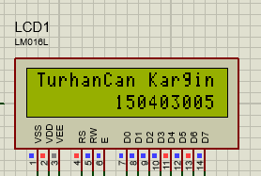

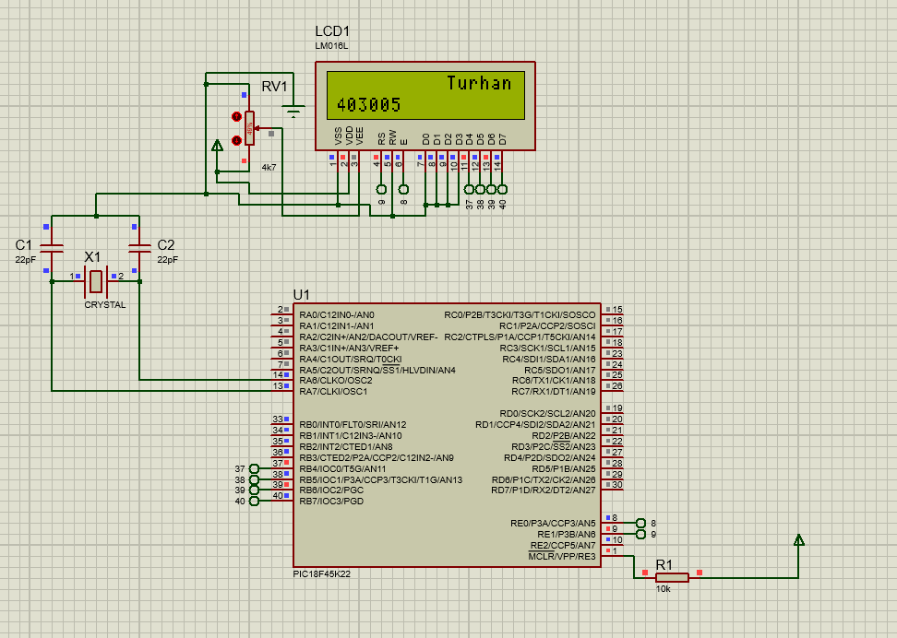

Question-2 :

Our aim is to display a countdown timer for 2 minutes in the middle of the 16x2 LCD.

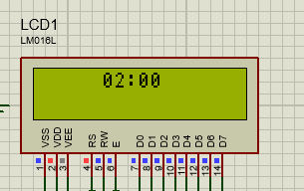

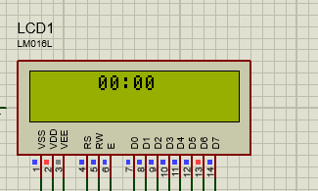

Question-3 :

Our aim is to repeat question 2 by sing a 4x4 keypad. We should enter four digits via keypad. A countdown timer counts for entered four digits and it should be displayed in LCD.

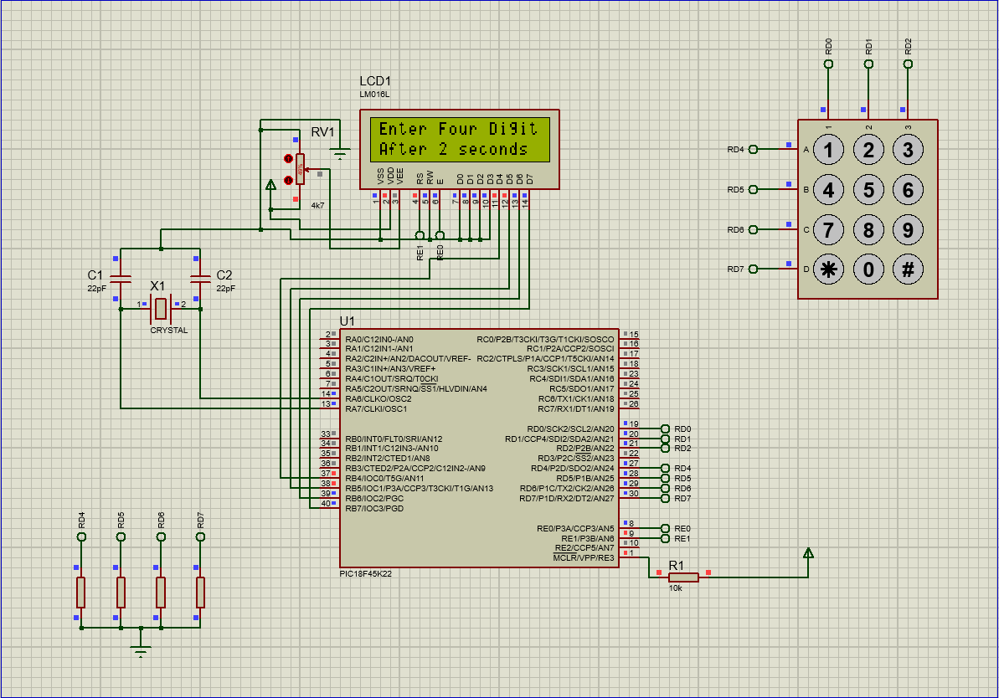

Question-4 :

Our aim is to Design a Decimal to Binary converter using 4x4 keypad and 16x2 LCD. The decimal number should be entered by user via keypad and should be written in the first line on LCD and the binary result should be shown in the second line. When power is applied to the system, the LCD displays text “Decimal to Binary Converter” for 2 seconds. Then, user is expected to type the decimal number and after press ENTER key, the binary result should be displayed for five seconds. Then, the LCD should be cleared, ready for next conversion.

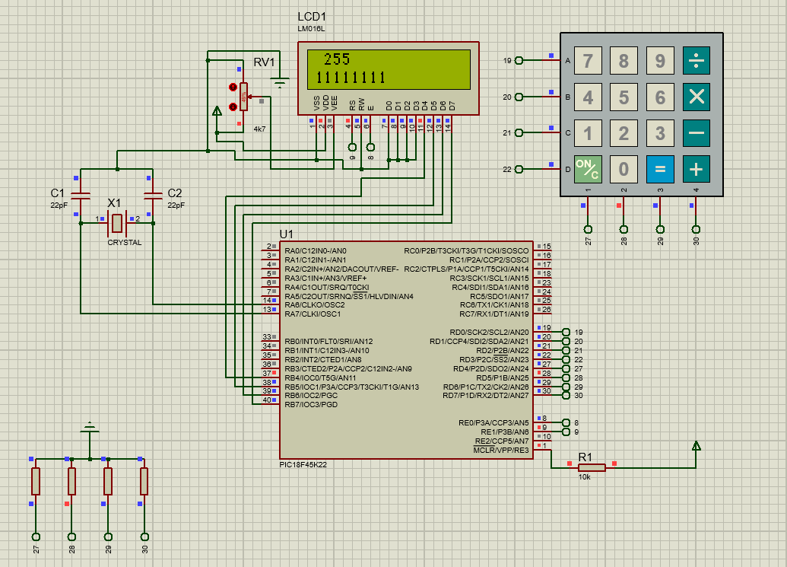

Note:
This document will be prepared before the lab session. Unless you bring this document in the desired format or prepared, you will not be let to the session.

